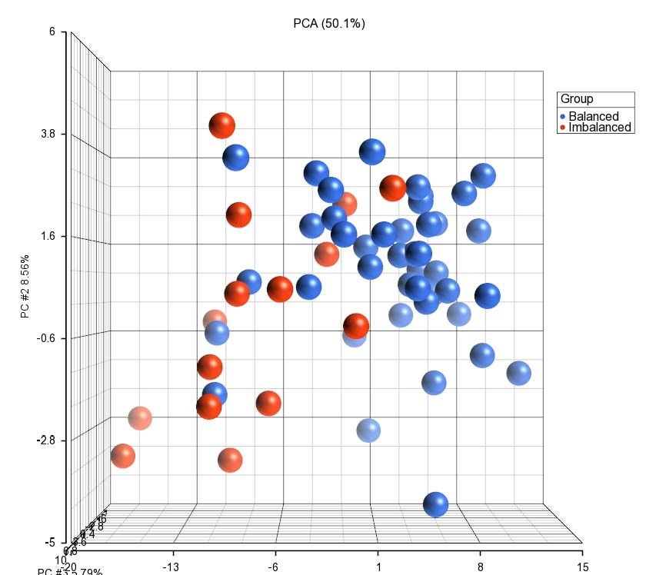

Supplementary Figure 1. Principal component analysis for liver transcriptomic gene expression. The RNA-Seq reads were normalised with reads per kilobase of transcript per million mapped reads (RPKM). The samples were taken from 104 multiparous Holstein Friesian cows on about 14 days after calving, in which 44 were classified as Balanced, 44 as Intermediate and 16 as Imbalanced based on their energy and metabolic status. This figure compares the data for the Balanced and Imbalanced groups.

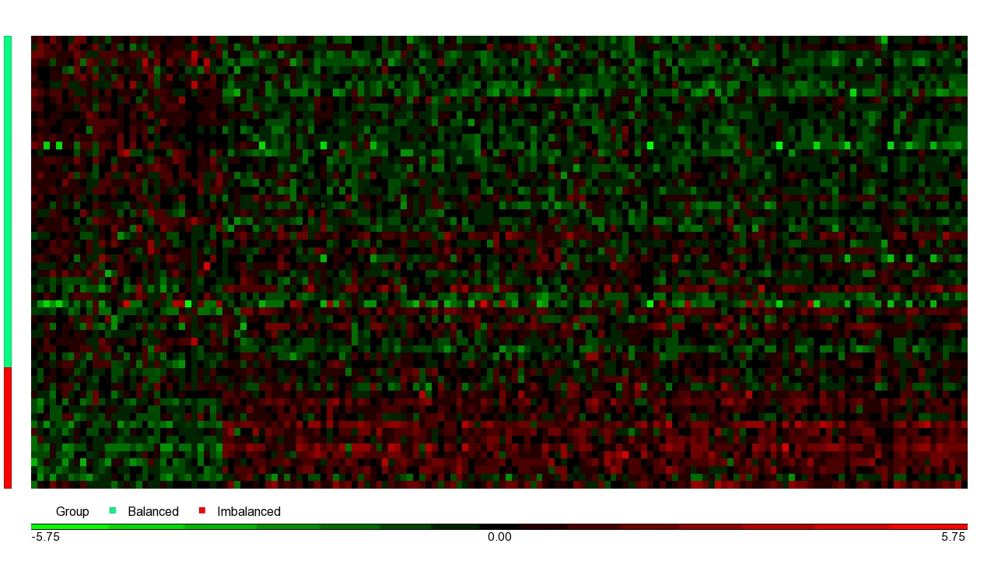

Supplementary Figure 2. Heatmap for liver transcriptomic gene expression. The RNA-Seq reads were normalised with reads per kilobase of transcript per million mapped reads (RPKM). The values were standardised by shifting to mean of zero and scaling to standard deviation of one. The samples were taken from 104 multiparous Holstein Friesian cows on about 14 days after calving, in which 44 were classified as Balanced, 44 as Intermediate and 16 as Imbalanced based on their energy and metabolic status. This figure compares the data for the Balanced and Imbalanced groups.

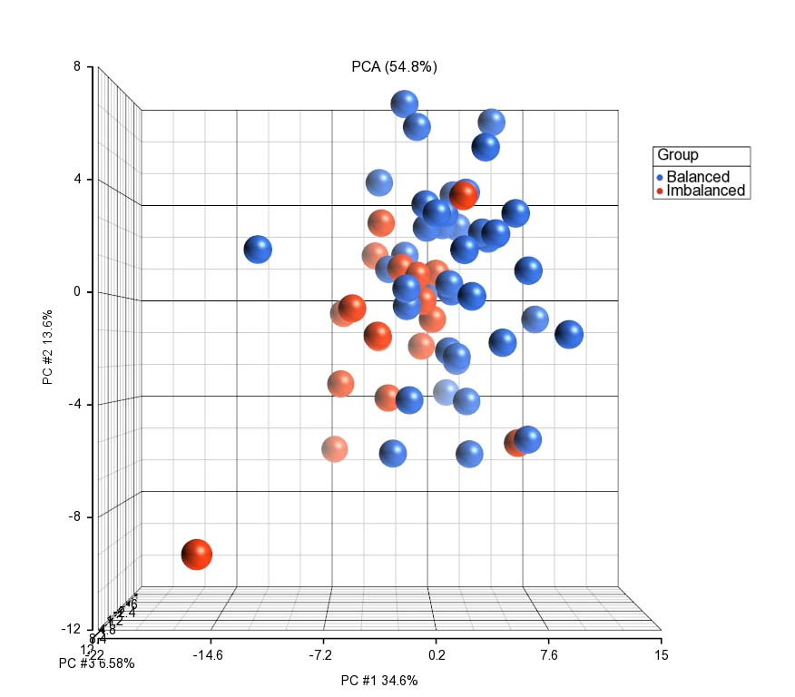

Supplementary Figure 3. Principal component analysis for leukocyte transcriptomic gene expression. The RNA-Seq reads were normalised with reads per kilobase of transcript per million mapped reads (RPKM). The samples were taken from 105 multiparous Holstein Friesian cows on about 14 days after calving, in which 42 were classified as Balanced, 44 as Intermediate and 19 as Imbalanced based on their energy and metabolic status. This figure compares the data for the Balanced and Imbalanced groups.

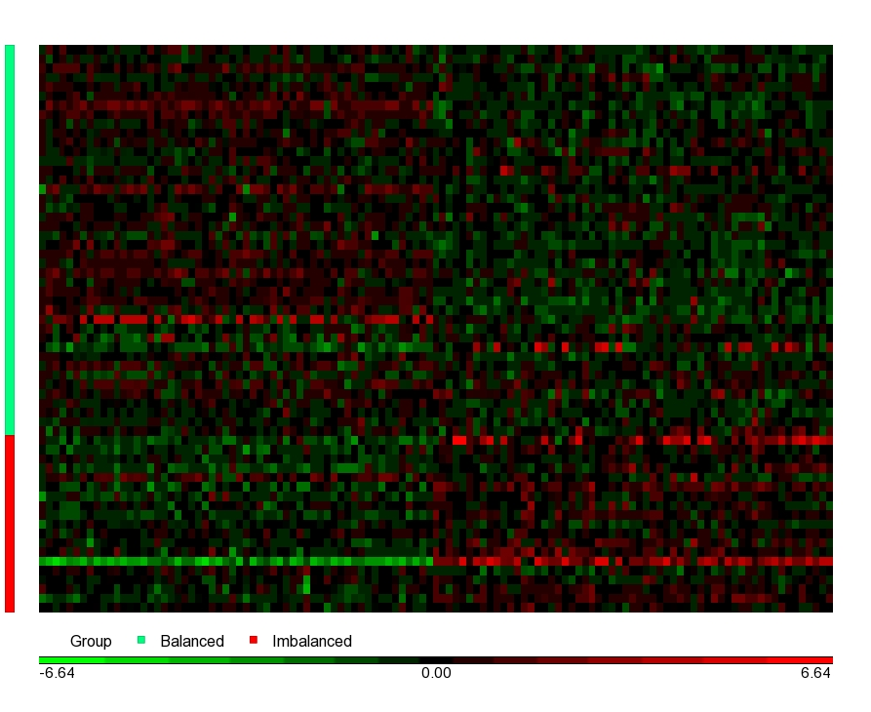
Supplementary Figure 4. Heatmap for leukocyte transcriptomic gene expression. The RNA-Seq reads were normalised with reads per kilobase of transcript per million mapped reads (RPKM). The samples were taken from 105 multiparous Holstein Friesian cows on about 14 days after calving, in which 42 were classified as Balanced, 44 as Intermediate and 19 as Imbalanced based on their energy and metabolic status. This figure compares the data for the Balanced and Imbalanced groups.

