Evaluation of Blunt Force Trauma for Neonatal Piglets On-Farm
Running title: Blunt Force Trauma for Piglets’ Culling
Filipe Antonio Dalla Costa†,‡,*, Troy J. Gibson§, Steffan Edward Octávio Oliveira†,‡, Neville George Gregory§, Arlei Coldebella#, Luigi Faucitano||, Charli Beatriz Ludtke¶, Liziè Peréirã Buss††, and Osmar Antonio Dalla Costa#
†Programa de Pós-graduação em Zootecnia, Faculdade de Ciências Agrárias e Veterinárias, UNESP - São Paulo State University, Jaboticabal, SP, Brazil;
‡Maneja bem-estar animal, MANEJA, Concórdia, SC, Brazil;
§Royal Veterinary College, Hawkshead Lane, Hatfield, United Kingdom;
#Embrapa Suínos e Aves, Concórdia, Brazil;
||Agriculture and Agri-Food Canada, Sherbrooke, Quebec, Canada;
¶Associação Brasileira dos Criadores de Suínos, Brasília, DF, Brazil;
††Departamento de Sistemas de Produção e Sustentabilidade, Ministério da Agricultura, Pecuária e Abastecimento – MAPA, Brasília, DF, Brazil.

*Filipe A. Dalla Costa; filipedallacosta@gmail.com; Maneja Consultoria Ltda.

Acknowledgments: This study was conducted as part of the PhD program of F.A.D.C. within the Animal Science Graduate Program at the UNESP-FCAV (Jaboticabal, SP, Brazil). The authors are grateful to M.J.R.P.C for the help during the project planning.

Conflicts of Interest: The authors declare no conflict of interest.
ABSTRACT: Twenty-seven neonate piglets (range from 0.35 to 1.17 kg) were evaluated for the effectiveness of blunt force trauma as a method of on-farm cull. Brainstem function, brain injury and haemorrhage scores (increasing from 0 to 3) were assessed after striking the head against a concrete floor. Electroencephalograms (EEG) from a subset of 15 piglets were recorded prior to and after blunt force trauma for electrophysiological assessments. Blunt force trauma was performed by a single experienced farmer in a commercial farm by holding the piglet by its both hind legs and striking the head against the concrete floor. All piglets remained recumbent and did not show brainstem reflexes. Only one piglet did not presented tonic/clonic physical activity. The mean time to onset of persistent isoelectric EEG was 64.3 ± 7.3 (range 18 – 115) s. Total power, theta, alpha and beta power decreased to approximately 45%, 30%, 20% and 15% from pre-treatment power, respectively by 15 s post-impact. There were no periods of normal-like EEG after the culling. Bruises in the neck and shoulder were found in 67% and 70% of piglets, respectively. All piglets presented skull fractures with 20% having the nasal bone(s) fractured. Brain damage was found in all piglets, mainly in the frontal lobe(s). The occipital lobe(s) presented the greatest frequency of severe damage. The analysis of the radiographs also found a high frequency of fractures in this region. Haemorrhage was most frequent in the frontal, parietal, occipital lobes and midbrain. When performed correctly with the appropriate weight class, blunt force trauma can be used as an effective method for on-farm killing of nursing piglets resulting in death. However, this method should not be promoted over more reliable and repeatable cull methods such as captive bolt gun (CBG). As with blunt force trauma there is significant potential for animal welfare harm associated with inappropriate practice, lack of accuracy, issues with repeatability and operator fatigue.
Keywords: animal welfare, culling, killing, piglet, brain injury, electroencephalogram (EEG)
List of abbreviations: EEG – Electroencephalogram; CAK – Controlled atmosphere killing; CBG – Captive bolt gun; Ptot – Total power

Introduction
On pig farms most non-viable neonatal piglets are culled to alleviate or prevent suffering or negative welfare outcomes with manual blunt force trauma (Whiting et al., 2011; Dalla Costa et al., 2019), despite being an illegal method in some countries (Council Directive 1099/2009, 2009) and not being considered acceptable for piglets with a bodyweight of more than 5 kg, or finishing pigs and sows (AVMA, 2020; CFMV, 2012). This method is usually performed by striking the animal’s head with a hammer or against a solid/hard surface, such as a wall or floor (Widowski et al., 2008; Grist et al., 2018; Dalla Costa et al., 2019). The decision to use this method is based on the low cost of the procedure and/or the lack of knowledge or experience with alternative methods (Dalla Costa et al., 2019). A survey of Brazilian pig farms reported that 90% used concussion methods (including striking the animal’s head with a hammer or against a solid/hard surface) to cull piglets (Dalla Costa et al., 2019). However, this study also reported that 33% of stockpeople would prefer an alternative method.
However, its efficiency in inducing immediate loss of sensibility in nursing piglets (less than 5 kg weight) is debatable (Whiting et al., 2011; Grist et al., 2018; Dalla Costa et al., 2019). As with captive bolt stunning, the effectiveness may depend on a number of operator and animal factors, such as, skill and training, force employed, precision, impact head site, strike speed, operator fatigue, size and weight of the animal and skull morphology (Gibson et al., 2015; 2019; Andrew Grist et al., 2018; Oliveira et al., 2018). Besides the potential welfare risks, striking piglets’ heads against a solid/hard surface or with a hammer is visually unpleasant and considered by some in society as repulsive and barbaric (Dalla Costa et al., 2019). It has been reported by several authors that stockpeople’s attitudes can be negatively affected by on-farm animal culling practices (Rault et al., 2017; Shearer, 2018; Dalla Costa et al., 2019). An acceptable method should be supported by complete studies that includes behavioural, pathology and brain activity data. The group of these parameters leads to a better understanding of the effects and risks of which method. However, the literature only reported manual blunt force trauma studies including behavioural and pathology data. Whiting et al. (2011) did not report fails in the application of manual blunt force trauma performed by 7 different operators for 50 piglets evaluated. However, the methods used to classify the efficiency is based only in some visual evaluation of respiration, vocalization and heart rate, which makes the conclusion doubtful. Also, there was no pathology evaluation. Widowski et al. (2008) reported the manual blunt force trauma as a rapid, effective and humane method of euthanizing low viability piglets. However, the study did not confirm the data using brain activity.
Currently, mechanical/manual blunt force trauma, controlled atmosphere killing (CAK), electrocution and anaesthetic overdose are accepted methods for on-farm killing of piglets. Studies that have evaluated mechanical blunt force trauma (Widowski et al., 2008) reported that some piglets (less than 1 day old) had brainstem reflexes returning after being shot with non-penetrating captive bolt gun (Zephyr-Rabbit Stunner, Bock Industries Inc.). However, an improved model of this captive bolt gun (Zephyr-E with a conical shape) and the cartridge powered Cash® Small Animals Tool (Accles and Shelvoke) have been shown to rapidly render piglets up to 10.9 kg to insensibility (Casey-Trott et al., 2013, 2014; Grist et al., 2017; Grist et al., 2018). Electrocution performed with a proper equipment and combined with a secondary procedure (bleeding, head trauma and cardiac compression) can be used to cull pigs (CFMV, 2012; AVMA, 2020). However, stockpeople should be aware of the risk of accidents during application with wet floors, inadequate personal safety equipment and incorrect electrode placement. The use of an overdose of general anaesthetic (barbiturates) is usually impractical for routine use in large scale pig production because of the costs and the need requirement of specific professionals as these compounds are commonly prescription only medicines. Despite recent improvements, the use of CAK for on-farm cull requires box/module equipment and there is still debate over the appropriate gases/mixtures and the overall potential for animal suffering (Rault et al., 2015; Kells et al., 2018). Thus, the cost of acquiring equipment, applying the method, convenience, human safety and lack of ease of application of the alternative methods make manual blunt force trauma a more frequently used method on commercial pig farms (Dalla Costa et al., 2019).
The objective of this study was to evaluate the effectiveness of blunt force trauma performed by just one farmer in a commercial farm in Brazil where this method is frequently used as a method of on-farm culling for neonatal piglets using brainstem mediated reflexes, EEG, cranial fractures and brain lesions.

Materials and Methods
This project was approved by the Committee of Ethical Use of Animals at EMBRAPA Swine and Poultry Brazil (Protocol number: 007/2018) and the Royal Veterinary College Clinical Research Ethical Review Board (URN 2019 1879-3).
The effectiveness of blunt force trauma as a method of on-farm culling for neonatal piglets (0.54 ± 0.17 kg, range from 0.35 to 1.17 kg and less than one-week-old) requiring cull was assessed with behavioral and pathological analysis (n = 27). A subset of these piglets (n=15) were in addition assessed with EEG. All piglets used were healthy and had no injuries at selection moment to guarantee the quality of evaluations.
Non-viable piglets were selected from a commercial farm based on their low weight at birth under the same criteria used in the farm routine. Piglets were culled by manual blunt force trauma to the head by a single operator holding the animal by its rear legs and striking the top of the head against the concrete floor. This method is widely used by many pig farms in Brazil as previously reported (Dalla Costa et al., 2019). The operator holding both rear legs initially swung the piglet upwards in an underarm action to approximately 20⁰ above the level of their head (angle based on the shoulder being the pivot point), before swinging downwards with a continuous single strong fluid motion with the head impacting against the concrete floor at the end of the swing arc. After a single strike the piglets were left on the floor by the operator in lateral recumbency. The operator was the farmer who was responsible for all routine daily practices. Effectiveness of blunt force trauma was assessed using brainstem reflexes, cranial fractures and macroscopic pathology in all animals. In a subset of these piglets (n = 15), EEG activity was assessed prior to and after blunt force trauma. The sample size (n = 15) was determined based on data reported by Indira et al. ( 2012) for EEG with α=0.05 – 0.10. The inclusion of the EEG subset allowed direct comparisons between electrophysiological, brainstem and pathological indices.

Behavioural assessment of brain function
Behavioral, posture and brainstem reflexes (rhythmic breathing, vocalization, palpebral and corneal reflex, spontaneous eye blinking, eyeball rotation, nystagmus, jaw tension and gasping) were evaluated immediately after the strike (n=27 piglets) and recorder for further evaluation by a trained observer, using a methodology similar to that described by Oliveira et al. (2017) until onset of cardiac arrest (checked by auscultation). The latency to cardiac arrest was not recorded. Concussion was considered effective when rhythmic breathing had ceased and there were no brainstem related reflexes. Additional information on blood extravasation (bleeding from the mouth and nostrils) was also recorded.

Electroencephalogram (EEG) recording subset
EEG from a subset of 15 piglets was recorded using three 24-gauge stainless steel subdermal electrodes (Subdermal electrode, Xi’an Friendship Medical Electronics Co. Ltd, Xi’an, Shaanxi, China), placed as a three electrode montage in the skin with the: active (non-inverting) left of midline in-line with the back of the eyes; reference (inverting), over the left caudal aspect of the frontal bone (top of head) in-line with the front of the ears; and ground electrode caudal to the poll. Electrodes were further secured in position with super glue to prevent displacement during the culling procedure. EEG signals were amplified and filtered with an analogue filter (Bio Amp, ADInstruments Ltd., Sydney, Australia) with low and high pass filters of 300 and 0.1 Hz, respectively. The signals were digitalized (1 kHz) with a 4/20 PowerLab (ADInstruments Ltd., Sydney, Australia) digital to analogue converter and recorded on a Sony laptop (Sony USA Inc. New York, NY, USA) for off-line analysis. Pre-treatment EEG signals were collected for 3 minutes before the BFT to obtain the normal EEG data to compare with post-treatment results.

Subjective EEG analysis
Electroencephalogram epochs contaminated by artefacts such as over- and under scale (DC drift), large single spikes, or electromyography were manually rejected from analysis using Chart 8.1.5 (ADInstruments Ltd). All waveforms were digitally filtered with a pass band of 1 to 30 Hz and traces were inspected visually and compared to baseline using the classification systems developed by Gibson et al. (2009a). They were classified into one of four categories previously published in the literature (Gibson et al., 2019): (1) Movement artefact; (2) Normal EEG; (3) Transitional EEG and (4) Isoelectric EEG. Briefly, normal EEG represents activity that is similar in amplitude and frequency to baseline period. Transitional EEG was classified as suppressed activity of having either an amplitude of less than half of that of the pre-treatment EEG and/or depressed high frequency activity. Isoelectric EEG was classified as a trace with an amplitude of < 1/8 (12.25%) of that of normal pre-stunning EEG with little or no low frequency components. From the group of 15 piglets, two animals were removed from the EEG analysis due to artefacts and external electrical noise.

Power spectrum analysis
The EEG power spectra of uncontaminated epochs were analysed as follows (Gibson et al., 2018). Fast Fourier Transformation with a Welch window was applied to non-overlapping 1 s epochs (pre-treatment and every second post stunning), generating sequential power spectra with 1-Hz frequency bins. Subsequent analysis was performed using Microsoft Excel 2016 (Microsoft Corporation, Redmond, USA). Electroencephalogram spectral data were calculated and are displayed as percentage changes in total power (Ptot), delta (0.5–4 Hz), theta (4–8 Hz), alpha (8–12 Hz) and beta (12–30 Hz) power from pre-treatment values. Spectral data contaminated by movement artefact was excluded based on the subjective analysis and video data.

Pathology evaluations
Heads (n = 27 piglets) were removed from the body and then placed in containers with 10% formalin and sealed. The neck and shoulder of each animal were evaluated for the presence of bruises. A randomized subset of nine heads prior to gross pathology evaluations were digitally radiographed in the frontal and sagittal plane to evaluate the cranial lesions. After each scan, these heads were returned to formalin containers for later pathology assessment.
All heads (including radiograph subjects) after 30 d of fixation, were assessed for subcutaneous haemorrhage and skull fractures were evaluated for cavitation, depressed and radiating fractures and number of bone fragments. The fixed brains were removed for further analysis.
Brains were subjectively scored for distribution of haemorrhage over the lateral, dorsal and ventral surface (0=none; 1=1-20%; 2=21-50%; 3=51-100%) and damage (1=distortion of normal shape without destruction of brain structures; 2=laceration without destruction of brain structure; 3=partial/total destruction of brain structure). Then, brains were sliced (range 9–13 slices) at approximately 5 mm starting rostrally and moving caudally. Each section on its rostral aspect was evaluated for severity of damage to internal brain structures (frontal, parietal, temporal and occipital lobes, corpus callosum, thalamus, hypothalamus, hippocampus, midbrain, occipital, cerebellum, lateral, third and fourth ventricle, cerebral aqueduct, medulla, pons), presence of bone fragments, percentage of haemorrhage over the surface and scored for damage using the same scoring system as previously described. Midline shift (presence/absence) was assessed as the lateral deviation of structures based on a superimposed line extending from the middle of the brain to the third ventricle on the axial plane.

Statistical analysis
Descriptive analysis of the data was performed on the frequency of the variables and calculation of the mean, standard deviation of the mean, minimum and maximum of the quantitative variables. The relationship between the time to become isoelectric (subjective analysis of EEG) and time to power spectrum data becoming 10% of the normal EEG was evaluated using linear regression with SAS (2012).

Results

Behavioural assessment of brain function
All piglets remained recumbent and most (96%; 26/27) presented tonic/clonic physical activity for on average for 88.5 s (SE: ± 27.6, range 10 – 179) after concussive trauma. None of the piglets presented rhythmic breathing, vocalization, palpebral and corneal reflexes, spontaneous eye blinking, eyeball rotation, nystagmus, jaw tension and gasping, nor brain extrusion or bleeding from the skin on top of the head. However, 89% of piglets presented bleeding from nostrils, 30% from the mouth, 19% from the ears and 4% from the impact site. No piglets required to be euthanized with an additional procedure.

Electroencephalogram response
All piglets culled by striking their heads against the floor (13/13) presented patterns of EEG activity (raw and spectral) different from patterns of normal EEG activity (pre-treatment) that were inconsistent with the maintenance of sensibility (Figure 1 and 2). Initial periods of movement/artefact varied from 8 to 51 s (Figure 3). After movement artefact, in 12 of the 13 piglets there were periods of transitional activity. The mean ± SE time to onset of persistent isoelectric EEG was 64.3 ± 7.3 s (range 18 – 115). Mean Ptot decreased at the first epoch after cull to ≈50% from the pre-treatment values (Figure 4 - white dashed line). Within ≈30 s after impact, the mean Ptot remained lower than 30% of the pre-treatment period (normal EEG activity) and after 67.5 ± 10.8 (means ± SE) s the EEG activity was lower than 10% compared to the pre-treatment period. There was no correlation (p = 0.775) between the time to become isoelectric and the time to became lower than 10% compared to the pre-treatment period (r = 0.093). The delta power initially presented a high variation of activity up to 15 s post culling, then decreased to lower than 50% from pre-treatment values (Figure 5). Theta, alpha and beta decreased to approximately 30%, 20% and 15% from pre-treatment power, respectively by 15 s post-impact (Figure 5). A shift from high to low frequency (alpha/delta and beta/delta) was observed after concussion up to the time of isoelectric activity (Figure 6). EEG data of two piglets were removed from these analyses due to artefacts and external electrical noise.
[FIGURE 1]
[FIGURE 2]
[FIGURE 3]
[FIGURE 4]
[FIGURE 5]
[FIGURE 6]

Pathology findings
Immediately after culling (while the animals were still in the tonic/clonic physical activity), the formation of a cranial hematoma at the impact site was visually observed by the change of skin color and an increase in head volume associated with hematoma formation.
Cranium radiographs (n=9) varied in the degree of damage (67 vs. 33% simple and multiple fractures, respectively; Figure 7). Most piglets had fractures in the occipital bone (56%) while 44% and 33% presented with fractures in the frontal and temporal bones, respectively. The length of the fractured edges of the breaks were on average 16 (range of 2-41 mm) and 10 mm (range of 0-29 mm) in the frontal and sagittal plane, respectively.
Bruises in the neck and shoulder regions were found in 67 and 70% of piglets, respectively. Cranial bone thickness at the site of injury was 1.0 ± 0.2 mm (means ± SE; Figure 7). There was fragmentation of the skull at the impact site in all animals and the majority of piglets presented radiating fractures (96%). On average, skulls had 2.7 ± 1.0 (means ± SE; range 0 to 6) and 4.3 ± 2.2 (means ± SE; range 0 to 9) radiating fractures and bone fragments, respectively. Cavitation and depression fractures were not observed. Fractures in the nasal bone were found in 7% of piglets.
All piglets presented damage of at least score 1 in the external evaluation of the brain (Table 1). Score 3 was the most frequent finding for external evaluation of the cerebrum (59%), mainly due to the high frequency of this score in the frontal, parietal and occipital lobe (43, 33 and 33%, respectively). Only 2 piglets (8%) presented lesions on the ventral surface of the pons. One was compressed resulting in loss of original shape and the other was lacerated on the ventral surface with loss of tissue. Less than 50% of piglets presented cerebellum lesions. Medulla was not macroscopically damaged by the concussive trauma.
[FIGURE 7]
The internal evaluation showed similar results to the external one (Table 1). Hippocampus, thalamus, corpus callosum and lateral and fourth ventricle were affected only in a few piglets (33, 19, 30, 33 and 8%, respectively). None of animals had gross damage to the third ventricle or cerebral aqueduct. Midline shift was observed in 37% of brains including thalamus and midbrain structures (Figure 8).
[FIGURE 8]
All brains presented hemorrhages with the greatest frequency of score 3 (Table 1). The majority of piglets had no detectable macroscopic hemorrhage in the pons (54 and 31% for external and internal evaluation, respectively) or medulla (48 and 37% for external and internal evaluation, respectively).
The piglet that had the shortest time to onset of isoelectric EEG and the piglet with longest time had similar skull thickness and presented brain midline shift. However, when compared the piglet that had the shortest time to onset of isoelectric EEG did not present tonic/clonic physical activity and presented a greater number of bone fragments in the skull (8 vs. 4) and had a higher damage score in the corpus callosum (deformation of regular shape vs. no damage), thalamus (deformation vs. no damage), hypothalamus (deformation of the regular shape), hippocampus (laceration vs. deformation), occipital lobe (deformation vs. laceration) and pons (deformation) than the piglet with the longest time to isoelectric EEG.
[TABLE 1]

Discussion
In this study, failure to regain posture, immediate absence of rhythmic breathing, presence of tonic/clonic physical activity, reflexes of brainstem dysfunction and absence of EEG states associated with sensibility after injury (transitional and isoelectric) suggest that all animals were rendered insensitive by blunt force trauma to the head. It is important to note that the study only used a single experienced operator and as such did not examine for variability between individuals. The experience of the operator was likely to be a contributing factor in the effectiveness of blunt force trauma on this farm. Similar results were reported by Wildowski et al. (2008) who found no failures for 76 piglets cullculled using blunt force trauma by seven stockpeople. However, these results are in disagreement with Whiting et al. (2011) who reported a failure rate of 12% (6/50 piglets) with hammer blunt force trauma. Walsh et al. (Walsh et al., 2017b) reported a 22% failure rate for rabbits using both striking animals’ heads with a hammer or against a rigid surface. However, the double of animals were used and included an operator effect not studied here. The authors of that study also reported that the effectiveness of culling decreases as animals’ age/weight increased (Walsh et al., 2017a). Associated with the presence of extensive bleeding from the nostrils, bruises in the neck/shoulder region and bone fractures as reported in the current study, there is a potential risk for pain, suffering and distress if the manual blunt force trauma fails to induce insensibility. This highlights the importance of training and correct performance of the technique to protect animal welfare. Duration of tonic/clonic physical activity found in this study (88.5 ± 27.6 s; means ± SE) was similar to that previously reported (68.4 ± 7.1 s) for blunt force trauma (Widowski et al., 2008).
In the EEG analysis there were periods of movement/artefact (8 to 51 s) immediately after blunt force trauma, this principally occurred due to operator handling, delays in manual restraint, tonic/clonic physical activity (range 66 – 108 s for the EEG piglets evaluated) and manipulation during evaluation of reflexes. Due to the nature of the experiment and recording EEG on-farms this was unavoidable. Despite some periods of movement/artefact the EEG assessment demonstrates that blunt force trauma was effective in inducing severe brain dysfunction and insensibility.
All piglets culled by striking their heads against the floor (13/13) presented patterns of EEG activity (raw and spectral) different from patterns of normal EEG activity (pre-treatment) and as explained below were inconsistent with the maintenance of sensibility (Figure 1 and 2). These findings were confirmed by the behavior and absence of brain function reflexes observed in this study. The operator in this study was experienced, skilled and felt comfortable in performing the culling procedures. These results are in agreement with Gibson et al. (2019) who reported post stunning, patterns of transitional EEG activity prior to the onset of isoelectric activity in successfully stunned cattle. Grist et al. (2017) in piglets (3 to 10.9 kg) reported loss of visual evoked potentials post stunning using mechanical blunt force trauma. The transitional activity was previously reported to be associated with insensibility in mammalian (Blackmore & Delany, 1988; Gibson, Johnson, Murrell, Chambers, et al., 2009; Gibson, Johnson, Murrell, Mitchinson, et al., 2009; Gibson et al., 2019) and avian species (Gibson et al., 2018). The isoelectric pattern found on average at 78.2 ± 6.5 (means ± SE; range 18 – 115) s after culling is characterized by a flat EEG state, and reflects an absence of functional electrical activity. This state means a complete and near irrecoverable brain dysfunction and is followed by brain death (Bauer, 2005). There was a decrease in power across all frequency bands post blunt force trauma. However, the decrease in power occurred soonest in alpha and beta bands, with Ptot and delta power more gradually decreasing. This shift in power across frequency bands has been previously described after concussion (Otto and Short, 1991; Gerritzen et al., 2004; Benson et al., 2012). A frequency shift with the predominance of delta and theta waves over alpha and beta waves (Gerritzen et al., 2004; Benson et al., 2012) has been associated with insensibility in broiler chickens. The time for EEG activity to become lower than 10% compared to the pre-treatment period is similar to the average time to onset of isoelectric EEG determined from subjective analysis of the trace (78.2 ± 6.5 s for the piglets evaluated with EEG). It was not possible to conclude from the EEG analysis whether or not concussion was immediate, because of delays in recording an interpretable EEG after delivering the blow to the head. However, the findings from the behavioral assessment of brain function were consistent with immediate insensibility.
The almost immediate swelling resulting from hematoma formation over the skull has also been observed after blunt force trauma in piglets (±1.86 kg; Grist et al., 2018) and rabbits (Walsh et al., 2017a). Furthermore, similar to our study, brain radiographies of rabbits killed by blunt force trauma showed either limited or depressed fractures in the skull (Walsh et al., 2017a). It is helpful in interpreting the results to note that the greater frequency of damage in the occipital bone found in the present study was consistent with the high frequency of lesions found in the corresponding brain lobes. Similarly, Grist et al. (2018) found depressed factures with subdural hematoma with parts of the occipital and parietal lobes crushed.
The maintenance of sensibility depends on the interaction between brain regions, such as brainstem and cerebral cortex (Blumbergs, 1997). In this study, macroscopic damage (physical lesions) to the external and internal structures of the hypothalamus, midbrain, pons, medulla, pons, medulla, corpus callosum, third ventricle, fourth ventricle and cerebral aqueduct was either absent or only mild. However, the presence of hemorrhage in the midbrain, pons and medulla would have been linked with marked brainstem dysfunction. It is hypothesized that the higher external hemorrhage extending over the frontal, parietal, occipital and midbrain structures, relates to the acceleration and rapid deceleration forces from the concussive trauma when the head impacted the concrete. These forces presumably resulted in the rupture of blood vessels in the meninges at the impacted site (coup injury) and on the opposite side of the brain (contrecoup injury) following acceleration/deceleration and impact of the brain against the tentorium and inner surface of the cranial vault (Oliveira et al., 2018).
The method of induction of insensibility during blunt force trauma is the transferring of kinetic energy from the momentum of the swung animal to head and brain when the piglet’s head impacts against the solid object. In the literature there have been reported concerns about the lack of repeatability, accuracy and training for manual blunt force trauma (Widowski et al., 2008; Dalla Costa et al., 2019). With this method there is the significant potential for animal welfare harm associated with inappropriate practice, performing it in animals of too high weight class and operator fatigue resulting in repeatability failures due to lack of accuracy in the impact site and kinetic energy applied. When performed correctly by a competent operator on neonate piglets this method can be effective. However, there is a potential risk for compromising welfare if performed incorrectly or on piglets heavier than studied here (1.17 kg). It was not possible in the study to assess velocity at the point of impact. This was attempted, however the cameras used were not of sufficient high-speed to accurately determine velocity and resulting kinetic energy.
There is a potential risk of inducing spinal disruption and/or concussion without inflicting insensibility when there is an injury in the neck and upper thoracic regions (Blumbergs, 1997; Fong et al., 2009). Spinal disruption and/or concussion would affect responses transmitted via the spinal cord, such as postures, noxious responses, and respiratory and cardiac functions. However, these events are unlikely to have occurred in the current study as responses unrelated to spinal cord function but mediated via the brainstem, such as corneal, palpebral and jaw tension through the cranial nerves V and VII (Limon et al., 2012), were absent in all animals. If there was spinal cord concussion in the absence of brain concussion it would be expected that the responses mediated via the cranial nerves would be present while the spinal functions were absent. Furthermore, in the subset of animals that were assessed with EEG, there were no periods of normal-like EEG activity that could indicate continued sensibility during spinal disruption/concussion.
Stockpeople's attitudes are negatively by on-farm animal culling practices (Rault et al., 2017; Shearer, 2018; Dalla Costa et al., 2019). Depression and remorse were the most common felling reported by stockpleople who perform the practices (Dalla Costa et al., 2019). These effects may get worst over time in piglet farms due to greater need of culling. Less experienced stockpeople (< 2 years) are more likely to have a empathic response to culling procedures (Campler et al., 2018) and, consequently suffer more the effects of the practice. However, in an another study 89% of those performing concussive cull methods reported no negative feelings after the act (Dalla Costa et al., 2019). In order to mitigate the potential for negative effects of these methods on stockpeople mental wellbeing, training and orientation session and psychological support must be provided for all operators who routinely perform these practices. Also, a rotation of the personnel responsible for performing this practice is recommended to avoid emotional exhaustion (CFMV, 2012; Spooner et al., 2014). The AVMA encourages those using manually applied blunt force trauma to the head as a euthanasia method to actively search for alternatives.

Conclusion
Blunt force trauma applied in this study was sufficiently effective to induce extensive brain damage resulting in irreversible insensibility in neonate piglets of less than 1.17 kg. Despite this, blunt force trauma should not be promoted over more reliable and repeatable cull method such as captive bolt. Further studies are needed to investigate the effects of operator variability on the efficiency of blunt force trauma for culling neonate piglets as the operator in this study was experienced, skilled and felt comfortable in performing the culling procedures.

Acknowledgments
This study was conducted as part of the PhD program of F.A. D. C. within the Animal Science Graduate Program at the UNESP-FCAV (Jaboticabal, SP, Brazil). The authors are grateful to M.J.R. P. C for the help during the project planning.

Funding
The authors are grateful to the CNPq for granting the scholarship to F.A. D. C., to EMBRAPA Swine and Poultry for the financial support (TED 21000.004262/2018-51), to the HSA for granting a Special Travel Award to T.J. G. and F.A. D. C.

Conflicts of Interest
The authors declare no conflict of interest.

References
AVMA. 2020. AVMA Guidelines for the euthanasia of animals: 2020 edition. J. Am. Vet. Med. Assoc. 121.
Bauer, G. 2005. Coma and brain death. In: E. Niedermeyer, & F. L. D. Silva, Electroencephalography, basic principles, clinical applications, and related fieldsElectroencephalography, basic principles, clinical applications, and related fields. Lippincott Williams & Wilkins, Philadelphia. p. 471–487.
Benson, E. R., R. L. Alphin, M. K. Rankin, M. P. Caputo, C. A. Kinney, and A. L. Johnson. 2012. Evaluation of EEG based determination of unconsciousness vs. loss of posture in broilers. Res. Vet. Sci. 93:960–964. Available from: http://dx.doi.org/10.1016/j.rvsc.2011.12.008
Blackmore, D. W., and M. W. Delany. 1988. Slaughter of stock. A practical review and guide. Massey University, Palmerston North.
Blumbergs, P. C. 1997. Pathology. In: P. Reilly and R. Bullock, editors. Head injury. Pathophysiology and management of severe closed injury. Chapman and Hall Medical, London. p. 39–70.
Campler, M. R., M. D. Pairis-Garcia, J.-L. Rault, G. Coleman, and A. G. Arruda. 2018. Caretaker attitudes toward swine euthanasia. Transl. Anim. Sci. 2:254–262. doi:doi.org/10.2527/jas.2016.0922.
Casey-Trott, T. M., S. T. Millman, P. V Turner, S. G. Nykamp, P. C. Lawlis, and T. M. Widowski. 2014. Effectiveness of a nonpenetrating captive bolt for euthanasia of 3 kg to 9 kg pigs. J. Anim. Sci. 92:5166–5174.
Casey-Trott, T. M., S. T. Millman, P. V Turner, S. G. Nykamp, and T. M. Widowski. 2013. Effectiveness of a nonpenetrating captive bolt for euthanasia of piglets less than 3 d of age. J. Anim. Sci. 91:5477–5484.
CFMV. 2012. RESOLUÇÃO Nº 1000, DE 11 DE MAIO DE 2012. Cons. Fed. Med. Veterinária - CFMV. 1–9.
Council Directive 1099/2009. 2009. Council Regularion No 1099/2009 on the protection of animals at the time of killing. Off. J. Eur. Union L303. 1–30.
Dalla Costa, F. A., T. J. Gibson, S. E. O. Oliveira, N. G. Gregory, A. Coldebella, L. Faucitano, and O. A. Dalla Costa. 2019. On-farm pig dispatch methods and stockpeople attitudes on their use. Livest. Sci. 221:1–5.
Fong, A. J., R. R. Roy, R. M. Ichiyama, I. Lavrov, G. Courtine, Y. Gerasimenko, Y. C. Tai, J. Burdick, and V. R. Edgerton. 2009. Recovery of control of posture and locomotion after a spinal cord injury: solutions staring us in the face. Prog. Brain Res. 175:393–418.
Gerritzen, M. A., B. Lambooij, H. Reimert, A. Stegeman, and B. Spruijt. 2004. On-farm euthanasia of broiler chickens: Effects of different gas mixtures on behavior and brain activity. Poult. Sci. 83:1294–1301.
Gibson, T. J., C. B. Johnson, J. C. Murrell, J. P. Chambers, K. J. Stafford, and D. J. Mellor. 2009a. Amelioration of electroencephalographic responses to slaughter by non-penetrative captive-bolt stunning after ventral-neck incision in halothane-anaesthetised calves. N. Z. Vet. J. 57:96–101.
Gibson, T. J., C. B. Johnson, J. C. Murrell, S. L. Mitchinson, K. J. Stafford, and D. J. Mellor. 2009b. Electroencephalographic responses to concussive non-penetrative captive-bolt stunning in halothane-anaesthetised calves. N. Z. Vet. J. 57:90–95.
Gibson, T. J., C. W. Mason, J. Y. Spence, H. Barker, and N. G. Gregory. 2015. Factors affecting penetrating captive bolt gun performance. J. Appl. Anim. Welf. Sci. 18:222–238.
Gibson, T. J., S. E. O. Oliveira, F. A. D. Dalla Costa, and N. G. Gregory. 2019. Electroencephalographic assessment of pneumatically powered penetrating and non-penetrating captive-bolt stunning of bulls. Meat Sci. 151:54–59.
Gibson, T. J., C. B. Rebelo, T. A. Gowers, and N. M. Chancellor. 2018. Electroencephalographic assessment of concussive non-penetrative captive bolt stunning of turkeys. Br. Poult. Sci. 59:13–20.
Grist, A., J. A. Lines, T. G. Knowles, C. W. Mason, and S. B. Wotton. 2018. The use of a non-penetrating captive bolt for the euthanasia of neonate piglets. Animals. 8:1–17. doi:10.3390/ani8040048.
Grist, A., J. C. Murrell, J. L. McKinstry, T. G. Knowles, and S. B. Wotton. 2017. Humane euthanasia of neonates I: validation of the effectiveness of the Zephyr EXL non-penetrating captive-bolt euthanasia system on neonate piglets up to 10.9 kg live-weight. Anim. Welf. 26:111–120.
Indira, V., R. Vasanthakumari, and V. Sugumaran. 2012. Sample size determination for classification of eeg signals using power analysis in machine learning approach. Int. J. Adv. Res. Eng. Technol. 1–9.
Kells, N., N. Beausoleil, C. Johnson, and M. Sutherland. 2018. Evaluation of different gases and gas combinations for on-farm euthanasia of pre-weaned pigs. Animals. 8:1–15. doi:10.3390/ani8030040.
Limon, G., J. Guitian, and N. G. Gregory. 2012. A review of the humaneness of puntilla as a slaughter method. Anim. Welf. 21:3–8.
Oliveira, S. E. O., F. A. Dalla Costa, T. J. Gibson, O. A. Dalla Costa, A. Coldebella, and N. G. Gregory. 2018. Evaluation of brain damage resulting from penetrating and non penetrating-stunning in Nelore Cattle using pneumatically powered captive bolt guns. Meat Sci. 145:347–351. doi:10.1016/j.meatsci.2018.07.016. Available from: www.elsevier.com/locate/meatsci
Oliveira, S. E. O., N. G. Gregory, F. A. Dalla Costa, T. J. Gibson, and M. J. R. Paranhos da Costa. 2017. Efficiency of low versus high airline pressure in stunning cattle with a pneumatically powered penetrating captive bolt gun. Meat Sci. 130:64–68. doi:10.1016/j.meatsci.2017.04.007.
Otto, K., and C. E. Short. 1991. Electroencephalographic Power Spectrum Analysis as a Monitor of Anesthetic Depth in Horses. Vet. Surg. 20:362–371. doi:10.1111/j.1532-950X.1991.tb01284.x.
Rault, J.-L., T. Holyoake, and G. Coleman. 2017. Stockperson attitudes toward pig euthanasia. J. Anim. Sci. 95:949–957. doi:https://doi.org/10.2527/jas.2016.0922.
Rault, J.-L., N. Kells, C. Johnson, R. Dennis, M. Sutherland, and D. C. Lay Jr. 2015. Nitrous oxide as a humane method for piglet euthanasia: Behavior and electroencephalography (EEG). Physiol. Behav. 151:29–37.
Shearer, J. K. 2018. Euthanasia of Cattle : Practical Considerations and Application. Animals. 8:57. doi:10.3390/ani8040057.
Spooner, J. M., C. a Schuppli, and D. Fraser. 2014. Attitudes of canadian pig producers toward animal welfare. J. Agric. Environ. Ethics. 27:569–589. doi:doi.org/10.1007/s10806-013-9477-4.
Walsh, J. L., A. Percival, and P. V. Turner. 2017a. Efficacy of blunt force trauma, a novel mechanical cervical dislocation device, and a non-penetrating captive bolt device for on-farm euthanasia of pre-weaned kits, growers, and adult commercial meat rabbits. Animals. 7:100. doi:10.3390/ani7120100.
Walsh, J. L., A. Percival, and P. V. Turner. 2017b. Efficacy of blunt force trauma, a novel mechanical cervical dislocation device, and a non-penetrating captive bolt device for on-farm euthanasia of pre-weaned kits, growers, and adult commercial meat rabbits. Animals. 7:1–15. doi:10.3390/ani7120100.
Whiting, T. L., G. G. Steele, S. Wamnes, and C. Green. 2011. Evaluation of methods of rapid mass killing of segregated early weaned piglets. Can. Vet. J. 52:753–758.
Widowski, T., R. Elgie, and P. Lawlis. 2008. Assessing the effectiveness of a non-penetrating captive bolt for euthanasia of newborn piglets. In: Allen D. Leman Swine Conference Proceedings. University of Minnesota Digital Conservancy, USA. p. 107–111.

Table 1. Brain and hemorrhage severity (%) in piglets following blunt force trauma (n=27 piglets).
 | Brain damage scoresª |  |  |  |  |  |  |  |  |  |  | Haemorrhage scores (%)^{b}
 | Exterior brain evaluation |  |  |  |  | Inner brain evaluation |  |  |  |  |  | Exterior brain evaluation |  |  |  |  |  | Inner brain evaluation
 | 0 | 1 | 2 | 3 |  | 0 | 1 | 2 |  | 3 |  | 0 | 1 | 2 | 3 |  |  | 0 | 1 | 2 | 3
Brain | 0 | 7 | 33 | 59 |  | - | - | - | - |  |  | 0 | 11 | 48 | 41 |  |  | - | - | - | -
Frontal | 22 | 4 | 41 | 43 |  | 22 | 0 | 41 | 37 |  |  | 0 | 33 | 41 | 26 |  |  | 0 | 33 | 19 | 48
Parietal | 15 | 11 | 41 | 33 |  | 15 | 11 | 44 | 30 |  |  | 4 | 48 | 7 | 41 |  |  | 0 | 33 | 37 | 33
Temporal | 15 | 11 | 52 | 22 |  | 19 | 4 | 48 | 30 |  |  | 7 | 33 | 30 | 30 |  |  | 0 | 33 | 30 | 33
Occipital | 15 | 11 | 41 | 33 |  | 15 | 7 | 44 | 33 |  |  | 0 | 19 | 52 | 30 |  |  | 0 | 19 | 37 | 44
Hypothalamus | 89 | 7 | 4 | 0 |  | 93 | 4 | 4 | 0 |  |  | 4 | 7 | 22 | 74 |  |  | 11 | 4 | 15 | 70
Midbrain | 89 | 11 | 0 | 0 |  | 96 | 0 | 0 | 4 |  |  | 0 | 4 | 22 | 74 |  |  | 11 | 4 | 15 | 70
Pons | 92 | 4 | 0 | 4 |  | 88 | 0 | 0 | 12 |  |  | 54 | 27 | 8 | 12 |  |  | 31 | 31 | 23 | 15
Medulla | 100 | 0 | 0 | 0 |  | 100 | 0 | 0 | 0 |  |  | 48 | 26 | 26 | 0 |  |  | 37 | 33 | 19 | 11
Cerebellum | 56 | 7 | 22 | 15 |  | 63 | 11 | 15 | 11 |  |  | 4 | 30 | 6 | 4 |  |  | 0 | 37 | 26 | 37
Hippocampus | - | - | - | - |  | 67 | 7 | 15 | 11 |  |  | - | - | - | - |  |  | 30 | 22 | 19 | 30
Thalamus^{c} | - | - | - | - |  | 81 | 7 | 4 | 7 |  |  | - | - | - | - |  |  | 11 | 52 | 19 | 19
Corpus callosum | - | - | - | - |  | 70 | 0 | 22 | 7 |  |  | - | - | - | - |  |  | 74 | 0 | 0 | 22
Lateral ventricles^{c} | - | - | - | - |  | 67 | 4 | 15 | 11 |  |  | - | - | - | - |  |  | 30 | 33 | 22 | 15
Third ventricle | - | - | - | - |  | 100 | 0 | 0 | 0 |  |  | - | - | - | - |  |  | 56 | 7 | 11 | 26
Fourth ventricle | - | - | - | - |  | 92 | 0 | 4 | 4 |  |  | - | - | - | - |  |  | 44 | 11 | 11 | 33
Cerebral aqueduct | - | - | - | - |  | 100 | 0 | 0 | 0 |  |  | - | - | - | - |  |  | 33 | 4 | 0 | 63
ª0=none; 1=distortion of normal shape without destruction of brain structures; 2=laceration without destruction of brain structure; 3=partial/total destruction of brain structure. ^{b}0=none; 1=1-20%; 2=21-50%; 3=51-100%. ^{c}N=26 for damage assessment because of missing data.

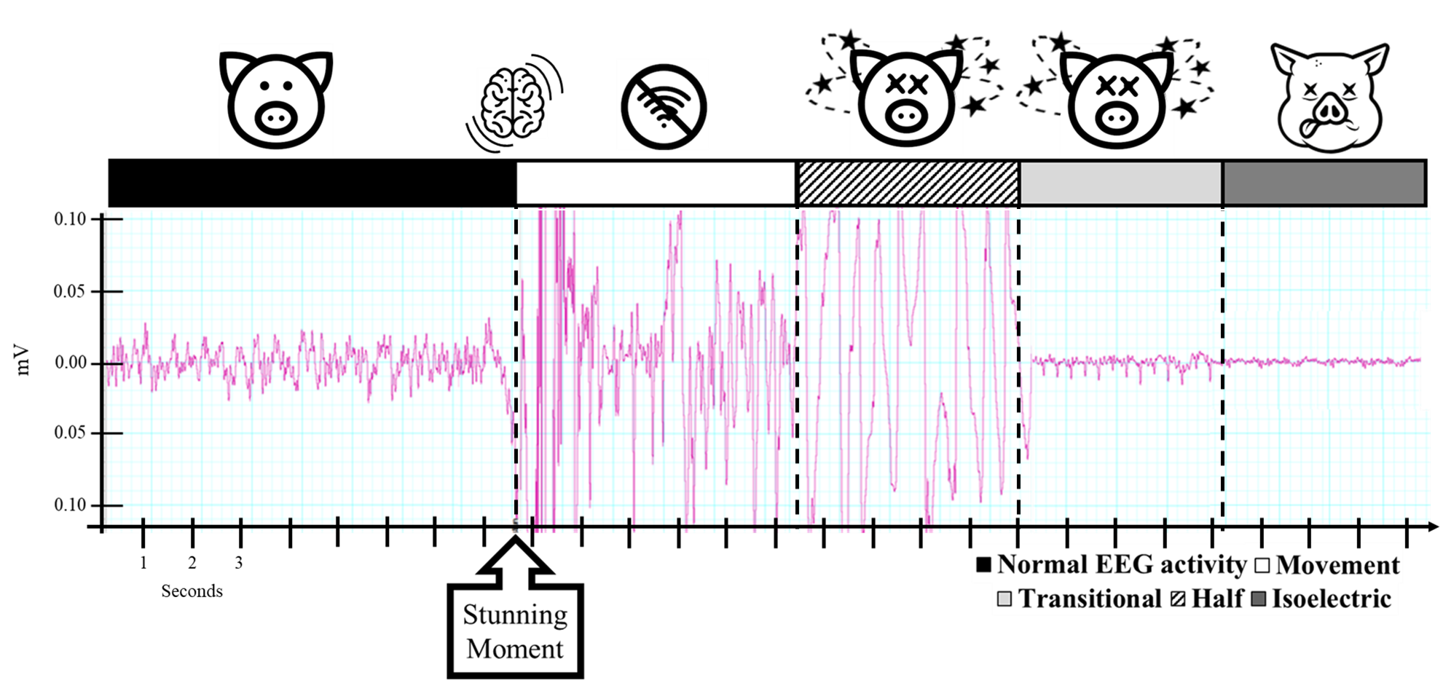
Figure 1. EEG subjective analysis (upper) and examples of EEG original traces (bottom) during brain states found before and after blunt force trauma culling (Note not a continuous trace).

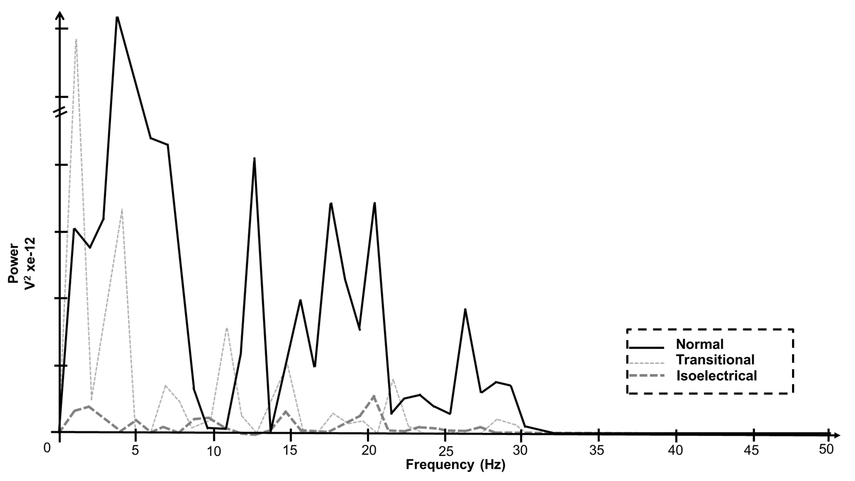
Figure 2. Power spectral analysis of brain states from piglets culled using blunt force trauma (Note it is a representative figure of brain states).

Figure 3. EEG subjective analysis of piglets culled by blunt force trauma (striking the head against the floor) (time point 0). White bars represent movement artefact; light grey transitional EEG; and dark grey isoelectric EEG activity. (N=13; two piglets were removed from the EEG analysis due to artefacts and external electrical noise).

Figure 4. Mean (N = 13 piglets; two piglets were removed from the EEG analysis due to artefacts and external electrical noise) and standard deviation (each 5 seconds) of percentage changes in total power (Ptot) of the electroencephalogram (EEG) of piglets before (-5 seconds) and after culling by striking the head against the floor. Note this excludes periods of movement artefact. Black line is the mean of all piglets. Dashed grey line is the exponential smoothing among periods of five seconds.

Figure 5. Mean (N = 13 piglets; two piglets were removed from the EEG analysis due to artefacts and external electrical noise) and standard deviation (each 5 seconds) of percentage changes in delta, theta, alpha and beta frequency bands of the electroencephalogram (EEG) of piglets before (-5 seconds) and after culling by striking their head against the floor. Note this excludes periods of movement artefact. Black line is the mean of all piglets. Dashed white line is the exponential smoothing among periods of five seconds.

Figure 6. Ratio of alpha/delta (black line) and beta/delta (grey line) and standard deviation (each 5 seconds) used to determine a shift in frequency associated with concussion.

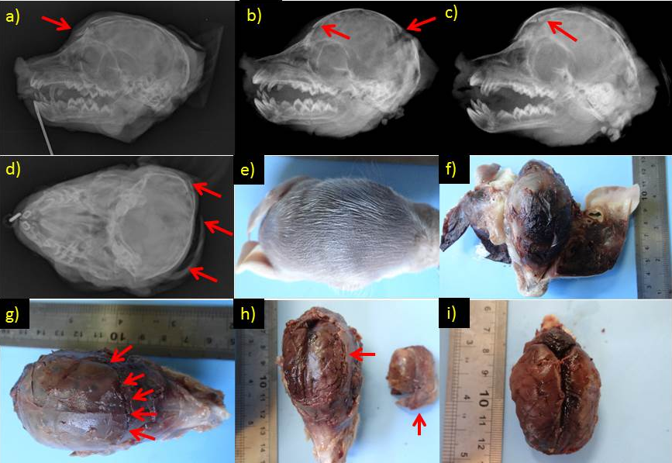
Figure 7. Radiographs showing fractures in cranium (a- frontal; b- frontal and occipital; c- frontal d- temporal and occipital) and pathology evaluations (e-extended bruise on the top of the head; f-subcutaneous extended bruise on the top of the head; g and h- cranium fracture extended through frontal, temporal and occipital; i- external brain showing preparation for brain surface evaluation).

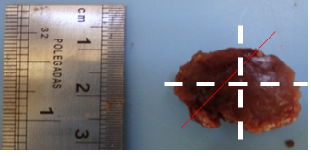 | 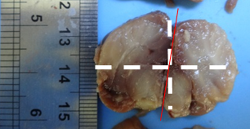
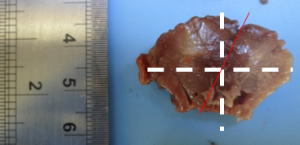 | 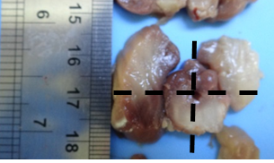
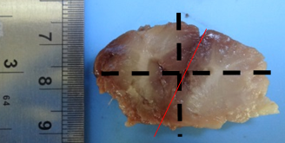 | 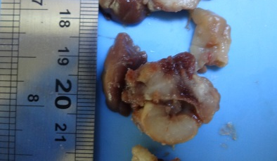
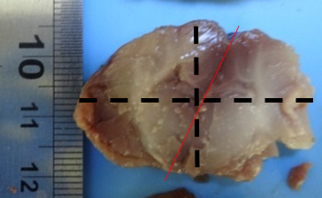
Figure 8. Examples of a brain slices with a midline shift (redline) in the frontal lobe, parietal lobe, thalamus, structures from the same piglet.

