Changes in Retinal vascular diameters in senior and geriatric cats IN ASSOCIATION WITH VARIATION IN SYSTEMIC BLOOD PRESSURE
Andra E Enache¹, Ursula M Dietrich¹, Oscar Drury², Emanuele Trucco³, Tom MacGillivray⁴, Harriet Syme¹, Jonathan Elliott² & Yu-Mei Chang²
¹Department of Clinical Sciences and Services, Queen Mother Hospital for Animals, Royal Veterinary College, London, UK
² Department of Comparative Biomedical Sciences, Royal Veterinary College, London, UK
³VAMPIRE project, Computing, School of Science and Engineering, University of Dundee, Scotland, UK
⁴VAMPIRE project, Centre for Clinical Brain Sciences, University of Edinburgh, Scotland, UK
Corresponding author:
Andra-Elena Enache DrMedVet, PgCertSAOphthal, MRCVS, North Downs Specialist Referrals, 3 & 4 The Brewerstreet Dairy Business Park, Brewer St, Bletchingley, UK
Email: enacheandra@gmail.com
Keywords: retinal vessel diameters; systemic hypertension; amlodipine besylate; VAMPIRE-AT

Abstract
Objectives Early diagnosis of arterial hypertension is essential to prevent target organ damage. In humans, retinal arteriolar narrowing predicts hypertension. This blinded prospective observational study investigated the retinal vessel diameters among senior and geriatric cats of varying systolic blood pressure (SBP) status and evaluated retinal vascular changes in hypertensive cats after treatment. Methods Cats with a median age of 14 years (range 9.1-22 years) were categorised into five groups (G): healthy G1 (SBP <140 mmHg, n = 40) and G2 pre-hypertensive (SBP 140-160 mmHg, n = 14) cats, cats with chronic kidney disease G3 normotensive (n = 26) and G4 pre-hypertensive (n = 13) and hypertensive cats, G5 (SBP >160 mmHg, n = 15). Colour fundus images (Optibrand ClearView) were assessed for hypertensive lesions. Retinal vascular diameters and bifurcation angles were annotated and calculated using the VAMPIRE-AT. When available, measurements were obtained at three and six months after amlodipine besylate treatment. Results Ten hypertensive cats had retinal lesions, most commonly intra-retinal haemorrhages and retinal exudates. Arteriole and venule diameters decreased significantly with increasing age (–0.17 ± 0.05 pixel/year, P = 0.0004; –0.19 ± 0.05 pixel/year). Adjusted means ± standard error for arteriole and venule diameter (pixels) were: 6.3 ± 0.2, 8.9 ± 0.2 (G1), 7.6 ± 0.3, 10.1 ± 0.4 (G2), 6.9 ± 0.2, 9.5 ± 0.3 (G3), 7.4 ± 0.3, 10.0 ± 0.4 (G4) and 7.0 ± 0.3, 9.8 ± 0.4 (G5). G1 arteriole and venule diameters were significantly lower than G2 and G4. G2 arteriole bifurcation angle was significantly narrower than G1 and G3. Post-treatment, vessel diameters decreased significantly at three and six months in seven hypertensive cats. Conclusions and relevance Increased age was associated with reduced vascular diameters. Longitudinal studies are required to assess if variations in vessel diameters are a risk indicator for hypertension in cats.
Introduction
Systemic arterial hypertension (SAH) in cats can lead to blindness and other target organ (the kidney, brain, heart and vasculature) damage (TOD), therefore successful management of this condition depends upon early identification, diagnosis and well-monitored response to treatment.^{1–4} Diagnosis is typically based on serial blood pressure (BP) measurements and regular monitoring.^{2,4} The American College of Veterinary Internal Medicine (ACVIM) guidelines recommend annual screening of cats and dogs aged 9 years or older.² However, various publications suggest that cats are typically presented late in their disease and already have signs of TOD.^{5–8}
Ocular fundus lesions and pathomechanisms in hypertensive cats have been classified into three categories similar to the disease in humans: hypertensive retinopathy, hypertensive choroidopathy and hypertensive optic neuropathy.^{9,10} Near-constant retinal blood flow is maintained despite fluctuations in BP due to a phenomenon termed autoregulation, by which the vascular diameter and resistance are adjusted to maintain tissue perfusion.^{10,11}
Ophthalmoscopically, early changes in the retinal vessels may be difficult to recognize and include vascular narrowing or beading and straightening of the arterioles due to immediate vasoconstriction to maintain tissue perfusion.^{1,10,11} As the retinal vessel walls become more damaged due to the increased vessel wall pressure and vessel wall necrosis, further changes may include vasodilation, aneurysmal dilations, tortuosity and haemorrhages.^{1,9–11}
Photograph-based methods for evaluation of the retinal vasculature through automated and semi-automated retinal analysis systems are widely used to diagnose SAH in humans. Generalized arteriolar narrowing has been associated with a high risk of SAH.^{12–15}
VAMPIRE-AT (Vascular Assessment and Measurement Platform for Images of the Retina) is a computer software designed for semi-automatic morphometric measurements of the retinal vasculature that has been used in various vascular conditions in people including hypertension, coronary heart disease, stroke and diabetes.^{16–20} The use of this annotation tool has previously been described in a group of healthy and hypertensive cats in Italy and it was shown that arteriolar diameters were significantly narrower in the hypertensive group.²¹
The purpose of the present study was to determine whether differences in retinal vascular diameters of senior and geriatric cats were associated with varying BP. If persistent hypertension is associated with retinal arteriolar narrowing, then measurement of arteriolar diameters might be useful in differentiating truly hypertensive cats from those with white coat hypertension.
Secondary outcome measures were used to evaluate the retinal vascular diameter changes of hypertensive cats after treatment with amlodipine besylate.
Materials and methods
Cats aged above 9 years presented to the Royal Veterinary College’s Beaumont Sainsbury Animal Hospital and Bow PDSA Pet Hospital, primary UK-based veterinary practices, were included in the study. Average BP readings were obtained with a sphygmomanometer and non-invasive Doppler detector (model 811-B; Parks Medical Electronics).²² Cats underwent fundus photography, blood and urine testing (biochemistry, urinalysis and total T4 if hyperthyroidism suspected clinically) every 6 months for healthy cats and every 4 months for cats with chronic kidney disease (CKD). Cats were considered azotaemic CKD if the plasma creatinine concentration was ≥177 µmol/L in conjunction with a urine specific gravity (USG) <1.035, or plasma creatinine concentration ≥177 µmol/L on two consecutive occasions 2 to 4 weeks apart. Ethical approval was granted by the RVC Ethic Committee, URN:20131258. Cats suspected of hyperthyroidism were excluded.
Cats were classified into five groups according to their systolic BP status and risk of TOD based on the ACVIM Guidelines into: group (G) 1 normotensive cats (SBP <140 mmHg), G2 pre-hypertensive cats (SBP 140−160 mmHg), G3 cats with CKD normotensive, G4 cats with CKD, pre-hypertensive and G5 hypertensive cats (SBP >160mmHg).² Cats were considered hypertensive if their SBP was >160 mmHg on at least two occasions 1 to 2 weeks apart, or they had a single SBP >160 mmHg in association with the presence of TOD. Age, sex, weight, medication and general health were recorded.
Colour fundus images were obtained without prior pharmacologic mydriasis using the Optibrand ClearView (1280x1024 pixels) fundus camera. Blood vessel diameters and bifurcation angles were measured by two annotators blinded to the cats’ ID, BP reading and clinical status.
When possible, hypertensive cats were also further evaluated at three and six months after treatment with amlodipine besylate (Amodip; Ceva) 0.625-1.25 mg/cat every 24 hours.
Image analysis
A photograph-based subjective assessment was initially performed recording the presence of vascular tortuosity, haemorrhages, retinal oedema, hyperreflectivity, chorioretinal changes and retinal exudates.
The VAMPIRE-AT annotation tool (https://vampire.computing.dundee.ac.uk/), was provided by its developers (TM, ET). Instructions regarding the use of this annotation tool were available on the online platform and its use in cats has been described elsewhere.²¹
Briefly, an image centred on the optic nerve head was selected followed by identification of the optic disc and the four standard measurement areas (SMA A, B, C and D), the annuli where summative width measurements are defined in most studies of the human retina (Figure 1a-d).^{15,17} The vessel diameter of the dorsal venule and arteriole was measured at four locations (SMA A, B, C and D) equidistant from the border of the optic disc. Another assessor (OD) measured the bifurcation angles between the daughter vessels for both vessel types at the first branching point. The vessel diameter readings were averaged across the vessel segment for comparison. Comparison was also performed between the readings obtained at locations closest to and furthest from the optic disc (SMA A and SMA D, respectively).
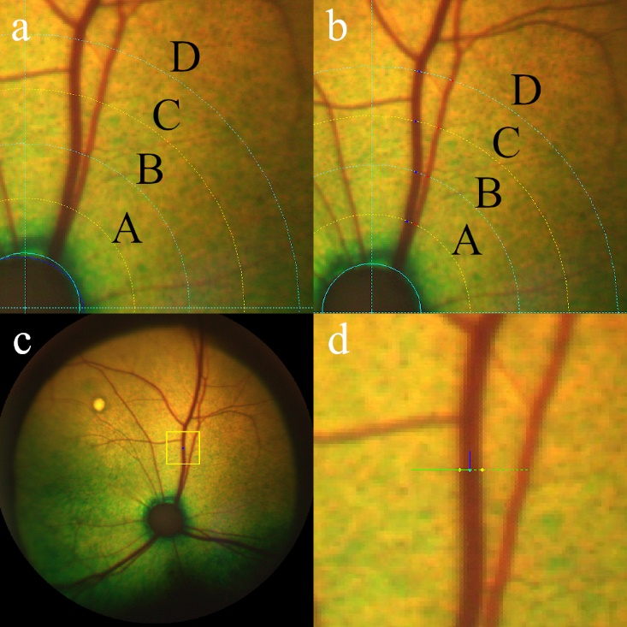
Figure 1(a-d) Annotation of vessel diameter using VAMPIRE-AT annotation tool. The circles in (a) and (b) show the retinal coordinates identifying standard measurement areas (SMA) A, B, C and D
- Manual outlining of the optic disc followed by generation of the five equidistant circles (defining SMA A, B, C, D)
- Manual selection of the centre of the arteriole (red dots) and venule (blue dots) at four locations (SMA A, B, C and D) equidistant from the optic disc
- Zooming in the area of interest to visualize the vessel segment
- Manual selection of the outline of the vessel walls

Inter and intra-observer reliability
Images from up to 10 randomly selected cats were used for intra and inter-observer agreement assessment. In addition to the lead investigator (AE), two annotators (EJ and UD), recorded the vessel diameter of selected images at the same locations in order to evaluate inter-observer reliability. Annotators were all blinded to the cats’ BP reading and clinical status.
Data analysis
All analyses were carried out using R software version 3.6.1. Data obtained included: BP status, age, breed, sex, weight, annotator, vessel type, eye, vessel diameter and bifurcation angle (Phi2). Linear mixed effects models were used to evaluate differences in vessel diameters and bifurcation angles between the groups, vessel type and their interaction; cat ID was included as a random effect to account for the repeated measures. Fisher’s LSD was used for post-hoc comparison. Results were reported as means ± standard error. Significance level was set at 5%. Inter-class correlation coefficient and its 95% confidence interval in vessel diameter between the annotators were reported.
Results
Signalments of the 107 cats (82 domestic shorthair, 11 domestic longhair, 2 Birman, 2 Siamese, 2 Main Coon, 2 Persian and one each for Birmilla, British Shorthair, Burmese, Norwegian Forest Cat, Oriental Cat and Tiffany Cat) in the five blood pressure groups are summarised in Table 1. One domestic shorthair cat was present in both G3 and G4 groups as its BP increased from normotensive to pre-hypertensive status during the study period. Normotensive cats were significantly younger than those in the other groups were (P ranged from <0.001 to 0.03) with a median age of 12.2 years (9.2−17.8 years). Cats with CKD and pre-hypertensive (G4) were the eldest with a median age of 16.3 years (10.1−22 years).
Table 1. Descriptive statistics of age, body weight and sex among the five groups of cats
Group | N | Age (years)  median (min, max) | Weight (kg)  median (min, max) | Sex  female/male
*G1 | 40 | 12.2 (9.2, 17.8) | 4.3 (2.6, 7.3) | 20/20
†G2 | 14 | 13.5 (9.8, 17.8) | 3.8 (2.6, 6.1) | 7/7
‡G3 | 26 | 15.4 (9.1, 19.1) | 4.0 (2.4, 7.2) | 14/12
§G4 | 13 | 16.3 (10.1, 22.0) | 3.9 (3.0, 6.2) | 7/6
¶G5 | 15 | 15.3 (9.6, 20.1) | 3.7 (2.6, 6.2) | 7/8
*G1 = normotensive cats with systolic blood pressure (SBP) <140 mmHg; †G2 = pre-hypertensive cats with SBP 140−160 mmHg; ‡G3 = cats with chronic kidney disease (CKD) normotensive with SBP <140 mmHg; §G4 = cats with CKD, pre-hypertensive with a SBP 140-160 mmHg;¶G5 = hypertensive cats with a SBP >160 mmHg
G5 hypertensive cats had idiopathic hypertension (n = 9) and CKD IRIS stage 2 (n = 6). There was no association between body weight and blood pressure in any of the groups.
Intra and inter-observer reliability
Intra-observer (AE) correlation was 0.80 (95% CI: 0.62, 0.89) between two repeated vessel diameter assessments that were performed three days apart. Inter-observer correlation coefficients were 0.73 (95% CI: 0.62, 0.81) between the annotators UD and AE and 0.77 (95% CI: 0.44, 0.89) between AE and EJ (Figure 2a-c). EJ consistently underestimated the vessel diameters for both arteriole and venule compared to AE.
Figure 2. Graph depicting the intra-observer agreement (AE, graph a) for 10 cats and inter-observer agreement for 9 and 10 cats, respectively for retinal arteriole (A, open circle) and venules (V, cross) diameters between annotators AE and EJ (graph b) and UD and AE (graph c)
c
b
a
Vessel diameter
Fundus images (n = 3921) from 107 cats were assessed. The venule diameters were larger than the arterioles in all the groups (P <0.0001) (Figure 3). After correcting for age, G1 arterioles were significantly smaller than G2 (P = 0.0007), G3 (P = 0.049) and G4 (P = 0.008) (Table 2). G1 cats had smaller venule diameters than G2 (P = 0.009) and G4 cats (P = 0.015). There was no overall effect of weight on the arteriole or venule diameters (P = 0.2 and P = 0.45, respectively).
Increased age significantly reduced both the arterioles and venules diameters by −0.17±0.05 pixel/year, P = 0.0004 and −0.19 ± 0.05 pixel/year, P = 0.001, respectively (Figure 4).
Figure 3. Boxplots representing the distribution of the retinal arteriole (A) and venule (V) diameters (in pixels) in each group (G1 = normotensive cats with systolic blood pressure [SBP] <140 mmHg, G2 = pre-hypertensive cats [SBP 140−160 mmHg], G3 = cats with chronic kidney disease (CKD) normotensive, G4 = cats with CKD, pre-hypertensive, G5 = hypertensive cats [SBP >160 mmHg])
Table 2. Age and weight corrected mean and standard error of the arteriole and venule diameters
Group | Arteriole diameter (pixel)  Mean ± standard error | Venule diameter (pixel)  Mean ± standard error
*G1 | 6.3 ± 0.2 | 8.9 ± 0.2
†G2 | 7.6 ± 0.3 | 10.1 ± 0.4
‡G3 | 6.9 ± 0.2 | 9.5 ± 0.3
§G4 | 7.4 ± 0.3 | 10.0 ± 0.4
¶G5 | 7.0 ± 0.3 | 9.8 ± 0.4
*G1 = normotensive cats with systolic blood pressure (SBP) <140 mmHg; †G2 = pre-hypertensive cats with SBP 140−160 mmHg; ‡G3 = cats with chronic kidney disease (CKD) normotensive with SBP <140 mmHg; §G4 = cats with CKD, pre-hypertensive with a SBP 140-160 mmHg;¶G5 = hypertensive cats with a SBP >160 mmHg
Figure 4. Representation of cats’ averaged retinal arteriole (A, full line, 0) and venule (V, dashed line, x) diameters showing that vascular diameters were reduced with increased age
G1 venule diameters were significantly smaller than G2 (P = 0.0026), G3 (P = 0.047), G4 (P = 0.024) and G5 (P = 0.0091) at the SMA D location (Table 3). The G1 diameters were significantly smaller than G2 (P = 0.0036) and slightly smaller than G3 (P = 0.066), G4 (P = 0.032) and G5 (P = 0.044) at SMA A location. Furthest from the optic disc (SMA D), the G1 arteriole diameters were significantly smaller than G2 (P = 0.007).
Table 3. Age and weight adjusted mean and standard error of the retinal arteriole and venule diameters closest and furthest from the optic disc (OD) corresponding to the standardized measurement area A (SMA A) and D (SMA D), respectively
Group | Arteriole diameter (pixel)  Mean ± standard error |  | Venule diameter (pixel)  Mean ± standard error
 | SMA A | SMA D | SMA A | SMA D
*G1 | 6.3 ± 0.2 | 6.1 ± 0.2 | 9.0 ± 0.3 | 8.9 ± 0.3
†G2 | 7.6 ± 0.4 | 7.3 ± 0.4 | 9.3 ± 0.4 | 10.7 ± 0.5
‡G3 | 7.0 ± 0.3 | 6.8 ± 0.3 | 9.1 ± 0.3 | 9.9 ± 0.4
§G4 | 7.4 ± 0.4 | 6.6 ± 0.5 | 9.1 ± 0.5 | 10.4 ± 0.6
¶G5 | 7.2 ± 0.4 | 6.8 ± 0.4 | 9.1 ± 0.4 | 10.5 ± 0.5
*G1 = normotensive cats with systolic blood pressure (SBP) <140 mmHg; †G2 = pre-hypertensive cats with SBP 140−160 mmHg; ‡G3 = cats with chronic kidney disease (CKD) normotensive with SBP <140 mmHg; §G4 = cats with CKD, pre-hypertensive with a SBP 140-160 mmHg;¶G5 = hypertensive cats with a SBP >160 mmHg; SMA= standard measurement area
Bifurcation angles
Bifurcation measurements at the first branching point were available for 67 cats where the image quality allowed it (Figure 5, Table 4). The angle between the daughter vessels varied widely with no observed effects of age and weight. The venule bifurcation angles were not different between the groups. Overall, there were some differences in the arteriole bifurcation angles between the groups (P = 0.047) with G2 angles significantly smaller than G1 (P = 0.0074) and G3 (P = 0.0052) groups.
Figure 5. Distribution of the bifurcation angles of retinal arterioles (A) and venules (V) in each group (G1 = normotensive cats with systolic blood pressure [SBP] <140 mmHg, G2 = pre-hypertensive cats [SBP 140−160 mmHg], G3 = cats with chronic kidney disease (CKD) normotensive, G4 = cats with CKD, pre-hypertensive, G5 = hypertensive cats [SBP >160 mmHg])

Table 4. Age and weight corrected mean and standard error of the bifurcation angle of retinal arterioles and venules by blood pressure groups
Group | N | Arteriole bifurcation angle (°)  Mean ± standard error | Venule bifurcation angle (°)  Mean ± standard error
*G1 | 31 | 74.8 ± 3.0 | 72.5 ± 2.2
†G2 | 7 | 55.6 ± 6.3 | 70.7 ± 4.3
‡G3 | 14 | 77.7 ± 4.9 | 69.5 ± 4.3
§G4 | 3 | 73.2 ± 10.5 | 74.6 ± 7.8
¶G5 | 13 | 66.7 ± 4.6 | 70.4 ± 3.4
*G1 = normotensive cats with systolic blood pressure (SBP) <140 mmHg; †G2 = pre-hypertensive cats with SBP 140−160 mmHg; ‡G3 = cats with chronic kidney disease (CKD) normotensive with SBP <140 mmHg; §G4 = cats with CKD, pre-hypertensive with a SBP 140-160 mmHg;¶G5 = hypertensive cats with a SBP >160 mmHg
Amlodipine treatment
7/15 hypertensive cats were re-evaluated at three and six months after treatment with amlodipine besylate. Of these, six cats had systolic BP <160 mmHg after three months. Comparing pre and post-treatment observations (Table 5), the arteriole and venule diameters were decreased at three and six month post-treatment (P = 0.03 for arteriole and P = 0.0009 for venule at 3 months and P <0.0001 for both vessels at 6 months).
Overall, vessel diameters of cats after amlodipine treatment approached the mean values of the normotensive cats. The venule diameters at SMA A location and the arteriole diameters at the SMA D location were not different between the groups (Table 6). When comparing the measurements closest to the optic disc (SMA A), the arteriole diameters were significantly reduced at six months after treatment (P = 0.026). Furthest from the optic disc (SMA D), the venule diameters were decreased at three months (P <0.0001) and six months (P <0.0001).
Only six hypertensive cats had bifurcation angles post-treatment data due to the image quality (Table 7). Amlodipine treatment had no effect on the bifurcation angles both at 3 and 6 months post-treatment (P = 0.59 and P = 0.43 for arteriole and venule, respectively). Neither vessel types showed significant angular changes and large standard errors were observed for the bifurcation angles.
Table 5. Mean and standard error of retinal arteriole and venule diameters among the seven hypertensive cats with 3 and 6 months post-treatment observations
Group | Arteriole diameter (pixel)  Mean ± standard error | Venule diameter (pixel)  Mean ± standard error
Pre-treatment | 7.2 ±0.5 | 10.5 ±0.5
At 3 months | 6.4 ±0.5 | 8.8 ±0.6
At 6 months | 5.8 ±0.5 | 8.3 ±0.6

Table 6. Mean and standard error of the retinal arteriole and venule diameters closest to (standardized measurement area, SMA A) and furthest from the optic disc (SMA D) among the 7 hypertensive cats with 3 and 6 months post-treatment observations
Group | Arteriole diameter (pixel)  Mean ± standard error |  | Venule diameter (pixel)  Mean ± standard error
 | *SMA A | SMA D | SMA A | SMA D
Pre-treatment | 7.4 ±0.5 | 6.7 ±0.5 | 9.2 ±0.6 | 11.1 ±0.7
At 3 months | 6.6 ±0.6 | 5.8 ±0.6 | 9.1 ±0.7 | 8.5 ±0.8
At 6 months | 5.5 ±0.8 | 5.8 ±0.8 | 8.7 ±0.8 | 8.2 ±0.8
*SMA= standardized measurement area
Table 7. Retinal arteriole and venule bifurcation angle pre and post-treatment observation for six hypertensive cats
Group | Arteriole bifurcation angle (°)  Mean ± standard error | Venule bifurcation angle (°)  Mean ± standard error
Pre-treatment | 68.0 ±4.7 | 71.2 ±5.9
At 3 months | 66.6 ±6.4 | 79.2 ±6.8
At 6 months | 74.8 ±6.5 | 76.3 ±7.6

Retinal changes were present in 10/15 hypertensive cats (Table 8, Figure 6a-d): arteriolar tortuosity, intra-retinal haemorrhages, retinal oedema, hyperreflective areas and multifocal subretinal. Multifocal subretinal exudates (causing bullous retinal detachments) were also present in one G2 and one G3 cat (Figure 7a, b). Intra-retinal haemorrhages were also recorded in one G1 (Figure 8), two G2 cats and one G4 cat. Arteriolar beading was observed in one pre-hypertensive G2 healthy cat (Figure 9). Arteriolar tortuosity was also recorded in five normotensive cats (Figure 10), one G2 cat, four G3 and one G4 cat. Two normotensive cats and one normotensive CKD cat had areas of retinal oedema.
Table 8. Subjective photograph-based qualitative analysis of cats and the retinal changes observed in the five groups
Subjective assessment | Number of eyes affected
 | *G1 | †G2 | ‡G3 | §G4 | ¶G5
Retinal changes | 8 | 3 | 4 | 4 | 10
Tortuosity | 5 | 1 | 4 | 1 | 2
Haemorrhages | 1 | 2 | - | 1 | 7
Retinal oedema | 2 | - | 1 | - | 2
Hyperreflective areas | - | - | - | 1 | 4
Chorioretinal lesions | 2 | - | - | 2 | -
Subretinal exudates | - | 1 | 1 | - | 4
*G1 = normotensive cats with systolic blood pressure (SBP) <140 mmHg; †G2 = pre-hypertensive cats with SBP 140−160 mmHg; ‡G3 = cats with chronic kidney disease (CKD) normotensive with SBP <140 mmHg; §G4 = cats with CKD, pre-hypertensive with a SBP 140-160 mmHg;¶G5 = hypertensive cats with a SBP >160 mmHg

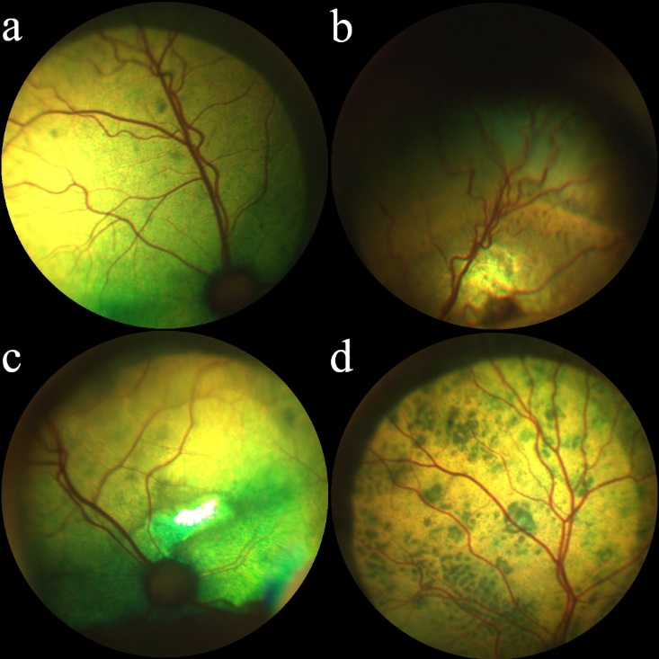
Figure 6(a-d). Qualitative analysis of the fundus images of hypertensive cats from group 5 showing a range of retinal changes (a-d)
- Mild arteriolar tortuosity and focal chorioretinal pigmentary changes
- Intra-retinal haemorrhage, arteriolar tortuosity and adjacent focal area of hyperreflectivity
- Focal area of hyper-reflectivity dorsal to the optic disc, mild peripheral arteriolar tortuosity
- Multifocal chorioretinal lesions (hypertensive chorioretinopathy)

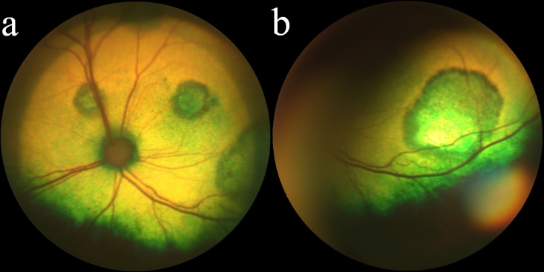
Figure 7(a-b). Multifocal subretinal exudates in one pre-hypertensive healthy cat G2 (a) and one CKD and normotensive cat G3 (b)

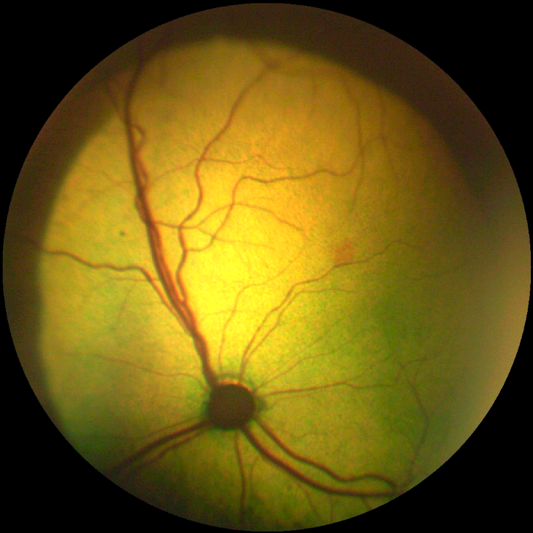
Figure 8. Intra-retinal haemorrhage adjacent to the terminal end of an arteriole in a normotensive G1 cat
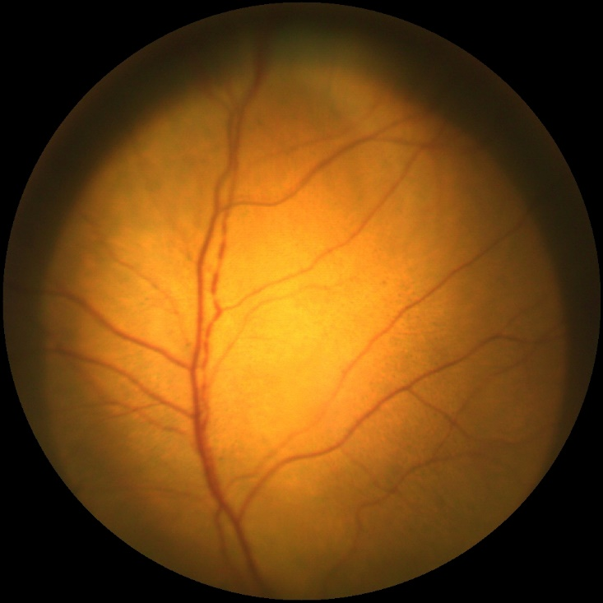
Figure 9. Retinal arteriolar beading (boxcarring) in a pre-hypertensive G2 healthy cat
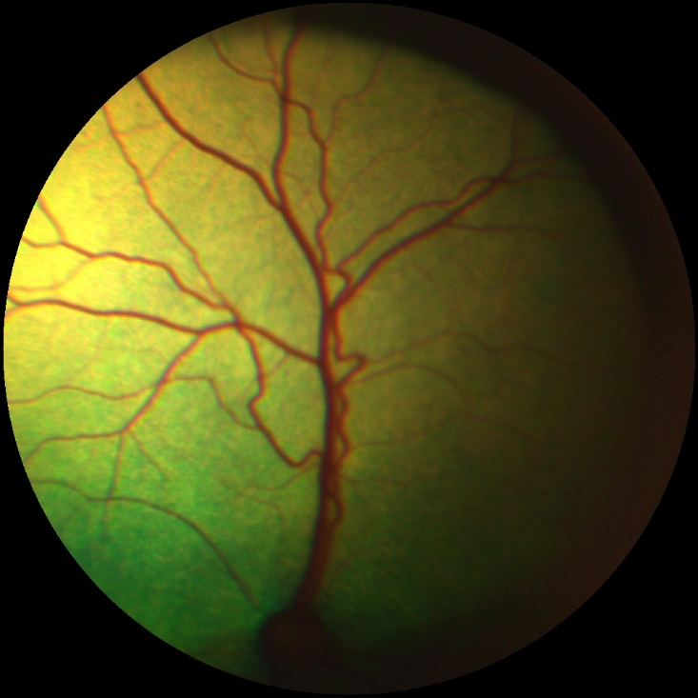
Figure 10. Marked retinal arteriolar tortuosity in a normotensive G1 cat

Discussion
First, we showed that both retinal arteriole and venule diameters decreased significantly with age by −0.17 ± 0.05 pixel/year and −0.19 ± 0.05 pixel/year, respectively. Increased age and hypertension have been associated with arteriolar narrowing in people.^{23,24} However, an association between hypertension and reduced arteriolar diameters was not observed in this study population. In the elderly people, the effect of hypertension on the retinal arteriole diameters is less marked than in the general population. This finding appears to reflect age-related structural changes in the wall of the arterioles (intimal thickening and medial hyperplasia, hyalinization and sclerosis) which lead to increased rigidity, loss of elasticity, reduced arterial compliance and arteriolosclerosis.^{24–27} This concept may explain the lack of association between hypertension and retinal arteriolar narrowing in the present study due to a median age of 14 years in this feline population.
When adjusted for age and weight, the retinal vessel diameters in the normotensive group were narrower than the pre-hypertensive groups. The retinal arteriolar diameters of hypertensive cats were not significantly different from the normotensive cats which is contradicting with the current literature.²¹ The hypertensive group (n = 15) had a mean arteriole diameter and standard error of 7.0 ± 0.3 pixels which was larger than the value (3.3 pixels) reported in the literature.²¹ The hypertensive group from the previously reported study²¹ had a larger and younger sample size (n = 45, median age of 138 months, range 120−185 months) than the hypertensive cats in this study. To add strength to the current study, all the annotators were blinded to the cat’s signalment, blood pressure status and their affiliation to the treatment groups. The inter-observer correlation coefficient was consistent with a good repeatability between the three annotators despite the reported difficulties in obtaining a clear visualization of the blood vessel walls. Measurements of the same vessel segment performed by the same annotator at different time points were also consistent with a good correlation coefficient.
In human subjects, the retinal vascular diameter is computed on the basis of measurements carried out in a single, arbitrary selected point of the vessel for analysis.¹⁵ However, symmetry of the measurements, hence interchangeability of the right and left eye still requires further studies in humans.²⁸ No significant differences in the retinal arteriole diameters were found between the left and right eyes in the present study which is in line with the current literature.²¹ The arteriole diameters were slightly smaller and venule diameters were slightly larger furthest from the optic disc. However, the normotensive healthy cats had smaller vessel diameters compared to the other groups independent of the location of the measurements. The BP in one normotensive CKD cat progressed to the pre-hypertensive status within three months, therefore this cat appeared in both G3 and G4 groups. A longitudinal study would be required to evaluate if the cats with the smallest arteriolar diameters go on to develop hypertension to be able to demonstrate that arteriolar narrowing is a predictor of hypertension.
Computed-based methods are used to automate the analysis of retinal images in humans. The main VAMPIRE software tools (VAMPIRE 3.1 and VAMPIRE-WEB) showed excellent inter-observer reliability in several studies in humans.^{29–31} The VAMPIRE-AT provided for this study has been previously validated for use in cats and proved useful for objective evaluation of retinal vascular changes associated with hypertension.²¹
One limitation of the study is that pixel measurements can vary with the image resolution, the refraction index and the clarity of the ocular media which in humans play an important role related to magnification effects from the camera.³² In images acquired by fundus cameras used currently in human ophthalmology (~3000 ×3000 pixels, 45∘ field of view) the camera resolution can influence the accuracy of the morphometric vascular measurements.³³
Variations in the vessel calibre may also be influenced by diurnal fluctuations of blood pressure and physiological blood flow parameters such as oxygenation and shear stress.³⁴ A telemetric study of normotensive cats showed that BP generally doesn’t vary much throughout the day and appears to be higher when the cats are active.³⁵
Ocular lesions have been reported in hypertensive cats with prevalence rates as high as 100%.^{6–8,36,37} 10/15 hypertensive cats had retinal changes of which intra-retinal haemorrhages and bullous retinal detachments were most common. Interestingly, arteriolar beading and retinal haemorrhages were also observed in pre-hypertensive and normotensive cats. Multifocal subretinal exudates were reported in a healthy pre-hypertensive cat and a normotensive cat with CKD. This suggests that hypertension-associated retinal changes may occur at lower BP levels or that cats may have experienced damaging BP spikes prior to their presentation. Vascular tortuosity was present in five normotensive healthy cats and four pre-hypertensive cats with CKD with only two hypertensive cats having tortuous arterioles suggesting this phenomenon may not be associated with hypertension in the cat.
Although CKD is a common concurrent disease associated with increased blood pressure, its direct effect on the retinal vessel diameters and angles in cats is currently unknown. It is also unknown whether CKD and SBP have independent effects on the blood vessel measurements. Because the effect of anxiety on blood pressure in cats is unpredictable, this potential measurement error makes it challenging to use measured SBP values directly in the analysis. Our classification of the cats according to their SBP and CKD status reflected the diseases diagnosis in clinics, and allowed the evaluation of diameters and angles variation as risk indicators for hypertension in cats.
A post hoc comparison revealed a tendency of reduced arteriolar bifurcation angles in the pre-hypertensive group compared to the two groups with SBP<140 mmHg. Furthermore, the hypertensive cats had narrower bifurcation angles compared to healthy normotensive cats which is consistent with human ophthalmology reports.³⁸ However, the prognostic value of identifying hypertensive cats based on the bifurcation angles may be small due to the presence of a large variation even in the normotensive group and the small number of hypertensive cats.
As a calcium channel blocker, the amlodipine relaxes the tone of arterioles and causes reduction in the arterial BP with a dilating effect on cardiac and vascular smooth muscle cells, thereby improving vascular resistance.³⁹ Hyperthyroidism causes profound cardiovascular changes and while hypertension does sometimes occur in this condition the major feature of thyrotoxicosis is a profound reduction in systemic vascular resistance.⁴⁰ Therefore, the reason for exclusion of the hyperthyroid cats was that in most hypertensive conditions one would expect vascular resistance to be increased, whereas in hyperthyroidism this is decreased. A vasodilation effect on the retinal arterioles has been reported in several studies in hypertensive humans.^{41–43} Such effect was not observed in the hypertensive cats after treatment, on the contrary the arteriole diameters were decreased at three and six months after treatment. 6/7 hypertensive cats had controlled BP, therefore responded to amlodipine treatment. With anti-hypertensive treatment, the retinal vascular diameters of hypertensive cats approached the values of the normotensive cats, therefore an effect on the vascular diameter could be observed. The lack of vasodilation effect may be due to altered calcium ions transport in the retinal vascular smooth muscle cells or a counter regulatory response that had masked such dilation.^{44,45}
Conclusions
Using a computer-assisted imaging method to measure the retinal vessel diameters from photographs, we observed that the diameters of retinal arterioles and venules narrowed with increasing age. Although elderly cats had decreased vascular diameters, an association of vessel diameter with hypertension was not observed.
The VAMPIRE-AT annotation tool may be useful to monitor the treatment effect on the retinal vasculature over time. Further studies are warranted to determine the prognostic value of assessment of retinal vascular architecture in the senior and geriatric cats for diagnosis of early hypertension.
Acknowledgements: The authors would like to acknowledge the RVC Geriatric Cat Clinic, Mrs Nicola Lotter and Dr Emily Jeanes for their contribution.
Author note Preliminary results were presented in part at the 2019 ECVO conference in Belgium.
Conflict of interest The authors declared no potential conflicts of interest with respect to the research, authorship, and/or publication of this article.
Funding The author(s) disclosed receipt of the following financial support for the research, authorship, and/or publication of this article: This work was supported by the Ceva Santé Animale (2110.RES.4685).
Ethical approval This work involved the use of non-experimental animals only (including owned or unowned animals and data from prospective or retrospective studies). Established internationally recognised high standards (‘best practice’) of individual veterinary clinical patient care were followed. Ethical approval from a committee was therefore not necessarily required.
Informed consent Informed consent (verbal) was obtained from the owner of all animal(s) described in this work for the procedure(s) undertaken. No animals or humans are identifiable within this publication, and therefore additional informed consent for publication was not required.
References
1 Barnett KC, Crispin SM. Feline Ophthalmology. An Atlas and text. W.B. Saunders, 1998, pp 155-159.
2 Acierno MJ, Papich M, Brown S, et al. ACVIM consensus statement : Guidelines for the identification , evaluation , and management of systemic hypertension in dogs and cats. J Vet Intern Med 2018; 32: 1803–1822.
3 Stepien RL. Feline systemic hypertension. Diagnosis and management. J Feline Med Surg 2011; 13: 35–43.
4 Jepson RE. Feline systemic hypertension. Classification and pathogenesis. J Feline Med Surg 2011; 13: 25–34.
5 Conroy M, Chang Y, Brodbelt D, et al. Survival after diagnosis of hypertension in cats attending primary care practice in the United Kingdom. J Vet Intern Med 2018; 32: 1846–1855.
6 Stiles J, Polzin D, Bistner SI. The prevalence of retinopathy in cats with systemic hypertension and chronic renal failure or hyperthyroidism. J Am Anim Hosp Assoc 1994; 30: 564–572.
7 Maggio F, DeFrancesco TC, Atkins CE, et al. Ocular lesions associated with systemic hypertension in cats: 69 cases (1985–1998). J Am Vet Med Assoc 2000; 217: 695–702.
8 Young WM, Zheng C, Davidson MG, et al. Visual outcome in cats with hypertensive chorioretinopathy. Vet Ophthalmol 2019; 22: 161–167.
9 Crispin SM, Mould JRB. Systemic hypertensive disease and the feline fundus. Vet Ophthalmol 2001; 4: 131–140.
10 Hayreh SS. Duke-Elder lecture. Systemic arterial blood pressure and the eye. Perfusion Pressure Levels. Eye 1996; 5–28.
11 Johnson PC. Autoregulation of blood flow. Brief review. Circ Res 1986; 59: 483–495.
12 Ikram MK, Witteman JCM, Vingerling JR, et al. Retinal vessel diameters and risk of hypertension. Hypertension 2006; 47: 189–194.
13 Cheung CY, Ikram MK, Sabanayagam C, et al. Retinal microvasculature as a model to study the manifestations of hypertension. Hypertension 2012; 1094–1103.
14 Nørrelund H, Christensen KL, Samani NJ, et al. Early narrowed afferent arteriole is a contributor to the development of hypertension. Hypertens (Dallas, Tex 1979) 1994; 24: 301–8.
15 Hubbard LD, Brothers RJ, King WN, et al. Methods for evaluation of retinal microvascular abnormalities associated with hypertension/sclerosis in the Atherosclerosis Risk in Communities Study. Ophthalmology 1999; 106: 2269–2280.
16 McKay GJ, Paterson EN, Maxwell AP, et al. Retinal microvascular parameters are not associated with reduced renal function in a study of individuals with type 2 diabetes. Sci Rep 2018; 8: 1–8.
17 McGrory S, Taylor AM, Pellegrini E, et al. Towards standardization of quantitative retinal vascular parameters: comparison of SIVA and VAMPIRE measurements in the Lothian Birth Cohort 1936. Transl Vis Sci Technol 2018; 7: 12.
18 Trucco E, Ruggeri A, Karnowski T, et al. Validating retinal fundus image analysis algorithms : issues and a proposal. Invest Ophthalmol Vis Sci 2013; 54: 3546–3559.
19 Giachetti A, Ballerini L, Trucco E. Accurate and reliable segmentation of the optic disc in digital fundus images the optic disc in digital fundus images. J Med Imaging; 1:2.
20 Fetit AE, Doney AS, Hogg S, et al. A multimodal approach to cardiovascular risk stratification in patients with type 2 diabetes incorporating retinal, genomic and clinical features. Sci Rep 2019; 9: 1–10.
21 Cirla A, Drigo M, Balleriini L, et al. VAMPIRE ® fundus image analysis algorithms : Validation and diagnostic relevance in hypertensive cats. Vet Ophthalmol 2019; 22:819-827.
22 Syme HM, Barber PJ, Markwell PJ, et al. Prevalence of systolic hypertension in cats with chronic renal failure at initial evaluation. J Am Vet Med Assoc 2002; 220: 1799–1804.
23 Sun C, Wang JJ, Mackey DA, et al. Retinal vascular caliber: systemic, environmental, and genetic associations. Surv Ophthalmol 2009; 54: 74–95.
24 Wong TY, Klein R, Klein BEK, et al. Retinal vessel diameters and their associations with age and blood pressure. Investig Opthalmology Vis Sci 2003; 44: 4644.
25 Jani B, Rajkumar C. Ageing and vascular ageing. Postgrad Med J 2006; 82: 357–62.
26 Pinto E. Blood pressure and ageing. Postgrad Med J 2007; 83: 109–14.
27 Leishman R. The eye in general vascular disease. Hypertension and arteriosclerosis. Br J Ophthalmol 1957; 41: 641–701.
28 Cameron JR, Megaw RD, Tatham AJ, et al. Lateral thinking – Interocular symmetry and asymmetry in neurovascular patterning, in health and disease. Prog Retin Eye Res 2017; 59: 131–157.
29 Trucco E, Giachetti A, Ballerini L, et al. Morphometric measurements of the retinal vasculature in fundus images with VAMPIRE. In: Joo-Hwee L, Sim-Heng O, Wei X (eds) Biomedical Image Understanding: Methods and Applications. John Wiley & Sons, Inc, 2015, pp. 91–111.
30 Perez-Rovira A, MacGillivray T, Trucco E, et al. VAMPIRE: Vessel assessment and measurement platform for images of the retina. In: IEEE Computer Society. (ed) 2011 Annual International Conference of the IEEE Engineering in Medicine and Biology Society. New York: IEEE, pp. 3391–3394.
31 Macgillivray TJ, Cameron JR, Zhang Q, et al. Suitability of UK Biobank Retinal Images for automatic analysis of morphometric properties of the vasculature. PLoS One 2015; 252: 1–10.
32 Lim LS, Carol Yim-lui Cheung XL, Mitchell P, et al. Influence of refractive error and axial length on retinal vessel geometric characteristics. Invest Ophthalmol Vis Sci 2011; 52: 669–678.
33 Pauli TW, Gangaputra S, Hubbard LD, et al. Effect of image compression and resolution on retinal vascular caliber. Investig Ophthalmol Vis Sci 2012; 53: 5117–5123.
34 Nagaoka T, Sakamoto T, Mori F, et al. The effect of nitric oxide on retinal blood flow during hypoxia in cats. Investig Ophthalmol Vis Sci 2002; 43: 3037–3044.
35 Mishina M, Watanabe N, Watanabe T. Diurnal variations of blood pressure in cats. J Vet Med Sci 2006; 68: 243–248.
36 Sansom J, Rogers K, Wood JLN. Blood pressure assessment in healthy cats and cats with hypertensive retinopathy. Am J Vet Res 2004; 65: 245–252.
37 Carter J, Irving A, Bridges J, et al. The prevalence of ocular lesions associated with hypertension in a population of geriatric cats in Auckland, New Zealand. N Z Vet J 2014; 62: 21–29.
38 Stanton A, Wasan B, Cerutti A, et al. Vascular network changes in the retina with age and hypertension. J Hypertens 1995; 13: 17724–8.
39 Wang R-X, Jiang W-P. Changes of action potential and L-type calcium channel current of Sprague-Dawley rat ventricular myocytes by different amlodipine isomers. Can J Physiol Pharmacol 2008; 86: 620–5.
40 Syme HM. Cardiovascular and renal manifestations of hyperthyroidism. Vet Clin North Am Small Anim Pract. 2007 Jul;37(4):723-43, vi.
41. Hughes AD, Stanton A V, Jabbar AS, et al. Effect of antihypertensive treatment on retinal microvascular changes in hypertension. J Hypertens 2008; 26: 1703–1707.
42 Thom S, Stettler C, Stanton A, et al. Differential effects of antihypertensive treatment on the retinal microcirculation: An anglo-scandinavian cardiac outcomes trial substudy. Hypertension 2009; 54: 405–408.
43 Antonio P-R, Marta P-S, Luís DDJ, et al. Factors associated with changes in retinal microcirculation after antihypertensive treatment. J Hum Hypertens 2014; 28: 310–315.
44 Mehlsen J, Jeppesen P, Erlandsen M, et al. Lack of effect of short-term treatment with amlodipine and lisinopril on retinal autoregulation in normotensive patients with type 1 diabetes and mild diabetic retinopathy. Acta Ophthalmol 2011; 89: 764–768.
45 Gallo A, Dietenbeck T, Kachenoura N, et al. Independent effect of high blood pressure and hyperglycemia on diameter and wall thickness of retinal microcirculation evaluated with adaptive optics in humans. J Hypertens 2019; 37: e73.

