Global epidemiology of COVID-19 infection in young children under five years: a systematic review and meta-analysis

Mejbah Uddin Bhuiyanª, Eunice Stiboy^{b}, Md. Zakiul Hassan^{c}, Mei Chan^{d}, Md. Saiful Islam^{c,e}, Najmul Haider^{f}, Adam Jaffe^{d,g}, Nusrat Homaira ^{d,g}

a Wesfarmers Centre of Vaccines and Infectious Diseases, Telethon Kids Institute, Western Australia, Australia
b School of Public Health, Faculty of Medicine and Health, The University of Sydney, New South Wales, Australia
c Program for Emerging Infections, Infectious Diseases Division, icddr,b, Bangladesh
d School of Women’s and Children’s Health, Faculty of Medicine, University of New South Wales, Sydney, New South Wales, Australia
e School of Public Health and Community Medicine, Faculty of Medicine, University of New South Wales, Sydney, New South Wales, Australia
f The Royal Veterinary College, University of London, Hatfield, Hertfordshire, AL9 7TA, UK
g Respiratory Department, Sydney Children’s Hospital, Sydney, New South Wales, Australia

ABSTRACT:
Yet to be developed

Target journal: Lancet CAH/ Global Health/ Paediatrics/ JID

Introduction:
Globally acute respiratory infection (ARI) including pneumonia is the leading cause of morbidity and mortality in young children aged less than five years. Respiratory viruses such as influenza and respiratory syncytial virus (RSV) remain the leading causes of ARI in under five children (1). The immature immune system have been linked to increased risk of respiratory viral infections in young children (1). The ongoing pandemic disease (COVID-19), which is caused by a novel respiratory virus, coronavirus SARS-CoV-2, is primarily causing pneumonia characterised by fever, cough and difficulty in breathing in the earlier stages of the disease and progressing to severe acute respiratory distress syndrome (ARDS) or respiratory failure in severe disease (2).

Data from the early stages of the pandemic suggested that children might not have been at increased risk of respiratory infection from SARS-CoV-2. However, as the pandemic progressed, more data emerged on COVID-19 in children. There is now evidence suggesting that children of all age groups are susceptible to the SARS-CoV-2 infection with most severe COVID-19 cases among children aged less than five years (3). Additionally, studies have reported that around 12-18% of infected children were aged <12 months (3, 4). Few studies have reported neonates born to mothers with SARS-CoV-2 infection, yet, evidence on vertical transmission is scarce (5-7).

As of 28th July 2020, globally there have been 16,646,987 confirmed cases of COVID-19 with 656,608 deaths (8). The magnitude of the crisis has led to unprecedented speed in developing an effective vaccine. There are currently 199 candidate vaccines against SARS-CoV-2 infection at different stages of development with at least two being in second/third stages of clinical trial (9). It is possible that a safe and efficacious vaccine may become available for clinical use by early 2021. Often vaccines for respiratory infections, such as influenza and pneumococcal disease are targeted to groups of population at increased risk of severe disease including children aged less than five years, pregnant women, people with chronic morbidities and elderly population (aged>65 years) (10).

When the paper is being written (July) it has already been six months since the pandemic emerged. More than 35200 research studies and case reports have been published as of 28th July 2020 which provides updated information relating to how the pandemic has evolved in different sub-groups of people indifferent parts of the world .However, there lacks comprehensive epidemiological data relating to the pandemic specifically in children aged less than five years, the most at-risk paediatric age-population for respiratory infection and vaccine recipient globally. The objective of this systematic review and meta-analysis was to compile existing literature and analyse published data to provide a comprehensive understanding on epidemiological and clinical pattern of COVID-19 in children aged less than five years to guide a road map for COVID-19 vaccine in young children once it becomes available.

Methods:

Search strategy and selection criteria
This systematic review and meta-analyses of available literature on epidemiology and clinical features of COVID-19 in children aged less than five years was conducted following standard PRISMA (Preferred Reporting Items for Systematic Review and Meta-Analyses) guidelines. The review protocol was registered in PROSPERO (CRD42020181936).
Relevant articles and reports published as of June 4, 2020 in the electronic databases MEDLINE, Pubmed, EMBASE, Web of Science, Scopus, CINAHL and Google Scholar reporting epidemiological and clinical data on laboratory confirmed COVID-19 in children aged <18 years were searched. The search strategy included a combination of free search terms and MESH terms with no language restriction. One review author (MUB) with previous experience of searching literature in electronic databases developed the search strategy. The following terms were included but not limited to the database search: “2019 nCoV”, “2019ncov”, “2019-nCoV”, “2019 novel coronavirus”, “Novel coronavirus 2019”, “COVID 19”, “COVID-19”, “COVID19”, “Wuhan coronavirus”, “Wuhan pneumonia”, “SARS CoV-2”, “SARS-Cov-2” and were limited to “all child (0-18 years)”, and “Human”. The detailed search strategies applied for different databases are available in Supplementary table 1. was used to manage literature search output.

The primary eligibility for inclusion of studies were published studies investigating epidemiology, transmission and clinical features of COVID-19 infection in children confirmed by laboratory diagnosis of SARS-CoV-2 from any type of biological specimen (e.g. respiratory specimen, stool etc.) through reverse-transcriptase polymerase chain reaction (rt-PCR). Publications included peer-reviewed articles, correspondences, short communication, case reports, case series, case control studies and cross- sectional studies. We excluded other systematic reviews of COVID-19 in children, policy and case-management guidelines, commentary, abstracts only, opinion pieces, editorials or letters to the editor with critical appraisal of an article. Additional studies were identified by hand searching reference lists from screened articles and reviews. Details of eligibility criteria for studies in this review are described in Supplementary Table 2.

Three reviewers conducted the initial search using different databases (MUB, MZH and NH). MUB compiled all articles identified through literature search. Two reviewers (MUB and ES) independently screened the title and abstract of all publications to confirm eligibility. The lists of potentially eligible articles from two reviewers were compared. Any discrepancies in primary screening were initially discussed by two reviewers and resolved by consensus. A third reviewer (NH) resolved any disagreements between the two primary reviewers. The reviewers extracted the following information from each eligible study: the year of publication, location of study, study year and timeline, total number of children with COVID-19 studied, the average age of study children (median or mean, whichever reported, if both reported, then median was preferred over mean), duration of illness, key symptoms, number of children developed severe illness requiring intensive care unit (ICU) admission, number of children died, and number of asymptomatic children (Supplementary table 3). For studies which included both adults and children of all ages, only data relating to children aged less than five years were extracted. Studies where data were not extractable for children aged less than five years, were not included in the analysis.

Data Analysis
The study characteristics including study design, implementing country was tabulated. Using data from all eligible studies, where available, descriptive analysis on socio-demographic characteristics of children less than five years with laboratory-confirmed COVID-19 infection, their clinical characteristics including signs and symptoms, disease severity and outcomes and vertical transmission of SARS-Cov-2 from COVID-19 positive mother to newborn children were done. The clinical signs and symptoms were categorised under broad clinical headings: a) Upper respiratory included rhinorrhoea, cough and blocked or stuffy nose; b) Lower respiratory included tachypnoea and dyspnoea; c) Gastrointestinal included vomiting, diarrhoea, abdominal pain and abdominal distention and, d) Other signs and symptoms that included, headache, poor feeding/decreased oral intake, hypothermia, tachycardia, paroxysmal crying, fatigue/drowsiness and hypotension were reported in few studies. Disease severity was classified as mild (no hospitalisation required or discharged from emergency room), moderate (required hospitalisation) or severe (required admission at intensive-care or high-dependency care unit or mechanical ventilation support). The meta-analysis initially intended to estimate the pooled prevalence for SARS-CoV-2 infection in children less than five years of age; however, as there were very few publications reported the denominator (total number of children tested for SARS-CoV-2), pooled prevalence could not be performed. All studies except case reports and case studies were included in meta-analysis and pooled estimates on key demographic (age, sex) and clinical characteristics (upper respiratory symptoms, lower respiratory symptoms, other symptoms, disease duration and severity, treatment received) was assessed using Freeman-Tukey double arcsine method, a random effects model. (11). Heterogeneity was assessed by Pearson χ² (Q statistic) test and I² statistics was used to report variations (12). An I² value of <25% was taken to indicate low heterogeneity, 26%-74% moderate heterogeneity, and >75% high heterogeneity(12).
PRISMA guidelines were followed for critical review of the publications and data extraction. The risk of reviewer publication bias was minimised by involving two independent reviewers and a third reviewer when required, and by using predefined inclusion and exclusion criteria to identify all relevant studies. Extracted data from each publication were recorded in a spreadsheet. The risk of bias were evaluated by methodological quality assessment tool suggested by Murad et al. (13) for case series and case reports, and by Hoy et. al (14) for all other studies included in the review.

Role of the funding source
No funding was secured for this publication. The first authors and corresponding author had the full access to all the data in the study and had final responsibility for the decision to submit this manuscript for publication.

Results:
We identified 1,964 articles from electronic databases and manual search (Figure 1). After removing duplicates, titles and abstracts were screened for 1,120 articles and 185 were eligible for full-text examination. Of 185 full-text articles, 65 articles including 26 case studies and case reports were included in this review. The main characteristics of the studies are presented in Table 1. Risk of bias assessment for included articles is displayed in Figure 2 and 3.
Figure 1: PRISMA Flow Diagram (15)

Eligibility

Screening

Included

Identification
Records identified through database searching and hand search
(n = 1964)
Full-text articles excluded
(n = 120)
for following reasons:
- Full text not available
- Total (n) children <5yrs with COVID-19 not mentioned
- Editorial for another study already included in the review
- Prospective study/correspondence/review
Records excluded
(n = 935)
Records after duplicates removed
(n = 844)
Title and abstract screened
(n = 1120)
Studies included in this review
(n = 65)
Full-text articles assessed for eligibility
(n = 185)
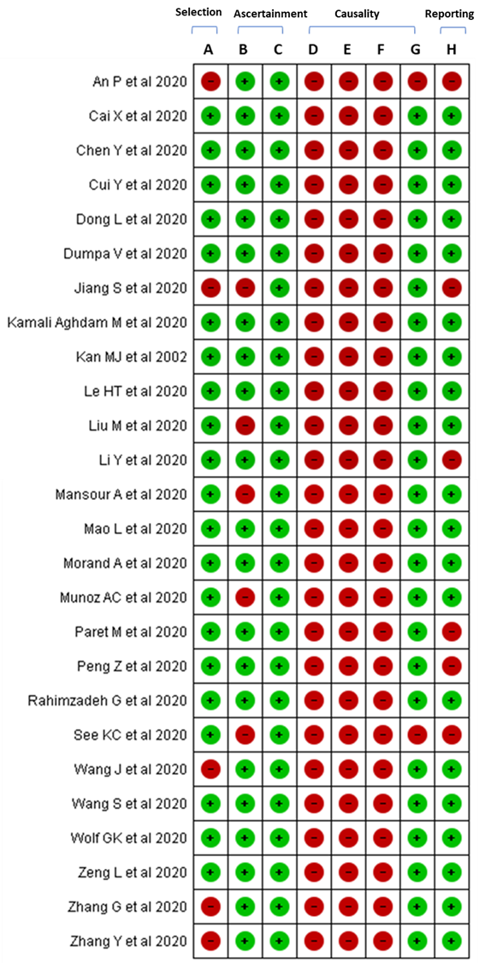
Figure 2: Risk of bias assessment for case-reports and case series included in the review (13)

Figure 3: Risk of bias assessment for studies included in the review (excluding case reports and case series studies) (14)
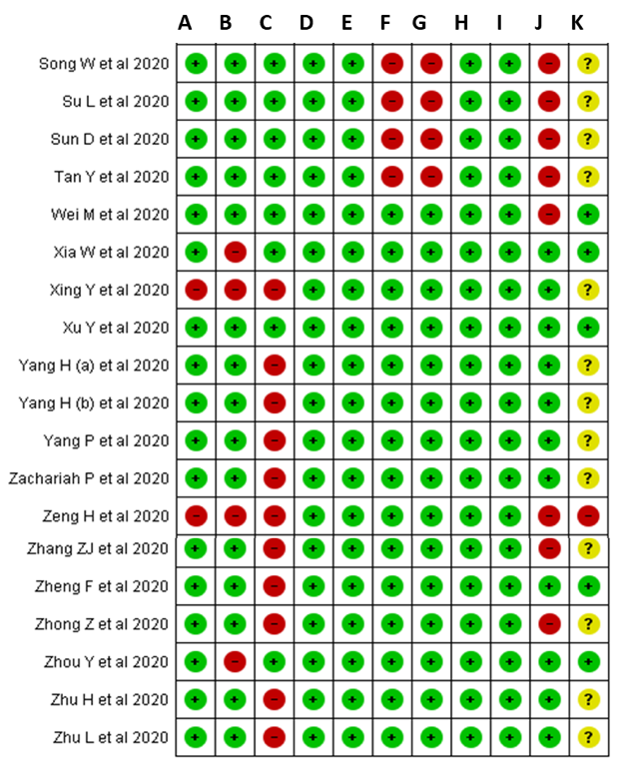
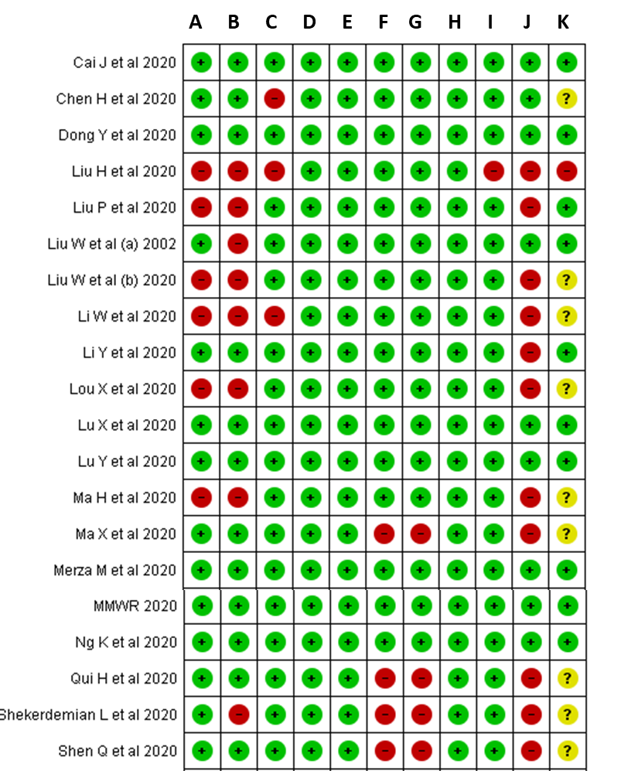

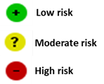

The included 65 studies were conducted in 11 different countries: China, United States, Iran, Vietnam, Lebanon, Iraq, France, United Kingdom, Malaysia, Canada and Germany (Table 1), and from four different WHO regions (European region, n=3; Western Pacific region, n=52 Pacific American region, n=6; Eastern Mediterranean region, n=4).
Table 1: Study and demographic characteristics of 1,214 children included from 65 eligible studies*
Study | Country | Data collection month | Study design | Total number of <5 years children with COVID-19 |  |  | Age | Male (n) | Reported Source of infection
 |  |  |  | N | <1 year | 1-5 years
An P(16) | China | Feb | Case report | 1 | 0 | 1 | 36m | 0 | Family
Cai J(17) | China | Jan – Feb | Prospective data collection | 4 | 2 | 2 | 3m - 60m | 1 | Community
Cai X(18) | China | Jan – Feb | Case report | 4 | 3 | 1 | 2m-15m | 3 | Family,  Community
CDC(19) | USA | Feb – Apr | Retrospective (medical record reviews) | 689 | 398 | 291 | 0-5y | NA | community
Chen H(20) | China | Jan | Retrospective | 0 | 0 | 0 | Newborn | NA | Vertical
Chen Y(21) | China | Jan – Feb | Case report | 0 | 0 | 0 | Newborn | NA | Vertical
Cui Y(22) | China | Feb | Case report | 1 | 1 | 0 | 55d | 0 | Community
Dong L(23) | China | Feb | Case report | 0 | 0 | 0 | Newborn | NA | Vertical
Dong Y(3) | China | Feb | Retrospective | 223 | 86 | 137 | 0-5y | NA | Community
Dumpa V(24) | USA | Mar | Case report | 1 | 1 | 0 | 22d | NA | Community
Jiang S(25) | China | May | Case report | 1 | 0 | 1 | 3.5y | 0 | Community
Kamali Aghdam M(26) | Iran | Mar | Case report | 1 | 1 | 0 | 15d | 0 | Community
Kan M(27) | USA | Apr | Case report | 1 | 1 | 0 | 35d | 0 | Community
Le H(28) | Vietnam | Mar | Case report | 1 | 1 | 0 | 3m | 0 | Community
Li W(29) | China | Jan – Feb | Retrospective | 4 | 0 | 4 | 10m-4y | 3 | Community
Li Y(30) | China | Jan – Feb | Retrospective | 8 | 0 | 8 | 1-5y | 3 | Community
Li Y(31) | China | Feb | Case report | 0 | 0 | 0 | Newborn | NA | Vertical
Liu H(32) | China | Jan – Feb | Retrospective | 2 | 2 | 0 | 2-11m | 2 | Community
Liu M(33) | China | - | Case report | 2 | 1 | 1 | 7m-2.4y | 1 | Community
Liu P(34) | China | Jan – Mar | Prospective | 0 | 0 | 0 | Newborn | 24 | Vertical
Liu W(35) | China | Jan – Feb | Prospective | 0 | 0 | 0 | Newborn | NA | Vertical
Liu W(36) | China | Jan | Retrospective | 5 | 0 | 5 | 1-5y | 2 | Community
Lou X(37) | China | Dec 2019 | Retrospective | 1 | 1 | 0 | 6m | 1 | Family
Lu X(38) | China | Jan – Feb | Retrospective | 71 | 31 | 40 | 1d-5y | NA | Community
Lu Y(39) | China | Jan – Feb | Retrospective | 3 | 1 | 2 | 2m-3y | 2 | Community
Ma H(40) | China | Jan – Feb | Retrospective | 50 | NA | NA | <2.5y | 28 | Community
Ma X(41) | China | Feb | Retrospective | 4 | 1 | 3 | 11m-43m | 2 | Community
Mansour A(42) | Lebanon | Mar | Case report | 1 | 0 | 1 | 16m | 0 | Community
Mao L(43) | China | Feb | Case report | 1 | 0 | 1 | 14m | 1 | Community
Merza M(44) | Iraq | Mar – Apr | Prospective | 1 | 0 | 1 | 60m | 1 | Family
Morand A(45) | France | Mar | Case report | 1 | 0 | 1 | 55m | 0 | Family
Munoz A(46) | USA | - | Case report | 1 | 1 | 0 | 21d | 1 | Community
Ng K(47) | UK | Mar – Apr | Retrospective | 8 | 8 | 0 | 5d-12m | 2 | Community
Paret M(48) | USA | Mar | Case report | 2 | 2 | 0 | 25-56d | 2 | Community
Peng Z(49) | China | NA | Case report | 0 | 0 | 0 | Newborn | NA | Vertical
Qiu H(50) | China | Jan – Mar | Prospective | 10 | NA | NA | 0-5y | 6 | Family cluster & Community
Rahimzadeh G(51) | Iran | NA | Case report | 4 | 0 | 4 | 2-5y | 2 | Community
See K(52) | Malaysia | Jan – Feb | Case report | 2 | 0 | 2 | 20m-4y | 1 | Community
Shekerdemian L(53) | USA & Canada | Mar – Apr | Retrospective | 14 | 8 | 6 | <1-5y | NA | Community
Shen Q(54) | China | Jan – Feb | Retrospective | 2 | 0 | 2 | 1-2y | 0 | Community
Song Q(55) | China | Jan – Mar | Retrospective | 4 | 1 | 3 | 11m-3y | 4 | Community
Su L(56) | China | Jan – Feb | Retrospective | 5 | 2 | 3 | 11-43m | 2 | Community
Sun D(57) | China | Jan – Feb | Retrospective | 4 | 2 | 2 | 2-25m | 3 | Community; Family
Tan Y(58) | China | Jan – Mar | Retrospective | 3 | 0 | 3 | 13m-3y7m | 1 | Community
Wang J(59) | China | Feb | Case report | 1 | 1 | 0 | 23d | 1 | Community
Wang S(60) | China | Mar | Case report | 1 | 1 | 0 | Newborn | 1 | Vertical
Wei M(61) | China | Dec - Feb | Community | 9 | 9 | 0 | 1-11m | 2 | Community
Wolf G(62) | Germany | Jan – Feb | Case report | 1 | 0 | 1 | 2y | 1 | Family
Xia W(63) | China | Jan – Feb | Retrospective | 14 | 9 | 5 | <1m-3y | NA | Community
Xing Y(64) | China | Jan – Mar | Prospective | 1 | 0 | 1 | 1.5y | 1 | Family
Xu Y(65) | China | Apr | Prospective | 3 | 2 | 1 | 2-41m | 2 | Community
Yang H(66) | China | Jan – Mar | Retrospective | 0 | 0 | 0 | Newborn | NA | Vertical
Yang H(67) | China | Jan – Mar | Prospective | 0 | 0 | 0 | Newborn | NA | Vertical
Yang P(68) | China | Jan | Prospective | 0 | 0 | 0 | Newborn | NA | Vertical
Zachariah P(69) | USA | Mar – Apr | Retrospective | 12 | 12 | 0 | <1yr | NA | Community
Zeng H(70) | China | Feb | Retrospective | 0 | 0 | 0 | Newborn | NA | Vertical
Zeng L(71) | China | Feb – Mar | Case report | 1 | 1 | 0 | <1y | NA | Community
Zhang G(72) | China | Jan | Case report | 2 | 0 | 2 | 14m | 0 | Community
Zhang Y(73) | China | Jan | Case report | 1 | 1 | 0 | 3m | 1 | Community
Zhang ZJ(74) | China | Jan – Mar | Retrospective | 4 | 4 | 0 | 30h-17d | 3 | Family
Zheng F(75) | China | Feb | Retrospective | 10 | NA | NA | 1m-3y | NA | Community
Zhong Z(76) | China | NA | Retrospective | 3 | 1 | 2 | 3m-2y | 1 | Community
Zhou Y(77) | China | Jan – Feb | Retrospective | 9 | NA | NA | 7m-3y | 4 | Community
Zhu H(78) | China | Jan – Feb | Retrospective | 0 | 0 | 0 | Newborn | NA | Vertical
Zhu L(79) | China | Jan – Feb | Retrospective | 2 | 0 | 2 | 1y7m-4y | 2 | Community
* Data presented where data available from selected publications included in the review; NA= Not available
Study design: Prospective: Data were collected prospectively; Retrospective: Data were collected by reviewing medical records

A total of 1,214 children younger than five years with rt-PCR confirmed COVID-19 (further mentioned as COVID-19 cases) were included in this systematic review (Table 1). Of 1,214 COVID-19 cases, age-distribution data were available for 1,135 (93%) children. The age of 1,135 COVID-19 cases: 596 (53%) were less than one year (infant) and 539 (47%) were one to five years (Table 1). Among the 596 COVID-19 infant cases, five were newborns. Of 65 studies, 45 studies reported gender distribution for 179 COVID-19 cases: 117 (65%) were male.
Of 1,214 COVID-19 cases, status of clinical symptoms were reported for 880 (72%) children: 834 (95%) were symptomatic and 46 (5%) were asymptomatic (Table 2). Detailed clinical symptoms were extracted for 196 children: fever (75/196, 38%) was the most frequently reported symptom followed by any upper respiratory symptoms (69/196, 35%). Disease severity (mild, moderate or severe) were extractable for 345 children: the majority were mild illness ( n=155, 44.9%); 22 cases required simply oxygen therapy and 4 (1%) cases required invasive ventilator support. Antiviral treatments were reported in 65 cases, the most common medications reported were Interferon (n=31, 47.7%) and Oseltamivir (n=20, 30.8%). Other antiviral medications included Ritonavir (n=9, 13.8%), Lopinavir (n=7, 10.8%), Ribavirin (n=7, 10.8%), Chloroquine (n=4, 6.2%) and Ioponavir (n=2, 3.1%). Antibiotic treatments were reported in 29 cases with the most commonly reported antibiotics being Azithromycin (n=8, 27.6%), Meropenem (n=5, 17.2%) and Vancomycin (n=4, 13.8%). Other antibiotics reported included Linezolid (n=2, 6.9%), Augmentin (n=2, 6.9%), Gentamicin (n=2, 6.9%), Ampicillin (n=1, 3.4%), Cefepime (n=1, 3.4%), Penicillin (n=1, 3.4%), Ceftriaxone (n=1, 3.4%), Amikacin (n=1, 3.4%), Cefotaxime (n=1, 3.4%), Amoxicillin (n=1, 3.4%) and Ceftazidime (n=1, 3.4%). Steroidal treatment was reported in nine cases: all received Methylprednisolone.
Disease outcome was reported for 121 cases, of these cases 120 cases were discharged from hospital or recovered with one death. The deceased case was a 10 month-old female infant with no underlying medical conditions or no history of preceding exposure to a known COVID-19 case. The infant died due to multiple organ failure (18).
Table 2: Descriptive clinical characteristics of 1,214 RT-PCR confirmed COVID-19 cases for all 65 articles included in review
 |  | Number of children (N) | (%)
Symptomatic status |  | 880
 | Symptomatic | 834 | 94.7
 | Asymptomatic | 46 | 5.2
Symptoms reported ª |  | 196
 | Fever | 75 | 38.2
 | Upper Respiratory | 69 | 35.2
 | Lower Respiratory | 10 | 5.1
 | Gastrointestinal | 15 | 7.7
 | Other | 27 | 13.8
Disease Severity ^{b} |  | 345
 | Mild | 155 | 44.9
 | Moderate | 173 | 50.1
 | Severe | 17 | 4.9
Medications |  | 102
 | Antivirals | 64 | 62.7
 | Antibiotics | 29 | 28.4
 | Steroids | 9 | 8.8
Disease Outcomes |  | 121
 | Recovered/Discharged | 120 | 99.2
 | Dead | 1 | 0.8
Source |  | 1211
 | Community | 1186 | 97.9
 | Family | 12 | 0.9
 | Vertical | 13 | 1.2
ªUpper respiratory symptoms included rhinorrhoea, cough and blocked or stuffy nose; Lower respiratory symptoms included tachypnoea and dyspnoea; Gastrointestinal symptoms included vomiting, diarrhoea, abdominal pain and abdominal distention; Other symptoms that were reported in few cases included, headache, poor feeding/decreased oral intake, hypothermia, tachycardia, paroxysmal crying, fatigue/drowsiness and hypotension; ^{b} Mild Disease= non-hospitalised, Moderate Disease = hospitalised, Severe Disease= HDU/ICU admission/mechanical ventilation.
Source of infection was reported for 1,211 cases, of which 1,186 (98%) were a community acquired source and 12 (1%) were from a family member. Of the 65 publications included in the review, 14 reported SARS-CoV-2 status in 139 newborns from 137 COVID-19 positive mothers (20, 21, 23, 31, 34, 35, 49, 60, 66-68, 70, 74, 78). Of the 137 deliveries, 122 (89%) were caesarean section (C-section). Of the 139 babies born, five (3.6%) were COVID-19 positive by rt-PCR at age 30 hours to 17 days. All the five mothers completed at least 40 weeks of gestation and all five newborns were delivered by C-section. All but one mothers developed respiratory symptoms before delivery. Of the five newborns, three of them showed at least one respiratory symptom including fever, cough, shortness of breath and vomiting. None of them required intensive care unit admission or mechanical ventilation. The hospital stays of newborns ranged from 16 days to 30 days.
The outputs from meta-analysis are presented in Table 3. The pooled prevalence showed that among children aged less than five years with COVID-19 infection, 50% (95%CI: 36% to 63%) of children were aged less than one year (Figure 4) and 53% (95%CI: 41% to 65%) were male (supplementary figure 1). Data were unable to be extracted to perform a meta-analysis on transmission source and death. Of the children who required hospitalisation (moderate/severe disease), 49% (95%CI: 12% to 86%) required oxygen therapy (not inclusive of mechanical ventilation), 99% (95%CI: 92% to 100%) were treated with antivirals and 71% (95%CI: 46% to 92%) were treated with antibiotics, many cases reported combined treatments for patients.

Table 3: Meta-analysis of outcomes (random effects model) ª
 | No. of Studies | Proportion | 95%CI ^{b} | Total no. of cases (n) | I² | t² | Q | P-value
Age
<1yr | 27 | 0.50 | 0.36 – 0.63 | 580 | 78.9% | 0.0379 | 123.17 | <0.0001
1-5yr | 27 | 0.50 | 0.37 – 0.64 | 523 | 78.9% | 0.0379 | 123.17 | <0.0001
Sex
Male | 24 | 0.53 | 0.41 – 0.65 | 78 | 20.4% | 0.0104 | 28.88 | 0.1844
Clinical Characteristics
Asymptomatic Cases | 9 | 0.43 | 0.15 – 0.73 | 42 | 82.7% | 0.1152 | 46.24 | <0.0001
Symptomatic Cases | 11 | 0.56 | 0.008 – 1.00 | 714 | 99.4% | 0.7045 | 1588.73 | 0
Symptoms reported
Fever | 18 | 0.76 | 0.61 – 0.89 | 43 | 0.0% | 0 | 14.70 | 0.6171
Upper Respiratory Symptoms | 13 | 0.75 | 0.55 – 0.91 | 37 | 25.3% | 0.0182 | 16.05 | 0.1887
Lower Respiratory Symptoms | 2 | 0.34 | 0.03 – 0.72 | 4 | 0.0% | 0 | 0.0 | 0.9545
Gastrointestinal Symptoms | 3 | 0.73 | 0.20 – 1.00 | 7 | 48.7% | 0.0772 | 5.85 | 0.1192
Other Symptoms | 2 | 0.97 | 0.54 – 1.00 | 10 | 32.5% | 0.0399 | 2.96 | 0.2272
Treatment
Antibiotics | 5 | 0.71 | 0.46 – 0.92 | 14 | 5.4% | 0.0032 | 4.23 | 0.3757
Antivirals | 10 | 0.99 | 0.92 – 1.00 | 48 | 0.0% | 0 | 6.11 | 0.7291
Steroids | 3 | 0.65 | 0.30 – 0.93 | 7 | 0.0% | 0 | 0.88 | 0.6438
Oxygen Therapy ^{c} | 7 | 0.49 | 0.11 – 0.87 | 14 | 78.2% | 0.1489 | 27.58 | 0.0001
Disease Severity
Mild | 4 | 0.40 | 0.06 – 0.78 | 132 | 84.1% | 0.0990 | 18.91 | 0.0003
Moderate | 7 | 0.51 | 0.16 – 0.85 | 98 | 87.9% | 0.1449 | 49.75 | <0.0001
Severe | 5 | 0.07 | 0.00 – 0.30 | 9 | 73.5% | 0.0545 | 15.08 | 0.0045
Disease duration (days) |  |  |  |  |  | Mean ^{d} | Min | Max
Duration of illness | 8 |  |  | 30 |  | 6.51 | 10 | 33.1
Duration between symptom onset to detection | 9 |  |  | 43 |  | 2.06 | 1.79 | 7.02
Duration of hospital stay | 5 |  |  | 24 |  | 4.08 | 8 | 22.27
ª Data presented in meta-analysis is only from 31 studies with available data (excluded single case reports).
^{b} 95%CI= 95% Confidence Interval
^{c} Not inclusive of mechanical ventilation
^{d} Mean calculated as weighted average

Figure 4: Forest plot of prevalence of COVID-19 infection in children aged less than one year for 31 studies included in meta-analysis
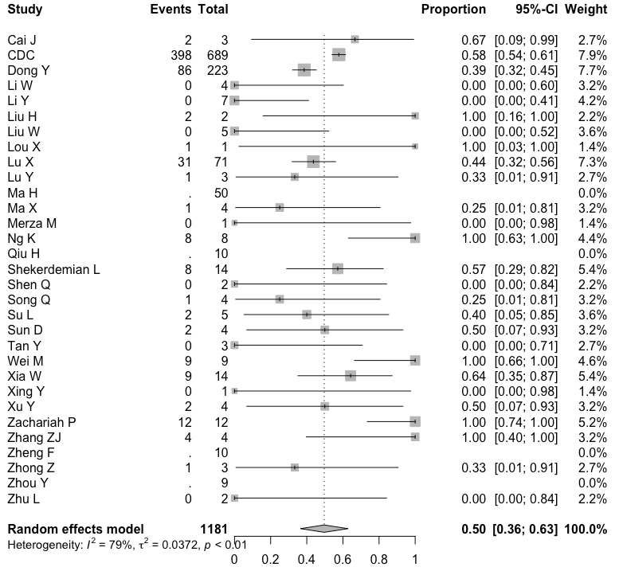

Discussion:
As of the 24th July 2020 there have been a total of 15, 296, 926 cases and 628, 903 deaths from COVID-19 globally recorded by the World Health Organisation (80). Since the first publications (24 Jan 2020) most of the published literature has focused on adults or all children aged less than 18 years. In this ever evolving and rapidly changing pandemic, we performed the largest and most comprehensive systematic review and meta-analysis of the literature specific for children aged less than five years with laboratory confirmed COVID-19 infection. Our systematic review suggests that prognosis of COVID-19 in children aged less than five years is excellent with more than 90% of children developing mild to moderate disease. Recent reviews by Castagnoli et al (81) and Hoang et al (82), also reported similar findings with Castagnoli et al also only reporting one death from 1,065 COVID-19 included all children <18 years. This also follows trends that only 7% of cases in our review were severe cases requiring intensive care unit (ICU) or high dependency unit (HDU) admission, comparative to 53% of adults recorded with severe COVID-19 disease requiring ICU admission (83) . Severe COVID-19 disease has been found to be highly resistant in the paediatric population. This is a particularly important finding given that infants and young children aged less than five years are already at high risk of severe disease associated with other respiratory infections including influenza and RSV due to the immaturity of the immune system(1). Research has suggested that children may be unlikely to produce a vigorous cell-mediated attack, on the alveoli and interstitial tissues of the lungs, due to a reduced number of memory cells that adults typically possess from cumulative exposure to other circulating coronaviruses (84). Adults often become naturally immune to coronaviruses circulating in the population, yet children are more susceptible to infection because they are likely to lack the immunity to circulating coronaviruses (84). As a result, children probably lack the memory cells to the coronavirus antigens, such asSARS-CoV-2 , thus leading to much milder cell-mediated immune responses and less severe inflammation, unlike adults (84). However, there was a large number of hospitalisations due to COVID-19 reported in our studies, this is disproportionate to the actual severity of disease as early in the pandemic many children were hospitalised for isolation only and not necessarily because they required a hospital admission due to severity of infection. It is likely that a substantial proportion of COVID-19 infections classified as moderate illness which meant they required hospital admission were mild disease. This is also likely that most asymptomatic children were not tested and thus only the children with certain level of clinical manifestations were included in this study. Thus, we the reported proportion of severe or moderate case could be higher than the actual proportion.
Majority (>95%) of the COVID-19 infections in children reportedly had a community source of infection, however, familial clusters were common in four case reports included in the review. Evidence suggests that young adults and children have a high likelihood of developing COVID-19 pneumonia due to household transmission once a family member tests positive to COVID-19 (16). This is of concern, as 43% of children under five years were reported as having asymptomatic disease, suggesting younger children can potentially transmit the disease to older children or adult family members unknowingly. There have also been multiple reports of prolonged faecal virus shedding in paediatric patients with one study concluding two children, aged one and half years and five years respectively, who were still testing RT-PCR positive in stools for up to 20 days, after nucleic acid testing turning negative in respiratory samples (64). Longer duration of virus shedding through the gastrointestinal tract can play a role in potential faecal-oral transmission of the virus, however this is yet to be confirmed (64, 65).
Our systematic review suggests, children aged less than five with COVID-19 infection do not always present with respiratory symptoms. Specifically, infants can frequently present with non-respiratory symptoms such as paroxysmal crying or poor feeding. As a result of this atypical presentation of the disease many children included in the review were treated empirically with antibiotics and antiviral medications, despite the fact they were unlikely to have severe disease. We found that 71% of children aged less than five were treated with antibiotics, despite having a confirmed diagnosis of COVID-19. This is a concerning proportion of antibiotic use as a treatment for the virus in children, during a continually evolving pandemic, given the inappropriate use of antibiotics in under five children is a significant contributor to the emergence and spread of antimicrobial resistance globally (85, 86). There were few reports in our review of prophylactic treatment with antibiotics in infants until the source of the infection was determined, which is routine in this age for preventing bacteraemia, urinary tract infection (UTI) or pneumonia, although this has limitations in populations of increased antimicrobial resistance (87, 88). It is likely that the empirical use of antibiotics for COVID-19 in children will continue until an effective treatment is sourced.
This meta-analysis with nearly 1250 children aged less than 5 years with COVID-19 infection showed half of the cases were aged less than one year, suggesting young infants. Infants are particularly at higher risk of infectious disease during the first few months of their lives due to the inadequately developed immune system and are often targeted for prevention strategies. Vaccine is one of the most effective public health interventions to prevent transmission of infectious diseases. However, the immature immune system of newborns also make them unsuitable for many vaccines. Maternal immunization during pregnancy has been proven to be an alternative effective strategy in providing protection to the infants against many vaccine-preventable diseases including pertussis, tetanus and influenza during the first few months of life. Maternal immunization during pregnancy has two benefits, it protects the mother and foetus and it also protects the newborn through transplacental transfer of maternal antibody (89). Till date, we do not have any suitable COVID-19 vaccine, but there are couple of vaccines in advance clinical stages (9). It remains unknown whether these new vaccines will be targeting young infants and neonates. In situation where the new COVID-19 vaccination deemed unsuitable for very young children, maternal immunisation could be an alternative approach to prevent COVID-19 in the infant paediatric population.

We also found that a handful of newborns (5%) from COVID-19 infected mothers had laboratory confirmed COVID-19 infection. Nonetheless, the vertical transmission of COVID-19 remains unclear as none of those studies could persuasively claim mother to neonate transmission. A recent review on vertical transmission of COVID-19 from infected mothers to newborns concluded with no evidence of intrauterine transmission during delivery from mothers to their fetuses (7). Recent literatures have demonstrated no abnormality in blood biomarkers such as white blood cell count, absolute lymphocyte count, and in immunological markers such as CD3, CD4, CD8, CD4/CD8, IL-2, 4, 6 or IFN-g or TNF-a in neonates as the effect of maternal immune response to COVID-19 (34, 90). Therefore, to date, there is no definite evidence suggesting that vertical transmission of COVID-19 can occur, similar to data reported during previous influenza pandemics and novel coronavirus strains associated with Severe Acute Respiratory Syndrome (SARS-CoV) and Middle East respiratory syndrome (MERS-Cov) epidemics (91, 92).

LIMITATION:
The systematic review demonstrates that paediatric population aged less than five years, is not only resistant to severe disease but it also has better outcomes than that of the adult population. However, half of infected young children are below one year, suggesting the infants should remain as a target for prevention. Despite confirmed diagnosis of the virus, antibiotics have been frequently prescribed as treatments, which is concerning given the ongoing global challenge with antimicrobial resistance. The neonates are at low risk of acquiring the infection from infected mother with limited evidence of vertical transmission till date, however, this should not be ruled out completely. Further research to understand this mode of transmission in infants would benefit future preventive strategies using vaccines to protect young children when available.
References
1. Tregoning JS, Schwarze J. Respiratory viral infections in infants: causes, clinical symptoms, virology, and immunology. Clin Microbiol Rev. 2010;23(1):74-98.
2. Chen N, Zhou M, Dong X, Qu J, Gong F, Han Y, et al. Epidemiological and clinical characteristics of 99 cases of 2019 novel coronavirus pneumonia in Wuhan, China: a descriptive study. Lancet. 2020;395(10223):507-13.
3. Dong Y, Mo X, Hu Y, Qi X, Jiang F, Jiang Z, et al. Epidemiological characteristics of 2143 pediatric patients with 2019 coronavirus disease in China. 2020.
4. Lu X, Zhang L, Du H, Zhang J, Li YY, Qu J, et al. SARS-CoV-2 infection in children. 2020;382(17):1663-5.
5. Hu X, Gao J, Luo X, Feng L, Liu W, Chen J, et al. Severe Acute Respiratory Syndrome Coronavirus 2 (SARS-CoV-2) Vertical Transmission in Neonates Born to Mothers With Coronavirus Disease 2019 (COVID-19) Pneumonia. Obstet Gynecol. 2020;136(1):65-7.
6. Alzamora MC, Paredes T, Caceres D, Webb CM, Valdez LM, La Rosa M. Severe COVID-19 during Pregnancy and Possible Vertical Transmission. Am J Perinatol. 2020;37(8):861-5.
7. Karimi-Zarchi M, Neamatzadeh H, Dastgheib SA, Abbasi H, Mirjalili SR, Behforouz A, et al. Vertical Transmission of Coronavirus Disease 19 (COVID-19) from Infected Pregnant Mothers to Neonates: A Review. Fetal Pediatr Pathol. 2020;39(3):246-50.
8. Worldometer. COVID-19 Coronavirus Pandemic 2020 [Available from: COVID-19 Coronavirus Pandemic.
9. COVID-19 Vaccine Tracker. 2020 [Available from: https://www.covid-19vaccinetracker.org/.
10. Centre for Disease Control. The National Respiratory and Enteric Virus Surveillance System (NREVSS) 2018 [Available from: https://www.cdc.gov/surveillance/nrevss/index.html.
11. Wang N. How to Conduct a Meta-Analysis of Proportions in R: A Comprehensive Tutorial 2018 [Available from: https://doi.org/10.13140/RG.2.2.27199.00161.
12. Del Re AC. A Practical Tutorial on Conducting Meta-Analysis in R. The Quantitative Methods for Psychology. 2015;11:37-50.
13. Murad MH, Sultan S, Haffar S, Bazerbachi F. Methodological quality and synthesis of case series and case reports. BMJ Evid Based Med. 2018;23(2):60-3.
14. Hoy D, Brooks P, Woolf A, Blyth F, March L, Bain C, et al. Assessing risk of bias in prevalence studies: modification of an existing tool and evidence of interrater agreement. J Clin Epidemiol. 2012;65(9):934-9.
15. Moher D, Liberati, A., Tetziaff, J., Altman, D. G., The PRISMA Group. Preferred Reporting items for Systematic Reviews and Meta-Analyses: The PRISMA Statement. PLoS Med. 2009;6(7).
16. An P, Zhang M. Novel coronavirus SARS-CoV-2: familial spread resulting in COVID-19 pneumonia in a pediatric patient. Diagnostic and interventional radiology (Ankara, Turkey). 2020.
17. Cai J, Xu J, Lin D, Yang Z, Xu L, Qu Z, et al. A Case Series of children with 2019 novel coronavirus infection: clinical and epidemiological features. Clinical infectious diseases : an official publication of the Infectious Diseases Society of America. 2020.
18. Cai X, Ma Y, Li S, Chen Y, Rong Z, Li W. Clinical Characteristics of 5 COVID-19 Cases With Non-respiratory Symptoms as the First Manifestation in Children. Frontiers in Pediatrics. 2020;8.
19. Centre for Disease Control. Coronavirus Disease 2019 in Children - United States, February 12-April 2, 2020. MMWR Morbidity and mortality weekly report. 2020;69(14):422-6.
20. Chen H, Guo J, Wang C, Luo F, Yu X, Zhang W, et al. Clinical characteristics and intrauterine vertical transmission potential of COVID-19 infection in nine pregnant women: a retrospective review of medical records. Lancet (London, England). 2020;395(10226):809-15.
21. Chen Y, Peng H, Wang L, Zhao Y, Zeng L, Gao H, et al. Infants born to mothers with a new coronavirus (COVID-19). 2020;8:104.
22. Cui Y, Tian M, Huang D, Wang X, Huang Y, Fan L, et al. A 55-Day-Old Female Infant Infected With 2019 Novel Coronavirus Disease: Presenting With Pneumonia, Liver Injury, and Heart Damage. The Journal of infectious diseases. 2020;221(11):1775-81.
23. Dong L, Tian J, He S, Zhu C, Wang J, Liu C, et al. Possible vertical transmission of SARS-CoV-2 from an infected mother to her newborn. 2020.
24. Dumpa V, Kamity R, Vinci AN, Noyola E, Noor A. Neonatal Coronavirus 2019 (COVID-19) Infection: A Case Report and Review of Literature. Cureus. 2020;12(5).
25. Jiang S, Liu P, Xiong G, Yang Z, Wang M, Li Y, et al. Coinfection of SARS-CoV-2 and multiple respiratory pathogens in children. Clinical Chemistry and Laboratory Medicine. 2020.
26. Kamali Aghdam M, Jafari N, Eftekhari K. Novel coronavirus in a 15-day-old neonate with clinical signs of sepsis, a case report. Infectious Diseases. 2020;52(6):427-9.
27. Kan MJ, Grant LMC, Muña MA, Greenhow TL. Fever without a source in a young infant due to SARS-CoV-2. Journal of the Pediatric Infectious Diseases Society. 2020.
28. Le HT, Nguyen LV, Tran DM, Do HT, Tran HT, Le YT, et al. The first infant case of COVID-19 acquired from a secondary transmission in Vietnam. The Lancet Child and Adolescent Health. 2020;4(5):405-6.
29. Li W, Cui H, Li K, Fang Y, Li S. Chest computed tomography in children with COVID-19 respiratory infection. Pediatric Radiology. 2020.
30. Li Y, Cao J, Zhang X, Liu G, Wu X, Wu B. Chest CT imaging characteristics of COVID-19 pneumonia in preschool children: A retrospective study. BMC Pediatrics. 2020;20(1):227.
31. Li Y, Zhao R, Zheng S, Chen X, Wang J, Sheng X, et al. Lack of Vertical Transmission of Severe Acute Respiratory Syndrome Coronavirus 2, China. Emerging infectious diseases. 2020;26(6).
32. Liu H, Liu F, Li J, Zhang T, Wang D, Lan W. Clinical and CT imaging features of the COVID-19 pneumonia: Focus on pregnant women and children. Journal of Infection. 2020.
33. Liu M, Song Z, Xiao K. High-Resolution Computed Tomography Manifestations of 5 Pediatric Patients With 2019 Novel Coronavirus. Journal of computer assisted tomography. 2020.
34. Liu P, Zheng J, Yang P, Wang X, Wei C, Zhang S, et al. The immunologic status of newborns born to SARS-CoV2-infected mothers in Wuhan, China. The Journal of allergy and clinical immunology. 2020.
35. Liu W, Wang J, Li WB, Zhou ZX, Liu SY, Rong ZH. Clinical characteristics of 19 neonates born to mothers with COVID-19. Frontiers of Medicine. 2020;14(2):193-8.
36. Liu W, Zhang Q, Chen J, Xiang R, Song H, Shu S, et al. Detection of Covid-19 in Children in Early January 2020 in Wuhan, China. The New England journal of medicine. 2020.
37. Lou XX, Shi CX, Zhou CC, Tian YS. Three children who recovered from novel coronavirus 2019 pneumonia. Journal of Paediatrics and Child Health. 2020.
38. Lu X, Zhang L, Du H, Zhang J, Li YY, Qu J, et al. SARS-CoV-2 Infection in Children. The New England journal of medicine. 2020.
39. Lu Y, Li Y, Deng W, Liu M, He Y, Huang L, et al. Symptomatic Infection is Associated with Prolonged Duration of Viral Shedding in Mild Coronavirus Disease 2019: A Retrospective Study of 110 Children in Wuhan. The Pediatric infectious disease journal. 2020.
40. Ma H, Hu J, Tian J, Zhou X, Li H, Laws MT, et al. A single-center, retrospective study of COVID-19 features in children: a descriptive investigation. BMC Med. 2020;18(1):123.
41. Ma X, Su L, Zhang Y, Zhang X, Gai Z, Zhang Z. Do children need a longer time to shed SARS-CoV-2 in stool than adults? Journal of Microbiology, Immunology and Infection. 2020.
42. Mansour A, Atoui R, Kanso K, Mohsen R, Fares Y, Fares J. First Case of an Infant with COVID-19 in the Middle East. Cureus. 2020;12(4).
43. Mao LJ, Xu J, Xu ZH, Xia XP, Li B, He JG, et al. A child with household transmitted COVID-19. Bmc Infectious Diseases. 2020;20(1).
44. Merza MA, Haleem Al Mezori AA, Mohammed HM, Abdulah DM. COVID-19 outbreak in Iraqi Kurdistan: The first report characterizing epidemiological, clinical, laboratory, and radiological findings of the disease. Diabetes and Metabolic Syndrome: Clinical Research and Reviews. 2020;14(4):547-54.
45. Morand A, Roquelaure B, Colson P, Amrane S, Bosdure E, Raoult D, et al. Child with liver transplant recovers from COVID-19 infection. A case report. Archives de Pediatrie. 2020.
46. Munoz AC, Nawaratne U, McMann D, Ellsworth M, Meliones J, Boukas K. Late-onset neonatal sepsis in a patient with covid-19. New England Journal of Medicine. 2020;382(19).
47. Ng KF, Bandi S, Bird PW, Wei-Tze Tang J. COVID-19 in Neonates and Infants: Progression and Recovery. The Pediatric infectious disease journal. 2020.
48. Paret M, Lighter J, Pellett Madan R, Raabe VN, Shust GF, Ratner AJ. SARS-CoV-2 infection (COVID-19) in febrile infants without respiratory distress. Clinical infectious diseases : an official publication of the Infectious Diseases Society of America. 2020.
49. Peng Z, Wang J, Mo Y, Duan W, Xiang G, Yi M, et al. Unlikely SARS-CoV-2 vertical transmission from mother to child: A case report. Journal of Infection and Public Health. 2020;13(5):818-20.
50. Qiu H, Wu J, Hong L, Luo Y, Song Q, Chen D. Clinical and epidemiological features of 36 children with coronavirus disease 2019 (COVID-19) in Zhejiang, China: an observational cohort study. The Lancet Infectious diseases. 2020.
51. Rahimzadeh G, Noghabi ME, Elyaderani FK, Navaeifar MR, Enayati AA, Anari AM, et al. COVID-19 Infection in Iranian Children: A Case Series of 9 Patients. Journal of Pediatrics Review. 2020;8(2):139-44.
52. See KC, Liew SM, Ng DCE, Chew EL, Khoo EM, Sam CH, et al. COVID-19: Four Paediatric Cases in Malaysia. International Journal of Infectious Diseases. 2020;94:125-7.
53. Shekerdemian LS, Mahmood NR, Wolfe KK, Riggs BJ, Ross CE, McKiernan CA, et al. Characteristics and Outcomes of Children with Coronavirus Disease 2019 (COVID-19) Infection Admitted to US and Canadian Pediatric Intensive Care Units. JAMA Pediatrics. 2020.
54. Shen QX, Guo W, Guo T, Li JH, He WL, Ni SS, et al. Novel coronavirus infection in children outside of Wuhan, China. Pediatric Pulmonology. 2020;55(6):1424-9.
55. Song W, Li J, Zou N, Guan W, Pan J, Xu W. Clinical features of pediatric patients with coronavirus disease (COVID-19). Journal of Clinical Virology. 2020;127:104377.
56. Su L, Ma X, Yu H, Bian P, Han Y, Sun J, et al. The different clinical characteristics of corona virus disease cases between children and their families in China - the character of children with COVID-19. Emerging microbes & infections. 2020;9(1):707-13.
57. Sun D, Li H, Lu XX, Xiao H, Ren J, Zhang FR, et al. Clinical features of severe pediatric patients with coronavirus disease 2019 in Wuhan: a single center's observational study. World journal of pediatrics : WJP. 2020.
58. Tan YP, Tan BY, Pan J, Wu J, Zeng SZ, Wei HY. Epidemiologic and clinical characteristics of 10 children with coronavirus disease 2019 in Changsha, China. Journal of Clinical Virology. 2020;127:104353.
59. Wang J, Wang D, Chen GC, Tao XW, Zeng LK. [SARS-CoV-2 infection with gastrointestinal symptoms as the first manifestation in a neonate]. Zhongguo dang dai er ke za zhi = Chinese journal of contemporary pediatrics. 2020;22(3):211-4.
60. Wang S, Guo L, Chen L, Liu W, Cao Y, Zhang J, et al. A case report of neonatal COVID-19 infection in China. Clinical infectious diseases : an official publication of the Infectious Diseases Society of America. 2020.
61. Wei M, Yuan J, Liu Y, Fu T, Yu X, Zhang ZJ. Novel Coronavirus Infection in Hospitalized Infants Under 1 Year of Age in China. JAMA. 2020.
62. Wolf GK, Glueck T, Huebner J, Muenchhoff M, Hoffmann D, French LE, et al. Clinical and Epidemiological Features of a Family Cluster of Symptomatic and Asymptomatic SARS-CoV-2 Infection. Journal of the Pediatric Infectious Diseases Society. 2020.
63. Xia W, Shao J, Guo Y, Peng X, Li Z, Hu D. Clinical and CT features in pediatric patients with COVID-19 infection: Different points from adults. Pediatric Pulmonology. 2020.
64. Xing YH, Ni W, Wu Q, Li WJ, Li GJ, Wang WD, et al. Prolonged viral shedding in feces of pediatric patients with coronavirus disease 2019. Journal of Microbiology, Immunology and Infection. 2020.
65. Xu Y, Li X, Zhu B, Liang H, Fang C, Gong Y, et al. Characteristics of pediatric SARS-CoV-2 infection and potential evidence for persistent fecal viral shedding. Nature Medicine. 2020.
66. Yang H, Hu B, Zhan S, Yang LY, Xiong G. Effects of SARS-CoV-2 infection on pregnant women and their infants: A retrospective study in Wuhan, China. Archives of pathology & laboratory medicine. 2020.
67. Yang H, Sun G, Tang F, Peng M, Gao Y, Peng J, et al. Clinical features and outcomes of pregnant women suspected of coronavirus disease 2019. Journal of Infection. 2020.
68. Yang P, Wang X, Liu P, Wei C, He B, Zheng J, et al. Clinical characteristics and risk assessment of newborns born to mothers with COVID-19. Journal of Clinical Virology. 2020;127.
69. Zachariah P, Halabi KC, Johnson CL, Whitter S, Sepulveda J, Green DA. Symptomatic Infants have Higher Nasopharyngeal SARS-CoV-2 Viral Loads but Less Severe Disease than Older Children. Clinical infectious diseases : an official publication of the Infectious Diseases Society of America. 2020.
70. Zeng H, Xu C, Fan J, Tang Y, Deng Q, Zhang W, et al. Antibodies in Infants Born to Mothers with COVID-19 Pneumonia. JAMA - Journal of the American Medical Association. 2020:E1-E2.
71. Zeng L, Tao X, Yuan W, Wang J, Liu X, Liu ZJZekzzCjop. First case of neonate infected with novel coronavirus pneumonia in China. 2020;58:E009.
72. Zhang GX, Zhang AM, Huang L, Cheng LY, Liu ZX, Peng XL, et al. [Twin girls infected with SARS-CoV-2]. Zhongguo dang dai er ke za zhi = Chinese journal of contemporary pediatrics. 2020;22(3):221-5.
73. Zhang YH, Lin DJ, Xiao MF, Wang JC, Wei Y, Lei ZX, et al. [2019 novel coronavirus infection in a three-month-old baby]. Zhonghua er ke za zhi = Chinese journal of pediatrics. 2020;58(3):182-4.
74. Zhang ZJ, Yu XJ, Fu T, Liu Y, Jiang Y, Yang BX, et al. Novel Coronavirus Infection in Newborn Babies Under 28 Days in China. The European respiratory journal. 2020.
75. Zheng F, Liao C, Fan QH, Chen HB, Zhao XG, Xie ZG, et al. Clinical Characteristics of Children with Coronavirus Disease 2019 in Hubei, China. Current medical science. 2020.
76. Zhong Z, Xie X, Huang W, Zhao W, Yu Q, Liu J. Chest CT findings and clinical features of coronavirus disease 2019 in children. Zhong nan da xue xue bao Yi xue ban = Journal of Central South University Medical sciences. 2020;45(3):236-42.
77. Zhou Y, Yang GD, Feng K, Huang H, Yun YX, Mou XY, et al. [Clinical features and chest CT findings of coronavirus disease 2019 in infants and young children]. Zhongguo dang dai er ke za zhi = Chinese journal of contemporary pediatrics. 2020;22(3):215-20.
78. Zhu H, Wang L, Fang C, Peng S, Zhang L, Chang G, et al. Clinical analysis of 10 neonates born to mothers with 2019-nCoV pneumonia. 2020;9(1):51.
79. Zhu L, Wang J, Huang R, Liu L, Zhao H, Wu C, et al. Clinical characteristics of a case series of children with coronavirus disease 2019. Pediatric Pulmonology. 2020;55(6):1430-2.
80. WHO. Coronavirus disease (COVID-19). Situation Report-186 Geneva: World Health Organisation; 2020 [Available from: https://www.who.int/docs/default-source/coronaviruse/situation-reports/20200724-covid-19-sitrep-186.pdf?sfvrsn=4da7b586_2.
81. Castagnoli R, Votto M, Licari A, Brambilla I, Bruno R, Perlini S, et al. Severe Acute Respiratory Syndrome Coronavirus 2 (SARS-CoV-2) Infection in Children and Adolescents: A Systematic Review. JAMA Pediatrics. 2020.
82. Hoang A, Chorath K, Moreira A, Evans M, Burmeister-Morton F, Burmeister F, et al. COVID-19 in 7780 pediatric patients: A systematic review. EClinicalMedicine. 2020:100433.
83. CDC. Severe Outcomes Among Patients with Coronavirus Disease 2019 (COVID-19)- United States, February 12-March 16,2020.: Center of Disease Control; 2020 [Available from: https://www.cdc.gov/mmwr/volumes/69/wr/mm6912e2.htm#suggestedcitation.
84. Abdulamir A, Hafidh R. The Possible Immunological Pathways for the Variable Immunopathogenesis of COVID-19 Infections among Healthy Adults, Elderly and Children. Electronic Journal of General Medicine. 2020;17.
85. WHO. Antibiotic resitance Geneva: World Health Organisation; 2018 [Available from: https://www.who.int/news-room/fact-sheets/detail/antibiotic-resistance.
86. Farkaš M, Čulina T, Sišul J, Pelčić G, Mavrinac M, Mićović V, et al. Impact of antibiotic consumption on the carriage of antibiotic-resistant bacteria by school children. European Journal of Public Health. 2019;30(2):265-9.
87. Prophylactic antibiotics in children. Paediatr Child Health. 1999;4(7):490-502.
88. Baraff LJ. Management of fever without source in infants and children. Annals of Emergency Medicine. 2000;36(6):602-14.
89. Steedman MR, Kampmann B, Schillings E, Al Kuwari H, Darzi A. Strategies To Boost Maternal Immunization To Achieve Further Gains In Improved Maternal And Newborn Health. Health Aff (Millwood). 2016;35(2):309-16.
90. Ong EZ, Chan YFZ, Leong WY, Lee NMY, Kalimuddin S, Haja Mohideen SM, et al. A Dynamic Immune Response Shapes COVID-19 Progression. Cell Host Microbe. 2020;27(6):879-82 e2.
91. Rasmussen SA, Jamieson DJ, Uyeki TM. Effects of influenza on pregnant women and infants. Am J Obstet Gynecol. 2012;207(3 Suppl):S3-8.
92. Li AM, Ng PC. Severe acute respiratory syndrome (SARS) in neonates and children. Arch Dis Child Fetal Neonatal Ed. 2005;90(6):F461-5.

