Understanding what shapes disease control:

an historical analysis of foot-and-mouth disease in Kenya

Polly Compston^{a, b*}, Georgina Limon^{a, b}, Abraham Sangula^{c}, Joshua Onono^{d}, Donald P King^{b} and Barbara Häslerª

ªVeterinary Epidemiology, Economics and Public Health Group, Royal Veterinary College, Hawkshead Lane, AL9 7TA, UK. pcompston@rvc.ac.uk, bhaesler@rvc.ac.uk
^{b}The Pirbright Institute, Ash Rd, Pirbright, Woking GU24 0NF, UK. georgina.limon-vega@pirbright.ac.uk, donald.king@pirbright.ac.uk
^{c}Foot-and-mouth Disease National Reference Laboratory, Embakasi, Nairobi, Kenya. aksangula@gmail.com
^{d}Department of Public Health, Pharmacology and Toxicology, College of Agriculture and Veterinary Sciences, University of Nairobi, Nairobi, Kenya. joshua.orungo@uonbi.ac.ke

*Corresponding author: Polly Compston, pcompston@rvc.ac.uk

Highlights
- Epidemiology, politics, economics and social demographics all influence disease control.
- Different control programmes for foot-and-mouth disease in Kenya have been implemented.
- None of these control programmes have led to elimination of the foot-and-mouth disease.
- Critical drivers influencing control programmes include post-colonial politics, structure of veterinary services and how different farming systems are engaged.
- Peer-reviewed accounts of socio-political and logistical aspects of disease control programmes are important for disease control programme evaluation.

Abstract

Interpreting the interplay between politics, social demographics and epidemiology is essential for understanding how a disease’s occurrence and control evolve over time. Foot-and-mouth disease (FMD) virus was first detected in Kenya in 1915 and serotyped in 1932. This review aims to describe and appraise initiatives to control FMD in Kenya since its independence from British rule in 1964, using information from the scientific literature. We describe the historical dynamics of FMD epidemiology in the country and determine socio-political factors that have shaped the control strategies used. PubMed, Scopus, CAB abstracts, Science Direct, Web of Science and Google Scholar were used to search and retrieve papers, using predetermined search criteria encompassing FMD, Kenya and disease control programme descriptors. In total 1234 papers were identified and screened for relevance using the World Health Organization’s guidelines for rapid review. Ultimately 69 references from this search were included, and information extracted and consolidated. These papers highlight that following independence, there was a structured effort to control FMD consisting of a compulsory subsidised vaccination programme in the Rift Valley with movement controls and quarantine when outbreaks occurred. This programme led to an initial decrease in recorded FMD outbreaks. However, endemic circulation continued and this programme was discontinued due to multiple factors, including political deprioritisation and changes in the structure of veterinary services. Only low levels of active surveillance have been applied since 1964; most surveillance is passive and relies on outbreak reports. Currently control focuses on outbreak management and a mixture of public- and privately-funded vaccination. This review highlights critical drivers influencing disease control programme implementation including veterinary service structure, the active participation of stakeholders with farming systems and availability of affordable and matched FMD vaccine. Additionally, it appraises the availability of historical information and draws attention to gaps in the historical record.

Keywords
Foot-and-mouth disease; rapid review; historical epidemiology; Kenya; Animal health systems

Introduction
Kenya is a country in East Africa within which many different farming systems exist. Livestock fulfil multiple roles in addition to commercial milk and meat production, including subsistence, draught power, manure, savings and social status. In 2009 livestock were estimated to contribute approximately 9% of Kenya’s GDP (Behnke and Muthami, 2013). Approximately 75% of cattle in Kenya are kept in pastoralist systems (Nyariki and Amwata, 2019), the rest are kept in agropastoral, semi-commercial smallholder and large commercial farms. Most dairy cows (approximately 90%) are kept in semi-intensive or intensive small-scale farms (FAO, 2018).
Control of FMD is advocated to reduce losses that occur at household and sub-sector levels and also to enhance a country’s trading opportunities by achieving disease-free certification by the World Organization for Animal Health (OIE) (Knight-Jones and Rushton, 2013; OIE and FAO, 2012). FMD virus was first isolated from samples collected from Kenya at the Pirbright Institute in 1931 (Crees, 1982). FMD is endemic throughout Kenya (Chepkwony et al., 2012; Kibore et al., 2013); recent studies have estimated that over one in twenty smallholder farms in Nakuru County are affected within a six-month period (Nyaguthii et al., 2019), and 12.5% to 32.5% cattle in pastoralist areas of southern Kenya have clinical FMD each year (Nthiwa et al., 2019).
From an epidemiological perspective multiple serotypes of FMD virus are present within Kenya, with O, A, Southern African Territories (SAT) 1 and SAT 2 thought to be responsible for most current clinical cases (Wekesa et al., 2015a). Within these serotypes, antigenic drift occurs and new strains emerge, which are readily spread via the movement of animals across internal and international borders. These dynamics make selection of appropriate vaccines a constant challenge. Furthermore, migrating buffalo herds represent wildlife reservoirs for FMD (Wekesa et al., 2015b), although these are not thought to be important in immediate FMD transmission and maintenance of the disease in domestic species. Social aspects that make disease control difficult include the periodic movement of pastoralists through areas where smallholder and commercial farmers are situated, which may be responsible for disease spread. Many different farming systems exist in the same area, making a homogenous approach to disease control difficult, as the management of animals and the motivations for disease control differ within each system. Political interventions to support FMD control exist at a national level; controlling endemic livestock disease such as FMD is seen as an important component of Kenya’s current political “Big Four” agenda, directly linked to food security, improved health care and manufacturing (Miheso, 2018).
Historical epidemiology has been described as “the study of impacts of efforts to control disease over time and the ways in which interventions have transformed patterns of disease and influenced disease transmission” (Webb, 2015). Historical analyses from Southeast Asia (Blacksell et al., 2019) and South America (Naranjo and Cosivi, 2013) describe how farming systems, geographical characteristics and policy interact to create an enabling (or obstructive) environment for effective FMD control. From both case studies, it is clear that the impacts of FMD on a country’s ability to trade have a strong influence over the control programmes implemented. Therefore, political ambitions to control FMD appear to be important both nationally and regionally.
The interplay between politics, economics, social demographics and epidemiology will impact how, when and where a disease occurs. Through description of historical dynamics of FMD control strategies in Kenya, and evaluation of how recommendations made for FMD control have been implemented, we sought to identify the drivers and barriers that have shaped these strategies with the aim of applying these lessons to the present-day situation. This review focusses on FMD control in Kenya since the country’s independence from British rule to understand changes in FMD policy. Specific objectives for this piece of work include: (i) description of the historical dynamics of FMD epidemiology and control strategies in Kenya; (ii) evaluation of how recommendations made for FMD control in Kenya have been implemented; (iii) determination of positive and negative factors that have shaped control strategies; and (iv) formulation of recommendations to enhance the effectiveness of future control.

Methods

2.1 General overview
The WHO’s guide for rapid reviews (Tricco et al., 2017) was initially used for this literature review. It follows an outline similar to the Preferred Reporting Items for Systematic Reviews and Meta-Analyses (PRISMA) guidelines (Moher et al., 2009), the main adaptation being that a sole reviewer (PC) was responsible for screening and assessing the articles identified during the electronic search. Literature databases were searched, the results combined, duplicates deleted and the resulting list screened for relevance as described below.

2.2 Search
PubMed, Scopus, CAB abstracts, Science Direct, Web of Science and Google Scholar were selected to obtain a full range of papers across different disciplines and searched on 6th November 2018, using the following criteria:
(“foot and mouth” OR “FMD”) AND (“Kenya” OR “British East Africa”) AND ("control" OR "surveillance" OR
"veterinary public health" OR "vaccin*" OR “strateg*” OR “policy” OR “recommendation” OR “eliminat*” OR
“eradicat*” OR “intervention” OR “mitigat*”); Date range 1950 – present

Titles and abstracts were included in the search, with no language restrictions. Two Google Scholar searches were conducted: one with the date range 1950-1990, and a second from 1950 – present. Due to the large number of records that were retrieved from the second Google Scholar search (8,930), these articles were ordered by ‘relevance’ by the Google Scholar algorithm and the first five pages (120 results) included, to capture as many relevant articles as possible. For all other search engines, all results were included.

2.3 Scanning and article inclusion/exclusion
Articles were initially categorised from title and abstract using the following criteria:
- Relevant: Articles describing strategies, recommendations, evaluation, reviews, policy papers or discussion papers of FMD control in Kenya, including those that present regional (East African) control.
- Irrelevant: Articles not related to the review’s subject, for example not located in East Africa, not primarily concerned with FMD, not related to FMD control.
- Not clear: Full paper required for classification after reading abstract or executive summary.

2.4 Data extraction
Once classified, articles in categories 1 and 3 were downloaded and read in full. The following data were collected from each article ultimately classified to category 1:
- Information source: publication type, date, authors, institution, type of article (e.g. editorial, review, original research).
- Demographics and disease information: species, geographical area, prevalence statistics, FMD serotype / strain.
- Control programmes: description, governance, funding, implementation, resources, personnel, outcomes, challenges, timeframes, type of surveillance.
- Recommendations identified and additional relevant information: political commentary, comments on species or serotypes that were not the focus of the paper, additional historical observations made within the paper.

Additional articles identified in the reference lists were treated in the same way as the articles found in the primary search.

Data extracted were first analysed descriptively, identifying main themes based on the concepts described most frequently in the articles. This first scanning of the results indicated the amount of information and literature dedicated to a specific topic. Next, main themes were organised according to the objectives listed and organised chronologically. Subsequently, each theme was subjected to summary analysis. Where information presented was not supported by other sources, this was included within the context of the authors and data source. Data extracted as per the predefined categories identified above were combined with contextual information to inform this historical account. Food and Agriculture Organization (FAO), European Commission for the Control of Foot-and-mouth Disease (EuFMD), the OIE’s World Animal Health Information System (WAHIS) and African Union InterAfrican Bureau for Animal Resources (AU-IBAR) websites were searched for relevant documents and data on disease outbreaks and control measures within the study period to provide contextual understanding and sense-check narratives emerging from the review. Information was analysed narratively: aspects from each article that were relevant to disease control programmes, especially those articulating evaluation or expressing opinions, were organised chronologically and synthesised into a historical narrative. All currency conversions were performed using fxtop.com on 22nd July 2020.

Results and discussion

3.1 Results from the literature search
Initially 1234 articles were identified and sorted (Figure 1). Table 1 lists key dates identified during the review.
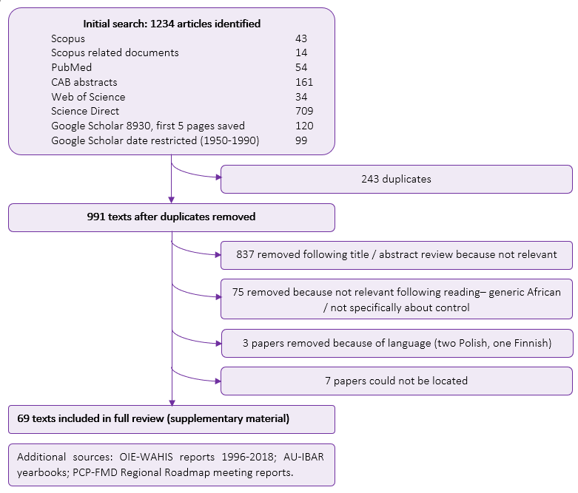
Figure 1: Summary of results: database searches and sorting (full list available in Annex A: supplementary data).

Table 1: Important events identified during literature review
Date | Event
1931 | FMD virus is first isolated in Kenya
1957 | FMD research institute established in Nairobi
1964 | Kenyan independence
1968 | First phase of the Compulsory Vaccination Programme initiated
1970 | Second phase of the Compulsory Vaccination Programme initiated
1974 | Third phase of the Compulsory Vaccination Programme initiated
1990 | The Compulsory Vaccine Programme is no longer operational  The joint venture for vaccine production within the Wellcome Trust FMD research institute in Nairobi becomes the Kenya Veterinary Vaccines Production Institute (KEVEVAPI), a parastatal organisation, and the rest is developed into the national FMD laboratory
1994 | Privatisation of veterinary services in Kenya is initiated
2012 | The Progressive Control Pathway (PCP) for FMD is launched and the first regional workshop to develop a “Long-Term Roadmap for the Progressive Control of FMD in Eastern Africa” is held
2013 | Devolution of agricultural services within Kenya to county level governance
2014 | Second East African Roadmap Meeting on the FMD-PCP held in Kigali, Rwanda
2018 | Third East African Roadmap Meeting on the PCP-FMD held in Entebbe Uganda

  - 3.2 Pre-independence
FMD virus was first isolated in Kenya in 1931 (Crees, 1982) although infection had been known previously, with some serotypes probably introduced by foreign settlers (Muriithi, 1976).
In the mid-1950s FMD was endemic and notifiable in Kenya (Beaton, 1956; Crees, 1982; Department of Veterinary Services, 1955). However, despite movement restrictions enforced by police and some preliminary attempts at vaccination, the British government had difficulties in controlling FMD. This was because mass vaccination was more difficult in kenya’s dispersed, often small-scale, farming systems than in the large accessible herds common in Europe, and movement controls, or animal-free zones around an outbreak, were difficult to enforce (Department of Veterinary Services, 1955).
At this time the farming systems were discussed as two distinct populations, ‘settled’ or ‘European’ and ‘African’ areas of production and dwelling. Language used to describe interactions between the indigenous population and colonial incomers corroborates this using descriptions that would not be acceptable today, for example, the advice that "the movement of African employees should be controlled" in the case of an FMD outbreak (Department of Veterinary Services, 1955), or that “uncooperative movement of Africans” was responsible for disease spread (Beaton, 1956). In contrast, large-scale farming (the preserve of the European settlers) was described as owned by “enlightened individuals” (Crees, 1982). Disease was not thought to affect smallholder African farmers significantly due to low yields and the use of indigenous breeds that exhibit only mild clinical signs (Beaton, 1956; Crees, 1982), although it was recognised that animals kept in pastoralist societies would suffer in times of drought, inflating any losses that did occur due to FMD (Department of Veterinary Services, 1955). Economic impact was primarily attributed, although not quantified, to interruption of meat supply within colonial settler communities (MacOwan, 1958) and risk to continuing butter exportation (Beaton, 1956). Therefore the European-owned herds that the government was primarily concerned with were felt to be at risk from the “African”-owned cattle surrounding them (MacOwan, 1956).
Although difficult to enforce, official movement controls were in place in the 1950s (Beaton, 1956). FMD vaccine use was seen as a mechanism to reduce losses associated with FMD as wider control was not thought to be feasible, and was implemented on a voluntary basis (Department of Veterinary Services, 1955). The government report of 1955 (MacOwan, 1956) describes that “vaccination … tends to produce patchy immunity over these areas and to maintain smouldering infection in many districts”. Some ranchers practiced rudimentary autologous vaccination when an outbreak occurred in order to hasten the disease’s course within their herd (Beaton, 1956; Department of Veterinary Services, 1955) and once available (from 1954 (Muriithi, 1976)) other farms would import vaccine from Europe despite a high financial outlay, collaborating with neighbours to create informal vaccination zones (Beaton, 1956; Chema, 1975). This became more expensive and impracticable once more serotypes emerged as multivalent vaccines were not available. However, twice-yearly vaccination seemed to protect adequately against disease, especially if all farmers within an area followed the same protocol (Muriithi and Henderson, 1969).
In 1931, serotype O was identified at Pirbright (Crees, 1982). There is some confusion over when serotype A was first identified; Crees (1982) states this occurred in 1931 although the World Reference Laboratory at Pirbright’s first record from Kenya of serotype A is from 1952. These serotypes remained predominant into the 1950s, with reported disease frequency increasing (MacOwan, 1956). Tension between authorities in Africa and Europe existed as it was apparent that incursion of SAT serotypes represented a risk in Kenya. Since these serotypes were not present in Europe, European institutes were reluctant to perform research for vaccine development on these serotypes in view of the risk of virus escape from laboratory facilities (Department of Veterinary Services, 1955).
In 1957, both SAT 2 and C serotypes of FMD virus were reported in Kenya for the first time (MacOwan, 1958). SAT 2 occurred in a pastoralist area of Samburu, in the north Rift Valley area, but was controlled through creation of a cattle-free zone, rigorous quarantine and movement controls of both livestock and wild animals and their products; no effective vaccination was available (MacOwan, 1958). Later in 1957 the first outbreak attributed to serotype C occurred. This time a vaccine was available (imported from The Netherlands) and was used to positive effect during a ring vaccination campaign and quarantine (MacOwan, 1958). At the same time, outbreaks caused by O and A were also happening, complicating disease control. Approximately a million more animals were vaccinated against these serotypes in 1957 compared to 1956 (MacOwan, 1958).
SAT 2 reappeared in Samburu in 1959 (MacOwan, 1960). This outbreak had a significant effect on meat marketing in the country, despite being in an area distant from commercial farms. Although sheep and goats were allowed out of the affected zone, all cattle were held stationary for a period of nine months (MacOwan, 1958). The African Livestock Marketing Association had approximately 6,000 cattle in holding grounds within the affected area. Once grazing was exhausted management of these animals became difficult. Local ‘field’ abattoirs were used to slaughter some animals; but this extended period of quarantine had knock-on effects for farmers from other areas looking to purchase immature stock (MacOwan, 1958). In 1960 the first outbreak of SAT 2 in a commercial (‘settled’) herd occurred in Kenya. By this time an experimental vaccine had become available, which was used for the outbreak (Galloway, 1962). Extensive local vaccination of 80,000 animals appeared to limit FMD spread, which was confined to three local farms, although some further instances of infection were recorded, and the field strain was a different type to that used in the vaccine (Galloway, 1962). Vaccine trials were coordinated by the Pirbright Institute in the UK, and difficulties in matching vaccine and field strains were becoming apparent, compounded by a reduced immune response following vaccination in indigenous breeds compared to European breeds (Mowat and Prydie, 1962). This work concluded that “the ideal vaccine which will stimulate a level of immunity in all types of cattle sufficiently high to protect against severe challenge by a wide variety of related strains may be difficult to achieve” (Mowat and Prydie, 1962). FMD was seen as “the most important problem” in the veterinary report from Kenya in 1960 (MacOwan, 1961).
  - 3.3 Independence and establishing local vaccine production
The awareness and importance of FMD precipitated a dialogue between the Government’s Department of Veterinary Services and the Kenya National Farmers’ Union (KNFU), who requested that a compulsory vaccination disease control programme was initiated (Muriithi and Henderson, 1969). The government declined this request with the justification that it would be too expensive, imported vaccine produced insufficient immunity against the field strains present and that without a coordinated approach with neighbouring territories (which was not forthcoming) the programme would be unlikely to work (Muriithi, 1976; Muriithi and Henderson, 1969). Despite this, in areas of the country where commercial farming practices were the norm, predominantly in the Rift Valley, control of disease spread was managed by stringent movement control and quarantine in the face of an outbreak (Muriithi and Henderson, 1969), alongside the vaccination practised by individuals described previously.
The local production of vaccine, which was more affordable and tailored to the field strains present in Kenya, was seen by both national and international policy makers as a necessary step towards a national disease programme (Beaton, 1956; MacOwan, 1957). In 1957 the Wellcome Trust, a UK-based research charitable organisation, gave £80,000 (equivalent to US$1,890,538 in 2020) to the Kenyan Government in order to create an FMD Research Institute at Embakasi, Nairobi (MacOwan, 1958). By 1964, this institute was producing vaccine from local strains: bivalent O /A and monovalent C and SAT 2 vaccines (Anon, 1969a; Muriithi and Henderson, 1969).
In 1964, Kenya became independent. The structure of the veterinary services was initially unchanged; these were largely publicly run, although the department no longer reported ‘settled’ and ‘African’ areas (Anon, 1969a). Multiple training programmes were developed to support an indigenous workforce, although the veterinary department was generally understaffed (Anon, 1969a; MacOwan, 1958). FMD was still frequently reported; evidence of serotypes O and A still dominated when serology was undertaken but infrequent outbreaks of both C and SAT 2 were also identified (Anon, 1969a, 1969b). Local production of vaccine changed the landscape of FMD control and allowed the government to initiate a phased and geographically-restricted Compulsory Vaccination Programme (CVP), where vaccination would be compulsory for all cattle and only lightly subsidised by the government (Chema, 1975).
  - 3.4 Compulsory Vaccination Programme – phase one
The Kenyan CVP had three phases (Chema, 1975) (Table 2). The first was initiated in 1968, covering three regions (Laikipia, Nakuru and Trans Nzoia) (Figure 2). These areas consisted of mainly European-style dairy and beef farming systems owned by ‘European’ farmers, who had to pay per head of cattle in the scheme. This payment covered routine vaccination against serotypes A and O every six months, with additional vaccination in face of an outbreak using the relevant serotype completely subsidised by the government (Muriithi and Henderson, 1969). These farmers were enthusiastic about the programme and were making enough from farming to justify its cost; in fact around 35% of these animals were already being vaccinated voluntarily (Chema, 1975).
Table 2: The three phases of the Compulsory Vaccination Programme (information from Chema, 1975).
Phase of CVP | Start year | Cumulative area (km²) | Cumulative cattle population | Cost
 |  |  |  | At the beginning of the CVP phase | Adjusted for inflation 2020
 |  |  |  |  | KSH | US$
1 | 1968 | 20,953 | 539,000 | 4.4 KSH/animal/ annum,  Government subsidy = 13% | 1,119 | 10.36
2 | 1970 | 34,983 | 1,309,100 | 4.5 KSH / animal / annum Government subsidy = 16% | 1,100 | 10.18
3 | 1974 | 74,460 | 2,209,600 | ~9 KSH / animal / annum  Government subsidy = 100% | 1,719 | 15.91

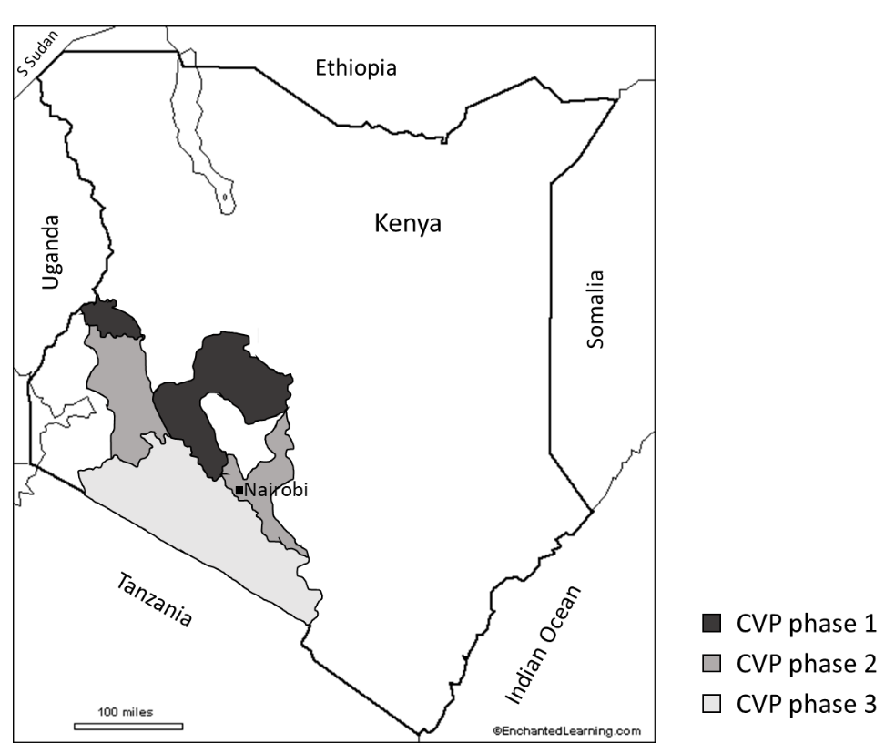

Figure 2: Geographical location of the three phases of Kenya’s Compulsory Vaccine Programme (from information in Chema, 1975).
The CVP was executed by government teams under veterinary supervision, every six months, for all cattle over three months old (Anderson et al., 1974; Capstick, 1972; Chema, 1975). Only cattle were vaccinated (Capstick, 1972; Chema, 1975). If an outbreak occurred, an 8km radius quarantine was imposed. Animals within this area would be revaccinated against the relevant serotype, which would be identified at the FMD Research Institute at Embakasi, Nairobi or the Pirbright Institute in the UK (Capstick, 1972). Quarantine would be lifted eight weeks after the last clinical case (Capstick, 1972). Reports of the CVP indicate a tightly regulated farming system, with cooperative farmers and stringent movement controls. Transport is described by rail or truck compared to trekking as the predominant method of animal transport in other areas (Capstick, 1972). The large resources needed in terms of transport equipment and personnel were seen as a major challenge to the success of the CVP (Muriithi and Henderson, 1969). Outside of the compulsory vaccination area, quarantine of the smallest relevant administrative subunit would be imposed in the case of an outbreak (Capstick, 1972).
The initial motivation for a formal control programme is poorly described, without clear strategic objectives laid out in the literature, although several authors describe the programme itself in detail. Improved access to markets, food security (due to protecting national protein supply, allowing improvement of the national herd and ensuring available agricultural traction) and a sense of generally improving animal health through establishing a cohesive infrastructure for disease control are identified as unprioritized drivers (Chema, 1975). In addition, it is likely that there was a strong European influence: at this time control was being established across the European continent after large economic losses associated with a continent-wide pandemic of serotype A in the 1950s (Leforban and Gerbier, 2002). Establishing the Wellcome-funded FMD Research Institute in Nairobi was a key enabler of the CVP. This externally, and in particular British, funded facilitation is likely to have played a role. Economic losses due to FMD within Kenya were identified and reportedly calculated in a mixed population of Zebu and exotic (dairy) cattle, although the only stated values available are percentage total losses attributed to milk reduction (46%), weight loss (35%), abortion and sterility (14%) and mortality (5%). These figures were used to prioritise dairy farming within prevention strategies as losses were estimated as four times greater in exotic breeds compared to Zebus (Chema, 1975).
  - 3.5 Compulsory Vaccination Programme – phase two
The second phase, starting in 1970, was designed to join-up the areas of phase one and extend east to include the Nairobi area (Figure 2); areas included Uasin Gishu, Kirinyaga, Mitiburi and Kikuyu divisions of Kiambu, the Nairobi area, Kakamega and Bungoma Settlements, parts of Machakos and Ngong Division of Kajiado district) (Chema, 1975; Metson, 1975). This area included more small-scale farms, and cooperatives that resulted from the Land Purchase Programme implemented after independence. Little vaccination had occurred in these areas prior to the CVP (Chema, 1975). There were concerns that this phase would be much more resource-intensive, as the smallholdings included would be less willing and less able to pay for the vaccination (Muriithi and Henderson, 1969). An additional problem was that by gathering these animals together for vaccination, they would be put at risk of other contagious disease, in particular East Coast Fever. Therefore a joint campaign against FMD and tick-borne disease (using dipping facilities) was proposed (Muriithi and Henderson, 1969). There was recognition at this stage of the high cost of current disease control measures (movement and quarantine) and that releasing the money used for this would allow it to be used in other livestock disease control plans, alongside opening trade opportunities (meat to Europe) and improving local production parameters (Muriithi and Henderson, 1969).
Outbreaks were obligatorily reported by the farmer to the local government veterinary department; this passive surveillance was the only method for disease identification (Capstick, 1972). In 1972 plans were underway to improve surveillance, with introduction of nationwide serosurveys and development of the FMD Research Institute laboratory’s facilities to improve identification of FMD subtypes (Capstick, 1972). The CVP was perceived as being successful in terms of reducing the number of outbreaks identified in commercial cattle, and at its peak some beef was being exported to Europe (Kitching, 1998). This success led to the perception that other species, whether wildlife or domestic (sheep, goats and pigs), were not important in the epidemiology of FMD in Kenya (Anderson et al., 1976; Chema, 1975; Paling et al., 1979).
Throughout this period, some outbreaks were reported in the areas covered in the first phase of the CVP, but far fewer than previously (28 between 1969-1971 compared with 157 between 1965-1967) (Capstick, 1972; Chema, 1975). Outbreaks were reported to be less clinically severe and resolved more quickly than those outside the CVP (Capstick, 1972). By 1973, 1.28 million cattle were covered by the CVP and only 2-5 outbreaks of O and A, the serotypes vaccinated against routinely, were being recorded annually (Anderson et al., 1974; Anon, 1974). Vaccine breakdown was thought to be responsible for these outbreaks due to new strain emergence and incomplete herd vaccination (Department of Veterinary Services Kenya, 1974).
However, there was awareness that other strains of FMD virus were spreading into this area, complicating vaccination requirements and escalating costs of control (Muriithi and Henderson, 1969). The first SAT 1 outbreak in Kenya was recorded in 1971 (Chema, 1975) in the south of the country, having originated in Tanzania (Chema and Rweyemamu, 1978). SAT 2 incursions to the north of the compulsory vaccination area had to be controlled by repeated vaccination (Anon, 1974). Serotype C outbreaks were occurring in an area where it had previously not been seen (Anon, 1974). Between 1964 and 1973, despite a drop in FMD in CVP areas, the frequency of FMD samples typed at Nairobi’s FMD Research Institute (assumed to represent the number of reported outbreaks) did not change (Chema, 1975). Different serotypes encountered appeared to have different epidemiological features; O and SAT 2 seemed to be geographically restricted, whereas A had a less well defined geographical distribution(Anderson et al., 1974). The CVP affected the predominant serotypes as well; the significantly lower number of serotype O outbreaks was attributed to a closer antigenic match of the vaccine, compared to serotype A (Chema, 1975). Optimistically it was hoped that after the first one or two years, reducing the vaccination frequency to once annually would continue to control disease in this area (Muriithi and Henderson, 1969) although this was later extended to five years (Chema, 1975).
  - 3.6 Compulsory Vaccination Programme – phase three
A bilateral agreement with the Swedish International Development Agency was reached in 1973, with Sweden agreeing to fund half of the costs involved in the third phase of the CVP, alongside Rinderpest control, until 1981 (Crees, 1982). Phase three extended the CVP area south to the border with Tanzania, starting in 1974 (Figure 2: areas included Isiolo, Baringo, Samburu, West Pokot, Elgeyo-Marakwet, Narok, Kajiado, Machakos and Mukogodo Reserve) (Chema, 1975; Metson, 1975). This area was inhabited mainly by pastoralists keeping animals in extensive systems that were very different to those found in the areas covered by the first two phases. These farmers were unlikely to pay for vaccination, despite a high frequency of FMD (Chema, 1975). This was one motivation for including the area, as many of the FMD outbreaks in the CVP zones were close to its border and were believed to have originated from it (Chema, 1975). Protecting the original areas of phases one and two was paramount as FMD control in western breed dairy cows, common in these areas, was seen as much more economically-efficient due to their high productivity and high susceptibility to FMD, as described above. In addition, the economic cost to the country due to FMD was high, with estimated annual losses of 2.37 million KSH (approximately US$4.79 million in 2020) due to FMD in non-vaccinated areas (Capstick, 1972). Multivalent vaccines were now available, so that vaccines containing either A/O/SAT 1/SAT 2 or A/O/C/SAT 1 could be used (Chema, 1975).
In 1975, commentary on the CVP as it was about to extend was positive (Chema, 1975). However, a baseline survey, designed to inform a five year plan to monitor this extension, revealed how this phase would be different to the ones that had preceded it (Metson, 1975). The population mainly belonged to Maasai communities for whom the infrastructure required for FMD control would represent a significant change to their lifestyle and livelihood, moving towards sedentary ‘ranching’-style animal management that would incur difficulties with grazing availability:
“The effects of quarantines imposed due to outbreaks of F.M.D, present the major impediment to commercial ranching. However, in addition to the other developments envisaged in Phase 2 of the Livestock Development Programme, social facilities such as schools, dispensaries, retailing centres and water schemes will have to be improved, if the settled, ranching life is to be made more attractive to the Maasai.” (Metson, 1975).
This, together with the fact that vaccination in this area would be completely subsidised by the government, would make the programme much more expensive for the public purse (Chema, 1975; Muriithi, 1976). The area, and number of animals included, represented an approximately 100% increase from the previous two phases (Chema, 1975). This cost was hoped to be recouped if export markets were opened, as this would up to double the value of both dairy and beef animals (Muriithi, 1976).
At the end of the 1970s, currency collapse in neighbouring Uganda and Tanzania promoted movement of animals into Kenya, where higher prices were available. This is likely to have played a role in transboundary disease spread (Crees, 1982). Results of a field survey published in 1979 that sampled animals in Laikipia and Narok revealed that no virus was isolated from cattle in Laikipia (serology was not performed as these animals were vaccinated), and in Narok 0.2-1% of cattle were positive for virus and 19-62% seropositive depending on serotype (O, A, SAT 1 and SAT 2 all present) (Anderson et al., 1979). The timing of the sero-survey is not given in the paper and the CVP is not discussed; but it is evident that this population of cattle would have fallen under phase three of the CVP and at this point was not vaccinated. Between 1972 and 1975 a significant SAT 2 incursion occurred, coming from the south and reaching areas that had been included in phase one (Ngichabe and Chema, 1982). This was not fully controlled until 1980 (Ngichabe and Chema, 1982). Some outbreaks within the area covered by the CVP were attributed to inadequate vaccination technique, in particular rushed vaccination and poor supervision (Crees, 1982). Throughout the vaccine campaigns of the CVP, 3500-6000 animals were being vaccinated daily (Crees, 1982). However, continuous evaluation during the programme showed that it was having no effect on production (milk, meat and hide production), with climatic variations being a much more important indicator of productivity (Crees, 1982).
  - 3.7 The 1980s and 1990s
In 1980, the cost of control had become ‘enormous’ (Ngulo, 1980). The disease protection zone included 3.5 million cattle, 2.2 million of which were routinely vaccinated, at a cost of 12.25 KSH or US$1.5 (US$5.07 in 2020) per animal vaccinated and 7.70 KSH or US$1.1 (US$3.72 in 2020) per head of cattle in the control area (these figures are in line with the costs in Table 2 when inflation is accounted for) (Ngulo, 1980). Seventy-six percent of expenditure was associated with routine vaccination: 16,570,000 routine vaccinations and 2,480,000 emergency doses had been given over four years (Ngulo, 1980). The radius for vaccination in the face of an outbreak had increased to 10km, occurring immediately, then again after 1 month and 5-6 months (Ngulo, 1980). At this point, movement controls and quarantines are not mentioned so their implementation cannot be commented on. Written by the government’s Department for Veterinary Services, an article in The Kenyan Veterinarian gives the impression that the annual budget of 27 million KSH for FMD control was difficult for the government to sustain. Rinderpest and contagious bovine pleuropneumonia were considered as higher priorities, and although the international ramifications of FMD were recognised, the difficulty of controlling disease in a population that largely consisted of smallholder farming outweighed this (Ngulo, 1980). Regional coordination was identified as necessary due to the role of transhumance in disease transmission, and recognition that it was a global problem also called for international cooperation (Ngulo, 1980). Difficulties in understanding the epidemiology of the disease, including carrier status and the changeable nature of field strains of virus and subsequent requirement for vaccine matching, added further complexity (Ngichabe and Chema, 1982; Ngulo, 1980).
In contrast, in 1982 a report discussing the history of the CVP calculated that the CVP was yielding an annual national benefit of 130 million KSH (US$15.5 million), with a benefit cost ratio of 4.55, and would eventually expand to include the entire country (Crees, 1982). This report, in contrast to Ngulo (1980), suggests that:
“at present vaccination rates the intensification of surveillance and of vaccine research and development could yield increased benefits of 56 million KSH (6.7 million USD), for a relatively modest but unspecified additional cost” (Crees, 1982).
Crees (1982) uses information from an economic evaluation, also externally-commissioned and written, that is no longer available and so its details cannot be commented on. The differences between Crees’ and Ngulo’s conclusions could represent an articulation of Kenya’s maturing self-regulation.
The vaccination campaign was still presented as positive by all, with reduced number of FMD outbreaks reported (Ngichabe and Chema, 1982), but complicated by the emergence of new endemic serotypes, in particular SAT 2 and new subtypes of serotype A (Ngichabe and Chema, 1982). Kenya had a good relationship between research, vaccine manufacture and disease control authorities, helping its vaccine campaign to be successful in reducing the frequency of FMD (Ndeti et al., 1982). The Wellcome Trust was responsible for staffing and strategic direction of the vaccine production laboratory, while it was co-funded by the Kenyan government (Ndeti et al., 1982). Although the CVP and its neighbouring regions encompassed 74% of the Kenyan cattle population, when the national situation was assessed no reduction in the number of FMD outbreaks confirmed by laboratory testing was seen (Ngichabe and Chema, 1982): it is not clear if this was due to differences in surveillance intensity, which there had been calls to improve. The highest number of FMD viruses typed occurred in the central zone, where there were high-yielding cattle and a greater number of veterinary officers (Ngichabe and Chema, 1982). Outbreaks seemed to occur on the edge of vaccination zones (Ngichabe and Chema, 1982). Vaccine strains used for serotypes C and SAT 1 remained unchanged from introduction to the early 1980s (Ndeti et al., 1982), whereas the vaccine for the serotype O was adjusted in 1978/9 (Ndeti et al., 1982). Vaccines against different strains of serotypes A and SAT 2 were available (Ndeti et al., 1982). These factors combined to emphasise the importance of surveillance and appropriate vaccine matching to monitor antigenic diversity of FMD viruses circulating in the field (Ndiritu et al., 1983). However, decreased government investment in both animal healthcare systems and FMD control compromised the efforts that had been made in the previous decades (Brangenberg and van Andel, 2011). This meant that despite high perceived benefits from FMD control, its capital cost was not available.
In 1982, four factors that pose challenges for FMD control in Kenya were identified: the presence of five serotypes in the country; that these serotypes have a diverse range of different strains; the existence of transboundary and informal animal movement, and sporadic use of vaccines (Ngichabe and Chema, 1982). As national demand for meat increased, export markets became less attractive (Rweyemamu, 1984). By the end of the decade, it appeared that the compulsory vaccination zone had dissolved. FMD was a “worse problem than rinderpest”, attributed to the many strains and serotypes circulating, although vaccination in the face of outbreaks was seen as successful (Kimengich, 1988). The public resourcing of veterinary services was under strain, and the change to private services was being tabled, due to rising and unsustainable personnel costs that reduced the budget available for the logistics of implementing animal health programmes (Kimengich, 1988).
The partnership between the Wellcome Trust and the Kenyan government was dissolved in 1990, and the FMD laboratory became publicly funded. As part of this transaction, the Kenya Veterinary Vaccines Production Institute (KEVEVAPI) was established as a parastatal institution. In 1994 a formal initiative by the Kenya Veterinary Association aimed to shift animal health services from the public to the private domain (Chema and Gathuma, 2004). The FMD control programme appears to have been a casualty of veterinary privatisation, as its control necessitates a universal and coordinated programme that includes vaccination and movement control, both of which usually require at least an element of public control (Leonard et al., 1999).
Little literature is available that describes the situation in the 1990s. An single outbreak in a herd of pigs in Nairobi was reported in 1991, causing the authors to question if FMD surveillance and control should be extended to include pigs (Munyua et al., 1991). In 1998 it was reported that “the situation has deteriorated with the breakdown of all components of the previous control programme” (Kitching, 1998). Despite increasing awareness among smallholder farmers and pastoralists about the impact of FMD on their animals, government support for the programme was withdrawn (Brangenberg and van Andel, 2011; Rweyemamu and Leforban, 1999). Additional reports of individual farm outbreaks were produced in local literature detailing, for example, that a quarantine of 35 days was imposed on a farm that experienced an outbreak (Mulei et al., 2001). In 1996 the FAO decided that FMD control was not an immediate target for international development (Rweyemamu and Leforban, 1999). Towards the end of the 1990s the number of reported outbreaks started to rise (Figure 3).
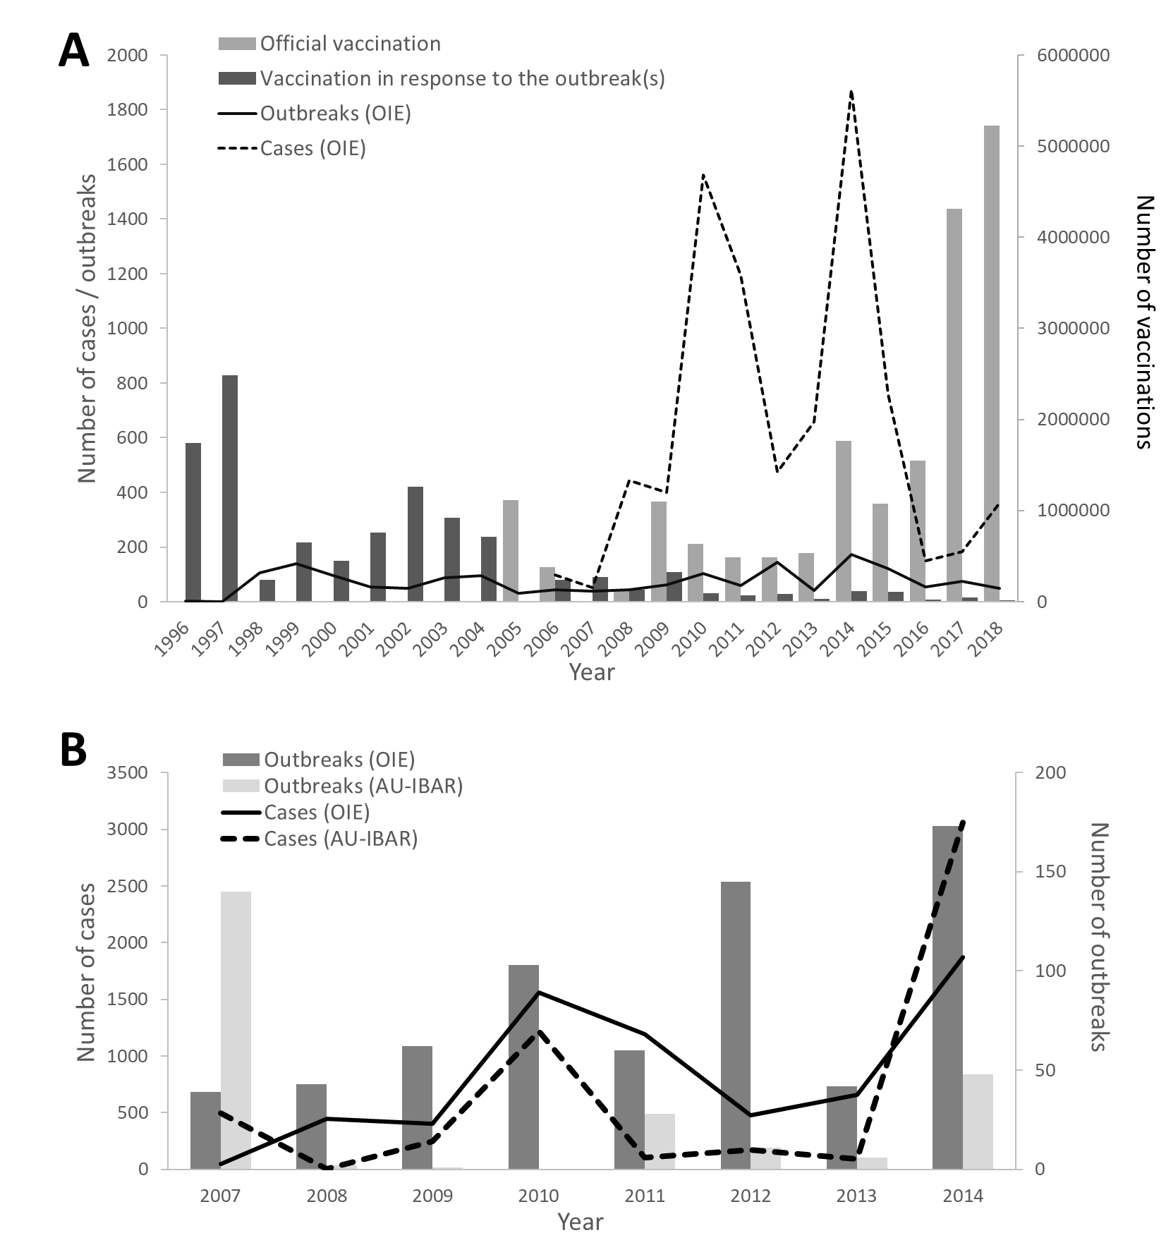
Figure 3: FMD vaccination and outbreak data for Kenya. (A) Data taken from OIE-WAHIS from 1996 – 2018. Data on official vaccination available from 2005 and on number of cases available from 2006. (B) Comparing data reported by OIE-WAHIS and AU-IBAR between 2007 and 2014.

  - 3.8 2000 to 2012
Passive surveillance was still the norm (Kanyari and Wandaka, 2005). The FMD laboratory used antigen detection enzyme-linked immunosorbent assay (ELISA) to analyse samples, making diagnosis more sensitive (Sangula et al., 2005), and understanding of the genetic evolution of viruses grew, focusing research on understanding the molecular epidemiology of FMD viruses (Sahle et al., 2007). This work supported the conclusions that transmission from wildlife was unlikely to be important within East Africa, as molecular epidemiology described transmission pathways that followed cattle movement across the African continent (Vosloo et al., 2004). Researchers differed on the role of vaccination in shaping FMD virus evolution (Balinda et al., 2010; Wekesa et al., 2015a), but the shifting nature of FMD serotypes and strains may have contributed to the failure of earlier vaccination policies. For example two historical and divergent strains of SAT 2 were identified in 2010, one extinct probably due to vaccination but the other emerging in the face of vaccination (Sangula et al., 2010). The use of inactivated vaccinations may also have played a role in repeated SAT 2 outbreaks (Sahle, 2004). Similar patterns were seen for serotypes O and A (Balinda et al., 2010; Wekesa et al., 2014b). In 2002, SAT 1 started to remerge after approximately 10 years (Brangenberg and van Andel, 2011; Kimani et al., 2005) resulting in a widespread outbreak of this serotype in 2010 (Wekesa et al., 2014a). These analyses provide a scientific basis to the conclusions of the Department of Veterinary Services in the 1950s that vaccination could contribute to maintaining disease endemicity (MacOwan, 1956).
However, this research was hampered as many outbreaks were not reported. Even when they were, appropriate material was not always submitted to for laboratory testing (Sahle et al., 2007), and the long-term storage of historical samples used in research may have been affected by intermittent power supply to the laboratories (Sangula et al., 2011). The patterns of strain variation identified confirmed that buffalo, despite being infected with the SAT serotypes of FMD virus, had a small role, if any in disease transmission, which was likely to have been maintained by contact between livestock species (Sahle et al., 2007). This highlighted the need for continuous monitoring of strains of FMD virus to ensure that comprehensive vaccine programmes were designed (Sangula et al., 2010) and emphasised the need for regional control as different strains and serotypes were mapped across the eastern African region (Balinda et al., 2010; Sahle et al., 2007). Serotype C was last isolated in Kenya in 2004 (Brangenberg and van Andel, 2011), although authors since have questioned whether it is still circulating (Sangula et al., 2011; Tekleghiorghis et al., 2016). In this time period, outbreak investigations were conducted by government vets, during a process that was supported by FAO training (Brangenberg and van Andel, 2011). Virus identification would be carried out at the FMD laboratory in Embakasi, with definitive PCR typing performed at Pirbright in the UK (Brangenberg and van Andel, 2011). Trivalent vaccination was used in some areas where quadrivalent vaccination was recommended (Chepkwony et al., 2012). Overall seroprevalence of FMD in Kenyan cattle in 2010 was estimated to be 52.5% (Kibore et al., 2013), which is similar to the sero-prevalence of 53% recorded in pigs at the same time (Wekesa et al., 2014a). Additionally it appears that some pigs were routinely vaccinated (Wekesa et al., 2014a).
At this time there was increasing interest in participatory methods within epidemiology (Mariner et al., 2011) and recognition of the epidemiological and socio-political importance of pastoralist systems. In 2007, the seroprevalence of FMD within cattle belonging to pastoralists living in the Somali ecosystem of northern Kenya was up to 45% (Chepkwony et al., 2012). These systems were recognised to have specific disease control requirements that were different to other systems, due to under-reporting, poor infrastructure for surveillance and animal healthcare, frequent border crossings and substandard application of vaccination, and therefore bespoke disease control strategies were recommended (Chepkwony et al., 2012; Onono et al., 2013).
Despite continued awareness and characterisation of FMD as an important transboundary livestock disease, control efforts that were put in place were not working (Balinda et al., 2010). The AU-IBAR reports show that Chief Veterinary Officers (CVOs) in Africa were making open requests to the OIE to develop FMD guidelines that were appropriate for the African continent and that considered the predominance of pastoral systems. In particular they requested the recognition of controlled slaughter rather than culling campaigns to allow animal consumption, and clarification of the roles and responsibilities of the different international and national agencies involved in animal disease control (AU-IBAR, 2011, 2010). FMD was not the only important disease of livestock and its control risked diverting resources away from other, more immediately relevant diseases (Vosloo et al., 2002). At a local level, the challenges that smallholder farming systems present for disease control programmes were starting to be recognised, for example breaches in biosecurity following artificial insemination services and regular contact between animals from different premises (Brangenberg and van Andel, 2011). Control was still officially mandated as ring vaccination around individual outbreaks during this period of time (Sangula et al., 2011).
  - 3.9 Development of the Progressive Control Pathway for FMD to present
In 2012, the Progressive Control Pathway (PCP) for FMD (PCP-FMD) (EuFMD and FAO, 2012), a structured and internationally-used framework to support national control of FMD and progression to official recognition of disease-free status by the OIE, was presented as the central tool to be used by endemic countries at the launch of the FAO/OIE Global Strategy for FMD control (OIE and FAO, 2012; Figure 4).
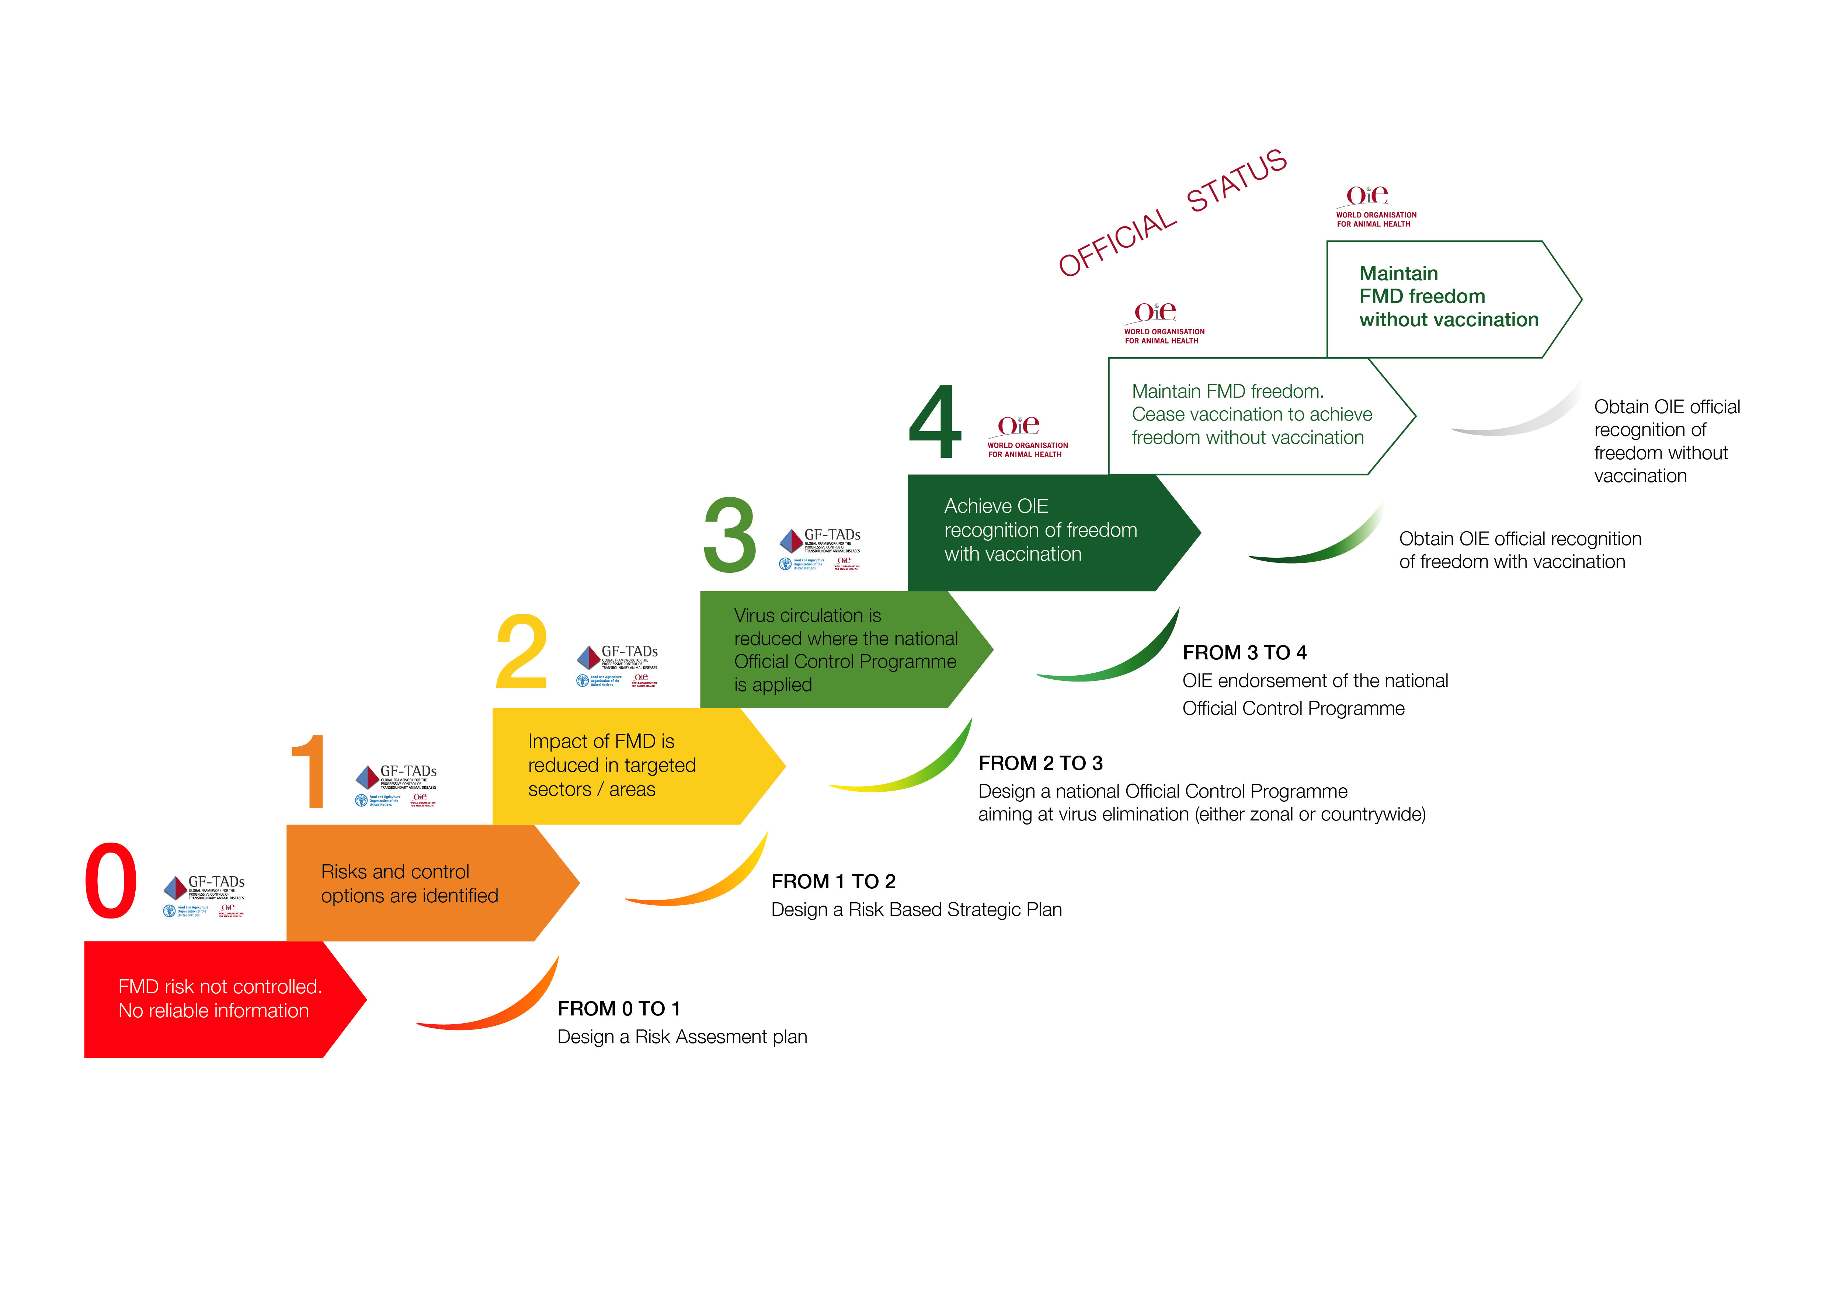
Figure 4: Schematic representation of the PCP-FMD (The EuFMD, FAO and OIE are acknowledged for the use of this figure).

At this time FMD was the fourth most commonly-reported livestock disease in Africa, and this strategy sought to address, surveillance, epidemiological investigation, weak laboratory capacity and the structure of disease control programmes on the continent to detect FMD (AU-IBAR, 2012; Namatovu et al., 2013). The scientific community hoped that the PCP-FMD would have positive development and conservation consequences across Africa through improving understanding of wildlife-livestock transmission, developing commodity-based trade and improving participation of farmers within disease control strategies (Ferguson et al., 2013). In a region where political instability and volatile markets are widespread, this common approach to disease control aspired to open up international markets (Ferguson et al., 2013).
An East African workshop resulted in a strategy for regional FMD control using the PCP-FMD (FAO et al., 2012). The PCP-FMD was introduced to the CVOs of East Africa, and the resources required for progression along it identified. For Kenya, a baseline situation was described where ring vaccination and quarantine were used to control outbreaks, with some preventative vaccination on dairy farms. Diagnostic samples were acquired in acute, subacute and chronic outbreak stages, pre- and post-vaccination and for research (Namatovu et al., 2013). KEVEVAPI, closely associated with the laboratory at Embakasi, was still responsible for producing most, if not all, vaccine used nationally, with serotypes O, SAT 1 and SAT 2 predominant. In 2012, Kenya aimed to move from Stage 1 (i.e. risk assessment) to Stage 2 (i.e. FMD impact is reduced) of the PCP-FMD in 2015 and Stage 3 (i.e. reduced virus circulation) in 2020 (FAO et al., 2012; Figure 4). However, in 2020 Kenya remains at Stage 1 (FAO and OIE, 2018) (although is expected to progress to Stage 2 imminently). The conclusions from the regional workshop’s report emphasise the need for collaboration with international agencies and development of mechanisms for regional coordination for countries at Stage 1 in the PCP-FMD in order to support their progression up the pathway (FAO et al., 2012). Development of stable, broad-spectrum vaccines were seen as an important component of regional control (Casey et al., 2014). Following implementation of the PCP in Kenya there were questions about the strains used during vaccine production and whether the work to ensure that these were matched adequately to field strains was carried out (Bari et al., 2014).
There was an increase in the number of outbreaks reported of serotype A in 2012 (Wekesa et al., 2014b). Although at this point work was beginning on the PCP-FMD, and this serotype was known to be diverse, the vaccine had not been matched to the field strain since 2001 and few resources were available for disease control (Wekesa et al., 2014b). Also in 2012, FMD outbreaks were described in commercial farms in Nakuru County. Control was initiated by the farmer, the government veterinary officer was immediately notified, and samples were taken to serotype the outbreak, diagnosed as SAT 2 (Lyons, 2015; Lyons et al., 2015). This herd had been vaccinated, highlighting concerns about the effectiveness of the vaccine, although whether this breakdown occurred due to inadequate vaccine matching, poor vaccine quality or problems in the vaccine supply chain was not clear. Despite evident awareness of disease, and expenditure on vaccination, biosecurity measures were poor, and this was compounded by the fact that most workers on the larger farm had their own smallholdings (Lyons et al., 2015). Vaccine security for FMD has been identified as important on a global scale as well as locally, with high quality, stable and matched vaccines a priority for control (Lloyd-Jones et al., 2017).
In 2014 AU-IBAR published their “Standard Methods and Procedures for Control of Foot and Mouth Disease in the Greater Horn of Africa” (AU-IBAR, 2014). This comprehensive document was designed to “support the entry and progression of the GHoA [Greater Horn of Africa] countries in the FAO-OIE Progressive Control Pathway for the foot-and-mouth disease (PCP-FMD)”; however apart from this mention in the objectives the PCP is not mentioned again and therefore the way in which these two documents complement each other is not clear. The AU-IBAR guidelines present gold standard protocols with little information about how different countries could and should prioritise activities, depending on the resources that they have available. Issues associated with this resource allocation included difficulties in imposing movement restrictions in pastoralist communities, lack of regional laboratory capacity, lack of a secure cold chain infrastructure and the economic resources needed for appropriate vaccination in face of an outbreak, especially when smallholders were involved (Brito et al., 2017). Recent research suggests that proactive vaccination, taking into account climatic and regional considerations may be effective in combating outbreaks, and is a more appropriate form of control compared to the fencing solutions that have been used in South Africa (Casey-Bryars et al., 2018). In the last couple of years, the number of routine vaccinations performed by the government has increased dramatically, initiated by a rising number of cases that subsequently decreased, although the number of outbreaks has remained relatively constant (Figure 3). This coincides with the devolution of agricultural services within Kenya to county level governance in 2013. Devolution will make widespread proactive vaccination across county borders more challenging, as coordination between different counties will be needed for these campaigns to be effective.

Challenges and factors of success
  - 4.1. Identifying the key objectives of FMD control programmes
Key components of disease control programmes include the identification of clear aims and objectives, that are built from strategic goals and from which explicit activity plans can be built. Alongside these, defined monitoring and evaluation plans and economic analyses can be developed. This manuscript describes two well-coordinated FMD control programmes that have been operational in Kenya: the CVP and the PCP-FMD.
Specific strategic objectives are poorly defined for the CVP. It may be that some relevant documentation is missing due to the nature of this search and the time that has elapsed since this programme was in place, for example, relevant documents may exist on personal office shelves or in uncatalogued libraries in Kenya or the UK. A “Continuous Evaluation Team” was in place to appraise the CVP (Crees, 1982); unfortunately evaluation documents produced were not able to be located and their results not published. Published evaluations should be part of the policy cycle. Where reports of progress over time are available, it is not possible to match the number of isolates reported for laboratory diagnosis with the number of outbreaks, number of cattle affected or differences in how disease is reported in different parts of Kenya.
Additionally, scientific reporting methods and in particular animal health economics have progressed in the intervening time span. Nowadays it would not be acceptable to publish economic results without their accompanying analyses. For this reason, the figures reported in the literature are difficult to reconcile with each other: annual losses due to FMD are reported as 2.37 million KSH in 1975 (Chema, 1975), costs associated with control are 27 million KSH in 1980 (Ngulo, 1980), and an annual national benefit of 130 million KSH is identified in 1982 (Crees, 1982). These values do not seem compatible with each other, but with minimal information about how they are calculated it is difficult to explain their discrepancies. This lack of transparency may hide how these figures reflect the different motivations of their authors; for example, lobbying the government for increased funds or reporting to a donor agency. Also, current good practice would require detailed logistical and scientific information about how disease outbreaks were defined and reported. However, key objectives or aims other than generic goals to control FMD in commercial cattle belonging to settler communities are not identified for the CVP in the literature included in this review.
The PCP-FMD has a clear methodology and procedure for defining clear aims and objectives, monitoring and evaluation, and socioeconomic analyses. One pre-requisite for moving from Stage 1 to Stage 2 of the PCP-FMD is the development of a “risk-based strategic plan”. Different strategies can be identified based on different stratifications of context-specific risk, for example based on differences between regions or farming systems.
Throughout this history, broad statements are often made about the economic impact of FMD in Kenya, especially on trade. Initially FMD control sat within a livestock sector that represented important economic interests for Kenya. Over time, although still important, other issues have risen to compete with the resources available for public spending. For example, increased trading opportunities were a result of the CVP. However, currently Kenya is a net importer of most dairy and beef products and therefore this is unlikely to be a significant benefit of FMD control. Recent analyses, to these authors’ knowledge, have not been conducted on the macroeconomic effects of FMD control in Kenya. These evaluations are even more important given the need for efficient and effective resource allocation in a system with very many competing demands. However, investment is required into the evaluation process itself, which must consider many production systems for which impact and benefits may be different.

  - 4.2 The legacy of a colonial past
The history of livestock disease and colonialisation in Kenya are interlinked, as white settlers sought to create profits from affluent farming areas in East Africa. Colonial structures of disease control and segregation of different farming systems and cultures has an impact on how FMD, and other diseases, are approached today (Waller, 2004). Several authors have discussed the way in which modern disease control measures have been imposed in Africa following colonialisation and how post-colonial influences following independence have shaped these measures up until the present time. The narrative in this article runs alongside changes in Kenyan dairy policy, a sector with powerful influence (Kaitibie et al., 2010) which resulted in significant market variations for all dairy-producing farmers, in turn having an effect on the economics of disease control. FMD is inextricably linked to politics, as high-income countries and large private companies use their influence and power to impose disease control. In some parts of the world this has resulted in effective disease control, for example Indonesia, the Philippines and much of South America. However, there are other examples where disease control programmes, imposed onto historically-colonialised communities, have run into challenges as they are inappropriate for the local farming systems. These disease control programmes have often been vehicles for broader political agendas, for example, imposing physical boundary infrastructure between Mexico and the USA in the late 1940s (Alvarez, 2019) and across countries in southern Africa (Scoones and Wolmer, 2007). This is echoed in the example of Kenya, where the call for FMD control originated from colonialised areas, was embedded in a veterinary service structure set up by the British, and in the present day is promoted heavily by international animal health agencies that are headquartered in Rome (FAO and OIE). The commentary in the Kenyan Veterinarian by Wellington Ngulo, the Deputy Director of Livestock Development at the time, articulated this:
“The control of FMD is a matter of time for it is unlikely that the world will choose to stay with the disease forever. Because of the highly infectious nature of FMD, for as long as there is the disease in Africa, the rest of the world will be insecure, and control measures will therefore increasingly become a subject of international concern” (Ngulo, 1980).
Within this review, the majority of the literature has at least one author from either Pirbright, the Kenyan Directorate of Veterinary Services or the FMD laboratory at Embakasi. This is especially so in the earlier references and applies to almost all prior to 1988. Undoubtedly these authors have an excellent situational understanding of disease and may well be the most appropriate commentators. However, there is a risk that closely-related institutions reinforce the same ideas and opinions, and the lack of outside opinion may result in unconscious bias. Additionally, people involved in the intricacies of epidemiology and disease characterisation may not be aware of the socio-political aspects of the disease. In the future, it is advisable that disease control programmes have an element of outside scrutiny as this may make them more robust. It is also an important component of maintaining an unbiased historical record.
  - 4.3 What changes and what stays the same?
From this review it is clear that FMD epidemiology has been influenced by disease control interventions, as described in the definition of historical epidemiology presented in the introduction section. In particular, the changing structures of farming and animal healthcare systems, and how these changes have shaped the disease control are discussed in more detail below.
In 2016, the challenges on FMD in Africa were articulated by Tekleghiorghis et al. (2016):
"The most significant problems are: (i) presence of multiple FMD virus serotypes having great genetic and antigenic diversity, which makes the application of vaccine challenging, (ii) involvement of wildlife (African buffalo) in maintenance of the virus and disease transmission with the three SAT (1–3) serotypes, (iii) poor quality vaccines having low stability and lacking matching with field strains, (iv) unregulated cross-border animal movement for grazing, water and trade practices, (v) poor veterinary services and inadequate infrastructure, and (vi) inadequate data on FMD epidemiology."
These are largely unchanged from challenges described thirty years or more previously. The reasons for this are likely to be a combination of inherent epidemiological factors, and factors relating to the infrastructure and regulatory capacity of disease control. These challenges have been amplified over time: biological risk factors have become more complicated as the predominant production systems have changed and small-scale farming has become the norm. Changes to the structure and the governance of veterinary services are likely to be contributing factors; a common theme throughout the literature is that animal health is under-resourced, making disease control programmes difficult to implement. Parastatal production of vaccine at KEVEVAPI has supported integration of matched vaccine supply into the public disease control system, although other private pharmaceutical companies do not have vaccine products on the Kenyan market. Devolution has shifted disease regulation to a local level, increasing the incentives for control. However, the nature of FMD makes such control difficult within the geographically-restricted region of a county. Furthermore, the OIE and FAO's interest in FMD control has changed over time; from being a disease to which little importance was attributed in Africa, to a priority with specific strategic goals for the EuFMD identifying “sustained progress of the GF-TADS Global Strategy against FMD” as one of three goals in its latest strategy (EuFMD and FAO, 2020), with regular activities in sub-Saharan Africa.
Effective movement controls are very difficult to implement in modern Kenya. Throughout the history of FMD control, it has been standard practice to allow continued access to communal facilities (for example watering points) as well as normal pastoral activities (Crees, 1982). The role of law enforcement agencies has changed, with ineffective fines and a widening remit of the police service (Crees, 1982). It is important to recognise that this is occurring, especially when reports and scientific literature mention that movement restrictions are in place. The endemic nature of FMD in Kenya is likely to be maintained while farmers are grazing animals communally and over areas that are not subject to clear boundaries, for example roadsides, and when this management is unaffected by official movement controls. A regional eco-system approach may be the most advantageous from an epidemiological perspective. The political consequences however must be considered, as Kenya will want to stay competitive within regional East African meat and milk markets. New transboundary disease control efforts (for example those associated with peste des petits ruminants, PPR) may open opportunities for enhanced FMD control. Commodity-based trade offers additional potential for developing livestock product markets where transboundary diseases are endemic (Thomson et al., 2004).
FMD is not the only disease affecting livestock in Kenya. Rinderpest and tick-borne disease control were both included as parallel objectives with phase three of the CVP, and public vaccination is currently often performed at communal dips. However, comorbidities are not explicitly included in discussion of disease control strategies included in this review. Taking comorbidities into account, and aligning animal health improvement programmes with each other is likely to have a positive effect on both the occurrence of disease and the success of vaccination programmes.

  - 4.4 Outbreak reporting
Outbreak reporting and investigation are important for effective surveillance, and integral to Stage 1 of the PCP-FMD. There is little specific information about surveillance in Kenya in the literature, for example logistics and responsibilities, although a generic recommendation to improve surveillance is repeated often. Passive surveillance is heavily influenced by external factors, for example awareness of disease, motivation and barriers to report disease if penalties occur and competing priorities within the animal healthcare system. The resources used to implement FMD control programmes should be supported by active surveillance initiatives that are feasible, affordable, efficient and effective for the country and that include feedback mechanisms to farmers. An example of this would be testing for FMD in pooled milk samples, collected from dairy processors and cooperatives, which has been shown to be viable in Kenya (Armson et al., 2019). Following FMD identification, epidemiological investigation and research would be possible and allow clear definition of farm-level risk factors for disease, which is currently lacking. A clear picture of how risk factors are different between different farming systems, and interventions based on these risk factors, could then be developed.
Currently, different organisations (e.g. AU-IBAR and OIE) report different numbers of outbreaks: this is shown in Figure 3, and is reinforced in documents accompanying the PCP-FMD workshops, which state that there were 249 confirmed outbreaks in 2010, 128 confirmed outbreaks in 2011 (FAO et al., 2012), and 65 outbreaks in 2017 (FAO and OIE, 2018); different numbers again from those reported by OIE-WAHIS and AU-IBAR. A lack of consistent outbreak reporting will hamper surveillance and intervention efforts, because it results in insufficient understanding of current disease status. All values are likely to be gross under-estimates of the true number of FMD outbreaks, as the endemicity of all serotypes will result in a level of background noise that makes it difficult to know which are more or less prevalent within any particular time span. For example, a particular strain or serotype may appear dormant for a period of time, but this could be due to its presence within infrequently studied, or sampled, populations. Strategies to strengthen FMD outbreak reporting include mapping the evolutionary history of FMD viral strains to understand the epidemiology of different serotypes and strains (Balinda et al., 2010; Bari et al., 2014; Gizaw et al., 2020; Velazquez-Salinas et al., 2020). Additionally, an agreed outbreak definition would help to harmonise the reported FMD outbreak frequency across different platforms and increase the ability to identify trends over time.

  - 4.5 Beyond epidemiology: the socioeconomic system
The lessons learnt during the CVP can be put into good effect today. Even when vaccination was completely subsidised during the third phase it was unsuccessful, showing that cost is not the only consideration for farmers involved in disease control programmes. This third phase was implemented in a completely different farming system; with a different system of subsidy and doubling the number of animals that would need to be vaccinated. Socioeconomic evaluation at the time indicated that the Maasai farming systems were not significantly affected by FMD (Crees, 1982). Although there was reduced frequency of disease in the zones covered by phases one and two, disease was still present and with consistent emergence of new serotypes and strains. These factors likely combined to make the CVP unsustainable in the long term. Pastoralist systems are recognised to require different disease control strategies than sedentary farming; simply upscaling the existing programme in this case demonstrates why this is unlikely to work.
Public funding and implementation for FMD control has been the norm. The control programme has been less effective as veterinary services have become privatised, and the public and private economic impacts of disease have become less clear; this is particularly apparent as the Kenyan dairy industry has increasing numbers of smallholder farmers. Currently some vaccination is provided by government services in response to outbreaks, but is otherwise paid for on a private basis for farms that want to practice routine prophylaxis.
Different farming systems are associated with representative bodies that have different degrees of political power and activity. This is seen in the earlier phases of disease control, where the large commercial farms, generally owned by families descended from the colonial settlers, were the driving force in, and primary beneficiaries of, disease control. Dairy production in the Rift Valley continues to be practised by the political elite in Kenya. This has influenced the way in which FMD control programmes have been funded, designed and implemented. Where this control is extended to farmer groups that have different motivations for livestock ownership, for example pastoralists, existing control programmes may struggle.
Regional collaboration is often discussed as an important component of control in East Africa and there is much cross-border movement of animals into Kenya. The regional roadmap meetings for the PCP-FMD operate as a mechanism to convene those leading FMD strategy in the East African region, and their reports discuss activities that aim to strengthen laboratory capacities, but highlight weaknesses in consistent information sharing and resource availability (FAO and OIE, 2018). However, mechanisms for this collaboration is not a theme of discussion in the literature. Reporting how these regional collaborations work in practice would be a valuable addition to the scientific record.
4.6 The importance of an accurate historical record
Evaluating historical disease control programmes is often reliant on written records within peer-reviewed and grey literature. It is important to consider how this information survives over time: where it is stored, what is contained within it, who can access it and who is writing it. This review identifies vulnerabilities within the historical record chronicling Kenyan FMD control programmes of which researchers should be mindful when examining evidence available for past interventions, and when creating reference information for the future. The documents identified rarely provided details on control programme logistics, concentrating on technical aspects of disease epidemiology, or making broad statements on challenges faced in disease control rather than specific technical information. Critical discourse or detailed discussion on the root causes of these challenges was generally lacking. The most useful documents were stand-alone reports or contained within conference proceedings; several had very restricted availability. Although information produced today is more likely to be distributed electronically, there remains a risk of losing valuable resources if organisational information repositories are not open-access. Safeguarding a space for peer-reviewed accounts of the socio-political and logistical context within which disease control programmes are set will help ensure that an unbiased and non-siloed information repository exists. This will enable those working in relevant disciplines and sectors to frame research questions more comprehensively, ensuring better understanding of who benefits from disease control programmes, potential challenges and unintended consequences.

Acknowledgements

Many thanks to librarians at The British Library and Cambridge University Library who assisted with identifying and accessing the texts referenced in this review. Particular thanks to the intern at the OIE who digitised several articles from the Bulletin de l'Office International des Épizooties in response to our request.

Funding
This work is part of a PhD project that is jointly funded by the Royal Veterinary College and The Pirbright Institute

References
Alvarez, C.J., 2019. The U.S.-Mexico border and the 1947 foot-and-mouth-disease outbreak in Mexico. J. Southwest. https://doi.org/10.1353/jsw.2019.0039
Anderson, E.C., Anderson, J., Doughty, W.J., 1974. The foot-and-mouth disease virus subtype variants in Kenya. J. Hyg. (Lond). 73, 237–239. https://doi.org/10.1017/S0022172400024074
Anderson, E.C., Doughty, W.J., Anderson, J., 1976. The role of sheep and goats in the epizootiology of foot-and-mouth disease in Kenya. J. Hyg. (Lond). 76, 395–402. https://doi.org/10.1017/s0022172400055315
Anderson, E.E.C., Doughty, W.J.W., Anderson, J., Paling, R., 1979. The pathogenesis of foot-and-mouth disease in the African buffalo (Syncerus caffer) and the role of this species in the epidemiology of the disease in Kenya. J. Comp. Pathol. 89, 541–549. https://doi.org/10.1016/0021-9975(79)90045-8
Anon, 1974. The zoo-sanitary situation and disease control methods used in Kenya in 1973. Bull. l’Office Int. des Epizoot. 82, 503–506.
Anon, 1969a. Department of Veterinary Services Annual Report. Nairobi, Kenya.
Anon, 1969b. Republic of Kenya. Veterinary Department annual report 1966.
Armson, B., Wadsworth, J., Kibona, T., Mshanga, D., Fowler, V.L., Knowles, N.J., Mioulet, V., Reeve, R., King, D.P., Bachanek-Bankowska, K., Lembo, T., 2019. Opportunities for enhanced surveillance of foot-and-mouth disease in endemic settings using milk samples. Transbound. Emerg. Dis. 66, 1405–1410. https://doi.org/10.1111/tbed.13146
AU-IBAR, 2012. Pan African Animal Health Yearbook. Nairobi, Kenya.
AU-IBAR, 2011. Pan African Animal Health Yearbook. Nairobi, Kenya.
AU-IBAR, 2010. Pan African Animal Health Yearbook. Nairobi, Kenya.
Balinda, S.N., Sangula, A.K., Heller, R., Muwanika, V.B., Belsham, G.J., Masembe, C., Siegismund, H.R., 2010. Diversity and transboundary mobility of serotype O foot-and-mouth disease virus in East Africa: Implications for vaccination policies. Infect. Genet. Evol. 10, 1058–1065. https://doi.org/10.1016/J.MEEGID.2010.06.017
Bari, F.D., Parida, S., Tekleghiorghis, T., Dekker, A., Sangula, A., Reeve, R., Haydon, D.T., Paton, D.J., Mahapatra, M., 2014. Genetic and antigenic characterisation of serotype A FMD viruses from East Africa to select new vaccine strains. Vaccine 32, 5794–5800. https://doi.org/10.1016/j.vaccine.2014.08.033
Beaton, W.G., 1956. Summary of information on Foot and mouth disease in Africa south of the Sahara, 1951-55. Bull. Epizoot. Dis. Africa 4, 287–307.
Behnke, R., Muthami, D., 2013. The contribution of livestock to the Kenyan economy, IGAD Livestock Policy Initiative Working Paper.
Blacksell, S.D., Siengsanan-Lamont, J., Kamolsiripichaiporn, S., Gleeson, L.J., Windsor, P.A., 2019. A history of FMD research and control programmes in Southeast Asia: Lessons from the past informing the future. Epidemiol. Infect. 147. https://doi.org/10.1017/S0950268819000578
Brangenberg, N., van Andel, M., 2011. Exotic disease focus: clinical and epidemiological investigation to exclude foot and mouth disease in cattle. Surveill. 38, 4–9.
Capstick, P.B., 1972. Republic of Kenya Notes of Provisional Agenda Item 1. XIIIth Conference of the O.I.E. Commission on Foot and Mouth Disease, Paris, 22-26 February 1972. 1. Comparative regional epidemiology of foot amd mouth disease and its effects on prophylactic measures. Bull. l’Office Int. des Epizoot. 77, 621–623.
Casey, M.B., Lembo, T., Knowles, N.J., Fyumagwa, R., Kivaria, F., Maliti, H., Kasanga, C., Sallu, R., Reeve, R., Parida, S., King, D.P., Cleaveland, S., 2014. Patterns of Foot-and-Mouth Disease Virus Distribution in Africa: The Role of Livestock and Wildlife in Virus Emergence, in: Johnson, N. (Ed.), The Role of Animals in Emerging Viral Diseases. Elsevier Inc, London, UK, pp. 21–38. https://doi.org/10.1016/B978-0-12-405191-1.00002-8
Chema, S., 1975. Vaccination as a method of Foot-and-Mouth Disease control: An appraisal of the success achieved in Kenya, 1968-1973. Bull. l’Office Int. des Epizoot. 83, 195–209. https://doi.org/10.1007/BF03030902
Chema, S., Gathuma, J.M., 2004. Kenya: the development of private services and the role of the Kenya Veterinary Association. OIE Rev. Sci. Tech. https://doi.org/10.20506/rst.23.1.1483
Chema, S., Rweyemamu, M.M., 1978. Selection of SAT 2 Foot-and-Mouth Disease vaccine strains for East Africa. Bull. l’Office Int. des Epizoot. 89, 887–898.
Chepkwony, E.C., Gitao, C.G., Muchemi, G.M., 2012. Seroprevalence of Foot and Mouth Disease in the Somali Eco-System in Kenya. Int. J. Anim. Vet. Adv. 4, 198–203.
Crees, H., 1982. A brief administrative history of Foot and mouth disease and its control in Kenya. Uppsala.
Department of Veterinary Services, 1955. Notes on Animal Diseases: VIII—Foot and Mouth Disease. East African Agric. J. 20, 140. https://doi.org/10.1080/03670074.1955.11664955
Department of Veterinary Services Kenya, 1974. Annual report, 1971. Kabete, Kenya.
EuFMD and FAO, 2012. The Progressive Control Pathway for FMD control (PCP-FMD).
EuFMD, FAO, 2020. Hold-FAST: A Europe secure from the threat of foot-and-mouth disease and similar transboundary animal diseases. New strategic plan, European Commission for the Control of Foot-and-Mouth Disease.
FAO, 2018. Livestock and livelihoods spotlight: Kenya. Cattle and poultry sectors.
FAO, OIE, 2018. Regional roadmap meeting III. Foot and Mouth Disease Progressive Control Pathway, Eastern Africa. Entebbe, Uganda.
FAO, OIE, AU-IBAR, 2012. Development of a Long Term Roadmap for the Progressive Control of FMD in Eastern Africa [WWW Document]. URL http://www.fao.org/fileadmin/user_upload/eufmd/docs/PCP_nairobi/Report.pdf (accessed 1.24.19).
Ferguson, K.J., Cleaveland, S., Haydon, D.T., Caron, A., Kock, R.A., Lembo, T., Hopcraft, J.G.C., Chardonnet, B., Nyariki, T., Keyyu, J., Paton, D.J., Kivaria, F.M., 2013. Evaluating the potential for the environmentally sustainable control of foot and mouth disease in sub-saharan Africa. Ecohealth. https://doi.org/10.1007/s10393-013-0850-6
Galloway, I.A., 1962. Results of the use of two live attenuated strain vaccines, Rho 1 (SAT 2 type) and RV. 11 (SAT 1 type), in controlling outbreaks of Foot and mouth disease. Bull. l’Office Int. des Epizoot. 57, 748–788.
Gizaw, D., Tesfaye, Y., Wood, B.A., Di Nardo, A., Shegu, D., Muluneh, A., Bilata, T., Belayneh, R., Fentie, A., Asgdome, H., Sombo, M., Rufael, T., Tadesse, F., Khan, F., Yami, M., Gelaye, E., Wadsworth, J., Knowles, N.J., King, D.P., 2020. Molecular characterisation of foot‐and‐mouth disease viruses circulating in Ethiopia between 2008 and 2019. Transbound. Emerg. Dis. tbed.13675. https://doi.org/10.1111/tbed.13675
Kaitibie, S., Omore, A., Rich, K., Kristjanson, P., 2010. Kenyan Dairy Policy Change: Influence Pathways and Economic Impacts. World Dev. 38, 1494–1505. https://doi.org/10.1016/j.worlddev.2010.06.008
Kanyari, P.W.N., Wandaka, F.K., 2005. A qualitative risk assessment of Kenya for Foot and Mouth Disease (FMD) for purposes of exportation of cooked pork frankfurters to USA. Kenya Vet. 29, 107–112.
Kibore, B., Gitao, C.G., Sangula, A., Kitala, P., 2013. Foot and mouth disease sero-prevalence in cattle in Kenya. J. Vet. Med. Anim. Heal. 5, 262–268. https://doi.org/10.5897/JVMAH2013.0220
Kimani, T.M., Mwirigi, J.W., Murithi, R.M., 2005. Financial Impact Assessment of Foot and Mouth Disease in Large Scale Farms in Nakuru District, Kenya. Kenya Vet. 29, 7–9.
Kimengich, J.M.C., 1988. Technical consultation on animal health problems in selected African countries. Kenya., in: Animal Health Problems in Selected African Countries. Report of a Technical Consultation in Lusaka, Zambia, 23-28 November 1987. Lusaka, Zambia, pp. 62–67.
Kitching, R.P., 1998. A recent history of foot-and-mouth disease. J. Comp. Pathol. 118, 89–108. https://doi.org/10.1016/S0021-9975(98)80002-9
Knight-Jones, T.J.D., Rushton, J., 2013. The economic impacts of foot and mouth disease - What are they, how big are they and where do they occur? Prev. Vet. Med. 112, 161–173. https://doi.org/10.1016/j.prevetmed.2013.07.013
Leforban, Y., Gerbier, G., 2002. Review of the status of foot and mouth disease and approach to control/eradication in Europe and Central Asia. OIE Rev. Sci. Tech. 21, 477–492. https://doi.org/10.20506/rst.21.3.1345
Leonard, D.K., Koma, L.M.P.K., Ly, C., Woods, P.S.A., 1999. The new institutional economics of privatising veterinary services in Africa, Rev. sci. tech. Off. int. Epiz.
MacOwan, K.D.S., 1961. Veterinary Department Annual Report, 1960. Nairobi, Kenya.
MacOwan, K.D.S., 1960. Kenya. Veterinary Department Annual Report, 1959.
MacOwan, K.D.S., 1958. Department of veterinary Services annual report 1957. Nairobi, Kenya.
MacOwan, K.D.S., 1957. Department of Veterinary Services annual report 1956.
MacOwan, K.D.S., 1956. Department of Veterinary Services Annual Report 1955. Nairobi.
Mariner, J.C., Hendrickx, S., Admassu, B., Knopf, L., Jones, B., 2011. Participatory epidemiology methods for foot and mouth disease surveillance, in: First OIE/FAO Global Conference on Foot and Mouth Disease: The Way towards Global Control, Asuncion, Paraguay, 24-26 June, 2009. Asunción, Paraguay, p. 35.
Metson, J., 1975. Discussion of the base line survey for the evaluation of the Foot and mouth disease control programme in Narok and Kajiado Districts. Nairobi., Kenya.
Miheso, M., 2018. Livestock vital in achieving “Big Four” plan [WWW Document]. Dly. Nation. URL https://www.pressreader.com/ (accessed 7.25.19).
Moher, D., Liberati, A., Tetzlaff, J., Altman, D.G., The PRISMA Group, 2009. Preferred Reporting Items for Systematic Reviews and Meta-Analyses: The PRISMA Statement. PLoS Med. 6, e1000097. https://doi.org/10.1371/journal.pmed.1000097
Mowat, G.N., Prydie, J., 1962. Observations in East African Cattle of the Innocuity and Immunogenicity of a Modified Strain of Foot-and-mouth Disease Virus Type S.A.T.2. Res. Vet. Sci. 3, 368–381. https://doi.org/10.1016/s0034-5288(19)31229-9
Mulei, C.M., Wabacha, J.K., Mbithi, P.M., 2001. Short-term economic impact of Foot and Mouth disease outbreak in a large Diary Farm in Kiambu District, Kenya. Kenya Vet. 22, 76–78. https://doi.org/10.4314/kenvet.v22i1.39523
Munyua, S.J.M., Nguhiu-Mwangi, J., Njenga, J., Karioki, D.I., 1991. An outbreak of Foot and mouth disease, and its socio-economic effects, in a herd of pigs in Nairobi, Kenya. Bull. Anim. Heal. Prod. Africa 39, 51–55.
Muriithi, E., 1976. Foot and Mouth Disease in Kenya, in: New Techniques in Veterinary Epidemiology and Economics, Proceedings of a Symposium. Reading, UK, pp. 195–199.
Muriithi, I.E., Henderson, W.M., 1969. Foot and Mouth Disease, in: Report of the Fourth Conference of the Royal Agricultural Society of the Commenwealth in Nairobi, Kenya, on 27th, 29th and 30th September, 1969.
Namatovu, A., Wekesa, S.N., Tjørnehøj, K., Dhikusooka, M.T., Muwanika, V.B., Siegsmund, H.R., Ayebazibwe, C., 2013. Laboratory capacity for diagnosis of foot-and-mouth disease in Eastern Africa: implications for the progressive control pathway. BMC Vet. Res. 9–19. https://doi.org/10.1186/1746-6148-9-19
Naranjo, J., Cosivi, O., 2013. Elimination of foot-and-mouth disease in South America: Lessons and challenges. Philos. Trans. R. Soc. B Biol. Sci. 368, 20120381. https://doi.org/10.1098/rstb.2012.0381
Ndeti, J., Ndiritu, C., Chema, S., Schermbrucker, C., Pay, T., Rweyemamu, M., 1982. The performance of FMD vaccines in Kenya, in: Proceedings of 16th Foot and Mouth Disease Conference of the International Office of Epizootics, Volume 1. Paris, France, pp. 51–68.
Ndiritu, C.G., Ouldridge, E.J., Head, M., Rweyemamu, M.M., 1983. A serological evaluation of 1979-1982 Kenyan foot-and-mouth disease type SAT 2 viruses. J. Hyg. (Lond). 91, 335–341.
Ngichabe, C., Chema, S., 1982. Effect of vaccination on the incidence of FMD in Kenya, 1960-1980, in: Proceedings of 16th Foot and Mouth Disease Conference of the International Office of Epizootics, Volume 2. Paris, France, pp. 639–654.
Ngulo, W.K., 1980. Strategies and costs of animal disease control with indications for research on Foot and Mouth Disease. Kenya Vet. 4, 27–28.
Nthiwa, D., Alonso, S., Odongo, D., Kenya, E., Bett, B., 2019. A participatory epidemiological study of major cattle diseases amongst Maasai pastoralists living in wildlife-livestock interfaces in Maasai Mara, Kenya. Trop. Anim. Health Prod. 51, 1097–1103. https://doi.org/10.1007/s11250-018-01790-1
Nyaguthii, D.M., Armson, B., Kitala, P.M., Sanz-Bernardo, B., Di Nardo, A., Lyons, N.A., 2019. Knowledge and risk factors for foot-and-mouth disease among small-scale dairy farmers in an endemic setting. Vet. Res. 50, 33. https://doi.org/10.1186/s13567-019-0652-0
Nyariki, D.M., Amwata, D.A., 2019. The value of pastoralism in Kenya: Application of total economic value approach. Pastoralism 9, 9. https://doi.org/10.1186/s13570-019-0144-x
OIE, FAO, 2012. The Global Foot-and-Mouth Disease Control Strategy: Strengthening Animal Health Systems through Improved Control of Major Diseases [WWW Document]. URL http://www.fao.org/3/a-an390e.pdf (accessed 10.30.18).
Onono, J.O., Wieland, B., Rushton, J., 2013. Constraints to cattle production in a semiarid pastoral system in Kenya. Trop. Anim. Health Prod. 45, 1415–1422. https://doi.org/10.1007/s11250-013-0379-2
Paling, R.W., Jessett, D.M., Heath, B.R., 1979. The occurrence of infectious diseases in mixed farming of domesticated wild herbivores and domestic herbivores, including camels, in Kenya. I. Viral diseases: a serologic survey with special reference to Foot and mouth disease. J. Wildl. Dis. 15, 351–358. https://doi.org/10.7589/0090-3558-15.2.351
Rweyemamu, M.M., 1984. Foot and mouth disease control strategies in Africa. Prev. Vet. Med. 2, 329–340. https://doi.org/10.1016/0167-5877(84)90076-X
Rweyemamu, M.M., Leforban, Y., 1999. Foot and mouth disease and international development, in: Margniorosch, K., Murphy, F.A.., Shatkin, A.J. (Eds.), Advances in Virus Research, Volume 53. Academic Press, California, USA, pp. 111–126.
Sahle, M., 2004. An epidemiological study on the genetic relationships of foot-and-mouth disease viruses in East Africa. University of Pretoria.
Sahle, M., Dwarka, R.M., Venter, E.H., Vosloo, W., 2007. Study of the genetic heterogeneity of SAT-2 foot-and-mouth disease virus in sub-Saharan Africa with specific focus on East Africa. Onderstepoort J. Vet. Res. 74, 289–299.
Sangula, A., Siegismund, H., Belsham, G., Balinda, S., Masembe, C., Muwanika, V., 2011. Low diversity of foot-and-mouth disease serotype C virus in Kenya: evidence for probable vaccine strain re-introductions in the field. Epidemiol. Infect. 139, 189–196. https://doi.org/10.1017/S0950268810000580
Sangula, A.K., Belsham, G.J., Muwanika, V.B., Heller, R., Balinda, S.N., Siegismund, H.R., 2010. Co-circulation of two extremely divergent serotype SAT 2 lineages in Kenya highlights challenges to foot-and-mouth disease control. Arch. Virol. 155, 1625–1630. https://doi.org/10.1007/s00705-010-0742-9
Sangula, A.K., Wekesa, S.N., Ng’ang’a, Z.W., Wamwayi, H.M., 2005. Detection of multiple serotypes of foot and mouth disease virus in stored isolates and the implications for control of the disease in Kenya. Kenya Vet. 28, 20–23.
Scoones, I., Wolmer, W., 2007. Land, landscapes and disease: The case of foot and mouth in southern zimbabwe. South African Hist. J. 58, 42–64. https://doi.org/10.1080/02582470709464744
Tekleghiorghis, T., Moormann, R.J.M., Weerdmeester, K., Dekker, A., 2016. Foot-and-mouth Disease Transmission in Africa: Implications for Control, a Review. Transbound. Emerg. Dis. 63, 136–151. https://doi.org/10.1111/tbed.12248
Thomson, G.R., Tambi, E.N., Hargreaves, S.K., Leyland, T.J., Catley, A.P., van’t Klooster, G.G.M., Penrith, M.L., 2004. International trade in livestock and livestock products: The need for a commodity-based approach. Vet. Rec. 155, 429–433.
Tricco, A.C., Langlois, E. V, Straus, S.E., 2017. Rapid reviews to strengthen health policy and systems: a practical guide [WWW Document]. URL https://apps.who.int/iris/bitstream/handle/10665/258698/9789241512763-eng.pdf;jsessionid=3F74D7D6E502930C71F3E91F71FCCB2C?sequence=1 (accessed 4.4.19).
Velazquez-Salinas, L., Mwiine, F.N., Ahmed, Z., Ochwo, S., Munsey, A., Lutwama, J.J., Perez, A.M., VanderWaal, K., Rieder, E., 2020. Genetic Diversity of Circulating Foot and Mouth Disease Virus in Uganda Cross-Sectional Study During 2014–2017. Front. Vet. Sci. 7, 162. https://doi.org/10.3389/fvets.2020.00162
Vosloo, W., Bastos, A., Sangare, O., Hargreaves, S., Thomson, G., 2002. Review of the status and control of foot and mouth disease in sub-Saharan Africa. Sci. Tech. Rev. OIE 21, 437–449.
Vosloo, W., Dwarka, R.M., Bastos, A.D.S., Esterhuysen, J.J., Sahle, M., Sangare, O., 2004. Molecular epidemiological studies of Foot-and-Mouth disease virus in sub-Saharan Africa indicate the presence of large numbers of topotypes: implications for local and international control, Open Session of the EUFMD Research Group. Chania, Crete.
Waller, R., 2004. “Clean” and “dirty”: Cattle disease and control policy in Colonial Kenya, 1900-40, Journal of African History. https://doi.org/10.1017/S0021853703008508
Webb, J.L.A., 2015. The historical epidemiology of global disease challenges. Lancet 385, 322–323. https://doi.org/10.1016/S0140-6736(15)60108-8
Wekesa, S.N., Muwanika, V.B., Siegismund, H.R., Sangula, A.K., Namatovu, A., Dhikusooka, M.T., Tjørnehøj, K., Balinda, S.N., Wadsworth, J., Knowles, N.J., Belsham, G.J., 2015a. Analysis of Recent Serotype O Foot-and-Mouth Disease Viruses from Livestock in Kenya: Evidence of Four Independently Evolving Lineages. Transbound. Emerg. Dis. 62, 305–314. https://doi.org/10.1111/tbed.12152
Wekesa, S.N., Namatovu, A., Sangula, A.K., Dhikusooka, M.T., Muwanika, V.B., Tjørnehøj, K., 2014a. A serological survey for antibodies against foot-and-mouth disease virus (FMDV) in domestic pigs during outbreaks in Kenya. Trop. Anim. Health Prod. 46, 575–581. https://doi.org/10.1007/s11250-013-0530-0
Wekesa, S.N., Sangula, A.K., Belsham, G.J., Muwanika, V.B., Heller, R., Balinda, S.N., Masembe, C., Siegismund, H.R., 2014b. Genetic diversity of serotype A foot-and-mouth disease viruses in Kenya from 1964 to 2013; implications for control strategies in eastern Africa. Infect. Genet. Evol. 21, 408–417. https://doi.org/10.1016/J.MEEGID.2013.12.006
Wekesa, S.N., Sangula, A.K., Belsham, G.J., Tjornehoj, K., Muwanika, V.B., Gakuya, F., Mijele, D., Siegismund, H.R., … A.S.-B. veterinary, 2015, U., 2015b. Characterisation of recent foot-and-mouth disease viruses from African buffalo (Syncerus caffer) and cattle in Kenya is consistent with independent virus populations. BMC Vet. Res. 11, 17. https://doi.org/10.1186/s12917-015-0333-9

