Control of Brucella melitensis in endemic settings: a simulation study in the Nile Delta, Egypt

Running title: Simulation of Brucella melitensis control

Yamen Mohammed Hegazy¹, David Schley², Anne Ridler³, Wendy Beauvais⁴, Imadidden Musallam⁵*, Javier Guitian⁵

¹ Department of Animal Medicine, Faculty of Veterinary Medicine, Kafrelsheikh University, Kafrelsheikh, Egypt.

² MS Society, University of Oxford, London, United Kingdom

³ School of Veterinary Science, Massey University, New Zealand

⁴ College of Veterinary Medicine, Cornell University, Ithaca, New York, USA

⁵ Veterinary Epidemiology, Economics and Public Health Group, Department of Pathobiology and Population Sciences, The Royal Veterinary College, Hawkshead Lane, Herts, U.K.

* Corresponding author: imusallam@rvc.ac.uk

Co-authors’ email addresses:

YH: yamen12@yahoo.com

DS: David.schley@msc.org

AR: A.L.Ridler@massey.ac.nz

WB: wab223@cornell.edu

JG: jguitian@rvc.ac.uk

ABSTRACT
Small ruminant brucellosis remains endemic in many low and middle-income countries (LMICs), where it poses a major economic and public health burden. Lack of resources to support long-term vaccination, inherent characteristics of small ruminant production systems such as mixing of different flocks for grazing and limitations of the vaccines currently available, which can induce abortion in pregnant animals, have all hindered the effectiveness of control programs. In the current study, the likely effect of different control scenarios on the seroprevalence of brucellosis among the small ruminant population in a hypothetical area of an endemic region was simulated using compartmental models. The model accounts for variability in transmission rates between villages and also simulates control scenarios that target villages with high seroprevalence. Our results show that vaccination of young replacement animals only can effectively reduce the prevalence of small ruminant brucellosis in endemic settings if a high vaccination coverage is achieved. On the other hand, test and slaughter alone is not a promising strategy for control of small ruminant brucellosis under husbandry practices typical of endemic low-resources settings. Furthermore, results show the potential success of some strategies requiring a relatively low overall vaccination coverage such as the vaccination of 50% of young replacements and 25% of adult animals each year. Control strategies selectively targeting high initial seroprevalence villages (p>10%) did not decrease the overall seroprevalence to acceptable levels in most of the examined scenarios. Scenario analysis showed that the efficacy of the simulated control strategies can be improved mostly by decreasing the proportion of between-village trade and also by improving the performance of the used serological tests and increasing vaccine efficacy.
KEYWORDS: Brucella melitensis, Brucellosis, disease control, epidemiological model, small ruminants, vaccination.

INTRODUCTION
Brucellosis is a bacterial zoonosis responsible for a high global burden due to recurring febrile illness and chronic disability in humans and productivity losses in livestock (WHO, 2010, OIE, 2019). Accurate data on the frequency of human infections are lacking because of underreporting and misdiagnosis (Jennings et al., 2007; Dean et al. 2012). In livestock, prevalence estimates are often biased and of narrow geographical coverage (Musallam et al. 2015). Despite these limitations, combining available data and expert elicitation, the World Health Organization (WHO) estimated that in 2010 there were more than 400,000 new cases of human brucellosis acquired through the foodborne route alone (Kirk et al., 2015; WHO, 2015). Moreover, using available data between 2006 and 2009, the World Bank ranked brucellosis among the top 10 diseases of cattle, sheep and goats in terms of livestock units lost (World Bank, 2011).
Ruminant species (cattle, buffaloes, sheep and goats) infected with Brucella spp. are the primary source of human infection, either through consumption of contaminated dairy products or direct contact with contaminated tissues or secretions from infected animals, in particular aborted fetuses, fetal membranes and vaginal discharges (Refai, 2002; Doganay and Aygen, 2003; Marcotty et al. 2009). The control of human brucellosis, therefore, depends on its control in ruminants, which can be based on vaccination and / or slaughter of infected animals (FAO, 1995; Glynn and Lynn, 2008). Some brucellosis control programs have been highly successful, in particular those targeting B. abortus infection in cattle in high-income countries (Cutler et al. 2005; Godfroid et al. 2013). However, progress in the control of B. melitensis in small ruminants (sheep and goats) has been disappointing except when intensive vaccination was strictly implemented (Ward et al. 2012).
In addition to resource constraints that preclude sustained vaccination, currently available Brucella melitensis vaccines suffer from a number of limitations that may explain the failure of control programs in endemic low-and middle-income countries (LMICs). The live Brucella melitensis Rev 1 strain, which is the most commonly used vaccine, does not provide sufficient protection across different ruminant host species, can cause human infection and induces abortions when administered to pregnant animals (Blasco, 2010). In 2016, in response to the global health challenge posed by B. melitensis in LMICs and the limitations of existing vaccines, international donors launched a $30 million prize for the development of a new vaccine that addresses the above shortcomings (AgResults and GALVmed, 2016; IDRC, 2017).
A common characteristic of most settings where B. melitensis is endemic at high levels is the existence of production systems that allow regular mixing of small ruminants from different households/flocks (Aidaros, 2005). Inability to regulate animal movement is likely to be a limiting factor for the effectiveness of a brucellosis control program (Corbel, 2006). Others include the inappropriateness of some control strategies given the baseline level of infection, for example, strategies based on test and slaughter have sometimes been proposed in low-resource settings with high initial prevalence, resulting in lack of sustainability of the control effort (Hegazy et al. 2011).
The aim of this study was to simulate the likely impact of control strategies for B. melitensis incorporating the main factors that could limit the effectiveness of control programs in highly endemic and resource-scarce settings. These factors include mixing of animals within and between villages and communities; the diversity of the baseline level of infection across villages or communities; and the inability to reach optimal vaccination coverage. Here we propose a simulation framework that is adaptable to different highly endemic settings; and present the results for realistic scenarios using data from field studies in the Nile Delta of Egypt (Hegazy et al., 2011).

MATERIALS AND METHODS
A stochastic metapopulation simulation model was developed to study the effect of different control strategies on the seroprevalence of small ruminant brucellosis in endemic areas. This model is composed of two components: an epidemiological component and a control component, and was explored through mathematical analysis and simulation.

Epidemiological component
A disease transmission model was built to represent the dynamics of brucellosis transmission among small ruminants in a hypothetical endemic area. The model was developed firstly at single village level and then up-scaled to an area including 40 villages. The within-village individual prevalence of brucellosis was obtained from the results of a previous study by the authors in the Nile Delta region of Egypt (Hegazy et al. 2011). In this previous study, the small ruminant populations of 40 randomly-selected villages from one governorate in the Nile Delta were serologically tested against Brucella spp. Villages were selected in proportion to their total number within the district (sampling proportional to size). In each of the study villages, small ruminants are kept either as sheep, goat or mixed (sheep and goat) flocks that are usually managed by sheepherders. For most of the year, one sheepherder keeps animals from different owners in one flock for grazing and breeding; this flock is referred to as village flock. From each of the selected villages, the study aimed to collect individual blood samples from 20 sheep and 10 goats, with a final number of 791 sheep and 383 goats tested. Serum samples were firstly screened by Rose Bengal Test (RBT), samples positive to RBT were then tested for confirmation by Complement Fixation Test (CFT). Serological results were interpreted in series, i.e. only samples that were positive to both, RBT and CFT were classified as positive. The average seroprevalence of brucellosis within a village was estimated as 41.3% (95% Confidence interval: 26.1%–56.7%) for sheep and 32.2% (95% Confidence Interval: 17.8%–46.7%) for goats, respectively (Hegazy et al. 2011). Out of the 40 villages studied, 20 were found to be ‘high prevalence villages’ (i.e. villages with >10% individual level seroprevalence among sheep/goats).

Village-level model
The disease transmission behaviour among the small ruminant population in each of the 40 villages that were sampled was simulated as follows:
Each individual in the small-ruminant population was assumed to exist in a mutually exclusive state; either susceptible (S), infectious (I), or positive non-infectious (Recovered) (R). The population was assumed to consist only of females, which form the vast majority of the flocks. Only adults are included in the model as it was assumed that juveniles do not contribute to transmission and have a low probability of becoming infected (Radostits et al., 2007). The serologically positive population consists of both the infectious and the positive non-infectious animals, and their proportion among the whole small-ruminant stock in the village is the within-village true seroprevalence (p). The total small ruminant population of a village (N=S+I+R) was assumed to be closed (i.e. no replacement animals are added from outside of the village), of fixed size (the number of young replacement animals born every year to the sheep flock of the village is equal to the total number that died or are culled from the flock every year) and with homogeneous mixing. All of the young replacement animals are susceptible females. Animals are assumed to become infectious immediately after being infected. Susceptible animals become infectious at a rate of βSI, where β is the transmission coefficient representing the number of animals that come into effective contact with one infectious animal per unit of time. Hence, it is assumed that effective contact rate β is density dependent, increasing proportionally with the total population size (N). Infectious animals recover at a rate γ = 1/infectious period and the mortality rate m = 1/the life expectancy of the small ruminants (i.e. there is no excess mortality associated with infection).
The model is given by:
$\frac{dS}{dt} = - βSI-mS +\left( m \left(S+I+R\right)\right)$ (1)
$\frac{dI}{dt} = - γI+ βSI – mI$ (2)
$\frac{dR }{dt} = γI- mR$ (3)
$N = S+I+R$ (4)
The proportion of seropositive animals equals the sum of the number of infectious and positive non-infectious animals divided by the total population size:
$p_{N}=(I+R)/N$ (5)
This assumes that there is no sero-reversion (conversion from seropositive to seronegative state) of animals exposed to infection.

Endemic Equilibrium State
It was assumed that the seroprevalence of brucellosis in each tested village was at endemic equilibrium. The value of p_{N} for each village was used as a stochastic input parameter in the model assuming Beta distributions (to capture uncertainty in the estimate of p_{N}) with the parameters for each individual village (based on number of tested small ruminants and number of truly infected small ruminants for each village) derived from field data (Hegazy et al. 2011).
The model for $\frac{dS}{dt}=\frac{dI}{dt}=\frac{dR}{dt}=0$ together with equations (4) and (5) were solved to obtain the steady-state of the system$\hat{ S},\hat{I}, \hat{R }$ as follows:
$\left( N-p_{N}N ,\frac{p_{N}Nm}{m+γ} and\frac{p_{N}Nγ}{m+γ} \right)$ (6)
In addition, the inherent transmission rate of the system was obtained after solving equations (2), (4) and (5) with the model for $\frac{dS}{dt}=\frac{dI}{dt}=\frac{dR}{dt}=0$ as:
$β=\frac{γ+m}{N(1-p_{N})}$ (7)
These equilibrium values are assumed to represent the natural state of the system, and considered as the initial conditions for the model before any control policy is applied. At equilibrium, the effect of trade was assumed to be negligible.
Model parameters
Parameters were obtained from the scientific literature and from the results of field studies where possible; input parameters are described in Table 1.

Area- level model
In this model, the simulation of disease transmission in an area was developed by combining the 40 individual village models. The total number of susceptible, infectious and positive non-infectious animals in the area were the sum of each $\hat{S}$ (${\hat{S}}_{1}…..{\hat{S}}_{40})$, $\hat{I}$ (${\hat{I}}_{1}…..{\hat{I}}_{40})$ and $\hat{R}$ (${\hat{R}}_{1}…..{\hat{R}}_{40})$, respectively obtained from the village level part of the model for the 40 villages. For each village, the transmission parameter was initially set to the value obtained from the village-level model.
Model assumptions and parameters were the same as in the village model. The initial values of different variables (S, I and R) for each village and the transmission coefficient were the values obtained from the results of the individual village model above.

Control component
Different combinations of control measures were used in the final model to simulate their effect on the seroprevalence of Brucella spp. infection in small ruminants, both at the level of the individual village and at area level. In order to simulate vaccination, a vaccinated compartment (V) was added to the model structure.

Between-village trade
Trade and exchange of animals between the villages was explored in a scenario analysis assuming that a fixed proportion of animals (f) were sold by the villages (farmers) every month. Animals selected to be sold from one village could be susceptible (f s), infectious (f i), positive non- infectious (f r) or vaccinated (f v). Animals leaving one village were randomly allocated a village of destination. Any individual village received the same number of animals that it sold. The fraction of trade (f) and the replacement fraction (x) in this model was divided randomly among these four states as f s, f i, f r and f v, and xs, xi, xr and xv, respectively as shown in Figure 1 and the model equations below. The sum of f s, f i, f r and f v, representing animals sold from one village, was equal to the sum of xs, xi, xr and xv of animals introduced to the same village and this applies to all villages. Because no empirical data were available to inform the between-village trade parameter, we used a wide range of plausible values for scenario analysis that were selected based on our familiarity with the livestock system.

Model assumptions and structure
The model structure was the same as for the area model with the following new elements: i) A proportion ($φ_{1}$) of young replacement animals were vaccinated at 3-8 months of age, the typical age at which small ruminants are vaccinated against Brucella (European Commission, 2001), before reaching the breeding age and joining the adult herd. Other susceptible adult females were moved to the vaccinated state at the rate of vaccination ($φ_{2}$). ii) A proportion of animals (θ₁) were randomly selected for serological testing with those testing positive slaughtered as part of the test and slaughter strategy. iii) Vaccinated animals are immune against Brucella spp. infection for a specific period (1/μ), so that the rate of loss of immunity of vaccinated animals is (μ). iv)The sensitivity and specificity of the serological test is given by Se and Sp. These parameters determine the number of seropositive animals missed (including those missed because of latency i.e. undetectable immune response) and the number incorrectly identified as positive and slaughtered.
The structure of this model is shown in Figure 1, while the model parameters are detailed in Table 1. The governing equations for each village and potential control are given by:
$\frac{dS}{dt} = \left(1-\left(φ_{1}*ε\right)\right)*\left(\left( m \left(S+I+R+V\right) \right)+\left(1-Sp\right){*θ}_{1}S+Se*θ_{1}\left(I+R\right)\right)-fs+xs- βIS-mS-{\left(1-Sp\right)*θ}_{1}S–{ε*φ}_{2} S+μV$ (8)$\frac{dI}{dt} = - γI+ βIS– mI-fi+xi –{Se*θ}_{1}I$ (9)
$\frac{dR}{dt} = γI- mR- fr+xr –{Se*θ}_{1}R$ (10)
$\frac{dV}{dt} = \left(\left(φ_{1}*ε\right)\right)*\left(\left( m \left(S+I+R+V\right) \right)+\left(1-Sp\right){*θ}_{1}S+Se*θ_{1}\left(I+R\right)\right)-fv+xv+{ε*φ}_{2} S-μV-mV$ (11)
$N=S+I+R+V$ (12)
$p_{N}N =I+R$ (13)
Where Se and Sp are the values of the sensitivity and specificity of the serological tests respectively and ɛ is the vaccination efficacy, defined as the proportionate reduction in disease attack rate (i.e. animals turning serologically positive due to infection) between the unvaccinated and vaccinated animals (Weinberg et al. 2010).
Control strategies tested
Different control strategies, which consisted of vaccination of different proportions of adult and young replacement animals and/or test and slaughter were examined to evaluate their impact on the seroprevalence of brucellosis in small ruminants. The Rose Bengal Plate test (RBPT) was assumed to be used for testing for the presence of antibodies against Brucella spp. infection in all serum samples collected in test and slaughter control strategies, followed by Complement Fixation test (CFT) to confirm the positive samples. These tests are the recommended serological tests used for diagnosis of brucellosis in different animal species by the World Animal Health Organization (OIE) (OIE, 2019; Garin-Bastuji et al. 2006). Control strategies examined in this work are either non-targeted or targeted scenarios as follows:
Non-targeted control strategies
These control measures were applied in the same way in all villages of the endemic area. Control strategies assessed consisted of combinations of i) yearly vaccination of different proportions of young replacement animals ii) yearly vaccination of different proportions of adults or testing of adults with slaughtering of seropositives (Table 2).

Targeted control strategies
These control measures were applied selectively in villages with high starting seroprevalence (p > 10%). Individual control strategies consisted of a combination of i) yearly vaccination of different proportions of young replacement animals ii) yearly vaccination of different proportions of susceptible adults or testing of adults with slaughtering of seropositives (Table 3).

Simulation settings and outcomes
Each model was run for 20 years using a time step of 1 day, with average results derived from 1,000 replicates for the seroprevalence in each individual village (n=40) and the average seroprevalence in the area. Analyses were carried out using Berkley Madonna software version 8.3.14 (Macey & Oster; http://www.berkeleymadonna.com); figures were created using Microsoft Excel and R (version 3.4.1) software.

Scenario analysis
The impact of the proportion of trade, vaccine efficacy (effectiveness), the frequency of vaccination and the sensitivity of the used serological tests on the end seroprevalence of brucellosis at village and at area levels was assessed. A baseline scenario with no trade between villages was compared with three scenarios that incorporate 1%, 2.5 % and 5% of between-village trade of small ruminants. Vaccination efficacy was decreased and increased by 10% of its original values. As for frequency of vaccination, all scenarios were explored with vaccination every 1.5 and every two years; while keeping the original values of the remaining parameters. The effect of changing the sensitivity of the used serological tests was explored by increasing and decreasing it by 20%; three scenarios that include test and slaughter of adults were explored. The end seroprevalence values under each strategy were recorded and compared based upon 1,000 replicates.

RESULTS
The results of the simulation of the 20-year implementation of a set of selected non-targeted and targeted strategies are presented in Table 2 and Figures 2 and 3. The results of all tested strategies in all the 40 studied villages are presented as supplementary material.

Non-targeted control strategies
All strategies combining vaccination of both adults and young replacements successfully achieved a marked seroprevalence reduction from the initial 15.6% to less than 1.5% after 20 years of implementation (Table 2 and Figure 2). Of the strategies tested, combined vaccination of 50% young replacement animals and 25% of adult animals in all villages every year was found to be a successful strategy whereby only a relatively small proportion of animals has to be vaccinated every year to bring down prevalence to 4% after 10 years and to 1.1% after 20 years (Figure 2).
Vaccination of adults alone would be similarly effective unless coverage is below 50% of adults every year because of the inability to reduce brucellosis prevalence in villages with high initial seroprevalence (Figure 2).
Conversely, vaccination of young replacement animals alone was not very effective unless very high coverage was achieved. Otherwise, this strategy is compatible with a relatively high overall seroprevalence after 20 years of implementation: p=6.4% when 50% of young replacement animals are vaccinated vs. p=1.7% when the same proportion of adults are also vaccinated (Figures 2).
Implemented in isolation, test and slaughter was not an effective way of controlling brucellosis in the simulated scenarios, given our assumptions; the overall prevalence remained at 8.5% after the first five years of implementation (Figures 2). Only in villages with low initial seroprevalence, was test and slaughter strategy alone capable of maintaining the within village seroprevalence below 1% (Figure 3). Incorporating this strategy (test and slaughter) to 50% vaccination of young replacements in all villages every year increased the effectiveness of vaccination at area level and at village level on most villages, except those with very high starting seroprevalence > 50% (Figure 2). On the other hand, a quick and dramatic reduction in brucellosis seroprevalence was achieved by combining vaccination of all young replacements in all villages every year with test and slaughter (Figure 3).

Targeted control strategies
Targeting only the villages with high starting prevalence (p>10%) with vaccination of all young replacements and testing 100% of adults with slaughtering of seropositives was very effective and quick for control of brucellosis at area level and village level (except villages with starting prevalence >50% which experience a slow decrease in the brucellosis prevalence; Figure 2 & 3).
Other targeted strategies such as test-and-slaughter of 50% of adults with vaccination of 100% of young replacement animals, were able to reduce the area level seroprevalence of brucellosis to around 5% after 10 years. On the other hand, they were not able to make any progress in disease control in the following years (Figure 3). At village level, only high-seroprevalence villages experienced a seroprevalence reduction, while the remaining villages -in which no control was implemented- experienced the opposite effect (Figure 2). Initially, we assumed that between village trade has a negligible impact on transmission; however the potential effect of between village trade was explored in the scenario analysis.

Results of scenario analyses
Results of the scenario analyses showed that incorporating between-village trade of small ruminants had a considerable effect on the end seroprevalence at both area and villages levels (Figure 4). Increasing the intensity of trade from 1 to 5%, dramatically reduced the efficacy of all tested control strategies on the overall end seroprevalence; this was the result of the prevalence increasing in villages with very low starting prevalence, despite the control measures.
This increase in the end overall seroprevalence is due to the very limited ability of the tested control strategies to decrease the prevalence in villages with very high starting seroprevalence (> 50%) under no trade and the key feature of our model that allows transmission coefficients to vary between villages. For all other villages, regardless of the starting seroprevalence, reducing the level of trade from 5% to 1% resulted in a large decrease in the end seroprevalence for most control strategies.
Changes in vaccine efficacy were found to have a minimal effect on the overall seroprevalence and on within village seroprevalence in all strategies that have vaccination as an element of them. The decrease in the values of vaccine efficacy by 20% resulted in a slight increase of the overall seroprevalence and the within village seroprevalence.
The reduction of the frequency of vaccination from yearly to every other year was responsible for a slight increase in the overall seroprevalence. Increasing or reducing the sensitivity (Se) of the used serological test by 20% proportionally influenced the overall seroprevalence and the within village seroprevalence in the tested scenarios: TS100A, TS100A_V50R and HP_TS100_V50R (Figure 5).

DISCUSSION
The control of B. melitensis in small ruminant populations of resource-scarce regions remains a major challenge (Ducrotoy et al. 2017; Rossetti et al. 2017). These production systems are diverse, but husbandry practices (i.e. mixing of animals at the village-level for grazing) and inability to reach optimal vaccination coverage are common to most areas where B. melitensis infection is endemic at high levels and could partially explain why control programs for B. melitensis in small ruminants have traditionally been less successful than equivalent programs for B. abortus in cattle.
We have developed a simulation model that incorporates key features of these production systems that could influence the effectiveness of control strategies, including the inability to reach optimal vaccination coverage. Furthermore, our model allows for infection to be sustained at different levels of endemicity in different villages or communities within an area. The uneven distribution of B. melitensis infection within an endemic area has been shown by our previous study in the Nile Delta of Egypt (Hegazy et al. 2011) as well as other studies in countries such as Jordan, Kosovo and Ethiopia (Jackson et al. 2004; Teshale et al. 2006; Musallam et al. 2015). By explicitly allowing the disease to be transmitted with different intensity in different subpopulations within the area of interest our model allowed us to assess the effectiveness of control strategies targeting these “hot spots”.
Given our assumptions of less than 100% performance of diagnostic tests and less than 100% vaccine efficacy, none of the tested strategies was able to eliminate small ruminant brucellosis in the study area after 20 years of implementation, even under the assumption of no trade of livestock between villages. The quickest and most effective way to control brucellosis was a combination of 100% vaccination of replacement animals and test and slaughter. This strategy was able to decrease the overall seroprevalence to < 0.5% as a result of a rapid decrease in brucellosis seroprevalence in villages with very high starting seroprevalence. However, the test and slaughter strategy is not a realistic choice in highly endemic settings with scarce resources given that owners should be compensated for the value of their animals. Lack of adequate compensation may result in farmers not adhering to the control program and lack of cooperation with the veterinary services.
Our results showed that it may be possible to reduce seroprevalence to very low values (<1.5% in our setting) with vaccination of only 50% of young replacement animals and 25% of adult animals. This is important in production systems typical of LMICs, where small ruminants are extensively managed and their pregnancy status is often unknown, thus precluding selective vaccination of adult, non-pregnant animals.
Test and slaughter was found to be an ineffective strategy in villages or communities with high initial seroprevalence even after testing of 100% of animals every year. This suggests that in villages with a very high force of infection (i.e. high rate of individuals becoming infected with Brucella spp. over time) the sensitivity of current testing regimes may not be high enough for test and slaughter to achieve a major reduction in the prevalence of infection. Incorporating vaccination of young replacement animals greatly increases the efficiency of test and slaughter.
Decreasing the frequency of vaccination to every other year was found to have a slight effect on seroprevalence. These results suggest that vaccination coverage has more impact than vaccination frequency on the control programmes that rely on vaccination. However, achieving high vaccination coverage in the context that we studied is complex and would require a heavily subsidized vaccine, ample resources to sustain the vaccination effort in the mid to long term and a well-designed awareness campaign including engagement of community leaders. Studies have shown high awareness of and concern about the disease in the Nile Delta region (Holt et al. 2011), which may eventually facilitate engagement of farmers with a vaccination program and the authors had some positive experiences working with community leaders to promote hygiene when handling aborted materials in the same villages.
Finally, selective targeting of control measures to high prevalence (p > 10%) villages did not decrease the overall seroprevalence in most of the examined scenarios to acceptable levels. Heterogeneous control strategies, where one strategy is applied to high-prevalence villages and a different strategy to low-prevalence villages, have also been simulated but the results of these simulations were not presented as the impact of different control measures remained broadly the same.
The results obtained using this model agree to a large extent with the guidelines for brucellosis control issued by the WHO/OIE/FAO. According to these guidelines, mass vaccination of both adult and young replacement animals is the strategy of choice in situations of very high seroprevalence levels, while in very low seroprevalence areas test and slaughter is the strategy of choice.
These results do not agree with those obtained by Aïnseba et al. (2010) who simulated the efficacy of a test and slaughter policy in the small ruminant population of Algeria. They concluded that this strategy was able to eliminate brucellosis after 7-10 years of application. A possible reason for this disagreement is that their simulation used much smaller transmission coefficient values. Moreover, their model did not take into account the replacement of culled animals, so that the total population of small ruminants was reduced from > 10⁷ to < 10⁵ after 10 years of applying the control strategy.
In order to fit transmission parameters, we assumed that there was no trade between-villages under the current scenario. If there was some between-village trade, this could have led to over-estimation of the transmission parameter in villages with a net increase in the number of seropositives as a result of trade (or under-estimation of the transmission parameters in villages with a net decrease in the number of seropositives as a result of trade).
From the scenario analysis, between-village trade of small ruminants was found to be an essential element in the success or failure of a control program. An increase in the trade intensity resulted in a decrease of the efficacy of the control strategies in most villages. On the other hand reducing the intensity of trade impaired the ability of control strategies to decrease the prevalence of brucellosis in all villages with starting prevalences > 50%. This is probably because of the low rate of removal of the infectious animals through trade and because animals in these villages are assumed to have a higher transmission coefficient.
The effect of trade in our model is amplified by allowing for village-specific transmission coefficients, with a small number of villages having a very high force of infection reflecting the assumption that the observed high seroprevalence in the village corresponded to a state of endemic stability. If our implicit assumption of the existence of local hubs with high force of infection holds, animal trade and movement between communities and villages would be a key limiting factor towards the control of B. melitensis in highly endemic areas.
Practically, controlling between-village trade of small ruminants in resource-scarce endemic settings, such as the setting studied here, is challenging given logistical obstacles such as limited ear tagging in small ruminants that precludes control of livestock movements. An important task of veterinary services in such settings is engagement with herders to raise awareness of the significant negative impact of uncontrolled between-village trade/movement. Other strategies that may help controlling between-village trade/movement include linking extension services or support provided to the herders to implementation and maintenance of animal identification by herders and increasing the number of legal / regulated animal markets. Our results should be interpreted with caution given i) the relative simplicity of the modelling framework which ignores any role of large ruminants in disease transmission, considers the trade of small ruminants the only source of between village transmission, assumes that all villages are equally likely to trade animals between each other and density dependent transmission; and ii) the assumptions and dependency of our results on critical inputs such as the level of between-village trade and vaccination coverage. However, scenario analysis suggests that the key findings are robust and unlikely to be heavily affected by realistic changes in input parameters. Although predictions should be interpreted with caution, the model brings some insight into the dynamics of small ruminant brucellosis in endemic areas. Not accounting explicitly for the proportion of latently infected animals could be one of the limitations of our model. This is mainly because of the lack of studies quantifying the frequency of asymptomatic latent carriers in small ruminant populations. However, the potential impact of these animals on the population dynamics of the infection is partly captured in the scenario analysis, which shows having a higher proportion of infected animals misdiagnosed as negative (due to decrease sensitivity) proportionally affects the performance of the tested strategies. We have not made any attempt to estimate the cost or formally evaluate the acceptability of the simulated strategies; this would be a useful exercise to be carried out. The findings obtained using this model could be used to inform the selection of a suitable strategy for brucellosis control given the required reduction of seroprevalence and the available economic resources.
Representative estimates of brucellosis seroprevalence among the small ruminant population in the study area were used to develop this model. Using such figures gives us the confidence that we are simulating a realistic scenario with respect to disease frequency. However, we studied the effect of different control strategies on the prevalence of brucellosis in the Nile Delta region of Egypt, we believe that we can extrapolate the obtained results and findings to other endemic areas where B. melitensis in small ruminants predominates. This is because the disease dynamics among small ruminant populations, husbandry practices and heterogeneous distribution of seroprevalence seem to be common features in different areas (Jackson et al. 2004; Teshale et al. 2006).
In conclusion, an important element of brucellosis control strategies in endemic LMICs with B. melitensis is vaccination of young replacement animals, where there are some realistic scenarios use the limited amount of resources available.

ACKNOWLEDGEMENTS
We thank Dr Martin Walker for the critical revision and useful comments on the manuscript.

CONFLICTS OF INTEREST
None.
ETHICAL APPROVAL
The authors confirm that the ethical policies of the journal, as noted on the journal's author guidelines page, have been adhered to. All relevant guidelines for the use of animals in scientific studies were followed.
DATA AVAILABILITY STATEMENT
Data sharing is not applicable to this article as no new data were created in this study.

REFERENCES
- AgResults and GALVmed, (2016): A novel initiative for a new brucellosis vaccine. Available: https://www.galvmed.org/diseases/novel-initiative-new-brucellosis-vaccine/
- Aidaros, H., (2005): Global perspectives the Middle East: Egypt. Rev Sci Tech, 24, 589-596.
- Ainseba, B. E., C. Benosman and P. Magal, (2010): A model for ovine brucellosis incorporating direct and indirect transmission. Journal of Biological Dynamics, 4, 2-11.
- Blasco, J. M., (2010): Control and eradication strategies for brucella melitensis infection in sheep and goats. Prilozi / Makedonska akademija na naukite i umetnostite, Oddelenie za bioloski i medicinski nauki = Contributions / Macedonian Academy of Sciences and Arts, Section of Biological and Medical Sciences, 31, 145-165.http://www.manu.edu.mk/prilozi/9bj.pdf
- Blasco, J. M. and B. Molina-Flores, (2011): Control and eradication of Brucella melitensis infection in sheep and goats. The Veterinary clinics of North America. Food animal practice, 27, 95-104.
- CFSPH, 2009. Ovine and caprine brucellosis: Brucella melitensis. CFSPH, Iowa State University, Iowa, USA. Available: http://www.cfsph.iastate.edu/Factsheets/pdfs/brucellosis_melitensis.pdf. Accessed May, 2020.
- Corbel, M. J., (2006): Brucellosis in humans and animals. World Health Organization.
- Cutler, S. J., A. M. Whatmore and N. J. Commander, (2005): Brucellosis: new aspects of an old disease. Journal of Applied Microbiology, 98, 1270-1281.
- Dean, A. S., L. Crump, H. Greter, J. Hattendorf, E. Schelling and J. Zinsstag, (2012): Clinical manifestations of human brucellosis: a systematic review and meta-analysis. PLoS Negl Trop Dis, 6, e1929.
- Doganay, M. and B. Aygen, (2003): Human brucellosis: an overview. International journal of infectious diseases: IJID: official publication of the International Society for Infectious Diseases, 7, 173-182.
- Ducrotoy, M., W. J. Bertu, G. Matope, S. Cadmus, R. Conde-Alvarez, A. M. Gusi, S. Welburn, R. Ocholi, J. M. Blasco and I. Moriyon, (2017): Brucellosis in Sub-Saharan Africa: Current challenges for management, diagnosis and control. Acta Trop, 165, 179-193.
- European commission, (2001): Brucellosis in sheep and goats. Scientific committee on animal, health and welfare. p. 89.
- FAO, (1995): FAO/WHO/OIE Round Table on the use of Rev. 1 vaccine in small ruminants and cattle. CNEVA. Maisons-Alfort. 21-22 September 1995. Available: http://www.fao.org/3/ai494e/ai494e00.pdf. Accessed May, 2020.
- Garin-Bastuji, B., J. Blasco, C. Marin and D. Albert, (2006): The diagnosis of brucellosis in sheep and goats, old and new tools. Small Ruminant Research, 62, 63-70.
- Glynn, M. K. and T. V. Lynn, (2008): Zoonosis update. AVMA, 233, 900-908. https://admin.avma.org/News/Journals/Collections/Documents/javma_233_6_900.pdf.
- Godfroid, J., S. Al Dahouk, G. Pappas, F. Roth, G. Matope, J. Muma, T. Marcotty, D. Pfeiffer and E. Skjerve, (2013): A "One Health" surveillance and control of brucellosis in developing countries: moving away from improvisation. Comparative Immunology, Microbiology and Infectious Diseases, 36, 241-248.
- Hegazy, Y. M., A. Moawad, S. Osman, A. Ridler and J. Guitian, (2011): Ruminant brucellosis in the Kafr El Sheikh Governorate of the Nile Delta, Egypt: prevalence of a neglected zoonosis. PLoS Negl Trop Dis, 5, e944.
- Holt, H. R., M. M. Eltholth, Y. M. Hegazy, W. F. El-Tras, A. A. Tayel and J. Guitian, (2011): Brucella spp. infection in large ruminants in an endemic area of Egypt: cross-sectional study investigating seroprevalence, risk factors and livestock owner's knowledge, attitudes and practices (KAPs). BMC Public Health, 11, 341.
- IDRC | CRDI, (2017): Livestock vaccine innovation fund. Available: https://www.idrc.ca/en/initiative/livestock-vaccine-innovation-fund. Accessed May, 2020.
- Jackson, R., L. Pite, R. Kennard, D. Ward, J. Stack, X. Domi, A. Rami and I. Dedushaj, (2004): Survey of the seroprevalence of brucellosis in ruminants in Kosovo. The Veterinary Record, 154, 747-751.
- Jennings, G. J., R. A. Hajjeh, F. Y. Girgis, M. A. Fadeel, M. A. Maksoud, M. O. Wasfy, N. El-Sayed, P. Srikantiah, S. P. Luby, K. Earhart and F. J. Mahoney, 2007: Brucellosis as a cause of acute febrile illness in Egypt. Transactions of the Royal Society of Tropical Medicine and Hygiene, 101, 707-713.
- Kirk, M., S. Pires, R. Black, M. Caipo, J. Crump, B. Devleesschauwer, D. Döpfer, A. Fazil, C. Fischer-Walker and T. Hald, (2015): World Health Organization estimates of the global and regional disease burden of 22 foodborne bacterial, protozoal, and viral diseases, 2010: A Data Synthesis. PLoS Medicine, 12, e1001921-e1001921.
- Marcotty, T., F. Matthys, J. Godfroid, L. Rigouts, G. Ameni, N. Gey van Pittius, R. Kazwala, J. Muma, P. van Helden, K. Walravens, L. M. de Klerk, C. Geoghegan, D. Mbotha, M. Otte, K. Amenu, N. Abu Samra, C. Botha, M. Ekron, A. Jenkins, F. Jori, N. Kriek, C. McCrindle, A. Michel, D. Morar, F. Roger, E. Thys and P. van den Bossche, (2009): Zoonotic tuberculosis and brucellosis in Africa: neglected zoonoses or minor public-health issues? The outcomes of a multi-disciplinary workshop. Annals of Tropical Medicine and Parasitology, 103, 401-411.
- Musallam, II, M. N. Abo-Shehada, Y. M. Hegazy, H. R. Holt and F. J. Guitian, (2015): Systematic review of brucellosis in the Middle East: disease frequency in ruminants and humans and risk factors for human infection. Epidemiol Infect, 28, 1-15.
- OIE, (2019): Bovine brucellosis. In: manuals of diagnostic tests and vaccines for terrestrial animals (Chapter 3.1.4). Available: https://www.oie.int/standard-setting/terrestrial-manual/access-online/. Accessed May, 2020.
- OIE, (2019): Brucellosis. Available: https://www.oie.int/en/animal-health-in-the-world/animal-diseases/Brucellosis/. Accessed May, 2020.
- Radostits, O. M., C. Gay, K. W. Hinchcliff and P. D. Constable, (2007): A textbook of the diseases of cattle, horses, sheep, pigs and goats. Veterinary Medicine. 10th ed. London: Saunders, 1548-1551.
- Refai, M., (2002): Incidence and control of brucellosis in the Near East region. Veterinary Microbiology, 90, 81-110.
- Rossetti, C. A., A. M. Arenas-Gamboa and E. Maurizio, (2017): Caprine brucellosis: A historically neglected disease with significant impact on public health. PLoS Negl Trop Dis, 11, e0005692.
- Teshale, S., Y. Muhie, A. Dagne and A. Kidanemariam, (2006): Seroprevalence of small ruminant brucellosis in selected districts of Afar and Somali pastoral areas of Eastern Ethiopia: the impact of husbandry practice. Revue de médecine vétérinaire, 157, 557.
- Verger, J.M., B. Garin-Bastuji, M. Grayon, A.M. Mahe (1989): Bovine brucellosis caused by Brucella melitensis in France. Annals of Veterinary Research, 20, 191-196.
- Ward, D., R. Jackson, H. Karomatullo, T. Khakimov, K. Kurbonov, M. Amirbekov, J. Stack, A. El-Idrissi and C. Heuer, (2011): Brucellosis control in Tajikistan using Rev 1 vaccine: change in seroprevalence in small ruminants from 2004 to 2009. Veterinary Record, vetrec-2011-100012.
- Weinberg, G. A. and P. G. Szilagyi, (2010): Vaccine epidemiology: efficacy, effectiveness, and the translational research roadmap. The Journal of infectious diseases, 201, 1607-1610.
- World Bank. (2011): World livestock disease atlas: a quantitative analysis of global animal health data (2006-2009). pp: 11. Available: http://documents.worldbank.org/curated/en/323671468179364909/pdf/668590WP00PUBL00Livestock0Atlas0web.pdf. Accessed May, 2020.
- WHO, (2010): First WHO report on neglected tropical diseases: working to overcome the global impact of neglected tropical diseases. Available: https://apps.who.int/iris/bitstream/handle/10665/44440/9789241564090_eng.pdf;jsessionid=5B2AADE3E34FD941383165E04C5AC76D?sequence=1. Accessed May, 2020.
- WHO, (2015). WHO: Estimates of the global burden of foodborne diseases: foodborne disease burden epidemiology reference group 2007–2015. Geneva, Switzerland: World Health Organization. Available: https://apps.who.int/iris/bitstream/handle/10665/199350/9789241565165_eng.pdf. Accessed May, 2020.
Figures legends
Figure 1. Structure of a model for the simulation of the transmission and potential control strategies against small ruminant brucellosis in an endemic area. S, susceptible females; I, infectious animals; R, positive non-infectious animals; V, vaccinated animals; m, mortality rate (which = replacement rate); γ, recovery rate; β, transmission coefficient; Se, sensitivity of serological tests; Sp, specificity of serological tests; φ1, rate of vaccination of young replacement females; φ2, rate of vaccination of adult susceptible females; and ɛ is the vaccination efficacy; θ1, rate at which animals are tested for antibodies against B. melitensis; μ , rate of the loss of immunity after vaccination; ƒs, ƒi, ƒr, ƒv; fractions of animals that leave the S, I, R, V compartments through animal trade, respectively; xs, xi, xr, xv are fractions of animals that replace sold animals to S, I, R, V compartments through animal trade, respectively.

Figure 2. The effect of vaccination (V) of replacement young animals (R) when combined with either test-and-slaughter (TS) or vaccination of adult animals (A) in all villages or in high prevalence villages only (>10% seroprevalence). Vaccination rates of 0%, 25%, 50% or 100% were applied in a simulated endemic area over a 20 year period.

Figure 3. Box plots for the effect of vaccination (V) of replacement young animals (R) when combined with either test-and-slaughter (TS) or vaccination of adult animals (A) in all villages or in high prevalence villages only (>10% seroprevalence). Vaccination rates of 0%, 25%, 50% or 100% were applied in a simulated endemic area over a 20 year period.

Figure 4. Effect of changing the between-village trade on the individual village seroprevalence after 20 years simulation of 4 scenarios that include vaccination (V) of replacement young animals (R) when combined with either test-and-slaughter (TS) or vaccination of adult animals (A) in all villages or in high prevalence (HP) villages only (>10% seroprevalence) presented as a relative change in the seroprevalence. Relative change was calculated as the percentage of increase or decrease in the seroprevalence of the selected scenario after changing the between-village trade percentage compared with the same scenarios without between-village trade.

Figure 5. Effect of increasing and decreasing the value of the sensitivity (Se) of the used serological test by (20%) on the individual village seroprevalence after 20 years simulation of 3 scenarios that include vaccination (V) of replacement young animals (R) when combined with either test-and-slaughter (TS) or vaccination of adult animals (A) in all villages or in high prevalence villages (HP) only (>10% seroprevalence) presented as a relative change in the. Relative change was calculated as the percentage of increase or decrease in the seroprevalence of the selected scenario after changing Se value compared with the same scenarios with the Se value of 78%.
Tables
Table 1. Input parameters used in a simulation model for transmission and control of small ruminant brucellosis; symbols, values and sources.
Input parameters | Symbol | Value or equation | Distribution | References
Infectious period | $$1/ γ$$ | 60 days | Fixed | CFSPH,2009
Life expectancy of small ruminants | 1/m | 1460 days | Fixed | Hegazy et al. 2011
Total number of small ruminants in a village | $$N$$ | 600 adult female animals | Fixed | Hegazy et al. 2011
Starting within-village seroprevalence | $$p_{t}$$ | Different for each individual village | Beta* | Hegazy et al. 2011
Sensitivity of serological tests | Se | 78%  ( Calculated) | Fixed | Hegazy et al. 2011
Specificity of serological tests | Sp | 99%  (Calculated) | Fixed | Hegazy et al. 2011
Vaccination efficacy | ɛ | Random  (65%, 80%) | Uniform | Verger et al, 1989
Loss of immunity rate | Μ | 1/1642 | Fixed | European commission, 2001
Transmission coefficient | β | Calculated as  $$\frac{\left( γ+ m\right)}{\hat{T}(1-p_{t})}$$ |  | Calculated
Fraction of trade | f | 1, 2.5 and 5% per month |  | Assumed
Proportion of vaccinated young replacements | $$φ_{1}$$ | % per year | Several fixed values | Assumed
Proportion of vaccinated adults | $$φ_{2}$$ | % per year | Several fixed values | Assumed
Proportion of tested animals | $$θ_{1}$$ | % per year | Several fixed values | Assumed
* Within-village prevalence assumed to follow a Beta distribution with parameters (number of small ruminants tested and number of seropositive small ruminants among those tested) specific for each village and obtained from (Hegazy et al. 2011). $\hat{T}$: The total number of animals in each village at the steady-state of the system at the endemic equilibrium and it equals the sum of$\hat{ S},\hat{I} and \hat{R }$.

Table 2. Effect of implementing different control strategies over a 10-year period on the average village-level seroprevalence of Brucella melitensis in 40 villages of the Nile Delta, Egypt. Strategies are presented in descending order from the most successful to least successful.

Control Strategy | Initial seroprevalence | Average seroprevalence (%) for the 40 studied villages after 10 years of implementation
Test and Slaughter of 100% of Adults and Vaccination of 100% Replacements | 15.5 | 0.2
Test and Slaughter 100% Adults and Vaccination 50% Replacements | 15.5 | 0.8
Vaccination 100% Adults and 100% Replacements | 15.5 | 3.2
Vaccination 50% Adults and 50% Replacements | 15.5 | 3.3
Vaccination 100% Replacements only | 15.5 | 3.5
Vaccination 100% Adults and 50% Replacements | 15.5 | 3.6
Vaccination 25% Adults and 50% Replacements | 15.5 | 4.0
Vaccination 25% Adults and 100% Replacements | 15.5 | 4.0
Vaccination 50% Adults only | 15.5 | 4.1
High Prevalence villages Test and Slaughter 100% Adults and Vaccination 50% Replacements | 15.5 | 4.3
Vaccination 100% Adults only | 15.5 | 4.4
High Prevalence villages Vaccination 50% adults and Vaccination 100% Replacements | 15.5 | 4.5
Vaccination 50% Adults and 100% Replacements | 15.5 | 4.7
High Prevalence villages Test and Slaughter 50% adults and Vaccination 50% Replacements | 15.5 | 4.7
Vaccination 25% Adults only | 15.5 | 6.4
High Prevalence villages Vaccination 50% adults and vaccination 50% Replacements | 15.5 | 6.5
High Prevalence villages Vaccination 100% adults and Vaccination 100% Replacements | 15.5 | 6.7
High Prevalence villages Test and Slaughter of 100% Adults and Vaccination 100% Replacement | 15.5 | 6.7
High Prevalence villages Test and Slaughter 50% Adults and Vaccination 100% Replacements | 15.5 | 6.9
Vaccination 50% Replacement only | 15.5 | 7.0
High Prevalence Villages Vaccination 100% Adults and Vaccination 50% Replacements | 15.5 | 7.2
Test and Slaughter 100% Adults only | 15.5 | 8.5

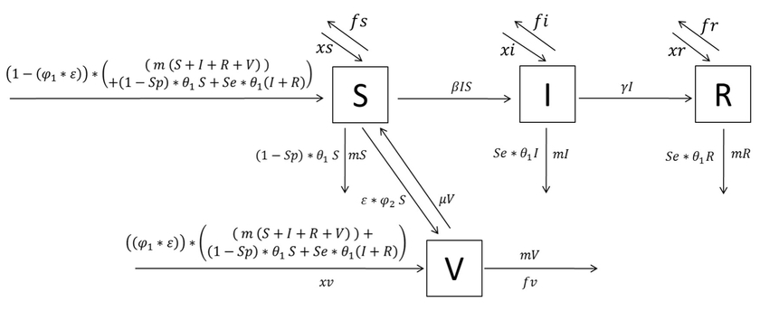

Figure 1.

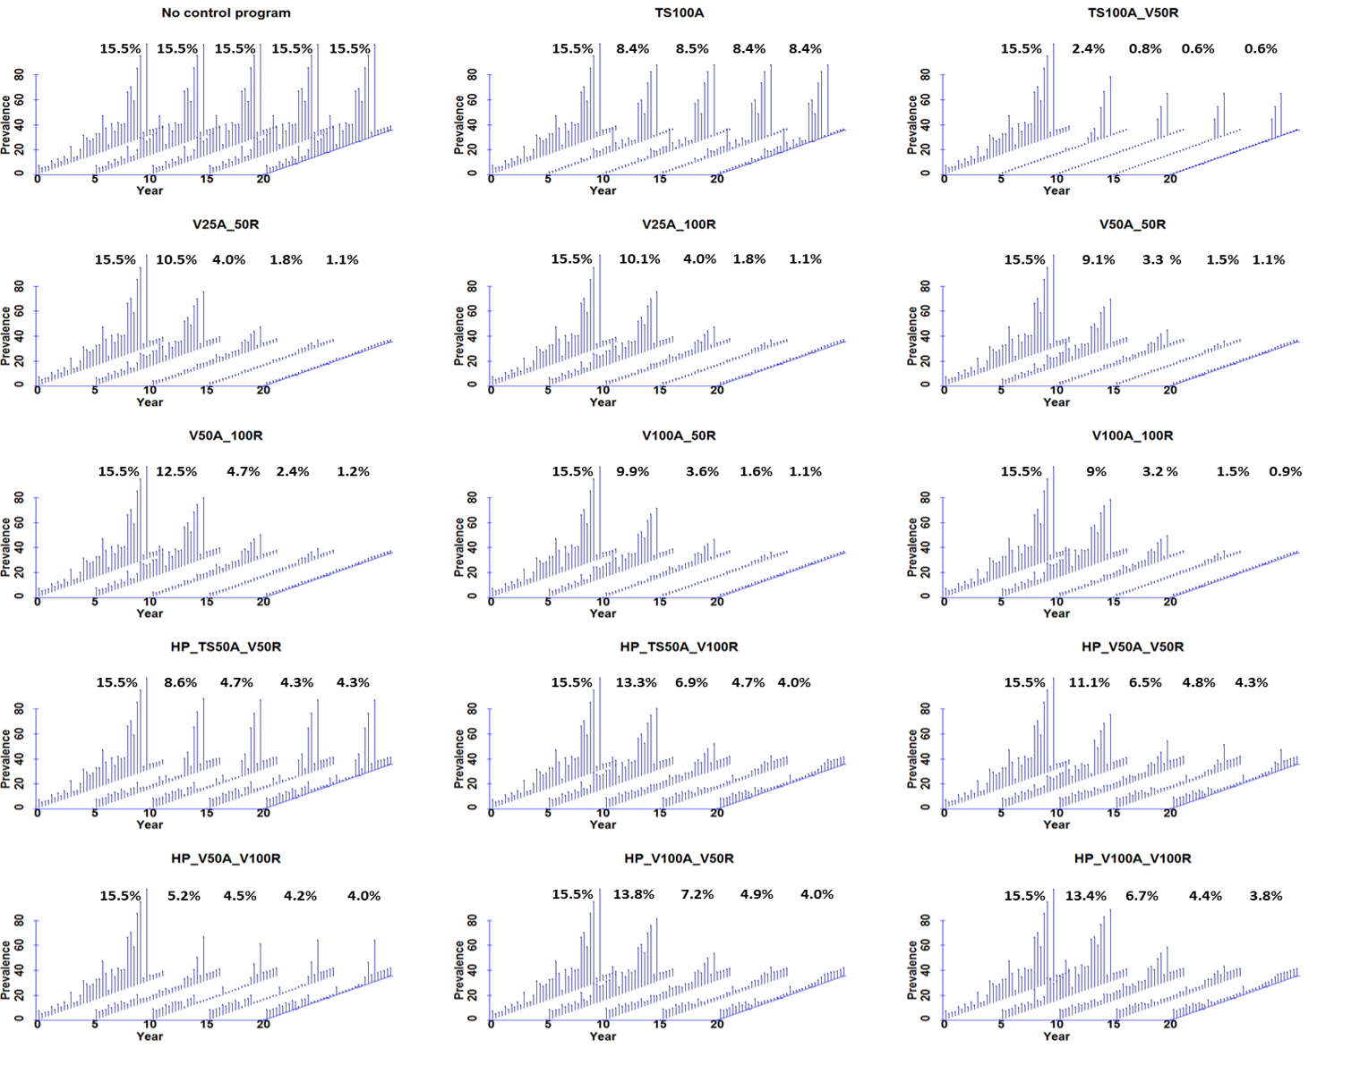
Figure 2.

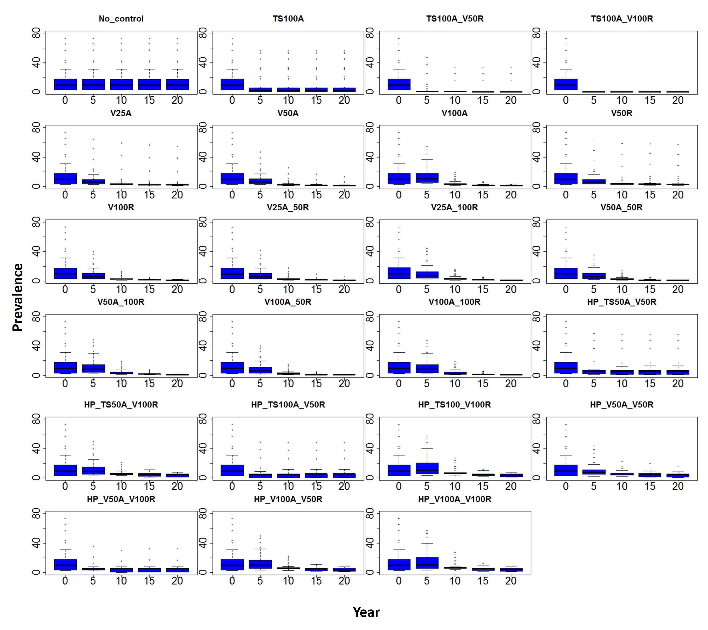
Figure 3.

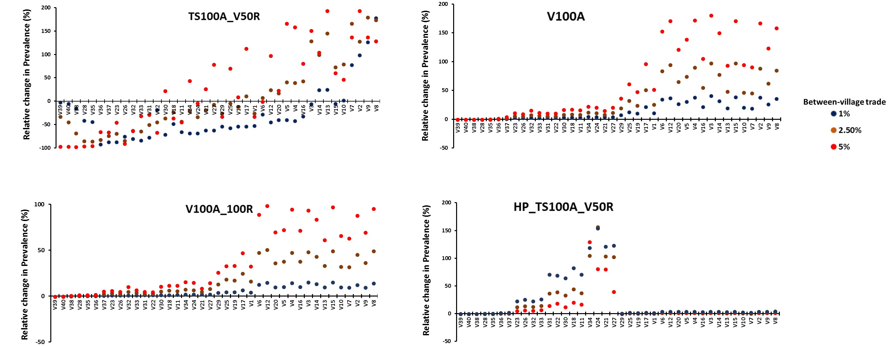
Figure 4.

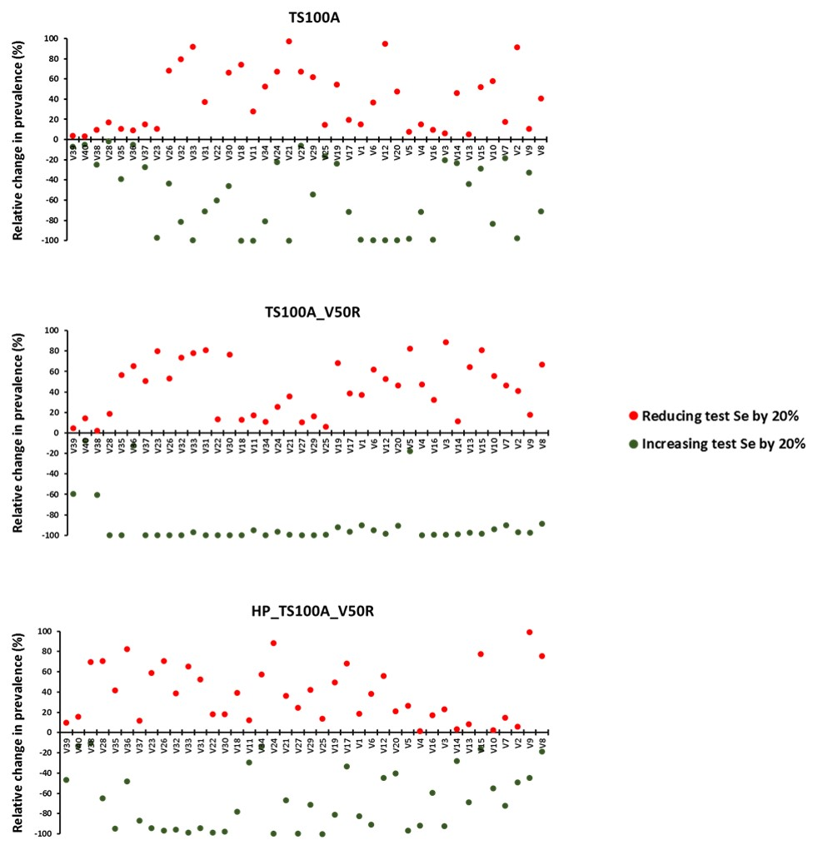
Figure 5.

