Title:
Traumatic physeal fractures in cats; a review of 36 cases (2010-2020)
Authors:
Carlos Rubinos¹, Richard L Meeson¹
¹Department of Clinical Science and Services, Queen Mother Hospital for Animals, The Royal Veterinary College, United Kingdom
Corresponding author:
Carlos Rubinos Lic.Vet., PgCertVMS, PgCertSAS, MRCVS, Clinical Science and Services, Queen Mother Hospital for Animals, The Royal Veterinary College, Hawkshead Lane, North Mymms, Hatfield, Hertfordshire, AL9 7TA, United Kingdom
Email: crubinosalonso@rvc.ac.uk

Abstract
OBJECTIVES To describe the demography, aetiology, location and classification of physeal fractures in cats and to describe their management and outcomes.
METHODS Clinical records and radiographs of cats referred for management of physeal fractures were retrospectively reviewed. Fractures of the proximal femoral physis were excluded. Descriptive statistics were used to describe signalment, cause of injury, presence of concurrent injuries, fracture description, treatment modality, complications, follow-up, physeal closure, implant removal and outcome.
RESULTS Thirty-four cats with 36 fractures were included, of which 17 affected the distal femur, 11 the distal tibia and fibula, five the distal radius and ulna, two the proximal tibia and one the distal humerus. Salter-Harris classification was type I in 14, type II in 16, type III in two and type IV in four fractures. Thirty-four fractures were treated with primary fixation, and the most common method was crossed Kirschner wires in 24/34 fractures. Complications were observed in 14 fractures, of which 12 were minor. At radiographic follow-up, physeal closure was reported in 23 fractures, of which 15 were considered premature. Implant removal was performed in three fractures. Outcome was good in 28, fair in four and poor in two fractures.
CONCLUSION AND RELEVANCE Fracture of the distal femoral physis was the most common physeal fracture seen. Cats presenting may be skeletally immature or mature with delayed physeal closure. The rate of physeal closure after fracture repair was relatively high, but without apparent impact. The frequency of implant removal was very low, indicating that despite having a physeal fracture repair, most cats did not require a second procedure to remove implants. Overall, internal fixation provided good outcome in most fractures.

KEYWORDS: Growth plate; Physeal fracture; Salter-Harris fracture; Premature physeal closure; Implant removal

INTRODUCTION
Physeal fractures occur in immature animals with open physes (1,2) and have been classified by human paediatric surgeons Salter and Harris into five radiographic configurations (3). Although it is acknowledged that the physis may close as a result of the inciting or surgical trauma regardless of the choice of fracture fixation (4–6), surgeons repair these fractures with the aim of maintaining normal bone growth post healing.
Physeal fracture repair options are sought that will minimally impact blood supply, give an accurate and stable reduction, be easily removable, and not cause further significant damage to the physis (7). Specifically, implants that would prevent further physeal growth in the skeletally immature patient by preventing longitudinal growth from locking or bridging the physis (bone plates, lag screws, tension bands and external skeletal fixators) are usually avoided (2) or removed early (two to four weeks after surgery). Thus, the most commonly used implants for repair of physeal fractures are K-wires (8), which can be applied as the sole fixation either in parallel or divergent (cross-pinning) fashion. Parallel K-wires (9,10) can theoretically allow for continued longitudinal physeal growth, whereas cross-pinning may create a locking effect resulting in premature closure of the physis. Anecdotally, the authors have noted that when cats return for early re-examination and pin removal following physeal fracture repair, the physis often appears radiographically closed and hence the implants were left in situ.
Long-bone physeal fractures are usually secondary to trauma (1–3). However, there are several pathologies seen in the feline proximal femoral physis which predispose them to separation or fracture without significant trauma (11,12). Spontaneous capital physeal fractures (SCPF), can be initially radiographically indistinct from a traumatic proximal femoral physeal fracture, but often have a particular patient demography, fracture aetiology and radiographic and histopathological features, prompting different management strategies (12–16). ﻿McNicholas identified certain risk factors including being male, neutered, and increased body weight (17). Histology has shown a widened physis with an irregular arrangement of chondrocytes with abundant matrix and areas of necrosis in these cats (18,19). A further condition termed metaphyseal osteopathy also predominantly affects young, male neutered, obese cats, and the history and clinical signs are similar to those associated with spontaneous capital physeal fracture. Again, they may present as an atraumatic proximal femoral fracture; however, radiographic osteolysis of the femoral neck typically precedes a femoral neck or sub epiphyseal pathological fracture (20). In these cats, the changes to the femoral neck are often present at the time of fracture helping to inform this diagnosis. However, it can be difficult to know exactly where the exact fracture line is in cats with proximal femoral metaphyseal osteopathy, physeal dysplasia and traumatic fractures, if there has been bone resorption. It is also difficult to definitively distinguish a physeal from a sub-physeal fracture with conventional radiography.
Currently, there is little described about feline physeal fractures, their repair, and outcome. As there are several underlying pathologies predisposing cats to non-traumatic proximal femoral physeal fractures, and the signalment, history and radiographic changes are not entirely reliable for distinguishing trauma vs pathological fractures, the authors have intentionally excluded this group from the survey and have focused on true traumatic physeal fractures. The primary objective of this study was to describe the demography and distribution of traumatic physeal fractures in cats, and determine their outcome and management including whether implants were removed or not at follow-up.
MATERIALS AND METHODS
Study design
Medical records of cats diagnosed with long-bone physeal fractures between May 2010 and March 2020 were reviewed and included if they had complete clinical and radiographic records. Surgically repaired fractures were excluded from analysis if follow-up clinical and/or radiographic records were not available. Fractures affecting the proximal femoral physis were excluded. Data obtained included signalment, fracture description, concurrent injuries, fracture management, complications, time to follow-up, radiographic evidence of physeal closure, whether implant removal was performed, and clinical outcome. The cause of the fracture was classified as either ’unknown’; ‘short fall’ for a low level fall; ‘high-rise’ when a fall from the balcony of a multi-story building was observed; and road traffic accident (RTA). Immediate post-operative care included strict cage rest and NSAID and opioid analgesia as appropriate. Cats managed with internal fixation or external coaptation alone were discharged with NSAID analgesia as appropriate for up to two weeks and cage rest with controlled periods of activity until the first agreed follow-up re-examination. All internal fixation cases were routinely re-examined at least once between three and eight weeks following fracture management, when at least one set of follow-up radiographs was obtained under sedation. Further follow-up re-examinations were carried out as needed on a case-by-case basis depending on clinical progress and complications. All radiographs were reviewed by at least one board-certified diagnostic imaging specialist and one board-certified small animal surgery specialist prior to the development of this study. All radiographs were reviewed again during the study period by one small animal surgery resident (three times) and by one board-certified small animal surgery specialist (once). Physeal fracture healing was assessed based on a combination of radiographic features described in the human literature (21–24). Radiographic closure of the physis was defined as the absence of any radiolucent physeal line on the orthogonal radiographs, and premature if this occurred in a cat whose age at the time of radiographic follow-up was younger than the reported physiological closure times for that particular physis (25). Any physes where at least part of the physeal radiolucent line was visible were considered open. For further assessment cats were categorised by their age on presentation into groups representing those with significant growth potential, reducing potential, and no further potential (<6 months, 6-10 months, >10 months old respectively) (26). Complications were classified as minor, major, or catastrophic and subjective clinical outcomes were graded as good (full function), fair (acceptable function), or poor (unacceptable function) as proposed by Cook et al. (27).
Statistical analysis
Data were tabulated (Excel version 16.33; Microsoft, Redmond, Washington), and descriptive statistics were used. Normality in data distribution was assessed by visual inspection and a Shapiro-Wilk test. Continuous data were non-normally distributed and are presented as median and range. Categorical data are presented as frequency and percentage.

RESULTS
Overall Demography
Thirty-four cats with a total of 36 fractures met the study criteria. The population included 18 male cats (11/18 neutered, 7/18 entire) and 16 female cats (13/16 neutered, 3/16 entire), with a median age of 10 months (range 3-25). Age group distribution was 8 (24%) cats <6 months, 12 (35%) 6-10 months, and 14 (41%) >10 months. Domestic short hair (DSH) cats were most common (n=27, 79%) followed by British short hair [BSH (n=2, 6%)], and one (3%) each of Maine Coon, Domestic long hair (DLH), Bengal, Domestic medium hair (DMH) and Russian Blue. The median body weight was 3.5kg (range 1.6-5.4).
The most frequent causes of injury were unknown (23/34, 68%), short fall (5/34, 15%), high-rise (5/34, 15%) and RTA (1/34, 3%). A total of 19/34 (56%) cats had concurrent injuries including fractures or luxations affecting a different limb (9%), other fractures or luxations affecting the same limb (24%), pelvic fractures (13%), pulmonary contusions (11%), degloving injuries (7%), pneumothorax (7%), skull fractures (4%), skin lacerations (4%), and diaphragmatic rupture (2%).
Overall, 17/36 (47%) fractures were of the distal femur, 11/36 (31%) the distal tibia and fibula, 5/36 (14%) the distal radius and ulna, two (6%) the proximal tibia, and one (3%) the distal humerus. Fourteen (39%) fractures were classified as Salter-Harris (SH) type I, 16 (44%) as type II, two (6%) as type III, and four (11%) as type IV (Figure 1). Two fractures were classified as open.
[Insert Figure 1]
Figure 1 Bar graph representing the number of fractures (“y” axis) classified by anatomical location as distal humerus (dHumerus), distal radius and ulna (dRadius), distal femur (dFemur), proximal tibia (pTibia) and distal tibia and fibula (dTibia), and by Salter-Harris classification (“x” axis) as type I (dark grey), type II (light grey), type III (descending stripes) and type IV (ascending stripes).

Management
Internal fixation was performed in 34/36 fractures, involving crossed K-wires in 24, crossed K-wires with plates and/or screws in six, crossed K-wires and IM pin in two, crossed K-wires and tension band in one and plate and screws in one fracture. A total of two K-wires were used in 62%, three in 24% and four in 15% of fractures. The most common K-wires used were 1.0 and 1.2mm (accounting for 71%). Conservative management consisting of external coaptation alone was performed in 2/36 fractures. Postoperative external coaptation was used in conjunction with internal fixation in eight fractures (all were distal radial and distal tibial fractures).
Median time to radiographic re-examination was 4.5 weeks (range, 3-8 weeks). Median duration of total follow-up was six weeks (range, 3-240). Complications were recorded in 14/36 (39%) fractures. Of these, 12 were minor and 2 major (see Table 2). Radiographic complete closure of the physis at the time of follow-up was identified in 23/34 (68%) fractures that had internal fixation (Figure 2 and Figure 3), of which 15 (65%) were considered premature. When stratified by age group (Table 1), premature closure in surgically repaired fractures was seen in 4/6 (67%) in the <6 month group (n=8), 6/12 (50%) in the 6-10 month group (n=12) and 5/16 (31%) in the >10 month group (n=16).
Implant removal was performed in 3/34 (9%) fractures at four, five and ten weeks postoperatively, due to K-wire loosening or migration. Outcome after fracture repair was good in 28/34 (82%), fair in 4/34 (12%) and poor in 2/34 (6%) fractures.
[Insert Table 1]

Table 1 Distribution of fractures repaired by internal fixation and cases of premature physeal closure (closure earlier than reported physiological closure times) by patient age group. Note the decreasing percentage of premature closure observed with increasing age group.
Age group | Overall fracture population | Fractures repaired by internal fixation | Fracture repairs with premature physeal closure
<6 months | 8 | 6 | 4 (67%)
6-10 months | 12 | 12 | 6 (50%)
>10 months | 16 | 16 | 5 (31%)

[Insert Figure 2]
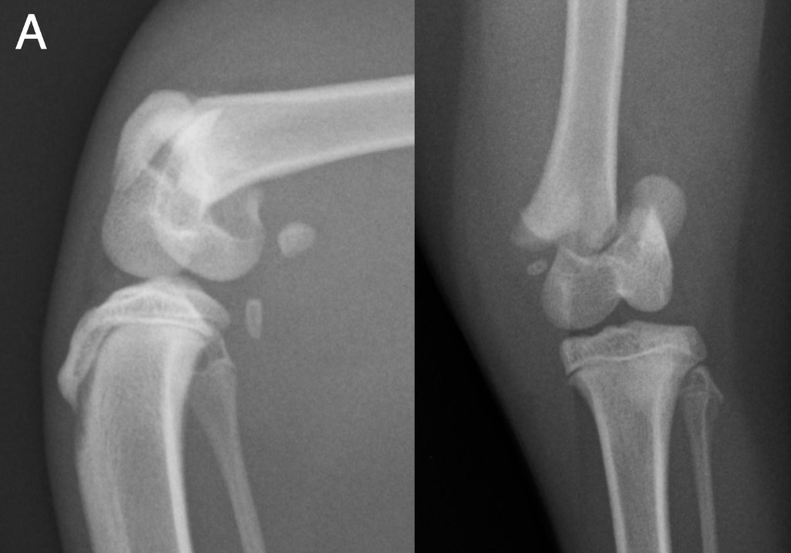
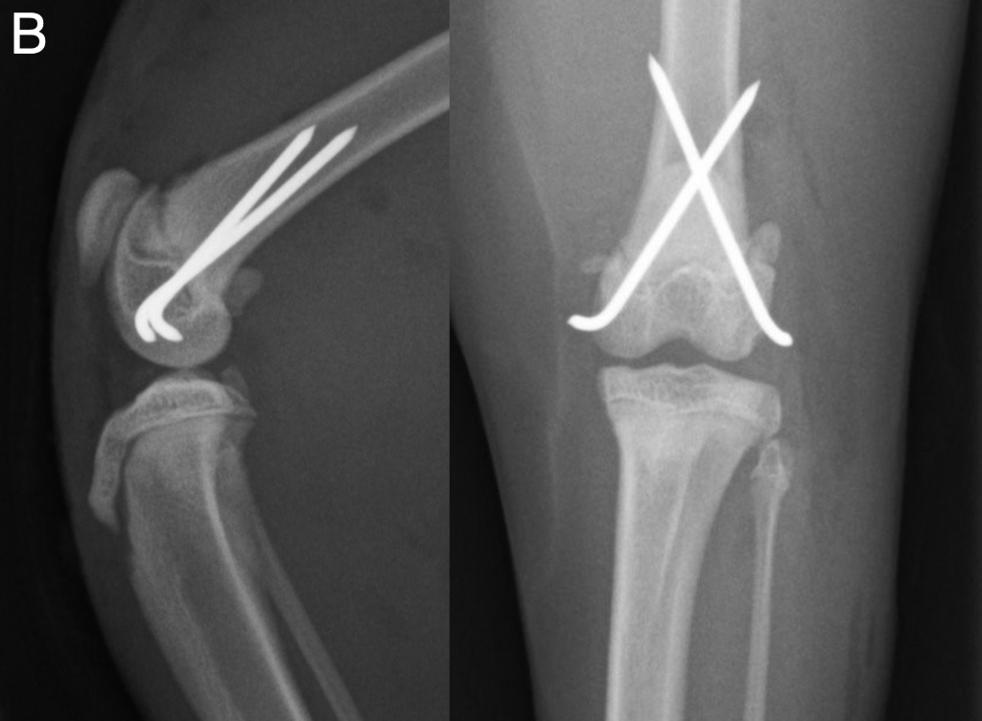

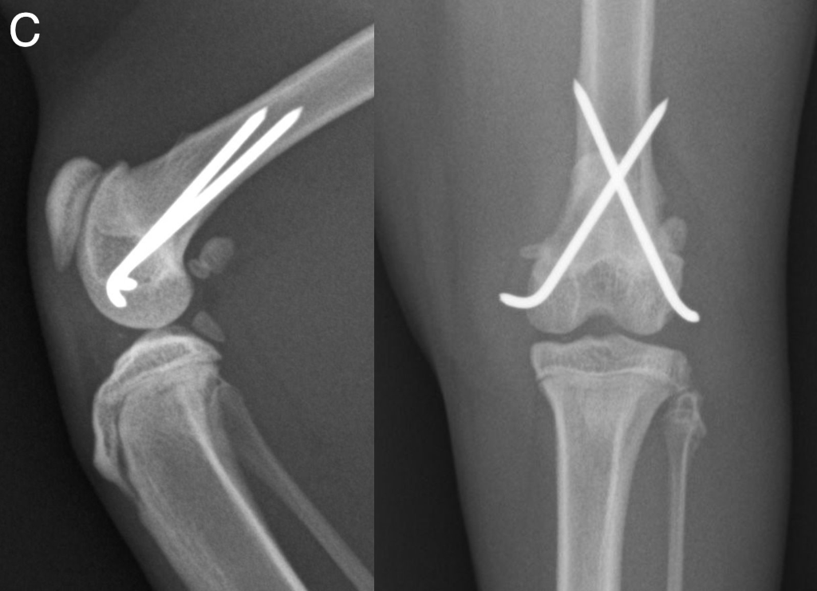

Figure 2 Orthogonal view radiographs of a distal femoral Salter-Harris type II physeal fracture which developed premature physeal closure, pre surgery (A), immediate postoperative after internal fixation with crossed K-wires (B) and six-week follow-up with signs of fracture healing (periphyseal increased radio-opacity, physeal bridging, callus and loss of visualization of the metaphyseal fracture line) and radiographic signs of physeal closure, with loss of radiolucent physeal line on both views (C).
[Insert Figure 3]
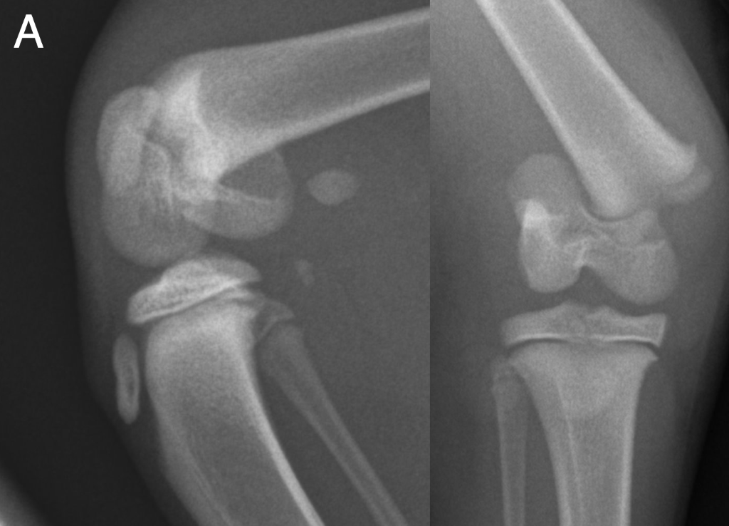
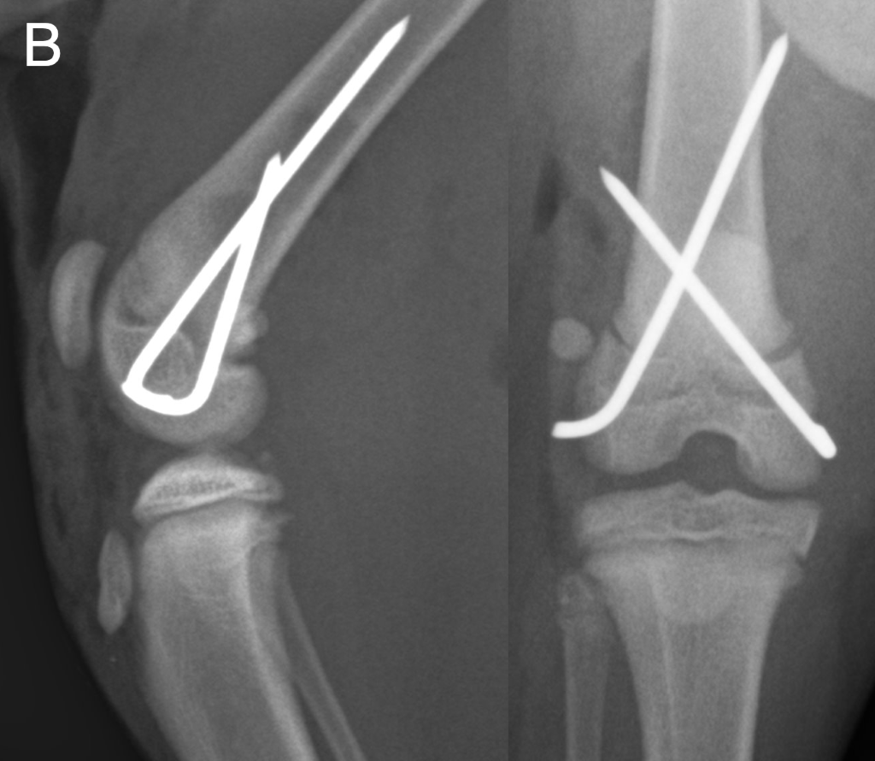
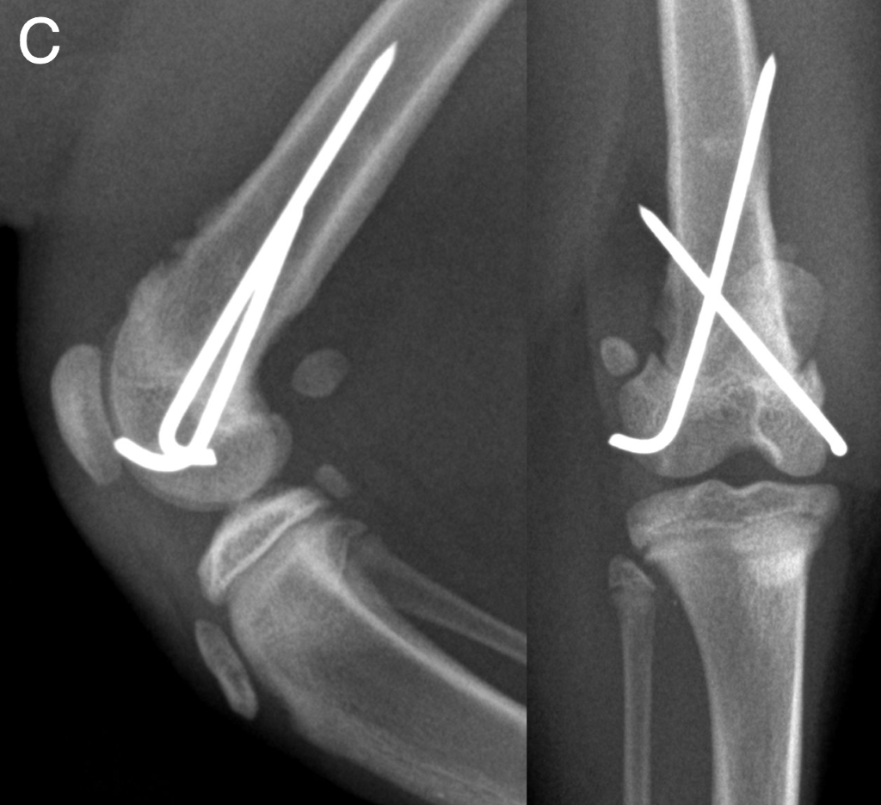

Figure 3 Orthogonal view radiographs of a distal femoral Salter-Harris type I physeal fracture, with signs of a partially open physis at follow-up, pre surgery (A), immediate postoperative after internal fixation with crossed K-wires (B) and six-week follow-up showing radiographic signs of fracture healing (metaphyseal increased radio-opacity and mild callus formation) with a mostly open radiolucent physeal line still visible (C).
Breakdown by anatomical location
Data were cross tabulated by fracture location and interrogated regionally (Table 2). There were no proximal humeral physeal fractures.
Distal humerus.
A single 14-month old MN DSH cat with a SH type II fracture of cause unknown and without concurrent injuries. Body weight was 3.8kg. Plate and screw fixation was performed and a minor complication developed (mild axial deviation of the distal limb). Physeal closure was confirmed at 12-week follow-up, without premature closure or subsequent implant removal. Outcome was good.
Distal radius & ulna.
Four DSH cats with a total of five fractures; two FE and two MN, with a median age of 8.5 months (range, 4-13) and a median body weight of 3.8kg (range, 2.0-4.9). SH classification was type I in 3/5, type II in 1/5 and type IV in 1/5 fractures. One fracture was open. The cause was unknown in two, high-rise in two and concurrent injuries were present in three. One fracture was treated conservatively (with external coaptation alone) and the remainder with combinations of K-wires (see Table 2). Post-operative external coaptation was used in 2/5. Median time to follow-up was eight weeks (range, 4-12) and minor complications were reported in 2/5 fractures (pin migration with swelling 10 weeks postoperatively and reduced range of movement in the carpus four weeks postoperatively). Physeal closure was reported in 3/5 fractures, of which two were premature and implants were removed in one fracture. Outcome was good in three and fair in one (persistent reduction in carpal flexion).
Distal femur.
Sixteen cats involving 17 fractures were included, with eight male (4 ME, 4 ME) and eight female (all neutered). Median age was 10.5 months (range, 4-25). Breed distribution was DSH (n=15) and one Domestic medium hair. Median body weight was 3.6kg (range, 2.2-5.4). Five of 17 fractures were SH type I, ten type II and two type IV. The cause was unknown in thirteen, high-rise in two and short fall in one. Concurrent injuries were present in 6/16 cats.
All fractures were repaired with internal fixation; 10/17 crossed K-wires, 6/17 crossed K-wires and plate and/or screws, and 1/17 with crossed K-wires and IM pin (see Table 2). Median follow-up time was six weeks (range, 3-144) and complications were reported in 4/17 fractures. Minor complications included lateral patellar luxation (n=1), mild superficial wound dehiscence (n=1) and limb shortening with ongoing mild lameness (n=1). One complication was considered major (suboptimal implant positioning causing instability and requiring revision). Physeal closure at follow-up was reported in 11/17 fractures, of which seven were premature. Implant removal was not performed and outcome was considered good in 14/17, fair in 2/17 and poor in 1/17 fractures.
Proximal tibia.
Two cats were included with a total of two fractures, both male DSH (one ME, one MN), with a median age of 14 months (range, 5-23) and a median body weight of 3.3 kg (range, 2.7-3.8). There was one SH type I and one type II. The cause of injury was unknown in one and a short fall in the other and both had concurrent injuries. One was treated with three crossed K-wires and the other with two crossed K-wires and tension band wire. Median time to follow-up was 128 weeks (range, 16-240). Complications were reported in both; one minor (proximal displacement of the tibial tuberosity, which was stable at follow-up) and one major (limb shortening, progressive lameness, and tibial apophyseal avulsion five months postoperatively requiring revision surgery). Physeal closure was observed in both fractures, of which one was premature. Implant removal was not performed. Outcome was good in one fracture and poor in the other.
Distal tibia.
Eleven cats with 11 fractures were included. Six were female (one FE, five FN) and five were male (two ME, three MN), with a median age of six months (range, 3-12) and a median body weight of 3.0 kg (range, 1.6-4.5). Breeds included DSH (n=5), BSH (n=2) and one each of DLH, Bengal, Maine Coon and Russian Blue. Cause of injury was unknown in six cats, a short fall in three, high-rise in one and RTA in one. Concurrent injuries were present in 8/11 cats.
Fractures were classified as SH type I in 5/11, type II in three, type III in two and type IV in one. One fracture was open. One fracture (SH type IV) was treated with external coaptation alone after aborted implant placement and 10/11 were treated with crossed K-wires. External coaptation was used postoperatively in 6/10 repairs. Median time to follow-up was five weeks (range, 3-6) and minor complications were reported in five, including implant loosening/migration (n=3), swelling (n=2) and bandage complications (n=1). Physeal closure was seen in 6 of the 10 fractures repaired with internal fixation, of which 5 were premature. Implant removal was performed in 2/10 fractures. Outcome was good in 9 fractures and fair in one case where there was incomplete fracture healing and mild lameness at the time of last follow-up examination.
[Insert Table 2]
Table 2 Descriptive analysis of 36 fractures involving the physis in cats. The columns correspond to fractures grouped by anatomical location and are divided into distal humerus (dHumerus), distal radius and ulna (dRadius), distal femur (dFemur), proximal tibia (pTibia) and distal tibia and fibula (dTibia).

 | dHumerus | dRadius | dFemur | pTibia | dTibia | TOTAL | Cats/Fractures
N of cats (%)  N of fractures (%) | 1 (3)  1 (3) | 4 (12)  5 (14) | 16 (47)  17 (47) | 2 (6)  2 (6) | 11 (32)  11 (31) | 34  36 | -  -
Age (months)
Median | 14 | 8.5 | 10.5 | 14 | 6 | 10 | -
Range | - | 4-13 | 4-25 | 5-23 | 3-12 | 3-25 | -
Body weight (kg)
Median | 3.8 | 3.8 | 3.6 | 3.3 | 3.0 | 3.5 | -
Range | 3.8 | 2.0-4.9 | 2.2-5.4 | 2.7-3.8 | 1.6-4.5 | 1.6-5.4 | -
Sex
ME | - | - | 4 (25) | 1 (50) | 2 (18) | 7 (21) | 7/7
MN | 1 (100) | 2 (50) | 4 (25) | 1 (50) | 3 (27) | 11 (32) | 11/12
FE | - | 2 (50) | - | - | 1 (9) | 3 (9) | 3/3
FN | - | - | 8 (50) | - | 5 (45) | 13 (38) | 13/14
Breed
Bengal | - | - | - | - | 1 (9) | 1 (3) | 1/1
BSH | - | - | - | - | 2 (18) | 2 (6) | 2/2
DLH | - | - | - | - | 1 (9) | 1 (3) | 1/1
DMH | - | - | 1 (6) | - | - | 1 (3) | 1/1
DSH | 1 (100) | 4 (100) | 15 (94) | 2 (100) | 5 (45) | 27 (79) | 27/29
Maine Coon | - | - | - | - | 1 (9) | 1 (3) | 1/1
Russian Blue | - | - | - | - | 1 (9) | 1 (3) | 1/1
Cause of injury
HR | - | 2 (50) | 2 (13) | - | 1 (9) | 5 (15) | 5/6
JF | - | - | 1 (6) | 1 (50) | 3 (27) | 5 (15) | 5/5
RTA | - | - | - | - | 1 (9) | 1 (3) | 1/1
UN | 1 (100) | 2 (50) | 13 (81) | 1 (50) | 6 (55) | 23 (68) | 23/24
Concurrent injuries | - | 3 (75) | 6 (38) | 2 (100) | 8 (73) | 19 (56) | 19/21
Time from injury to treatment (days)
Median | 3 | 4.5 | 2 | 2.5 | 1 | 3 | -
Range | - | 1-6 | 1-4 | 1-4 | 1-5 | 1-6 | -
Time to radiographic follow-up (weeks)
Median | 8 | 3 | 4.5 | 6 | 5 | 5 | -
Range | - | 3-4 | 3-8 | - | 3-6 | 3-8 | -
Salter-Harris classification
I | - | 3 (60) | 5 (29) | 1 (50) | 5 (45) | 14 (39) | 12/13
II | 1 (100) | 1 (20) | 10 (59) | 1 (50) | 3 (27) | 16 (44) | 17/17
III | - | - | - | - | 2 (18) | 2 (6) | 2/2
IV | - | 1 (20) | 2 (12) | - | 1 (9) | 4 (11) | 3/4
Open fractures | - | 1 (20) | - | - | 1 (9) | 2 (3) | 2/2
Treatment
CO | - | 1 (20) | - | - | 1 (9) | 2 (6) | -
CW | - | 3 (60) | 10 (59) | 1 (50) | 10 (91) | 24 (67) | -
CWIM | - | 1 (20) | 1 (6) | - | - | 2 (6) | -
CWPS | - | - | 6 (35) | - | - | 6 (17) | -
CWTB | - | - | - | 1 (50) | - | 1 (3) | -
PS | 1 (100) | - | - | - | - | 1 (3) | -
Number of K-wires
2 | - | 3 (60) | 13 (77) | 1 (50) | 4 (40) | 21 (62) | -
3 | - | - | 2 (12) | 1 (50) | 5 (50) | 8 (24) | -
4 | - | 2 (40) | 2 (12) | - | 1 (10) | 5 (15) | -
Size of K-wires
0.6 mm | - | 2 (14) | - | - | 2 (7) | 4 | -
0.8 mm | - | 4 (29) | 1 (3) | 4 (57) | 6 (22) | 15 | -
1.0 mm | - | 8 (57) | 5 (13) | 3 (43) | 15 (56) | 31 | -
1.2 mm | - | - | 26 (65) | - | 4 (15) | 30 | -
1.6 mm | - | - | 8 (20) | - | - | 8 | -
Postoperative external coaptation | - | 2 (40) | - | - | 6 (60) | 8 (53) | 8/8
Complications
Total | 1 (100) | 2 (40) | 4 (24) | 2 (100) | 5 (45) | 14 (39) | 14/14
Minor | 1 (100) | 2 (40) | 3 (18) | 1 (50) | 5 (45) | 12 (33) | 12/12
Major | - | - | 1 (6) | 1 (50) | - | 2 (6) | 2/2
Physeal closure | 1 (100) | 3 (75) | 11 (65) | 2 (100) | 6 (60) | 23 (68) | 22/23
Of which premature | - | 2 (67) | 7 (64) | 1 (50) | 5 (83) | 15 (65) | 15/15
Implant removal | - | 1 (20) | - | - | 2 (20) | 3 (9) | 3/3
Outcome of fracture repair
Good | 1 (100) | 3 (75) | 14 (82) | 1 (50) | 9 (90) | 28 (82) | 28/28
Fair | - | 1 (25) | 2 (12) | - | 1 (10) | 4 (12) | 4/4
Poor | - | - | 1 (6) | 1 (50) | - | 2 (6) | 2/2

Data are n (%).
Abbreviations used: ME; male entire, MN; male neutered, FE; female entire, FN; female neutered, BSH; British short hair, DLH; Domestic long hair, DMH; Domestic medium hair, DSH; Domestic short hair, HR; High-rise, JF; short jump or fall, RTA; road-traffic accident, UN; unknown, EU; euthanasia, CO; external coaptation alone, CW; crossed K-wires, CWIM; crossed K-wires and intramedullary pin, CWPS; crossed K-wires and plate and/or screws, CWTB; crossed K-wires and tension band, PS; plate and screws.

DISCUSSION
In this survey of traumatic feline physeal fractures, the vast majority of fractures were SH I and II, which are relatively similar in form and likely associated with bending or shear forces applied to a relatively uniplanar physis. With the intentional exclusion of the proximal femoral physis, the distal long bone physes (the distal femur and tibia in particular) dominated. These findings are similar to those previously reported in dogs (28,29). No known underlying pathology has been reported with feline physeal fractures seen in locations other than the proximal femoral physis, suggesting that SH I and II are the most common patterns of fracture propagation from trauma. Fractures of the distal humerus and proximal tibia were rare and fractures of the proximal humerus were not observed in this study. Approximately 40% of the cats in the study were older than one year, representing a considerable number of adult cats with open physes that would be expected to be skeletally mature at the time of injury (25). Delayed closure of physes is not uncommon in neutered male cats as gonadectomy is usually performed before physeal closure occurs and appears to retard its progression (30–33).
The most common fracture repair option was crossed K-wires, which is expected to cause minimal damage to the physis but will ‘lock’ the physis and prevent ongoing growth. Open reduction and internal fixation provided a good outcome with a return to full function in 82% of fractures accompanied by a relatively low rate of complications and a surprisingly low number of implant removals at follow-up (9%). The only recorded reason for implant removal in this study was K-wire loosening or migration. The apparent high level of physeal closure at re-examination could explain the low levels of implant removal. The proportion of cats with physeal closure at re-examination was 68% and when physeal closure was considered in context of the cats’ age and expected physiological closure times, 65% of all closures were considered premature. Premature closure is suspected to be due to the inciting trauma to the physis and/or the surgery, and generally occurs within 2-3 weeks of injury but is influenced by the age and breed of the animal (13,34). Defining a premature closure is problematic however, and is best addressed by a prospective study whereby the contralateral limb physis is also radiographed and compared with the fractured leg. The use of established physiological closure times is helpful but of limited accuracy since cat breed, individual genetics, and neuter status can have further influence on closure times. Additionally, assessing physeal closure from orthogonal radiographs in some physes is more difficult if they do not have a planar physis which is aligned to the X-ray beam when they are radiographed. However, despite these caveats it does appear that the trauma and/or the surgical repair accelerates the closure of the physis. In our study this was particularly noticeable in young cats that should clearly not have had a closed physis at the age they were radiographed. Theoretically, early closure may result in varying degrees of limb shortening and/or deformity, which may lead to osteoarthritis due to abnormal joint loading. However, these complications have rarely been associated with clinical signs (4). Longer-term follow-up studies are required to comment further, but the present study shows that in the short-term, the lack of implant removal in cats over six months of age did not appear to have any negative effects. Additionally, nearly 70% of cats under six months of age will have an apparently closed physis at follow-up examination, arguably negating implant removal.
There is a scarcity of information regarding radiographic assessment of physeal healing and growth arrest in the veterinary literature. This subject has been more comprehensively explored in humans (10,21–24), where the difficulty in assessing physeal injury and healing using radiography alone has been acknowledged, in particular the subjective nature of describing a physis as open, partially closed or completely closed. In our study, physeal closure was defined as a complete absence of a radiolucent physeal line on orthogonal view radiographs and was observed in 23/34 fractures repaired with internal fixation. Further studies evaluating growth plate injuries, healing and growth using advanced imaging techniques may help our understanding of physeal fracture healing in the cat.
A preliminary survey of all the feline physeal fractures identified for the present study also identified 23 cats with 27 fractures of the proximal femoral physis. In this subgroup, male cats accounted for 22/23 cases (20 MN, 2 ME), with one female neutered cat; the median age was 18 months and the median body weight was 5.0kg. Breed distribution was also different from that seen in the overall study population, with a higher prevalence of British short hair and Maine Coon cats, and the cause of injury was unknown in 20/23, with anecdotal evidence of most fractures occurring in an indoor setting without apparent overt trauma. The demography of this group was consistent with that described for cats with spontaneous capital physeal fractures and metaphyseal osteopathy (11,12,15,17,18,20). However some of these fractures may well have been truly traumatic. There is a need for a well-designed multi-centre prospective study to develop our understanding of fractures in this location, and hence they were excluded in this retrospective case series.
This study has several limitations due to its retrospective nature, including the accuracy and completeness of the clinical records. The cause of injury was classified as unknown when a specific cause could not be objectively confirmed in the history, even when anecdotal evidence or subjective assessment were suspicious of a particular cause. Long-term follow-up was not available for all patients, so it is possible that further implant removal procedures or complications might have been present in some patients at a later date. Assessment of outcome was subjective and based on the available follow-up clinical records only. A large prospective study assessing objective outcome variables would be needed to more accurately determine the impact of premature physeal closure on limb length and this should include co-evaluation of the contralateral limb physis to improve the assessment of physeal closure after trauma and surgery. Finally, the small sample size of some population subgroups in this study precluded establishing the significance of statistical associations between certain variables.

CONCLUSIONS
Distal femoral physeal fractures were the most common location for traumatic physeal fractures in cats when fractures of the proximal femoral physis were excluded. Most fractures were repaired with crossed-K wires and subsequent implant removal was rare despite their potential role in preventing ongoing limb growth. When implant removal was performed, it was due to K-wire loosening or migration only. Radiographic physeal closure at follow-up was seen in nearly 70% of fractures and 65% of those were younger than the reported age of closure for the particular physis. This study tentatively suggests it may be reasonable that any cat older than six months of age would not routinely require implant removal at follow-up and the high level of premature closure seen in cats younger than six months of age should change current advice to “pin removal is unlikely to be needed at re-examination”. However, with the current evidence, the authors would still recommend follow-up radiography and implant removal in this cohort if the physis remained open at follow-up.

Acknowledgements The authors would like to acknowledge Carlos Sanchez Villamil for his input into the initial discussion for this project.
Conflict of interest The authors declared no potential conflicts of interest with respect to the research, authorship, and/or publication of this article.
Funding The authors received no financial support for the research, authorship, and/or publication of this article.
Ethical approval This work involved the use of non-experimental animals only (including owned or unowned animals and data from prospective or retrospective studies). Established internationally recognized high standards (‘best practice’) of individual veterinary clinical patient care were followed. Ethical approval from a committee was therefore not necessarily required.
Informed consent Informed consent (either verbal or written) was obtained from the owner or legal custodian of all animals described in this work for the procedures undertaken (either prospective or retrospective studies). No animals or humans are identifiable within this publication, and therefore additional informed consent for publication was not required.

References
1. Johnson JM, Johnson AL, Eurell JAC. Histological Appearance of Naturally Occurring Canine Physeal Fractures. Vet Surg. 1994;23(2):81–6.
2. Piermattei D, Flo G. Fractures in Growing Animals. In: Brinker, Piermattei, and Flo’s Handbook of Small Animal Orthopedics and Fracture Repair. 3rd ed. Philadelphia; 2006. p. 676–85.
3. Salter RB, Harris WR. Injuries Involving the Epiphyseal Plate. J Bone Jt Surg. 1963;45-A(3):587–622.
4. Voss K, Lieskovsky J. Trauma-induced growth abnormalities of the distal radius in three cats. J Feline Med Surg. 2007;9(2):117–23.
5. O’Brien TR, Morgan JP, Suter PF. Epiphyseal plate injury in the dog: a radiographic study of growth disturbance in the forelimb. J Small Anim Pract. 1971;12(1):19–36.
6. Hajdu S, Schwendenwein E, Kaltenecker G, Lászlõ I, Lang S, Vécsei V, et al. The effect of drilling and screw fixation of the growth plate-an experimental study in rabbits. J Orthop Res. 2011;29(12):1834–9.
7. Roe S. Internal Fracture Fixation. In: Textbook of Small Animal Surgery, vol 2 (ed 3). Philadelphia, PA: Saunders; 2003. p. 1798–818.
8. Milton J, Horne R, Goldstein G. Cross-pinning: a simple technique for treatment of certain metaphyseal and physeal fractures of the long bones. J Am Anim Hosp Assoc. 1980;16:891–906.
9. Ma J, Wang T, Lovric V, Johnson KA, Walsh WR. A biomechanical comparison of Kirschner-wire fixation on fracture stability in Salter-Harris type I fractures of the proximal humeral physis in a porcine cadaveric model. BMC Vet Res. 2017;13(1):1–10.
10. Inal S, Gok K, Gok A, Pinar AM, Inal C. Comparison of biomechanical effects of different configurations of kirschner wires on the epiphyseal plate and stability in a salter-harris type 2 distal femoral fracture model. J Am Podiatr Med Assoc. 2019;109(1):13–21.
11. Forrest L, O’Brien R, Manley P. Abstracts From the Annual Meeting of the American College of Veterinary Radiology Chicago, Illinois. Feline Capital Physeal Dysplasia Syndrome. Vet Radiol Ultrasound. 1999;40:657–84.
12. Lafuente P. Young, male neutered, obese, lame?: Non-traumatic fractures of the femoral head and neck. J Feline Med Surg [Internet]. 2011;13(7):498–507. Available from: http://dx.doi.org/10.1016/j.jfms.2011.05.007
13. Culvenor JA, Black AP, Lorkin KF, Bradley WA. Repair of femoral capital physeal injuries in cats - 14 Cases. Vet Comp Orthop Traumatol. 1996;9(4):182–5.
14. Fischer HR, Norton J, Kobluk CN, Reed AL, Rooks RL, Borostyankoi F. Surgical repair of capital physeal fractures in cats: 13 cases (1998-2002). J Am Vet Med Assoc. 2004;224(9):1478–82.
15. Borak D, Wunderlin N, Brückner M, Schwarz G, Klang A. Slipped capital femoral epiphysis in 17 Maine Coon cats. J Feline Med Surg. 2017;19(1):13–20.
16. Kalis RH, Liska WD, Jankovits DA. Total Hip Replacement as a Treatment Option for Capital Physeal Fractures in Dogs and Cats. Vet Surg. 2012;41(1):148–55.
17. McNicholas TW, Wilkens BE, Blevins WE, Snyder PW, McCabe GP, Applewhite AA, et al. Spontaneous femoral capital physeal fractures in adult cats: 26 Cases (1996-2001). J Am Vet Med Assoc. 2002;221(12):1731–6.
18. Craig LE. Physeal dysplasia with slipped capital femoral epiphysis in 13 cats. Can Vet J. 2001;38:92–7.
19. Newton AL, Craig LE. Multicentric physeal dysplasia in two cats. Vet Pathol. 2006;43(3):388–90.
20. Queen J, Bennett D, Carmichael S, Gibson N, Li A, Payne-Johnson CE, et al. Femoral neck metaphyseal osteopathy in the cat. Vet Rec. 1998;142(7):159–62.
21. Dodwell ER, Kelley SP. Physeal fractures: Basic science, assessment and acute management. Orthop Trauma [Internet]. 2011;25(5):377–91. Available from: http://dx.doi.org/10.1016/j.mporth.2011.08.001
22. Escott BG, Kelley SP. Management of traumatic physeal growth arrest. Orthop Trauma [Internet]. 2012;26(3):200–11. Available from: http://dx.doi.org/10.1016/j.mporth.2012.02.001
23. Islam O, Soboleski D, Symons S, Davidson LK, Ashworth MA, Babyn P. Development and duration of radiographic signs of bone healing in children. Am J Roentgenol. 2000;175(1):75–8.
24. Jawetz ST, Shah PH, Potter HG. Imaging of Physeal Injury: Overuse. Sports Health. 2015;7(2):142–53.
25. Smith RN. Fusion of Ossification Centres in the Cat. J Small Anim Pract. 1969;10(9):523–30.
26. Brioschi V, Langley-Hobbs SJ, Kerwin S, Meeson R, Radke H. Combined physeal fractures of the distal radius and ulna: complications associated with K-wire fixation and long-term prognosis in six cats. J Feline Med Surg. 2017;19(8):907–14.
27. Cook JL, Evans R, Conzemius MG, Lascelles BDX, McIlwraith CW, Pozzi A, et al. Proposed Definitions and Criteria for Reporting Time Frame, Outcome, and Complications For Clinical Orthopedic Studies in Veterinary Medicine. Vet Surg. 2010;39(8):905–8.
28. Marretta SM, Schrader SC. Physeal injuries in the dog: a review of 135 cases. J Am Vet Med Assoc. 1983;182(7):708–10.
29. Phillips IR. A survey of bone fractures in the dog and cat. J Small Anim Pract. 1979;20:661–74.
30. Houlton J, McGlennon N. Castration and physeal closure in the cat. Vet Rec. 1992;131:466–7.
31. May C, Bennett D, Downham DY. Delayed physeal closure associated with castration in cats. J Small Anim Pract. 1991;32:326–8.
32. Perry KL, Fordham A, Arthurs GI. Effect of neutering and breed on femoral and tibial physeal closure times in male and female domestic cats. J Feline Med Surg. 2014;16(2):149–56.
33. Root M V., Johnston SD, Olson PN. The effect of prepuberal and postpuberal gonadectomy on radial physeal closure in male and female domestic cats. Vet Radiol Ultrasound. 1997;38(1):42–7.
34. Daly WR. Femoral Head and Neck Fractures in the Dog and Cat: A Review of 115 Cases. Vet Surg. 1978;7(2):29–38.

