TECHNICAL REPORT

Old Dog, New Tricks: An alternative method of representing costal cartilages in a Basset Hound skeleton exhibiting multiple skeletal diseases and disorders

Sarah Nicoll BSc(Hons) PGCert(VetEd) FHEA FIAS

Department of Comparative Biomedical Sciences, The Royal Veterinary College, Royal College Street, London, NW1 0TU, United Kingdom.

Keywords: Basset Hound, Skeleton, Costal Cartilages, Spondylosis Deformans, Osteoarthritis, Angular Limb Deformities.

ABSTRACT

A Basset Hound cadaver was donated to the Royal Veterinary College (RVC). The skeleton of this breed with chondrodysplasia was articulated for use in anatomy teaching and for display in the RVCs anatomy museum. The skeleton showed signs of grade 3 spondylosis deformans and coincidental osteoarthritis in several areas. Following articulation there was also evidence of angular limb deformities. The costal cartilages of the skeleton were not preserved during maceration however the excess bony growth present at their insertion points on the sternebrae was obvious. The decision was therefore made to recreate them. A novel method was used involving a multi-use sealant/adhesive which is described in this report.

INTRODUCTION

The cadaver of a female Basset Hound was donated to the Royal Veterinary College (RVC) for use in anatomy teaching. Basset hounds are a breed of dog which have been bred to exhibit

chondrodysplasia (Gough and Thomas 2004), or shortened limbs. The college’s museum

collection did not contain a complete skeleton of a Basset Hound or other similar, short-limbed dog breed. It was therefore thought that the addition of such a display would be a useful teaching aid in comparative skeletal anatomy.

The skeleton was prepared using a traditional technique of hot water maceration. This primarily involved the disarticulation of the cadaver and physical removal of the majority of the soft tissues. The disarticulated bones were then immersed in a water bath at approx. 60°C, and regularly removed from the bath and scraped clean of any remaining soft tissue. Once clear of all soft tissue the bones were by bleached using a diluted solution (6-10%) of Hydrogen Peroxide.

During preparation of the skeleton it was noted that the Basset Hound appeared to have been suffering severely from spondylosis deformans resulting in bony growths along the ventral and lateral borders of the vertebrae and sternebrae. In some places these bony growths have bridged the gaps between the individual vertebrae and sternebrae. The Basset Hound also appeared to be suffering from osteoarthritis on several of the facet joints between vertebrae, the costovertebral joints and less severely on some of the joints in the limbs. The costal cartilages were ossified in places but were not salvageable for rearticulating. Costal cartilages are not always represented in skeletal articulations. If they are represented, they are frequently replaced by alternative media such as wire or modelling clay. It was decided that having the costal cartilages represented in this articulation would be beneficial for this display due to the excess bony growths at their joints clearly indicating they should be present. The skeleton was articulated on a plinth supported by two steel rods and using a combination of glues (hot glue and cyanoacrylate) and wires. The method chosen for recreating the costal cartilages was new to the RVC and is described in this report.

MATERIALS AND METHODS

The costal cartilages in this articulation were created using Geocel Sealant and Adhesive in clear, 1mm steel wire and cyanoacrylate glue. Geocel Sealant and Adhesive in clear was chosen because it adheres to any surface, is flexible and can be painted over if desired (Geocel 2020). Throughout this method the use of the term “bead” will be used to describe a cylindrical shaped amount of Geocel, in accordance with the manufacturer’s instructions. A copy of Miller’s Anatomy of the Dog (Evans and Christensen 1979) was used as a reference.

- Onto the surface of a clean and dry non-porous piece of laminated card, a long continuous bead of Geocel was produced. The supplied nozzle was not used as this would have produced beads which were too thin. The bead was created straight from the cartridge. The exact length required was unknown and so this was overestimated. Several lengths were produced to create sufficient for all the costal cartilages. This was left for a minimum of 24 hours to dry.
- Once the Geocel was sufficiently dry the beads were peeled away from the underlying surface.
- Each length required was roughly measured by holding up the bead to the distal end of a rib and flexing it to reach the articulation point on the sternum.
- The bead was easily cut using scissors. The initial length cut was slightly overestimated so that more could be easily removed to refine the length required.
- Steps 3 and 4 were repeated for the same rib on the opposing side.
- A 3-4 cm length of 1mm steel wire was cut and the centre of the length marked with a bend of approximately 90 degrees.
- The ends of the wire were inserted into the ends of the beads to be articulated with the sternum. A 2-3mm gap was left between the beads at the bend in the wire.
- The beads were put temporarily into position by placing the wire joined end of the beads into the gap between sternebrae where they would naturally articulate. The sternebrae had been previously wired together using 2mm steel wire so the wired beads could be supported in position by this temporarily.
- The end of a bead to be attached to the rib was brought into position. At this point any small adjustments in the length were made by removing excess with scissors.
- The bead was adhered to the distal end of the rib using a small amount of cyanoacrylate glue. This was then repeated with the bead on the opposite side.
- Fresh Geocel was then added to the joints between the beads and the sternebrae, and the beads and the ribs.
- This was repeated with all the other costal cartilages with the exclusion of the 1st which attaches to the manubrium and the 10th, 11th, 12th and 13th.
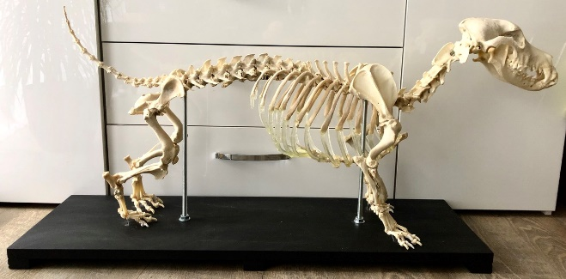
- The 1st costal cartilages attach individually to the manubrium so were not wired. They were short enough that cyanoacrylate glue was sufficient to hold them in position followed by a little fresh Geocel added to the joints.
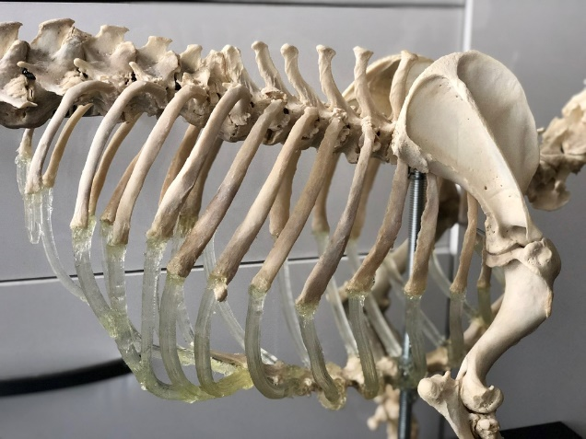
- Costal cartilages 10, 11 and 12 do not articulate directly with the sternum but with the caudal edge of the preceding costal cartilage. Therefore, no wire was used. Once an appropriate length of bead was selected, the end to be attached to the preceding cartilage was cut at an angle and then secured in place using cyanoacrylate glue with fresh Geocel used to fill any gaps and smooth the appearance of the join.
Figure 2. Right view of completed Basset Hound skeleton.
- The costal cartilage of rib 13 is very short and does not normally articulate with the sternum or preceding costal cartilage. This was created by using a very short length of bead which was trimmed to taper at its distal end. It was adhered to the distal end of rib 13 using cyanoacrylate and a small amount of Geocel to smooth the joint.
- All joints were checked with more Geocel added if necessary.
Figure 3. Close up of the lateral thorax showing the replicated costal cartilages.

- After 24 hours all the joints were dry.
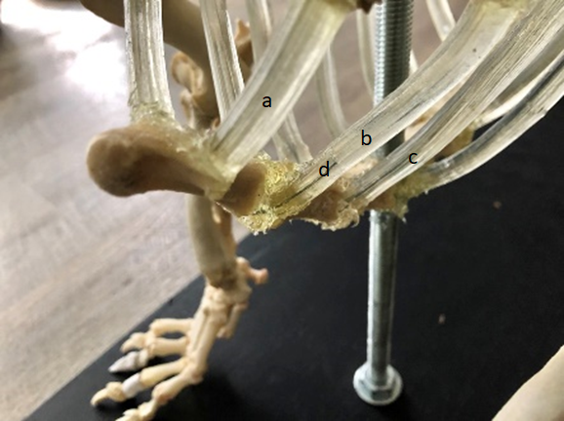

RESULTS

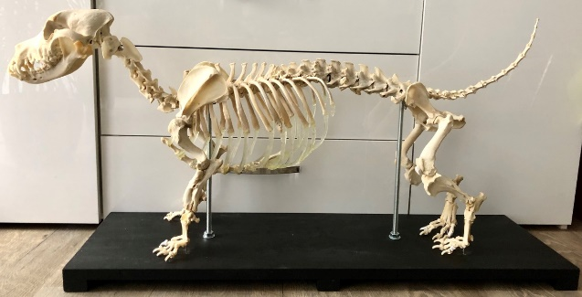
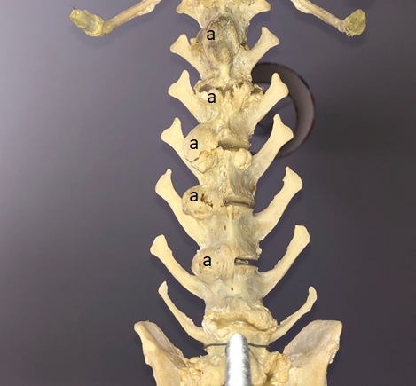
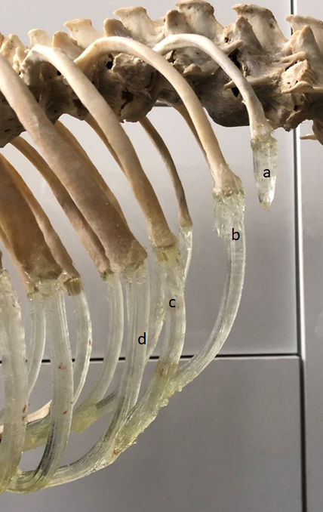
The completed skeleton, and in particular the replicated costal cartilages are shown in Figures 1-5. The Geocel appears to have worked well as a replica for the costal cartilages. The decision was taken not to paint the costal cartilages as the clear Geocel was unobtrusive and in keeping with the rest of the skeleton. The costal cartilages remain flexible on the skeleton which means they should be able to withstand minor knocks and bumps from students.
Figure 4. Left cranio-lateral view of the 1st (a), 2nd (b) and 3rd (c) costal cartilages and their insertion on the sternum. Wires used in the attachment of the costal cartilage are visible (d).

Figure 1. Left view of completed Basset Hound skeleton.
Figure 7. Ventral view of some of the thoracic vertebrae showing osteophytes (a) associated with spondylosis deformans.

The completed skeleton also demonstrates the extent to which the dog was suffering from spondylosis deformans (Figures 6-9) and osteoarthiritis (Figures 10 and 11). The bony growths associated with the spondylosis deformans and ostoarthiritis have resulted in a skeleton which is displaying relatively poor posture.

Additionally, completing the articulation has demonstrated that this dog also had angular limb deformities in both the fore and hind limbs (Figures 12 and 13).
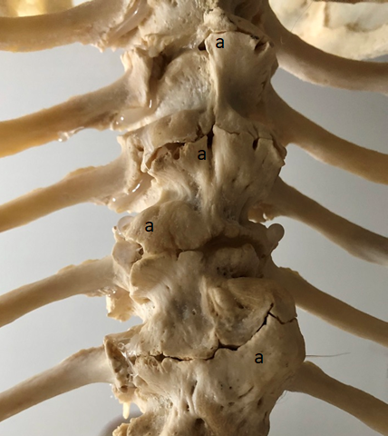
Figure 6. Ventral view of the lumbar vertebrae showing osteophytes (a) associated with spondylosis deformans.

Figure 5. Left lateral view of the 10th-13th costal cartilages. The 13th costal cartilage (a) is short and floating free of the rest of the ribs, costal cartilages and sternum. The 10th (d), 11th (c) and 12th (b) costal cartilages do not adhere to the sternum but to the preceding costal cartilage.

DISCUSSION

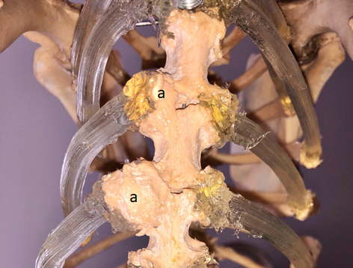
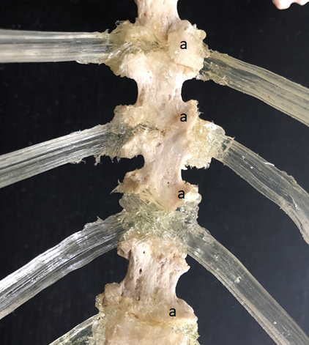
This completed Basset Hound skeleton, as a breed with chondrodysplasia, is a useful teaching aid. It also demonstrates a severe case of spondylosis deformans with coincidental osteoarthritis, something usually only visualised radiographically. Additionally, there are some other breed specific problems shown which will be briefly noted in this discussion.
Figure 9. Ventral view of the 4th-8th sternebrae showing osteophytes (a) associated with spondylosis deformans.
Figure 8. Dorsal view of the 4th-7th sternebrae showing osteophytes (a) associated with spondylosis deformans.

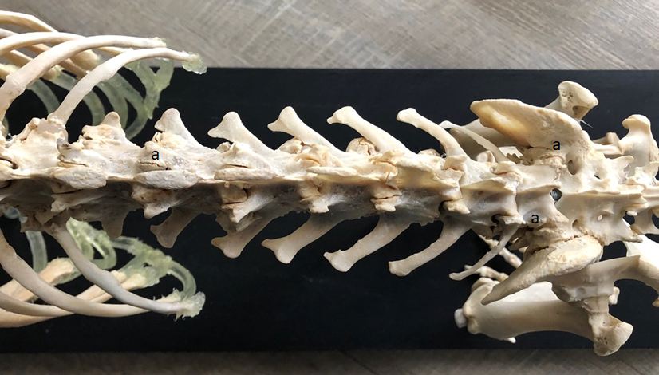
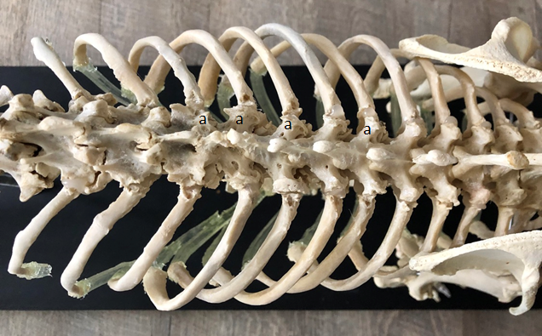
Spondylosis deformans is defined as a non-inflammatory, degenerative disease of the region peripheral to the vertebral end-plate associated with new bone formation originating several millimetres from the intervertebral junction (Meij 2012). The bony growths may be called osteophytes (Meij 2012) or enthesophytes (Fingeroth and Thomas 2015). The condition of this skeleton shows a Grade 3 spondylosis deformans since the osteophytes/enthesophytes have, in some places, connected to each other forming a bony bridge (Fingeroth and Thomas 2015; Meij 2012). Spondylosis deformans is not a condition to which Basset Hounds seem predisposed (Gough and Thomas 2004), although the prevalence of spondylosis deformans does increase with age (Meij 2012). Unfortunately, the age of this dog was not supplied at the point of donation and it is difficult to accurately age a canine skeleton without knowing information about the dog’s lifestyle and diet. However, there is evidence within the skeleton which may give some clues as to the dogs age. The epiphyses throughout the skeleton are fused. Basset Hounds are a medium sized dog and are considered to be fully grown at approximately 18 months of age. The skull contains a full set of adult teeth which are in good condition with little plaque, wear or breakages. However, in contrast there is evidence of bone loss along the roots of the teeth consistent with advanced periodontal disease. Mouth size is a significant risk factor for periodontal disease in dogs (Bellows et al 2015). Larger, older dogs may have healthy mouths and teeth with little plaque and calculus accumulation, while smaller dogs may have greater accumulations of plaque and calculus, are more likely to develop periodontal disease at an early age, and tend to show more severe disease, compared with larger dogs (Bellows et al, 2015). This perhaps suggests that Basset Hounds as a medium sized breed are less likely to develop advanced periodontal disease at an early age. Lastly during initial preparation of the skeleton, it was noted that many of the costal cartilages were ossified in places, something that would not normally be found in a young animal. Overall, the evidence available indicates that this dog was a physically mature adult which was probably at least middle aged but may have been older. The median life expectancy for Basset Hounds in Britain is 12.8 years (Mitchell, 1999). It is therefore unclear if advanced age could be a contributing factor in this case.
Figure 10. Dorsal view of some of the thoracic vertebrae and dorsal ribs with osteoarthritis visible at the costovertebral junctions (a).

Figure 11. Dorsal view of the lumbar and sacral vertebrae showing osteoarthritis visible at some of the facet joints between vertebrae (a).

Osteoarthritis in the facet joints of the vertebra can occur coincidentally to spondylosis deformans however it is considered to be a separate condition (Fingeroth and Thomas 2015). There is osteoarthritis present in the costovertebral joints and several of the limb joints, although to a lesser degree. It is again not known if these changes are age related or if the dog had a genetic predisposition. Both the spondylosis deformans and the osteoarthritis may have caused pain and stiffness in the spine and other joints.
Figure 12. Cranial view of the forelimbs showing a valgus limb deformity in both forelimbs.

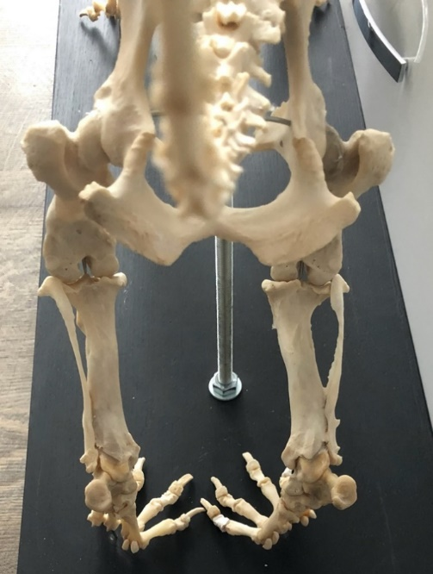
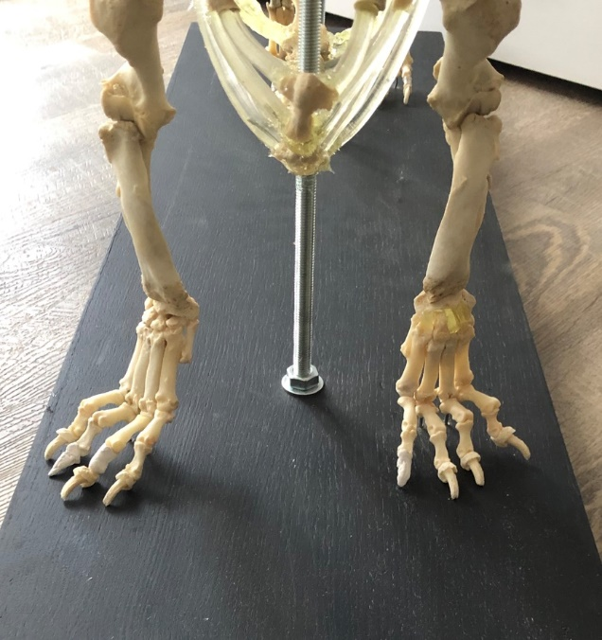
Completion of the articulation also demonstrated that this dog has angular limb deformities in both fore and hind limbs. The forelimbs exhibit a valgus deformity (Figure 12) resulting in the distal limb turning outwards something not uncommon to Basset Hounds (Denny and Butterworth 2008). The hindlimbs show a varus deformity (Figure 13) resulting in the distal limbs turning inwards which has been described in dachshunds (Jaeger et al 2007, Johnson et al 1989), another chondrodysplastic dog breed.
Figure 13. Caudal view of the hindlimbs showing the varus limb deformity in both hindlimbs

RVC Manuscript number is CBS_02195.

REFERENCES:

Bellows, J., Colitz, C., Daristotle, L., Ingram, D., Lepine, A., Marks, S., Sanderson, S., Tomlinson, J., Zhang, J. (2015) Common physical and functional changes associated with aging in dogs. Journal of the American Veterinary Medical Association. 246. 67-75.

Denny, H.R. and Butterworth, S.J. (2000) The Radius and Ulna. In A Guide to Canine and Feline Orthopaedic Surgery. Wiley Blackwell Publishing . Pp 397-399

Evans, H.E., Christensen, G.C. (1979) Miller’s Anatomy of the Dog (Second Edition). W.B. Saunders Company. Pp174-177.

Geocel (2020) Geocel theWorks Multi-use sealant and Adhesive [online]. Sheffield, Sherwin-Williams Diversified Brands Limited. Available from:
https://www.geocel.co.uk/products/geocel-theworks-multi-use-sealant-adhesive/ [Accessed 13th May 2020]

Gough, A., Thomas, A. (2004) Breed Predispositions to Disease in Dogs and Cats (First Edition). Blackwell Publishing Ltd. pp 17-19

Jaeger, G.H., Marcellin‐Little, D.J. and Ferretti, A. (2007) Morphology and correction of distal tibial valgus deformities. Journal of Small Animal Practice, 48: 678-682.

Johnson, S.G., Hulse, D.A., Vangundy, T.E. and Green, R.W. (1989) Corrective Osteotomy for Pes Varus in the Dachshund. Veterinary Surgery, 18: 373-379.

Meij, B.P. (2012) Spondylosis and Spinal Abnormalities: When Are They Relevant?. In: WSAVA/FECAVA/BSAVA World Congress 2012. Utrecht, The Netherlands. Available from: https://www.vin.com/apputil/content/defaultadv1.aspx?pId=11349&catId=34765&id=5328287&ind=405&objTypeID=17&print=1 [Accessed 15th May 2020)

Michell, A.R. (1999) Longevit of British breeds of dog and its relationships with‐sex, size, cardiovascular variables and disease. Veterinary Record, 145: 625-629.

