Journal of the Institute of Anatomical Sciences 18 (2017)

TECHNICAL PAPER

From cadaver to museum plinth:

A novel method of articulating an ostrich skeleton
S. NICOLL* & A. CROOK**

Anatomy, Department of Comparative and Biomedical Sciences, Royal Veterinary College

The Lanyon Museum of Comparative Anatomy at the Royal Veterinary College (RVC) displays an extensive collection of articulated skeletons many of which are produced and presented in-house by the anatomy technical staff. Using an ostrich (Struthio camelus) cadaver, we detail novel and inexpensive methods for skeleton preparation and articulation to provide a valuable teaching resource. We also summarize alternative techniques and their advantages and disadvantages. Our ostrich skeleton is now displayed in The Lightwell at the RVC’s Camden campus, and is accessible as a teaching tool for a broad range of scientific staff and students.

Keywords: Ostrich, Struthio camelus, osteology, skeleton, articulation, maceration

INTRODUCTION

The Royal Veterinary College’s (RVC) Department of Comparative Biomedical Sciences (CBS) displays a wide array of specimens in The Lanyon Museum of Comparative Anatomy (LMCA) at the college’s Camden campus. These specimens range from fully articulated skeletons to museum pots and plastinates. It is a valuable resource as anatomy comprises a considerable portion of many RVC students’ basic science studies and provides a strong foundation for later clinical studies.

The collection of articulated skeletons in the LMCA is maintained and regularly added to by the anatomy technical staff. The use of articulated skeletons in teaching has been shown to be extremely valuable for cognitive learning (Tefera, 2011). They are particularly useful in veterinary anatomy because they illustrate the wide variety of species students must learn about, and the considerable anatomical differences between these species.
Osteological specimens can be relatively inexpensive to produce when materials are readily available. Here we use an ostrich (Struthio camelus) cadaver to describe methods of producing a fully articulated skeleton. The methods of maceration and articulation used for this project were new to the RVC and were chosen over more traditional methods in order to assess their effectiveness. Several alternative methods for efficiently producing osteological specimens have been described by Hendry (1999), Solovyev (2013) and Sullivan (1999). These and other techniques are detailed in Appendices 1, 2 and 3 along with their advantages and disadvantages. Ostrich cadavers are frequently available as these birds are popular livestock and an attractive biomechanical research model (Chadwick et al., 2014). The end-product will provide a useful teaching and research resource as well as being a welcome addition to the RVCs collection.

METHODS

Overview. We have summarized the main stages of the process in Table 1. Sources of key pieces of equipment and consumables used during the project are summarized in Appendix 4.
Sourcing of cadaver. The 140kg 18-20 years old adult male died suddenly on an ostrich farm in Buckinghamshire. The cadaver was transported to the RVC pathology department on 14th February 2012 for a post-mortem. With permission from the owner, muscle samples were retained for research

purposes and the cadaver was transported to the RVCs Camden campus to be used as a teaching resource.

Maceration. We extensively de-bulked soft tissues via dissection to reduce mass, enable disarticulation into smaller sections, and accelerate the maceration process. Bones and sections were labeled for easy identification via long lengths of baler twine allowing card labels to remain external to the maceration processes. We maintained the correct anatomical order of vertebrae and ribs using baler twine tethering before maceration. All de-bulked sections were immersed in covered plastic containers full of horse manure. The container lids were perforated to allow aerobic decomposition and methane by-products to escape. We stored the containers in a well-
ventilated area away from offices and teaching spaces.

Maceration was continued for several months and we regularly inspected bones (~ every 2 weeks) to assess progression. Containers were topped up with water when required to prevent the manure drying out and slowing decomposition. Smaller bones were first to complete maceration (~ 4 weeks) and therefore removed from the manure. We observed several bones of the maxilla and mandible to be broken after soft-tissue maceration, and these fractures likely occurred during post- mortem transportation. Maceration was deemed to be complete when all of the soft tissues had been removed from the bones either mechanically or by decomposition.

Table 1: Stages of the project
Stage | Process | Description
1 | Maceration | Removes soft tissues from the bones.
2 | De-greasing | Removes grease from the bones
3 | Bleaching | Provides a clean and aesthetically pleasing finished skeletal product
4 | Articulation | Presenting the bones in an anatomical or aesthetically pleasing position

De-greasing. Manure provided adequate de- greasing for small and flat bones. After ~ 4 weeks of maceration, we removed marrow-rich long bones and drilled holes through articular surfaces at each end. We aligned holes across the long bones so we could use them to insert metal support rods during articulation. These holes allowed both flush (warm water and detergent) and rigid wires to further clear the medullary cavity. Long bones were then returned to the manure with the holes enhancing deep tissue maceration and de-greasing. After ~ 4 months all bones were removed from the manure and washed in water prior to bleaching.

Bleaching. We immersed de-greased bones in a container of 3% solution of hydrogen peroxide (H2O2) (~24-48 hours). Bleaching was complete once the hydrogen peroxide solution had ceased bubbling. On removal from the hydrogen peroxide, bones were rinsed and air-dried. Once dry, bones were bagged and stored, ensuring labels were consistently maintained, until all parts of the skeleton were bleached and dried.

Articulation. To enable accuracy in our articulated ostrich skeleton, we gained a detailed understanding of avian structure including the key skeletal differences from mammals and a realistic articulated posture using a number of sources: Bezuidenhout, 1999; Smith et al., 2006; Pop et al., 2007; and Tivane, 2008.

Supporting materials. We used an 8mm stainless steel threaded rod (M8) as the primary long-bone support (Figure 1). Rod selection was governed by combining requirements for strength to support skeletal weight, a small enough diameter to allow intramedullary passage, and sufficient malleability for optimal positioning. A 6mm stainless steel threaded rod (M6) was selected for the vertebral column (Figure 1). Rods were cut to size using a small hacksaw and connected using nuts and washers. We also used 2mm galvanized steel wire (Figure 2), 1mm steel wire, cyanoacrylate
Correspondence to:
*Sarah Nicoll, snicholl@rvc.ac.uk; &
**Andrew Cook, acook@rvc.ac.uk

Journal of the Institute of Anatomical Sciences 18 (2017)

and hot glue gun adhesive to articulate any smaller bones, and sealant. Additionally a bespoke presentation plinth was created from softwood
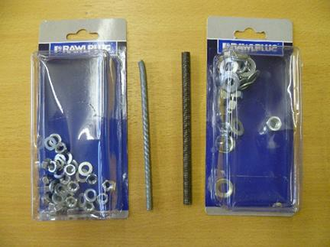
Figure 1: Examples of M6/M8 supporting rods, washers and nuts
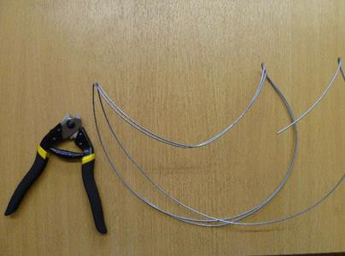
Figure 2: 2mm galvanized steel wire and wire cutters

Long bones (pelvic limb). We passed 8mm rods through each long bone utilizing the previously drilled holes, but widening the hole with a cylindrical file where necessary and twisting the bones/rods to ease passage (Figure 3). We bent the rods as required to enable articular surfaces of the bones to meet (Figure 4). Joint angles were selected by comparing to images of natural standing ostrich postures (Daniels (2010), National Geographic (2015)). Once the long bones of the pelvic limbs were connected, each limb was mounted on the plinth. The limbs were secured to the plinth using nuts and washers (Figures 5 and 6).

Synsacrum. We articulated the synsacrum by ensuring femoral rods were protruding (~20cm) cranially out of the femoral head (Figure 6). The highly pneumatic (with natural perforations and hollow spaces) synsacrum could be easily threaded onto rods without pre-drilling (Figure 7). However we restricted range of motion of the coxofemoral joint by drilling vertically and inserting additional

boards and finished with varnish. Appendix 4 summarizes the equipment and consumables used and their sources where appropriate.

roads that connected the femoral head and synsacrum, before filling the joint area with sealant.

Vertebral column. We assembled the vertebral column caudocranially. 2mm holes were drilled through successive vertebral bodies and threaded together using 2mm wire. We drilled an additional 2mm hole on the caudal edge of the synsacrum and connected the first caudal vertebrae with 2mm wire and hot glue adhesive (Figure 8). We threaded the thoracic and caudal cervical vertebrae as far cranially as C12 onto a 6mm rod using the vertebral canal. The remaining cervical vertebrae were connected using 2mm wire that we passed through the vertebral bodies (Figures 9 and 10) as far caudally as C14. We provided overlap between rod- supported and wire-supported vertebrae to prevent a significant stress-riser.

Ribs. 2mm holes were drilled in the proximal and distal ends of each rib and on the corresponding points of the vertebrae and keel, before 2mm wires were used to connect them (Figures 11, 12 and 13).

Wings. The wings (Figure 14) were articulated using 2mm wire which was passed through the long bones where possible (smaller bones were glued), bent at the appropriate angle and secured in place using hot glue adhesive. Each wing was articulated with its respective coracoid and then the coracoid was secured to the cranial aspect of the sternum using 2mm wire (Figure 15).

Skull. We used cyanoacrylate to articulate and connect the bones of the skull. An existing articulated ostrich head within the RVC collection was used for comparison to correctly articulate the 22 individual bones (Figures 16 and 17) and scleral ossicles (Figure 18). Once complete the scleral rings were suspended inside of the orbit using 1mm wire (Figure 19). The skull was attached using a single length of 1mm wire through the foramen magnum to the base of the atlas vertebrae and then secured with hot glue (Figure 20).

Hyoid and phalanges. The hyoid apparatus and phalangeal bones were applied to the skeleton last, using hot glue and 2mm wire respectively. The claws were washed and varnished before slotting them onto the distal phalanges. The phalanges were wired to each other and the tarsometatarsus proximally, and distally secured to the plinth.

Once fully articulated we sealed all joint surfaces with a strong clear sealant for aesthetic reasons and to reduce joint mobility.

At every stage of preparation and articulation, Health and Safety Association (H.S.A) procedures were strictly abided by at all times, including necessary and appropriate personal protection and equipment training (including power tools).
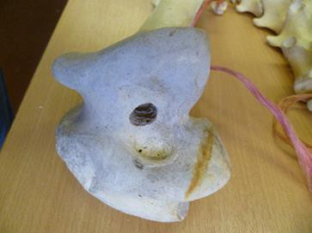
Figure 3: Example of hole drilled into the distal end of a femur for degreasing and articulation
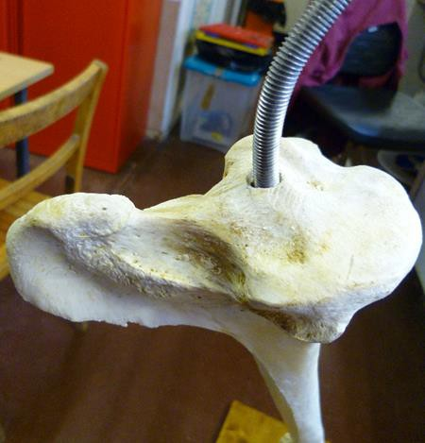
Figure 4: M8 support rod emerging from the proximal articular surface of the tibiotarsus, bent to an appropriate angle to articulate with the femur

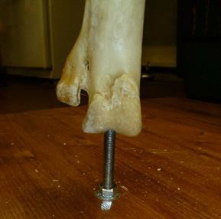
Figure 5: M8 support rod emerging from the distal end of the tarsometatarsus and secured to the plinth

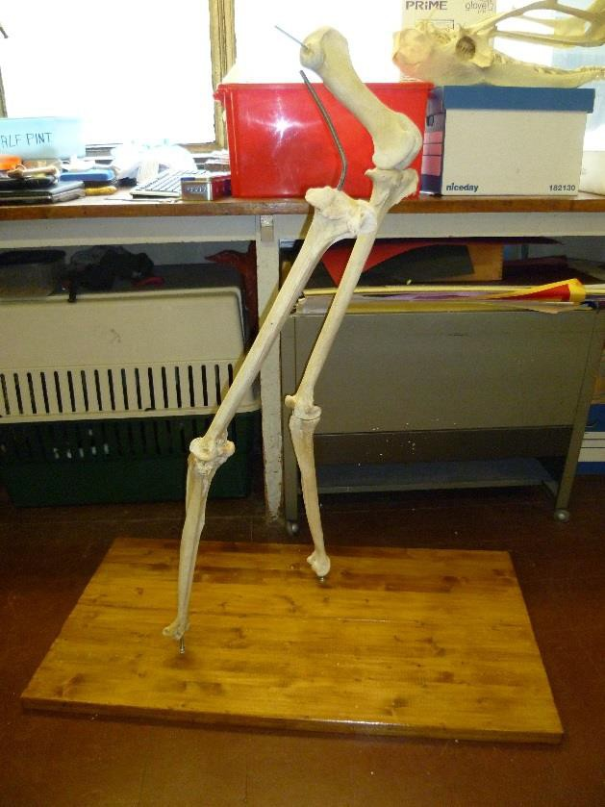
Figure 6: Both pelvic limbs secured to the presentation plinth

Journal of the Institute of Anatomical Sciences 18 (2017)

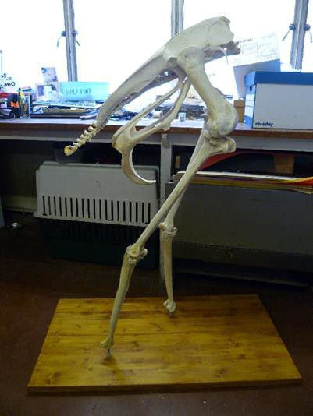

Figure 7: Synsacrum attached to pelvic limbs

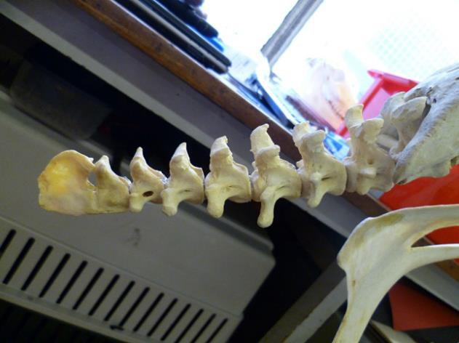
Figure 8: Caudal vertebrae attached to caudal edge of synsacrum

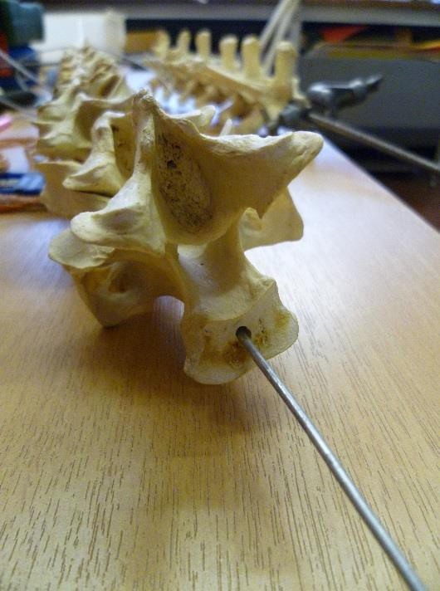
Figure 9: 2mm galvanized steel wire shown passing through the cervical vertebrae (foreground) and M6 support rod passing through vertebral canal of thoracic vertebrae (background)
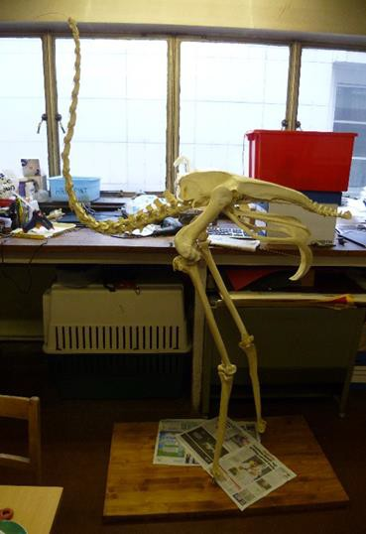
Figure 10: Thoracic and cervical vertebrae have been attached to the cranial aspect of the synsacrum

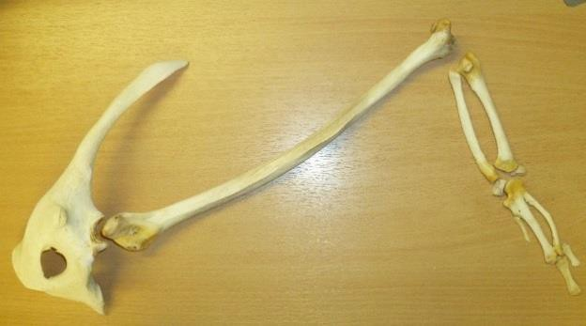

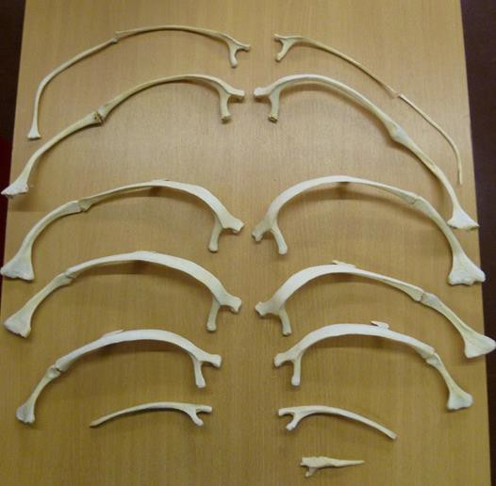
Figure 11: Ribs (sternal and thoracic)
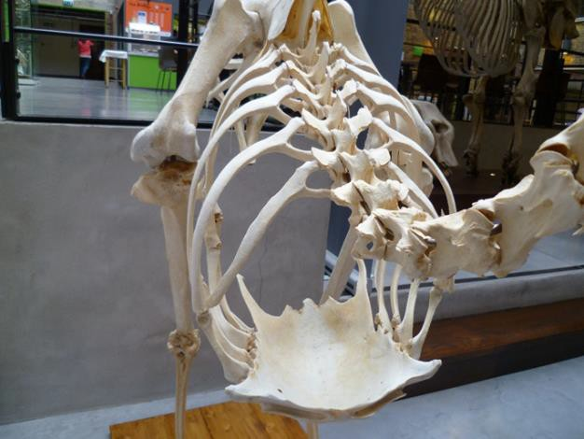
Figure 12: Ribs attached to thoracic vertebrae and keel (cranial view)
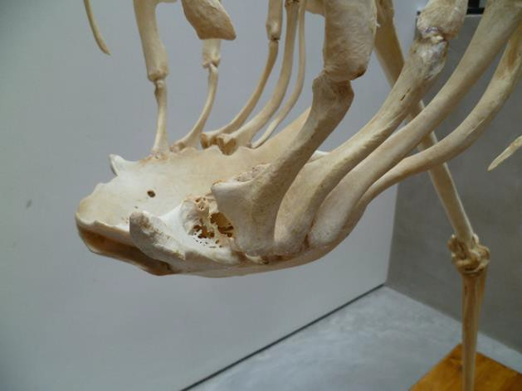
Figure 13: Ribs attached to keel (lateral view)
Figure 14: Left wing and coracoid prior to articulation
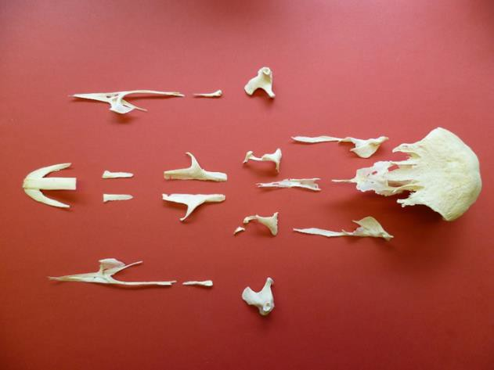
Figure 16: Bones of the skull
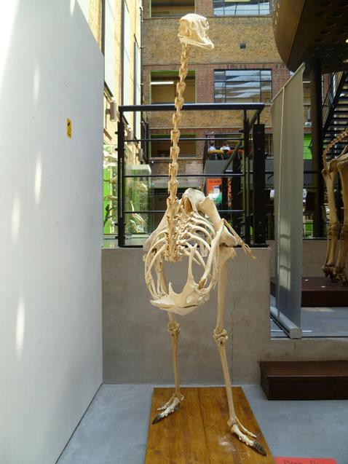
Figure 15: Left wing articulated with skeleton

Journal of the Institute of Anatomical Sciences 18 (2017)

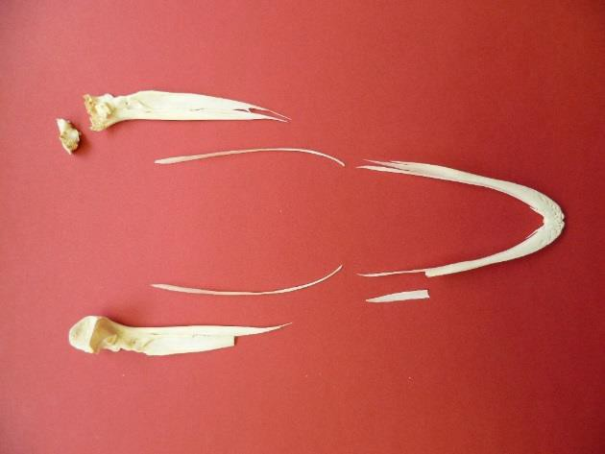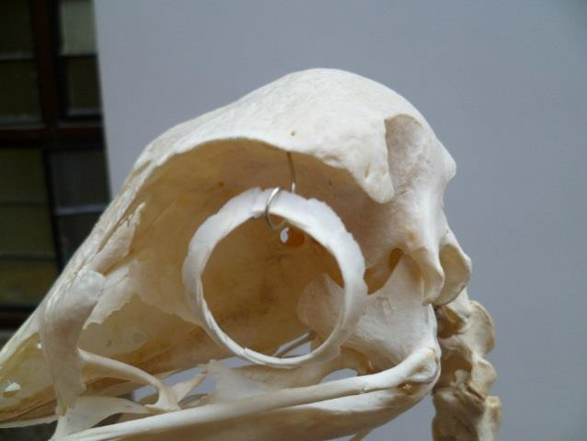

Figure 17: Bones of the mandible
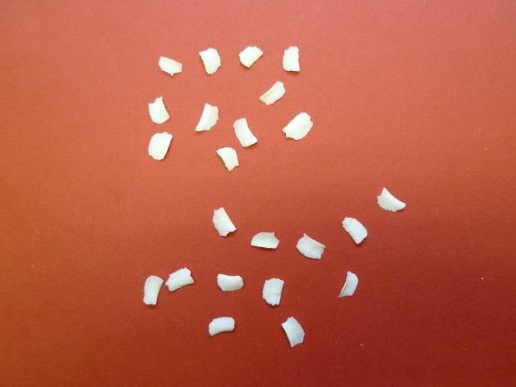
Figure 18: Scleral ossicles
Figure 19: Scleral ring suspended in the orbit
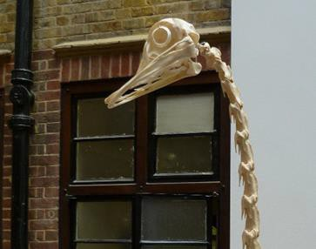
Figure 20: Skull successfully articulated with the atlas

EVALUATION AND DISCUSSION

Articulation was completed on 5th July 2013 and the ostrich skeleton remains on permanent display in The Lightwell (a social learning space) which is immediately adjacent to the LMCA at the RVCs Camden campus (Figure 21). An accompanying sheet of ostrich skeletal facts is displayed alongside the specimen. Although we consider the postural display to be realistic, some instability has led to mild postural pitch. This could have been avoided by using a slightly deeper (>2.5cm), hardwood plinth.

Overall, by articulating using methods that reduce visible external support, we have an effective and aesthetically pleasing result. Manure maceration has provided a useful and low-cost addition to the methods of osteological preparation already practiced in the RVC. The skeleton receives regular positive comments from staff, students and visitors.

According to The Leiden Declaration on Human Anatomy/Anatomical Collections (2012), a letter
from the participants, delegates and supporters of the International Conference on “Cultures of Anatomical Collections” states that there is unfortunately a general decline in the number and condition of anatomy museum collections worldwide. However the RVC is proud of the LMCA which houses a wide anatomical collection that is well used by staff and students.

Marreez et al. (2010) suggest that medical museums can serve as powerful tools for self- directed learning and reviewing anatomy. This is also suggested by the many RVC students which can be seen using the LMCA to carry out their own private study. Small group teaching sessions also take place there and specimens (osteological, potted and plastinated) are frequently loaned for use in teaching elsewhere in the college.

It is hoped the collection at the LMCA will continue to grow and adapt with changes in teaching practices, curriculum and technology.

ACKNOWLEDGEMENTS

The authors would like to thank the farmer who donated the ostrich cadaver to the RVC for teaching purposes. Also thanks go to Ben Garrod for suggesting we trial the maceration and articulation methods used in this project. Lastly thanks go to Jo Gordon, Rebecca Norman and Samantha Saunders for proof reading and suggesting edits to this manuscript.

REFERENCES
Allen, E. R. and Neill, W. T. (1950) 'Cleaning mammal skeletons with meal worms', Mammology, 31, 1.

Banta, B. H. (1961) 'The use of clothes moth larvae (Lepidoptera: Tineidae) to prepare osteological specimens, with an annotated bibliography on the use of other arthropods for vertebrate skeletal preparation', Journal of Biology, 19, 3.

Bezuidenhout, A. J. (1999) 'Anatomy' in Deeming, D. C., ed., The Ostrich: Biology, Production and Health, Wallingford, Oxon, UK: CABI Publishing, 38.

Chapman, D. I. and Chapman, N. (1969) 'The use of sodium perborate tetrahydrate (NaBO3.4 H2O) in the preparation of mammalian skeletons', Journal of Zoology, 159, 2.

Daniels, D. (2010) 'Ostrich Male RWD', [online], available: https://commons.wikimedia.org/wiki/File:Ostrich_ male_RWD.jpg [accessed 27th June 2015].

Egerton, C. P. (1968) 'Method for the preparation and preservation of articulated skeletons', Turtox News, 46(5), 2.

Fenton, T. W., Birkby, W. H. and Cornelison, J. (2003) 'A Fast and Safe Non-Bleaching Method for Forensic Skeletal Preparation', Journal of Forensic Science, 48(1), 3.

Finlayson, H. H. (1932) 'A simple apparatus for degreasing bones for museum purposes', in Transactions of the Royal Society of South Australia, 172-174.

Geographic, N. Ostrich (struthio camelus) [online], available: http://animals.nationalgeographic.com/animals/bi rds/ostrich/ [accessed 27th June 2015].

Hendry, D. (1999) 'Chapter 1: Care and Conservation of Natural History Collections' in Carter, D. and Walker, A., eds., Vertebrates, Oxford: Butterworth Heinemann, 1-36.

Huthman, I. O., Shoyebo, O., Akinbowale, O., Ajayi,
R. T., Huthman, A. S., Adenowo, T. K. and Adefule,
A. K. (2009) 'Monosodium Glutamate: A good replacement for hydrogen peroxide in bone preparations', The Internet Journal of Biological Anthropology [online], 4(1)available: [accessed 27th June 2015]

Majeed, Z. Z. (2009) 'Maceration of Delicate Osteological Material by Fly Larvae', Journal of Animal and Veterinary Advances, 8(11), 3.

Marreez, Y. M. A. H., Willems, L. N. A. and Wells, M.
R. (2010) 'The role of medical museums in contemporary medical education

Anatomical Sciences Education Volume 3, Issue 5',
Anatomical Sciences Education [online], 3(5), 249-
253, available:[accessed 27th June 2015].

Museum, N. H. Flesh Eating Beetle Fact File [online], available: http://www.nhm.ac.uk/kids- only/naturecams/beetlecam/beetle- facts/index.html [accessed 27th June 2015].

Museum, N. H. Skeleton Preparation [online], available: http://www.nhm.ac.uk/research- curation/collections/our-collections/vertebrate- collections/bird-group/anatomical- collections/skeleton-collection/helpful-beetle- colonies/index.html [accessed 27th June 2015].

Participants, Delegates and Supporters (2012) 'The Leiden Declaration on Human Anatomy/Anatomical Collections', in International Conference on "Cultures of Anatomical Collections", Leiden, Leiden University, 5.

Pop, C. and Pentea, M. (2007) The osteological features of the skeleton in ostrich (struthio camelus), unpublished thesis (XL), LUCRĂRI STIINłIFICE MEDICINĂ VETERINARĂ.

Post, L. FAQ [online], The Boneman.com, available: http://www.theboneman.com/FAQ.html [accessed 27th June 2015].

Journal of the Institute of Anatomical Sciences 18 (2017)

Scharff, R. F. (1911) 'On a dry system of macerating bones', Museums Journal, 10(7), 198-200.

Simonsen, K. P., Rasmussen, A. R., Mathisen, P., Petersen, H. and Borup, F. (2011) 'A Fast Preparation of Skeletal Materials Using Enzyme Maceration*

Journal of Forensic Sciences Volume 56, Issue 2', Journal of Forensic Sciences [online], 56(2), 480- 484, available: [accessed 27th June 2015].

Smith, N. C., Wilson, A. M., Jespers, K. J. and Payne,
R. C. (2006) 'Muscle architecture and functional anatomy of the pelvic limb of the ostrich (struthio camelus)', Journal of Anatomy, 209, 14.

Solovyev, V. A., Sergeyev, A. A., Zhiryakov, A. S. and Rukavishnikova, T. L. (2013) 'A method of

preparation of osteological specimens of mammals and birds', Russian Journal of Theoriology, 12(1), 6.

Sullivan, L. M. and Park Romney, C. (1999) 'Cleaning and Preserving Animal Skulls', Cooperative Extension(AZ1144), 4http://extension.arizona.edu/pubs/az1144.pdf [accessed 27th June 2015].

Tefara, M. (2011) 'Enhancing cognitive learning in Veterinary Osteology through student participation in skeleton preparation project', Ethiopean Veterinary Journal, 15(1), 15.

Tivane, C. (2008) The morphology of the oral cavity, pharynx and oesophagus of the ostrich (struthio cumulus), unpublished thesis (Master of Science), University of Pretoria.

APPENDIX 1: MACERATION TECHNIQUES (ADVANTAGES AND DISADVANTAGES)

Technique | Method | Advantages | Disadvantages
Hot water (Fenton, 2003; Hendry, 1999; Solovyev,  2013; Sullivan, 1999) | immerse in water (60-70˚C) | minimal labour, fast, easy to monitor, particularly suitable for mature or cartilaginous skeletons | delicate specimen damage and/or shrinkage particularly if water boils
Cold water (Hendry, 1999; Sullivan, 1999) | immerse in water ((1-4°C) | will not shrink or damage minimal labour | slow, smelly, teeth will most likely fall out
Burial in soil | bury in the ground | minimal labour, useful for very large specimens
 |  |  | slow
Burial in sand  (Hendry, 1999; Scharff,  1911) | bury in sand | minimal labour | slow
Flesh-eating dermestid beetles  (Dermestes maculatus)  (Hardy, 1999; NHM, 2013;  Sullivan, 1999; Solovyev,  2013) | place specimens in appropriate container with a beetle colony | delicate specimens remain intact  fast (4kg of flesh per week) popular with museums | maintenance of colony, escaped beetles can damage furniture and buildings
Fly larvae (Majeed, 2009) | place specimen in jar with fly larvae and cover with porous material | inexpensive, suitable for delicate specimens | difficult to dispose of beetle and larvae once maceration complete
Hydrogen peroxide (NHM, 2013) | immersion |  | damage or alter bone material properties
Sodium perborate tetrahydrate  (Chapman, 1969; Hendry,  1999; Soloveyv, 2013) | pour boiling water onto bones and dry sodium perborate tetra hydrate then seal container | reduced smell | can be expensive (Solovyev, 2013), can result in bones becoming soft and chalky
Manure | immersion | minimal labour | slow
Enzymes (Fenton, 2003;  Hendry, 1999; Simonsen,  2011) | Incubation of bones at 37-50˚C | quick | smell, denaturing the enzymes can lead to bone damage, possible discolouration
Sodium decahydrate tetraborate (borax) (Solovyev, 2013) | dissolve borax in water (70-80˚C) and then immerse specimens | very quick, inexpensive, no need for de-greasing or bleaching

Journal of the Institute of Anatomical Sciences 18 (2017)

APPENDIX 2: DEGREASING TECHNIQUES (ADVANTAGES AND DISADVANTAGES)

Technique | Method | Advantages | Disadvantages
Acetone  (Adams, 1986; Hardy  1999; Solovyev, 2013) | immersion |  | flammable
Detergent (Hendry, 1999;  Fenton, 2003) | immersion | inexpensive
Vapour Degreaser (Finlayson, 1932; Hardy,  1999) |  |  | expensive, explosive
Ammonia  (Fenton, 2003; Post, 2005) | immersion

APPENDIX 3: BLEACHING TECHNIQUES (ADVANTAGES AND DISADVANTAGES)

Technique | Method | Advantages | Disadvantages
Ammonia hydroxide (Solovyev, 2013)
Household bleach/chlorine (Sullivan, 199) | immersion | inexpensive | can dissolve bone tissue
Hydrogen peroxide (Hardy, 1999; Huthman, 2009;  Simonsen, 2011; Sullivan,  1999) | immersion of bones in a 3- 6% solution of hydrogen peroxide | quick | depending on location availability and cost may be prohibitive
Monosodium glutamate (MSG) (Huthman, 2009) | immersion 2% concentration | inexpensive, easily available
Sunlight (Sullivan, 1999) | Place outside in direct sunlight | inexpensive | slow, requires plenty of sunlight

APPENDIX 4: EQUIPMENT AND CONSUMABLES

Equipment/Consumable | Process | Source
Plastic containers (plant troughs and plastic bins) | Maceration | Homebase http://www.homebase.co.uk/en/homebaseuk/garden/pots- and-garden-ornaments/pots-and-planters/terrace-trough--- green---100cm-877930 : http://www.homebase.co.uk/en/homebaseuk/garden/compos ters-and-bins/strata-essentials-black-bin---80l-942081
Manure | Maceration | RVC anatomy teaching ponies and cows
Bosch Drill (PBS 750 RCE) | De-greasing | RVC existing equipment
Drill bit 10mm | De-greasing | RVC existing equipment
Detergent (Fairy Professional Original) | De-greasing | RVC existing consumable
Steel wire | De-greasing | Straightened wire coat hanger
Hydrogen peroxide (H2O2) | Bleaching | VWR
Hacksaw (small) | Articulation | RVC existing equipment
Dremell 300 | Articulation | RVC existing equipment
Dremell drill bit 2mm | Articulation | Amazon  http://www.amazon.co.uk/Dremel-Drill-Bit-Set- Pieces/dp/B0002SMO5Y/ref=sr_1_1?ie=UTF8&qid=14354 24404&sr=8-1&keywords=dremel+drill+bits
8mm threaded steel rod (M8) | Articulation | Metals4U http://www.metals4u.co.uk/fasteners/threaded-rod/a2- stainless-steel/m8-a2-3m-length/detail.asp?prd_id=8989
6mm threaded steel rod (M6) | Articulation | Metals 4U http://www.metals4u.co.uk/fasteners/threaded-rod/a2- stainless-steel/m6-a2-3m-length/detail.asp?prd_id=8988
8mm and 6mm nuts and washers | Articulation | http://www.travisperkins.co.uk/Rawlplug-Nuts+Washers- M8-Pack-20-Zinc-Plated-B-OW-NW-M8/p/936970
2mm galvanised steel wire | Articulation | Romanys LTD http://www.romanys.co.uk/about-us-1- w.asp
1mm steel wire | Articulation | Romanys LTD http://www.romanys.co.uk/about-us-1-w.asp

Journal of the Institute of Anatomical Sciences 18 (2017)

Equipment/Consumable | Process | Source
LocktiteTM Cyanoacrylate | Articulation | Homebase http://www.homebase.co.uk/en/homebaseuk/diy/sealants- and-adhesives/loctite-power-flex-control---translucent---3g- 311062
Bostik Trigger Action Glue Gun | Articulation
Glue (for use in glue gun) | Articulation | Homebase http://www.homebase.co.uk/en/homebaseuk/stanley-glue- sticks---113mm 24-pack-138199
Sealant (Ever Build Stixall Extreme Power - Crystal Clear) | Articulation | Romanys LTD http://www.romanys.co.uk/about-us-1-w.asp
Softwood pine boards x2 | Articulation | Homebase http://www.homebase.co.uk/en/homebaseuk/unfinished- pine-shelf-board 120-x-30cm-901677
Ronseal Dark Oak Satin Varnish | Articulation | Homebase http://www.homebase.co.uk/en/homebaseuk/ronseal- interior-varnish-gloss-dark-oak---250ml-211481

