Journal of the Institute of Anatomical Sciences 18 (2017)

TECHNICAL REPORT

Creating a Teaching Aid for Ferret Reproductive and Adrenal Anatomy
R.T. NORMAN* & S. NICOLL**

Comparative Biomedical Sciences, Royal Veterinary College, London

The ferret (Mustela putorius furo) is a species often overlooked in veterinary teaching as it is not one of the core domestic species traditionally taught on vet programs. Ferrets are popular pets in the UK and US thus it is likely they will increasingly present to small animal general practitioners requiring advice and treatment. Ferret reproductive behaviour and physiology can be inconvenient for owners and can present health risks if not managed appropriately (Sherrill and Gorham, 1985). Surgical neutering is one way to control reproduction, it is a controversial procedure in ferrets as early neutering is a potential risk factor for development of primary hyperadrenocorticism (Schoemaker et al., 2000). Therefore a good working knowledge of the reproductive and adrenal systems in the ferret is clinically relevant, and a teaching aid was required specifically to demonstrate this. The teaching aid consisted of a ferret cadaver that had been embalmed, dissected to show the urogenital tract and adrenal glands and then subsequently plastinated. A poster was produced to accompany the plastinated ferret detailing reproductive issues which arise in this species and how to control them.

Keywords: Ferret, embalming, dissection, plastination, reproduction

INTRODUCTION

Ferrets are a popular pet in both the UK and USA, with estimates of approximately 748,000 pet ferrets in the US in 2012 (Shaumberg, 2012). Consequently ferrets are commonly encountered in small animal and exotics veterinary practice. Several clinically important issues are related to reproductive anatomy and physiology in the ferret. The ferret is a long day polyoestrus breeder and an induced ovulator (Wolf, 2009). If a ferret is not bought out of oestrus by mating or medical management the high levels of oestrogen produced by the ovaries can suppress bone marrow and cause aplastic anaemia which may be life threatening (mortality 40%) (Sherrill and Gorham, 1985). One way of preventing this is surgical neutering which is a commonly performed procedure. A potential
disadvantage of neutering is that age at neutering is significantly correlated with age at onset of primary adrenal disease, suggesting that neutering may contribute to the onset of primary hyperadrenocorticism. Prevalence of this in the ferret is estimated at 0.55% (Schoemaker et al., 2000).
Therefore it is of importance that ferret reproductive and adrenal anatomy is taught to veterinary students. Our aim was to create a teaching aid for this purpose consisting of a dissected and subsequently plastinated ferret to show the urogenital system and adjacent adrenal glands.

METHODS

The body of an unfixed, frozen female ferret was donated to the RVC by a wildlife hospital in Essex, UK for teaching purposes. The cause of death was unknown. There were no external abnormalities although the ferret was noted to have a swollen vulva. Upon dissection it was noted that internally

Correspondence to:
*Rebecca Norman- norman@rvc.ac.uk &
** Sarah Nicoll- nicoll@rvc.ac.uk

the left kidney was misshapen and discolored at the caudal pole, but no other abnormalities were detected.
The ferret cadaver was embalmed using Syn Cav which is a cavity embalming fluid produced by The Dodge Company Inc. The fluid was injected using a 20ml syringe and fine needle into the abdominal (approx. 80mls) and thoracic (approx. 30mls) cavities, and also in smaller quantities (approx. 1ml) at multiple points subcutaneously throughout. The cadaver was then washed with a simple detergent and sprayed with Dis Spray, a disinfectant embalming spray also produced by The Dodge Company Inc. The cadaver was positioned in dorsal recumbency, left until firm and then bagged and stored in a cold room until needed for dissection.
At dissection a ventral midline skin incision was made from the xiphoid process to the pubis, the linea alba was located and a stab incision made into it. The stab incision was then lengthened with Mayo scissors from the xiphoid process to pubis. Cranial to the umbilicus care was taken to transect the falciform ligament from the body wall to allow the body wall to be detached from the liver.
From this access point into the abdominal cavity a window was created to view the abdominal organs. Mayo scissors were used to cut through the body wall (including skin and abdominal musculature) along the edge of the last rib from medial to lateral to a point approximately half way dorsoventrally on the abdomen. The incision through the body wall was then continued by cutting in a caudal direction to the inguinal region and then from there in a medial direction to a point just cranial to the pelvic symphysis. This was repeated on the contralateral side. This created a roughly rectangular window exposing the abdominal organs.
The gastrointestinal tract was removed by transecting the oesophagus at the level of the oesophageal hiatus in the diaphragm, transecting the rectum as far caudally as possible within the abdominal cavity. The tract was removed by transecting the serous membranes suspending it from the dorsal body wall (namely the mesoduodenum, root of the mesentery, mesocolon and mesorectum) and that attaching the stomach to the liver (lesser omentum). The pancreas was removed along with the tract.
The urogenital tract was thus exposed and left intact. Fat surrounding the kidneys, ureters and adrenal glands was carefully removed to aid visualisation of the tract.

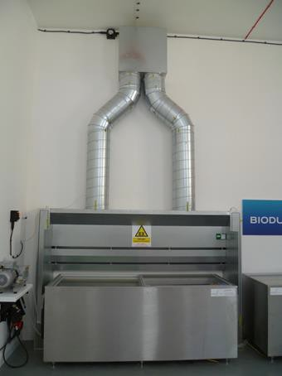
Figure 1 The dehydration freezer in the RVC plastination suite
In this particular specimen a dissection of the thorax was also conducted so it could be used for other teaching purposes but as this was not the main aim of producing this learning resource it will not be discussed further here. Following dissection the specimen was sprayed with Dis Spray, bagged and returned to storage until plastination could begin. The specimen was plastinated over a 6 week period and involved 3 stages: dehydration, silicone impregnation, and curing.
During dehydration the specimen was placed in acetone within a freezer at a temperature of -22°C (figure 1). The purpose was to replace all the tissue fluid/water in the specimen with a solvent (DeJong et al, 2007) in this case acetone. This technique is called freeze substitution (Brown et al, 2002). It was achieved by regularly exchanging the acetone the specimen was immersed in until the acetone concentration remained at 100%. Acetone concentration was monitored using an acetonometer and measuring cylinder (figure 2).

Journal of the Institute of Anatomical Sciences 18 (2017)

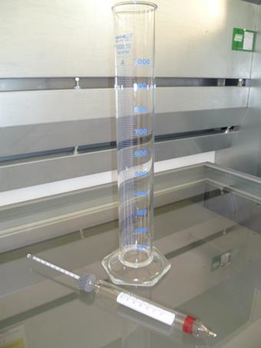
Figure 2 Acetonometer and measuring cylinder for monitoring acetone concentration during dehydration
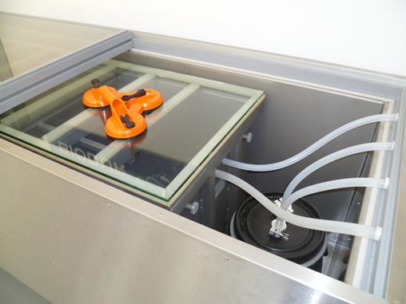
Once the specimen was fully dehydrated it was removed from the acetone and submerged in a container of BIODUR® S10 (a silicone polymer) and BIODUR® S3 (a hardener). The container was then placed in a vacuum chamber at -22°C (figure 3). The level of vacuum placed on the chamber was slowly increased over a period of approx. 21 days. The application of a vacuum causes the acetone to vaporize and become extracted from the specimen. This leaves a tissue void which the polymer is drawn into (Henry et al, 1993). Silicone impregnation was considered complete when all the acetone had been drawn away from the specimen, which was evident when there were no further gaseous bubbles rising from with the polymer/ hardener mixture.

Figure 3 Glass topped vacuum chamber situated with a freezer for impregnation of the S10/S3 polymer mixture
The specimen was removed from the vacuum chamber and the polymer/hardener mixture and then left to drain for several days. During this time a small comb was used to remove plastic residues from the fur and the whole specimen was regularly wiped in order to remove excess polymer which had risen to the surface.
Once the specimen had ceased exuding excessive amounts of polymer it was placed into the curing chamber (figure 4) where it was exposed to BIODUR® S6, is a gas hardener. The S6 reacts with the silicone polymer/hardener mixture initially on the surface of the specimen and then eventually diffuses into the specimen itself, causing it to harden (Weiglein et al, 1993). Once firm and no longer tacky to touch plastination is considered complete.
A poster was produced to illustrate ferret reproductive issues and associated adrenal disease to accompany the plastinated specimen.
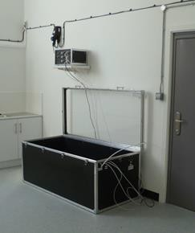
Figure 4 Curing chamber where the specimen is exposed to the gas hardener S6

DISCUSSION

Due to the delicate nature of the structures dissected in this specimen we chose to use a plastination technique. Plastination was developed by Gunther Von Hagens at the University of Heidelberg (Biodur Products, 2015) and is a process that confers two advantages. First, it allows the specimen to be displayed without having to be mounted in a pot to keep it wet. This would come with increased maintenance issues and make the specimen difficult to handle directly. Second, the plastination process makes the specimen more durable and thus the delicate structures are likely to remain intact for longer. A small disadvantage to plastination is the difficulty in retaining the original texture of the fur. We alleviated this to a certain degree with repeated brushing prior to and during curing, however the fur does still retain a slightly waxy quality.
The completed plastinated specimen (figure 5a) displays the desired structures and will prove a useful teaching aid. However the right adrenal gland, although partially visible in this specimen, is difficult to visualise (figure 5b) because the caudal vena cava partially or fully overlies the right adrenal gland ventrally in this species (Holmes, 1961).
Following the success of this project, we plan to process a male ferret to be displayed alongside the female. The plastinated female ferret, and accompanying poster, are currently on display in the Lanyon Museum of Comparative Anatomy at the Royal Veterinary College’s Camden campus (figure 6).

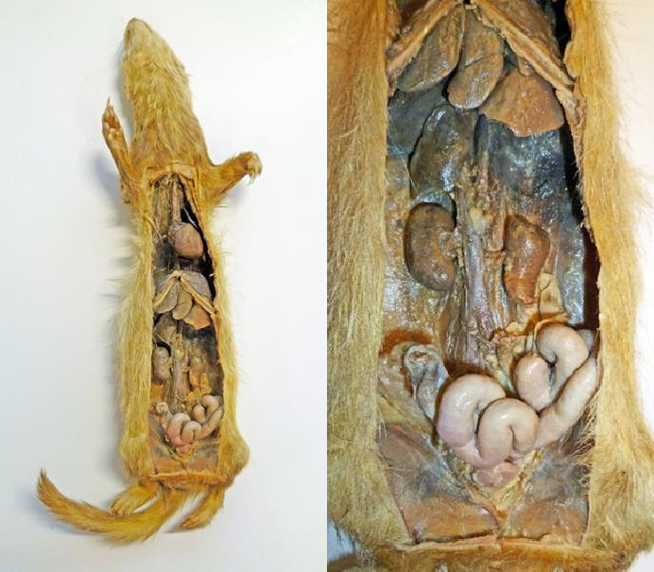
(a)
(b)

Figure 5 ( a) Completed plastinated ferret; (b) Close up view of the urogenital tract and surrounding viscera. Note the misshapen left kidney and restricted view of the right adrenal gland

Journal of the Institute of Anatomical Sciences 18 (2017)

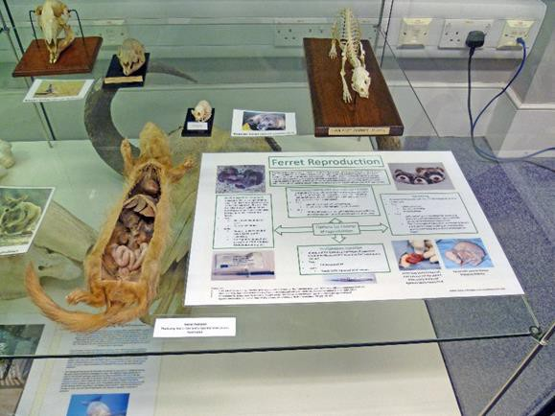
Figure 6 Plastinated ferret and accompanying poster on display at the Lanyon Museum of Comparative Anatomy

ACKNOWLEDGEMENTS

The authors would like to thank the wildlife hospital that donated the ferret cadaver

REFERENCES

Biodur Products (2015) http://www.biodurproducts.com/en/gunther_von
_hagens/inventor_plastination.html (Accessed online 9th July 2015)
Brown MA, Reed RB, Henry RW (2002) Effects of dehydration mediums and temperature on total dehydration time and tissue shrinkage. Journal of the International Society of Plastination. 17:28-33
Henry RW and Nel, PPC (1993) Forced impregnation for the standard S10 method. Journal of the International Society of Plastination. 7:27-31
Holmes RL (1961) The adrenal glands of the ferret,
Mustela putorius. Journal of Anatomy. 95:325–336.

Schaumberg IL (2012) 2012 U.S. pet ownership & demographic sourcebook. American Veterinary Medical Association. In Smith SA, Zimmerman K and Moore DM (2015) Hematology of the Domestic
Ferret (Mustela putorius furo). Veterinary Clinics of North America: Exotic Animal Practice. 18(1):1–8.
Schoemaker NJ, Schuurmans M, Moorman H and Lumeij JT (2000) Correlation between age at neutering and age at onset of hyperadrenocroticism in ferrets. Journal of the American Veterinary Medical Association. 216(2): 195-197.
Sherill A and Gorham J (1985) Bone marrow hypoplasia associated with estrus in ferrets. Laboratory Animal Science. 35(3): 280-6.
Weiglein AH and Henry RW (1993) Curing (Hardening, Polymerisation) of the polymer – Biodur S10. Journal of the International Society of Plastination. 7:32-35.
Wolf TM (2009) Chapter 13- Ferrets. In Manual of Exotic Pet Practice. Saunders Elsevier, St. Louis. Pages 345-374.

