Equine Induced Pluripotent Stem Cells

Dr Debbie Guest^{1,} *

* corresponding author.

¹Centre for Preventive Medicine, Animal Health Trust, Lanwades Park, Kentford, Newmarket, Suffolk, CB8 7UU, UK.

debbie.guest@aht.org.uk

Key words: induced pluripotent stem cells; horses; equine; differentiation; disease modelling; cell therapy; musculoskeletal; myopathies; neuropathies; one health.

Abstract
Horses are kept throughout the world as working animals, competition athletes or to provide pleasure and companionship to their owners. For many injuries, particularly those affecting the musculoskeletal system, horses provide a relevant model for the human conditions and could be used in pre-clinical trials for testing novel treatments. Horses also share hereditary conditions with humans and a one health approach to studying some of these could prove to be very valuable. Equine induced pluripotent stem cells (iPSCs) have been derived by multiple groups and differentiated into a variety of cell types that could be useful for clinical transplantation to aid tissue regeneration and/or disease modelling. In this chapter, the current status on the isolation, characterisation and differentiation of equine iPSCs is discussed along with the current challenges that must be addressed before the full potential of these cells to improve horse health and welfare can be realised.

Introduction
Horses are a leading companion animal throughout the world. In developing countries they are still frequently used for transport and labour, but in developed countries they are now mainly used in competitions, recreational or pleasure riding and to provide companionship to their owners.

The vast array of over 400 different horse breeds that exist today[1] reflects the original purpose that the animal was used for. For example, large draft horses were bred to pull farm machinery and heavy loads, native pony breeds were bred to survive in harsh conditions and provide transport over rough terrain, Thoroughbred racehorses have been bred for speed and stamina and quarter horses have been bred for power and the short bursts of speed required for herding cattle.

The common theme underlying all of these breeds is that to be successful at its job, the horse must be athletic and fit to work. Diseases and injuries can therefore have a significant negative impact on a horse’s competitive career and an economic impact at the population level. Entire industries based around horses now bring in significant economic contributions to countries. For example the UK racing industry supports over 85,000 jobs and contributes £3.5 billion to the UK economy[2].

In addition to injury and disease, 237 hereditary traits have been reported in horses, 132 of which provide potential models of human disease (OMIA: https//omia.org/home/). As the genes and biochemical pathways involved are often conserved across species, findings from equine studies are likely to be of benefit to human medicine. Additionally, in complex human disorders which are caused by both environmental and genetic factors, horses may have exposure to the same environmental risk factors (Figure 1). The detailed breeding records for pedigree horses combined with the large size of their families can make the identification of disease-associated genes easier in horses than in man, and it may prove to be easier to obtain primary cells from horses with inherited diseases than it is from humans.

Novel strategies to aid tissue repair in response to injury or disease-induced damage, along with new tools to study inherited conditions are therefore in demand. As in human medicine, stem cell technology and regenerative medicine strategies may have applications in a wide range of conditions affecting horses. Furthermore, for many tissue injuries, in particular those affecting the musculoskeletal system, horses provide a much better model of the human injury than small lab animal species[3-5]. Horses are long-lived compared to small laboratory species which will allow long term monitoring to determine efficacy and safety. They are genetically outbred compared to laboratory mice and their larger size makes them more anatomically similar, as well as providing more accurate information on any issues that may arise when a stem cell therapeutic product is scaled up for the later stage human clinical studies and post product launch. And, when being tested clinically in horses, the therapy can be used on naturally occurring diseases which is likely to be advantageous to artificially inducing disease models in laboratory species. Therefore, the use of horses for the experimental and clinical testing of stem cell and regenerative medicine products would provide relevant animal models for the translation of therapies to the human field. (Figure 1).
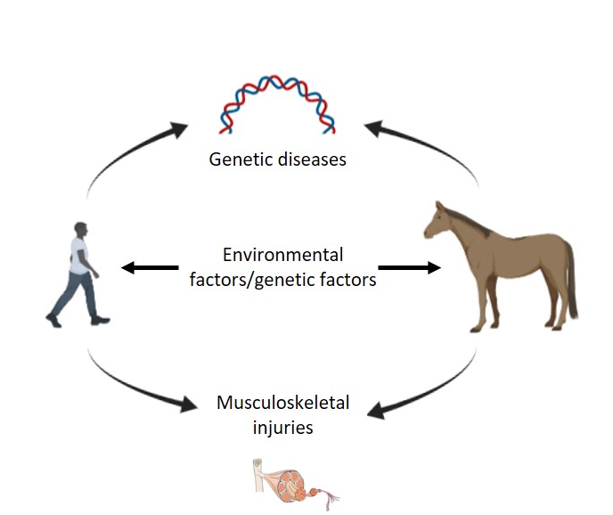

Figure 1. Horses and humans share numerous hereditary disease-associated traits and injuries to musculoskeletal tissues. Horses may therefore provide a relevant large animal model for understanding disease and testing novel therapies.

The most common type of stem cells that have been studied in horses are mesenchymal stromal cells (MSCs). These cells can be isolated from a wide range of tissue sources and have been applied to a range of tissue injuries in horses including: tendon injuries[6, 7], cartilage damage[8] and fractures[9]. While they have historically been used autologously in horses, in 2019 two allogeneic MSC-based therapies were licenced in the UK[10]. While equine MSCs may hold promise to aid tissue regeneration through their trophic effects[8, 11], issues over long-term engraftment exist[12, 13] and their exact mechanisms of action are still unknown[14].

Pluripotent embryonic stem cells (ESCs) and induced pluripotent stem cells (iPSCs) have both been derived from horses. ESCs can be isolated from day 7 blastocyst stage horse embryos[15-19]. By this stage of development, the preimplantation embryo has entered the uterus of the horse and can be flushed out in a minimally invasive technique under standing sedation. This technique is commonly applied in horses used in various sporting activities to allow embryos to be transferred from a high value competition mare to a surrogate mare who can carry the developing foal, thus allowing the biological mother to continue her competition career without interruption[20]. It is significantly easier to access embryos of the correct gestational age for ESC derivation in horses than it is, for example, in dogs and cats, where the blastocyst stage embryos have not yet reached the uterus and must be retrieved surgically by ovariohysterectomy[21-26] or surgical laparotomy followed by flushing of the uterine horns[27]. Despite this, horse ESCs have not been reported widely in the literature which may reflect the fact that they are a relatively expensive research animal to purchase and keep and are seasonal breeders that produce only a single offspring at a time. Therefore, access to enough embryos for ESC derivation can be a limitation.

iPSC technology provided the ability to overcome the expense and ethical issues involved in using horse blastocysts in ESC isolation and there was an initial flurry in the derivation of equine iPSCs by multiple different groups[28-37]. This chapter will outline the derivation and characterisation of equine iPSCs to date, the benefits that they could bring for modelling horse disorders and treating injuries in the clinic and discuss how close we are to achieving these goals.
Derivation of equine iPSCs
Equine iPSCs were first reported in 2011 when a piggybac transposon system was used to overexpress mouse Oct4, Sox2, Klf4 and c-myc in horse fetal fibroblasts[28]. Dermal fibroblasts from both fetal[28, 38], young (foals)[29] and adult[30, 32, 35] horses are the most common cell type which have been used in reprogramming since then. However, keratinocytes[31], myogenic mesoangioblasts[34] and MSCs [33, 34] have also been used successfully. The effect of the starting cell type on the subsequent differentiation potential of the cells has been assessed in one report [34]. The authors found that myogenic differentiation was augmented in iPSCs derived from mesoangioblasts, and chondrogenic differentiation was augmented in iPSCs derived from MSCs. This result supports those from early human studies which demonstrated that the donor cell type could influence differentiation potential of human iPSCs[39] due to the epigenetic memory retained by the cells[40]. However, more recent, large scale studies have found that differentiation potential of iPSC lines is more likely to be attributable to the genetic background of the donor than the tissue type from which the cells were derived[41, 42]. As Quattrocelli et. al., 2016[34] used isogenic cells in their study (i.e. derived from the same animal) they controlled for the effects of genetic background and therefore this is an area that requires further investigation.

All of the reports on equine iPSCs to date have used four factor reprogramming (through overexpression of Oct-4, Klf4, cmyc and Sox2), with the exception of one report which performed the reprogramming without cmyc[30]. In other species, additional reprogramming factors have been utilised, for example Nanog[43] and Lin28[44], to improve reprogramming efficiency. However, the addition of other factors to generate equine iPSCs has not been reported. As Oct-4, Klf4, cmyc and Sox2 are highly conserved between species it has been possible to generate equine iPSCs using both human[30, 32, 34, 35, 38] and murine[28, 29, 31] reprogramming factors. With the exception of the first report on equine iPSCs which used a piggybac transposon system to generate the cells[28], all subsequent reports on equine iPSCs have used integrating viruses (lentivirus or retrovirus) to overexpress the pluripotency factors[29-35, 38]. The use of Sendia virus to provide “footprint-free” iPSCs[45] is commonly used to reprogram human cells but attempts to use it to reprogram equine cells have not been reported.

For clinical translation, footprint-free reprogramming would be critical, as the continued expression of the transgenes could lead to tumour formation[46]. Upon complete reprogramming to pluripotency, viral transgenes should become silenced, leaving only the endogenous genes expressed[47]. Complete silencing of the viral transgenes in equine iPSCs has only been directly shown in one report[34], with another report demonstrating indirectly that the transgenes were silenced[35]. The initial report on the derivation of equine iPSCs found that continued transgene expression was required to maintain pluripotency[28] and the majority of equine iPSCs have variable but persistent transgene expression[29-32].

Characterisation of equine iPSCs
The gold standard test for pluripotency is the ability of cells to contribute to all cell types in the developing embryo. This has successfully been demonstrated for mouse and rat ESCs/iPSCs which can generate germ-line competent chimeras following the injection of the cells into blastocyst stage embryos[48-51]. Mouse ESCs and iPSCs can also generate viable offspring following tetraploid complementation, where the animals are formed entirely from the injected cells[52, 53]. Equine iPSCs have not yet been used in such stringent in vivo tests of pluripotency and in part this may be due to their long gestation time (320 days), single offspring and long time to maturity (2-4 years) which would make such in vivo experiments expensive. Interspecies chimeras taken through to just the fetal stage have been produced from human pluripotent stem cells, following injection of the primed cells into gastrula stage mouse embryos[54] and would provide a more cost effective option than generating full term horse chimeras. However, attempting this technique may require the generation of footprint free iPSCs first as equine iPSCs have, to date, failed to generate cloned animals because the embryos fail to reach the blastocyst stage of development[55]. It was postulated that this may have been due to the continued expression of the Oct4 transgene by the iPSCs[29, 55].

For equine iPSCs less stringent measurements of pluripotency have been performed. Numerous equine iPSCs have been used in teratoma assays to successfully demonstrate that the cells can differentiate into derivatives of all three germ layers in vivo[28-34]. However, as discussed above many of these iPSC lines have continued transgene expression which can enhance teratoma formation through an increased proliferative capacity of the cells[56]. The in vitro alternative to the teratoma assay is to culture pluripotent stem cells in suspension to produce embryoid bodies which consist of derivatives of endoderm, ectoderm and mesoderm and this has been shown in all reports on equine iPSC derivation.

Naïve PSCs display small, domed colonies and are reliant on leukaemia inhibitory factor (LIF) and mitogen-activated protein kinase (MEK) and Glycogen synthase kinase 3β (GSK3β) inhibitors, whereas primed PSCs display flattened colonies and are reliant on basic fibroblast growth factor (bFGF). Mixed reports on the culture conditions and morphology of equine iPSCs have been published with studies using LIF and/or FGF. However, there is no clear correlation between the culture conditions used and the morphology of the resulting colonies which have appeared both primed and naïve (Table 1). To date, there is only one report on the feeder free culture of equine iPSCs[31] and improvements must be made to standardise the culture conditions of equine iPSCs in a defined medium if the cells are to be used in clinical applications in the future.

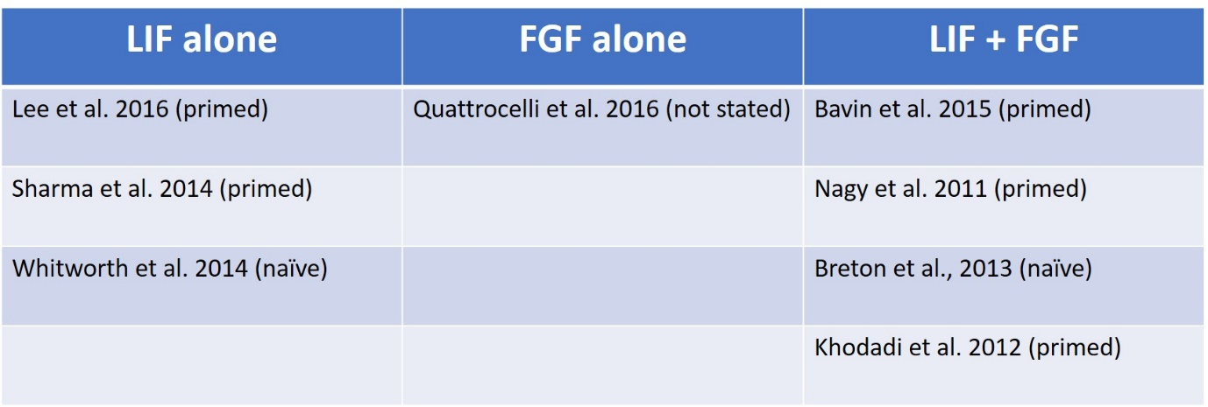
Table 1. Different combinations of LIF and/or FGF have been reported for the successful derivation and propagation of equine iPSCs. There is no clear correlation between culture conditions and the primed versus naïve morphology of the resulting iPSC colonies.

Numerous cell surface markers have been identified that correspond to pluripotency. These include Stage Specific Embryonic Antigens SSEA-1, SSEA-3 and SSEA-4 and Tumour Rejection Antigens TRA-1-81 and TRA-1-60. Typically, naïve mouse pluripotent stem cells express only SSEA-1, whereas primed human pluripotent stem cells express SSEA-3, SSEA-4, TRA-1-60 and TRA-1-81. As these cell surface markers can be used to purify populations of cells[57], they could be used to generate more homogenous populations of iPSCs. However, the reports on equine iPSCs have demonstrated variability in the expression of these cell surface markers (summarised in Table 2). It is not clear if this merely reflects that different panels have been tested in each report, different culture conditions have been used or different antibodies and reagents have been selected. Or if it reflects that there are differences between the iPSCs lines which may represent different stages of development.

Other typical markers of pluripotency, such as alkaline phosphatase (AP) activity, have been consistently found to be present in all reports on equine iPSCs (Table 2). Transcription factors associated with pluripotency have also been examined in some reports on equine iPSCs. Key pluripotency regulators such as Oct-4, Sox2 and Nanog, which are present in both naïve and primed human and mouse PSCs[58-61], have been shown to be expressed by many of the iPSC lines derived to date (Table 2). Other transcription factors such as Rex1 and KLF4 associated with naïve states of pluripotency [62-64] and have a been reported in some equine iPSCs, but less extensively examined (Table 2).

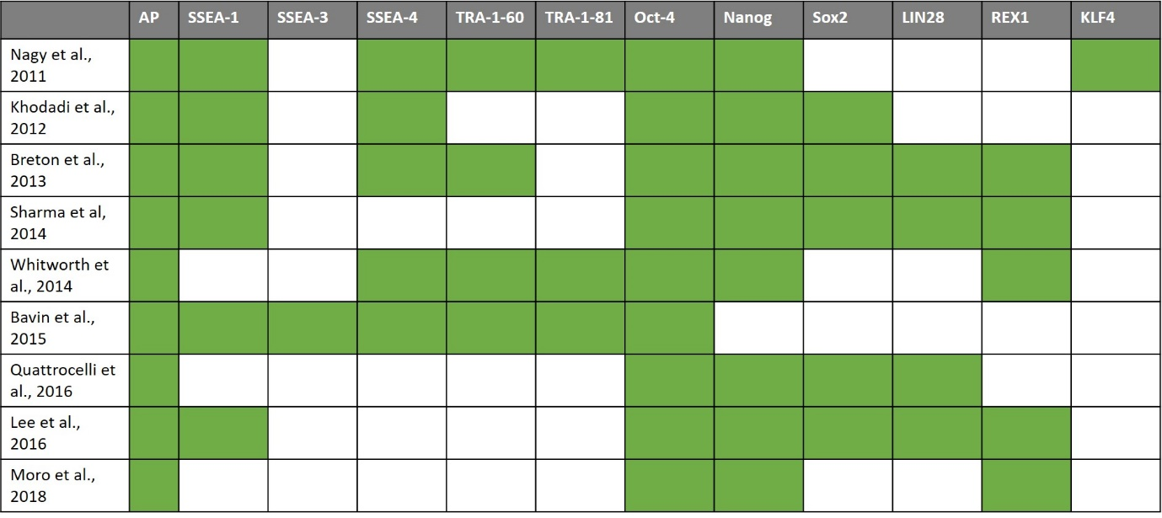
Table 2. Different pluripotency associated proteins and genes have been reported in equine iPSCs. Green shaded boxes represent positive expression of the marker, white boxes indicate that the expression of the gene/protein was not reported.

Most of the original reports on equine iPSCs reported that they have a normal karyotype (n = 64 chromosomes)[28-32, 34, 35]. However, more detailed analyses to identify more subtle genetic abnormalities have not been performed. Genetic abnormalities have been shown to occur during the culture of human PSCs, with a particular subset of abnormalities showing high levels of occurrence across many different reports[65]. As some genetic abnormalities are associated with improved growth of human PSCs[66], it is likely that there will be genetic abnormalities in equine iPSCs but they have not yet been reported.

Directed differentiation of equine iPSCs
In addition to the assessment of differentiation potential to determine pluripotency via spontaneous, non-directed differentiation, equine iPSCs have been directed to differentiate into a variety of cell types which may have therapeutic relevance for the horse (Figure 2). This includes musculoskeletal cell types such as tendon[35], cartilage[34, 67], muscle[34, 67, 68] and bone[67, 69, 70] cells. To differentiate equine iPSCs towards these mesodermal lineages, some reports have first differentiated the cells into a mesenchymal stromal cell intermediate[67, 68, 71]. Transgene overexpression of MyoD in these intermediate cell types has also been utilised to improve the efficiency of differentiation to generate myocytes[68]. However, this was performed using an integrating viral vector, which raises safety concerns for the clinical application of the myocytes.

Equine iPSCs have also been differentiated into keratinocytes[37], which may have clinical applications for non-healing, chronic wounds in horses, and neurons[31], which may provide an in vitro source of cells for studying neuropathies and neurodegenerative conditions such as grass sickness[72] and equine motor neuron disease[73].

As these studies are small in number relative to the human field there are still questions that remain to be addressed. For example, differentiation is often assessed by marker expression and whether the resulting cell types are functional is often more difficult to ascertain. Osteoblasts derived from iPSCs have been shown to produce a mineralised matrix in vitro[69-71] but in vivo functionality in bone repair has not yet been shown. iPSC-derived tenocytes express the appropriate gene and protein markers, but fail to contract a collagen gel in 3D culture, suggesting they are not functionally equivalent to adult tenocytes or equine ESC-derived tenocytes[35]. iPSC derived neurons have been shown to produce acetylcholine and fire action potentials, suggesting that they are functional in vitro[31] and iPSC derived myocytes can respond to a membrane depolarization stimuli in vitro[68] and express dystrophin in vivo following injection into injured mouse muscle[33].

Future work must also address the stage of development that the differentiated cells represent. Generally, human and mice iPSCs give rise to immature cell types following differentiation[74-76]. Equine iPSC derived myotubes have been characterised as being immature[68] but it has not been studied in detail in many of the other reports. For example, in equine iPSC-derived neurons, maturity was not quantified but they did share some characteristics with mature cells[31]. Likewise, in equine iPSCs derived keratinocytes, maturity was not directly assessed but the cells were found to have similar migratory capacity to adult skin derived keratinocytes and a greater proliferative capacity[68], which may suggest that they are in a less mature state.

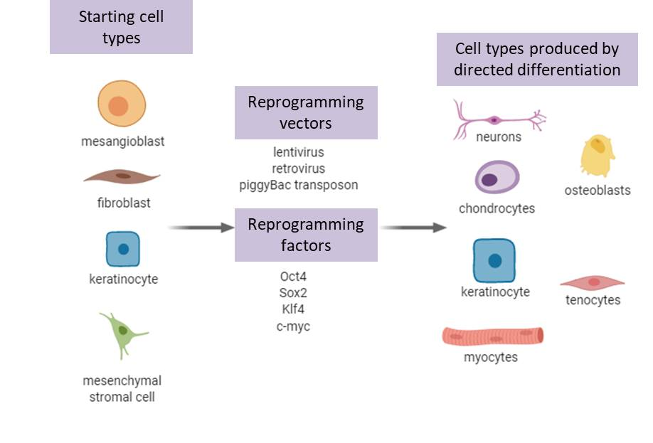
Figure 2. Overview of the equine cell types that have been reprogrammed to iPSCs, the methods used to induce reprogramming, and the differentiated cell types produced.

Cell therapy with equine iPSCs
The focus of directed differentiation approaches has largely been on musculoskeletal cells due to the high rate of injuries to these tissues in horses. For example, tendon injuries affect horses undertaking a wide range of different disciplines They account for 46% of all limb injuries in racehorses[77] and commonly occur in other competition horses[78, 79]. Tendon injuries undergo poor natural regeneration, instead healing through the formation of biomechanically inferior scar tissue which predisposes horses to a high re-injury rate of up to 67%[78]. Tendon injuries are the number one reason for retirement from racing[80] and the primary cause of veterinary-related career breaks in sport horses[81]. They therefore have a significant welfare impact. Fractures caused by bone overloading or direct trauma also occur in horses taking part in many different disciplines[82] and are also a significant welfare issue. All horses are at risk of developing osteoarthritis (OA), including wild horses[83]. The management of OA in horses is one of the most common medical problems encountered in equine practice[84] and two independent studies have demonstrated that around 33-35% of horses have signs of cartilage damage post-mortem[85, 86]. Although OA is more common in older horses it can occur in young horses and lameness due to joint disease is one of the main factors responsible for racehorses not being able to race[87].

Only three in vivo studies using equine iPSCs have been performed to date. In 2014, Aguiar et al.[36] injected undifferentiated iPSCs intradermally into two horses to study the immunological response. They demonstrated that iPSCs express low levels of major histocompatibility complex (MHC) class I and II proteins compared to the parental fibroblast lines from which they are derived. However, although no system immune response was detected, the iPSCs did cause the formation of small wheals at the injection sites and immune cells were recruited.

In 2016, Lee et al[33] injected undifferentiated equine iPSCs into muscle injured Rag/mdx mice. These mice have a mutation which leads to dystrophin deficiency and are immuno-deficient. After 15 days there was enhanced muscle regeneration in the iPSC injected group compared to the controls, with a proportion of the iPSCs demonstrating differentiation into myofibers. However, undifferentiated iPSCs also remained.

More recently, Chung et al[67] differentiated equine iPSCs into MSCs and injected them into 16 horses. Two of the horses were healthy and the others had a range of injuries including fracture, tendonitis, arthritis and osteochondrosis. The sample numbers were small, and no controls were performed and so no conclusions can be made on the efficacy. However, some of the horses exhibited adverse effects, including lameness, high temperature and edema following the injection of the iPSC-MSCs. Given that allogeneic MSCs have been authorized for use[10] and used to treat many horses without any adverse effects, it seems likely that the adverse effects may have been due to the presence of other cell types. However, this was not directly studied. To reduce the expression of MHC I proteins, the authors exposed the iPSC-MSCs to transforming growth factor beta 2 (TGF-β2) for 48 hours. This reduced MHC expression by 50% but the effect on allorecognition in vitro or in vivo was not investigated.

Therefore, there are continued safety concerns over the clinical application of equine iPSCs, with regard to the immune responses and the presence of undifferentiated cells which may have the potential to form tumours.

Equine iPSCs for disease modelling
Human iPSCs are proving to be a valuable tool for modelling inherited disorders to understand more about their disease pathophysiology and to use in drug screening. As described in the introduction, horses suffer from a number of inherited conditions and it may be possible to use equine iPSCs for disease modelling. For example, there are many inherited myopathies in horses, including polysaccharide storage myopathy (PSSM1), hyperkalemic periodic paralysis (HYPP) and recurrent exertional rhabdomyolysis[88]. Equine iPSCs have already been differentiated into functional muscle cells[34, 67, 68] and deriving iPSCs from horses affected with an inherited myopathy as well as breed match control horses would be the next step to establishing these models.

Other conditions in horses have also been shown to have an inherited component including recurrent laryngeal neuropathy[89], fracture[90, 91], osteochondrosis dissecans[92] and tendon injuries[91, 93]. Again, the methods to differentiate equine iPSCs into neurons[31], osteoblasts[69, 70], chondrocytes[34, 67] and tendon cells[35] have been reported. As conditions such as these affect welfare and performance of horses, an increased understanding of the biological pathways which underpin them would be beneficial. However, as they are largely complex diseases which have many environmental risk factors and for which the genetic contributions are often only partially understood it can be complicated to classify horses as robust cases and controls for iPSC generation.

Future directions
To maximise the potential of equine iPSCs for both disease modelling and future clinical translation there are a number of improvements which need to be made. Footprint free iPSCs generated by non-integrating methods have not yet been reported and will be vital to ensure the safety of clinically applied cells. Improved culture conditions are also required to enable single cell cloning and genome editing to be performed for disease modelling. Reduced cost, defined media and weekend free culture regimes necessary to make it affordable to move into the clinic and allow more research groups to work on equine iPSCs[94]. Larger scale culture methods also need to be developed if the clinical use of iPSCs is to become widespread[95]. Improved monitoring of equine iPSCs during culture is also required to ensure that genomic aberrations are not accumulating that might impact on clinical safety.

Improved differentiation protocols to specific lineages are also needed to generate more homogenous cultures. This has relevance for both clinical applications, where the presence of unwanted cell types could have negative consequences for safety and efficacy, and for disease modelling where the cell types of interest need to be generated with high efficiency.

As we move forward with equine iPSCs, further in vivo studies to determine efficacy in tissue regeneration will be required. iPSCs will also need to be generated from healthy horses and those affected by inherited diseases. As experiments utilising iPSCs for tissue repair and disease modelling become more widespread, the translation of the results to improve horse health can begin. “One Health” is a global strategy to encourage collaboration and communication on all aspects of human and animal health and there is a growing awareness of the benefits that research into companion animals, including horses, can provide to human health[96-98]. Equine iPSCs may therefore not only benefit the health and welfare of horses but also provide future benefits to human health.

References

1. Hendricks, B.L., International Encylopedia of Horse Breeds. 2007: Norman, OK: University of Oklahoma Press.
2. The contribution of thoroughbred breeding to the UK economy and factors impacting the industry's supply chain. 2018, PricewaterhouseCoopers LLP on behalf of the Thoroughbred Breeders' Association.
3. Patterson-Kane, J.C. and T. Rich, Achilles tendon injuries in elite athletes: lessons in pathophysiology from their equine counterparts. Ilar j, 2014. 55(1): p. 86-99.
4. McCoy, A.M., Animal Models of Osteoarthritis: Comparisons and Key Considerations. Vet Pathol, 2015. 52(5): p. 803-18.
5. McIlwraith, C.W., D.D. Frisbie, and C.E. Kawcak, The horse as a model of naturally occurring osteoarthritis. Bone Joint Res, 2012. 1(11): p. 297-309.
6. Godwin, E.E., et al., Implantation of bone-marrow derived mesenchymal stem cells demonstrates improved outcome in horses with overstrain injury of the superficial digital flexor tendon. Equine vet J, 2012. 44(1): p. 25-32.
7. Ahrberg, A.B., et al., Effects of mesenchymal stromal cells versus serum on tendon healing in a controlled experimental trial in an equine model. BMC Musculoskelet Disord, 2018. 19(1): p. 230.
8. Broeckx, S.Y., et al., The use of equine chondrogenic-induced mesenchymal stem cells as a treatment for osteoarthritis: A randomised, double-blinded, placebo-controlled proof-of-concept study. Equine Vet J, 2019. 51(6): p. 787-794.
9. Seo, J.P., et al., Osteoinductivity of gelatin/beta-tricalcium phosphate sponges loaded with different concentrations of mesenchymal stem cells and bone morphogenetic protein-2 in an equine bone defect model. Vet Res Commun, 2014. 38(1): p. 73-80.
10. Saville, V., Status of equine stem cell-based veterinary medicine in the UK. Veterinary Record, 2019. 185: p. 575.
11. Smith, R.K., et al., Beneficial effects of autologous bone marrow-derived mesenchymal stem cells in naturally occurring tendinopathy. PLoS One, 2013. 8(9): p. e75697.
12. Guest, D.J., M.R.W. Smith, and W.R. Allen, Equine embryonic stem-like cells and mesenchymal stromal cells have different survival rates and migration patterns following their injection into damaged superficial digital flexor tendons. Equine vet. J., 2010. 42(7): p. 636-642.
13. Becerra, P., et al., Distribution of injected technetium^{99m} labeled mesenchymal stem cells in horses with naturally occuring tendinopathy. J Orthop Res, 2013. 31(7): p. 1096-1102.
14. Caplan, A.I., Mesenchymal Stem Cells: Time to Change the Name! STEM CELLS Translational Medicine, 2017. 6(6): p. 1445-1451.
15. Saito, S., et al., Derivation, maintenance, and induction of the differentiation in vitro of equine embryonic stem cells. Methods Mol Biol, 2006. 329: p. 59-79.
16. Saito, S., et al., Isolation of embryonic stem-like cells from equine blastocysts and their differentiation in vitro. FEBS Letters, 2002. 531: p. 389-396.
17. Li, X., et al., Horse embryonic stem cell-like cell lines from the proliferation of inner cell mass cells. Stem Cells and Development, 2006. 15: p. 523-531.
18. Abavisani, A., et al., Maintenance of horse embryonic stem cells in different conditions. Iranian J Vet Res, 2010. 11: p. 239-248.
19. Guest, D.J. and W.R. Allen, Expression of cell surface antigens and embryonic stem cell pluripotency genes in equine blastocysts. Stem Cells and Development, 2007. 16: p. 789-795.
20. Hinrichs, K., Assisted reproduction techniques in the horse. Reprod Fertil Dev, 2012. 25(1): p. 80-93.
21. Schneider, M.R., et al., Canine embryonic-derived stem cells - Toward clinically relevant animal models for evaluating efficacy and safety of cell therapies. Stem Cells, 2007. 25: p. 1850-1851.
22. Vaags, A.K., et al., Derivation and characterisation of canine embryonic stem cell lines with in vitro and in vivo differentiation potential. Stem Cells, 2009. 27(2): p. 329-340.
23. Hayes, B., et al., Derivation, characterisation and in vitro differentiation of canine embryonic stem cells. Stem Cells, 2008. 26: p. 465-473.
24. Tobias, I.C., et al., Derivation and culture of canine embryonic stem cells. Methods Mol Biol, 2013. 1074: p. 69-83.
25. Yu, X., et al., Isolation and characterisation of embryonic stem-like cells derived from in vivo produced cat blastocysts. Mol Reprod Dev, 2008. 75: p. 1426-1432.
26. Yu, X.F., et al., Serum-free derivation of cat embryonic stem-like cells derived from in vivo-produced blastocysts on cat embryonic fibroblast feeders. Reproduction, Fertility and Development, 2007. 19(1): p. 232-232.
27. Hatoya, S., et al., Isolation and characterisation of embryonic stem-like cells from canine blastocysts. Molecular Reproduction and Development, 2006. 73: p. 298-305.
28. Nagy, K., et al., Induced pluripotent stem cell lines derived from equine fibroblasts. Stem Cell Rev and Rep, 2011. 7(3): p. 693-702.
29. Breton, A., et al., Derivation and characterization of induced pluripotent stem cells from equine fibroblasts. Stem Cells Dev, 2013. 22(4): p. 611-21.
30. Khodadadi, K., et al., Induction of pluripotency in adult equine fibroblasts without c-MYC. Stem Cells Int, 2012. 2012: p. 429160.
31. Sharma, R., et al., Generation of functional neurons from feeder-free, keratinocyte-derived equine induced pluripotent stem cells. Stem Cells Dev, 2014. 23(13): p. 1524-1534.
32. Whitworth, D.J., et al., Generation and Characterization of LIF-dependent Equine Induced Pluripotent Stem Cells From Adult Dermal Fibroblasts. Stem Cells Dev, 2014. 23: p. 1515-1523.
33. Lee, E.M., et al., Generation of Equine-Induced Pluripotent Stem Cells and Analysis of Their Therapeutic Potential for Muscle Injuries. Cell Transplant, 2016. 25(11): p. 2003-2016.
34. Quattrocelli, M., et al., Equine-Induced Pluripotent Stem Cells Retain Lineage Commitment Toward Myogenic and Chondrogenic Fates. Stem Cell Reports, 2016. 6(1): p. 55-63.
35. Bavin, E.P., et al., Equine Induced Pluripotent Stem Cells have a Reduced Tendon Differentiation Capacity Compared to Embryonic Stem Cells. Front Vet Sci, 2015. 2: p. 55.
36. Aguiar, C., et al., Immune potential of allogeneic equine induced pluripotent stem cells. Equine Vet J, 2014.
37. Aguiar, C., et al., Differentiation of equine induced pluripotent stem cells into a keratinocyte lineage. Equine Vet J, 2016. 48(3): p. 338-45.
38. Moro, L.N., et al., MicroRNA characterization in equine induced pluripotent stem cells. PLoS One, 2018. 13(12): p. e0207074.
39. Polo, J.M., et al., Cell type of origin influences the molecular and functional properties of mouse induced pluripotent stem cells. Nat Biotechnol, 2010. 28(8): p. 848-55.
40. Kim, K., et al., Epigenetic memory in induced pluripotent stem cells. Nature, 2010. 467(7313): p. 285-90.
41. Choi, J., et al., A comparison of genetically matched cell lines reveals the equivalence of human iPSCs and ESCs. 2015. 33(11): p. 1173-81.
42. Mallon, B.S., et al., Comparison of the molecular profiles of human embryonic and induced pluripotent stem cells of isogenic origin. Stem Cell Res, 2014. 12(2): p. 376-86.
43. Dutton, L.C., et al., Inducing Pluripotency in the Domestic Cat (Felis catus). Stem Cells Dev, 2019. 28(19): p. 1299-1309.
44. Wang, L., et al., NANOG and LIN28 dramatically improve human cell reprogramming by modulating LIN41 and canonical WNT activities. Biol Open, 2019. 8(12).
45. Fusaki, N., et al., Efficient induction of transgene-free human pluripotent stem cells using a vector based on Sendai virus, an RNA virus that does not integrate into the host genome. Proc Jpn Acad Ser B Phys Biol Sci, 2009. 85(8): p. 348-62.
46. El Khatib, M.M., et al., Tumor-Free Transplantation of Patient-Derived Induced Pluripotent Stem Cell Progeny for Customized Islet Regeneration. Stem Cells Transl Med, 2016. 5(5): p. 694-702.
47. Hotta, A. and J. Ellis, Retroviral vector silencing during iPS cell induction: an epigenetic beacon that signals distinct pluripotent states. J Cell Biochem, 2008. 105(4): p. 940-8.
48. Okita, K., T. Ichisaka, and S. Yamanaka, Generation of germline-competent induced pluripotent stem cells. Nature, 2007. 448(7151): p. 313-317.
49. Bradley, A., et al., Formation of germ-line chimeras from embryo-derived teratocarcinoma cell lines. Nature, 1984. 309: p. 255-256.
50. Li, P., et al., Germline competent embryonic stem cells derived from rat blastocysts. Cell, 2008. 135(7): p. 1299-1310.
51. Buehr, M., et al., Capture of authentic embryonic stem cells from rat blastocysts. Cell, 2008. 135(7): p. 1287-98.
52. Zhao, X.Y., et al., iPS cells produce viable mice through tetraploid complementation. Nature, 2009. 461(7260): p. 86-90.
53. Nagy, A., et al., Derivation of completely cell culture-derived mice from early-passage embryonic stem cells. PNAS, 1993. 90: p. 8424-8428.
54. Mascetti, V.L. and R.A. Pedersen, Human-Mouse Chimerism Validates Human Stem Cell Pluripotency. Cell Stem Cell, 2016. 18(1): p. 67-72.
55. Olivera, R., et al., In Vitro and In Vivo Development of Horse Cloned Embryos Generated with iPSCs, Mesenchymal Stromal Cells and Fetal or Adult Fibroblasts as Nuclear Donors. PLoS One, 2016. 11(10): p. e0164049.
56. Koh, S., et al., Growth requirements and chromosomal instability of induced pluripotent stem cells generated from adult canine fibroblasts. Stem Cells Dev, 2013. 22(6): p. 951-63.
57. D'Antonio, M., et al., High-Throughput and Cost-Effective Characterization of Induced Pluripotent Stem Cells. Stem Cell Reports, 2017. 8(4): p. 1101-1111.
58. Chambers, I., et al., Functional expression cloning of Nanog, a pluripotency sustaining factor in embryonic stem cells. Cell, 2003. 113(5): p. 643-55.
59. Mitsui, K., et al., The homeoprotein Nanog is required for maintenance of pluripotency in mouse epiblast and ES cells. Cell, 2003. 113(5): p. 631-42.
60. Nichols, J., et al., Formation of pluripotent stem cells in the mammalian embryo depends in the POU transcription factor Oct4. Cell, 1998. 95: p. 379-391.
61. Kuroda, T., et al., Octamer and Sox elements are required for transcriptional cis regulation of Nanog gene expression. Mol Cell Biol, 2005. 25(6): p. 2475-85.
62. Kalkan, T. and A. Smith, Mapping the route from naive pluripotency to lineage specification. Philos Trans R Soc Lond B Biol Sci, 2014. 369(1657): p. 20130540.
63. Silva, J., et al., Nanog is the gateway to the pluripotent ground state. Cell, 2009. 138(4): p. 722-37.
64. Guo, G., et al., Klf4 reverts developmentally programmed restriction of ground state pluripotency. Development, 2009. 136(7): p. 1063-9.
65. Assou, S., et al., Recurrent Genetic Abnormalities in Human Pluripotent Stem Cells: Definition and Routine Detection in Culture Supernatant by Targeted Droplet Digital PCR. Stem Cell Reports, 2020. 14(1): p. 1-8.
66. Zhang, J., et al., Anti-apoptotic Mutations Desensitize Human Pluripotent Stem Cells to Mitotic Stress and Enable Aneuploid Cell Survival. Stem Cell Reports, 2019. 12(3): p. 557-571.
67. Chung, M.J., et al., Differentiation of equine induced pluripotent stem cells into mesenchymal lineage for therapeutic use. Cell Cycle, 2019. 18(21): p. 2954-2971.
68. Amilon, K.R., et al., Generation of Functional Myocytes from Equine Induced Pluripotent Stem Cells. Cell Reprogram, 2018. 20(5): p. 275-281.
69. Baird, A., et al., Biocompatible Three-Dimensional Printed Thermoplastic Scaffold for Osteoblast Differentiation of Equine Induced Pluripotent Stem Cells. Tissue Eng Part C Methods, 2019. 25(5): p. 253-261.
70. Baird, A., et al., Osteoblast differentiation of equine induced pluripotent stem cells. Biology Open, 2018.
71. Lepage, S.I., et al., Generation, Characterization, and Multilineage Potency of Mesenchymal-Like Progenitors Derived from Equine Induced Pluripotent Stem Cells. Stem Cells Dev, 2016. 25(1): p. 80-9.
72. Pirie, R.S., R.C. Jago, and N.P. Hudson, Equine grass sickness. Equine Vet J, 2014. 46(5): p. 545-53.
73. Divers, T.J., H.O. Mohammed, and J.F. Cummings, Equine motor neuron disease. Vet Clin North Am Equine Pract, 1997. 13(1): p. 97-105.
74. Fujita, J., et al., Concise Review: Genetic and Epigenetic Regulation of Cardiac Differentiation from Human Pluripotent Stem Cells. Stem Cells, 2019. 37(8): p. 992-1002.
75. Berry, B.J., et al., Advances and Current Challenges Associated with the Use of Human Induced Pluripotent Stem Cells in Modeling Neurodegenerative Disease. Cells Tissues Organs, 2018. 205(5-6): p. 331-349.
76. Donato, M.T. and L. Tolosa, Stem-cell derived hepatocyte-like cells for the assessment of drug-induced liver injury. Differentiation, 2019. 106: p. 15-22.
77. Williams, R.B., L.S. Harkins, and J.L.N. Wood, Racehorse injuries, clinical problems and fatalities recorded on British racecourses from flat racing and National Hunt racing during 1996, 1997 and 1998. Equine vet. J., 2001. 33(5): p. 478-486.
78. Dyson, S.J., Medical management of superficial digital flexor tendonitis: a comparative study in 219 horses (1992-2000). Equine vet J, 2004. 36(5): p. 415-419.
79. Singer, E.R., et al., Injuries in the event horse: Training versus competition. The Veterinary Journal, 2008. 175: p. 76-81.
80. Lam, K.H., et al., Descriptive analysis of retirement of Thoroughbred racehorses due to tendon injuries at the Hong Kong Jockey Club (1992-2004). Equine vet. J., 2007. 39(2): p. 143-148.
81. Sloet van Oldruitenborgh-Oosterbaan, M.M., W. Genzel, and P.R. van Weeren, A pilot study on factors influencing the career of Dutch sport horses. Equine Vet J Suppl, 2010(38): p. 28-32.
82. Morgan, R. and S. Dyson, Incomplete longitudinal fractures and fatigue injury of the proximopalmar medial aspect of the third metacarpal bone in 55 horses. Equine Vet J, 2012. 44(1): p. 64-70.
83. Cantley, C.E.L., Naturally occuring osteoarthritis in the metacarpophalangeal joints of wild horses. Equine vet J, 1999. 31(1): p. 73-81.
84. Goodrich, L.R. and A.J. Nixon, Medical treatment of osteoarthritis in the horse - A review. The Veterinary Journal, 2006. 171: p. 51-69.
85. Rose, R., An analysis of conditions causing lameness in the horse. Proceedings of the 54th Annual Meeting of the Australian Veterinary Association, 1977(99-102).
86. Tew, W.P. and R.P. Hackett, Identification of cartilage wear fragments in synovial fluid from equine joints. Arthritis Rheum, 1981. 24(11): p. 1419-24.
87. Jeffcott, L.B., et al., An assessment of wastage in Thoroughbred racing from conception to 4 years of age. Equine vet J, 1982. 14(3): p. 185-198.
88. Mickelson, J.R. and S.J. Valberg, The genetics of skeletal muscle disorders in horses. Annu Rev Anim Biosci, 2015. 3: p. 197-217.
89. Boyko, A.R., et al., Genomic analysis establishes correlation between growth and laryngeal neuropathy in Thoroughbreds. BMC Genomics, 2014. 15: p. 259.
90. Blott, S.C., et al., A genome-wide association study demonstrates significant genetic variation for fracture risk in Thoroughbred racehorses. BMC Genomics, 2014. 15(1): p. 147.
91. Welsh, C.E., et al., Estimates of genetic parameters of distal limb fracture and superficial digital flexor tendon injury in UK Thoroughbred racehorses. Vet J, 2014.
92. Naccache, F., J. Metzger, and O. Distl, Genetic risk factors for osteochondrosis in various horse breeds. Equine Vet J, 2018. 50(5): p. 556-563.
93. Tully, L.J., et al., Polymorphisms in TNC and COL5A1 genes are associated with risk of superficial digital flexor tendinopathy in National Hunt Thoroughbred racehorses. Equine Veterinary Journal, 2013: p. n/a-n/a.
94. Kuo, H.-H., et al., Negligible-Cost and Weekend-Free Chemically Defined Human iPSC Culture. Stem Cell Reports, 2020.
95. Jenkins, M.J. and S.S. Farid, Human pluripotent stem cell-derived products: advances towards robust, scalable and cost-effective manufacturing strategies. Biotechnol J, 2015. 10(1): p. 83-95.
96. Stroud, C., et al., A One Health overview, facilitating advances in comparative medicine and translational research. Clin Transl Med, 2016. 5(Suppl 1): p. 26.
97. Volk, S.W. and C. Theoret, Translating stem cell therapies: the role of companion animals in regenerative medicine. Wound Repair Regen, 2013. 21(3): p. 382-94.
98. Hoffman, A.M. and S.W. Dow, Concise Review: Stem Cell Trials Using Companion Animal Disease Models. Stem Cells, 2016. 34(7): p. 1709-29.

