Wildlife nursing (Part one): An introduction and literature review

Jesle Varu BSc (Hons), RVN
Ilford, Essex, UK

ORCID: 0000-0002-5980-6389
229 Hampton Road,
Ilford,
Essex,
IG1 1PP

Jesle graduated in 2017 from the Royal Veterinary College as a Registered Veterinary Nurse and then undertook the BSc course, graduating in 2018. He currently works in Wanstead Veterinary Hospital (Goddard Veterinary Group) in east London with keen interests in exotics, medicine, teaching and wildlife.

Hilary Orpet MScVetEd, BSc, Dip AVN (Surgical), Cert Ed. FHEA, DipCABT, RVN
Hertfordshire, UK

Hilary is a senior lecturer on the Foundation and BSc Veterinary Nursing degrees at the Royal Veterinary College. In 2007 she developed The Ability model of nursing care with Andrea Jeffery which is currently the only published veterinary model of care in use.

Keywords:
Wildlife; veterinary nursing; challenges; attitudes; education

Acknowledgments
This article was produced as part of the primary author’s studies at the Royal Veterinary College’s BSc Veterinary Nursing course. Many thanks to Hilary Orpet as the supervisor for this project and the Royal Veterinary College for approval.

Conflict of interest
None

Abstract

Nursing of British wildlife species are not included in the curricula for most veterinary nursing training programmes. Yet, when presented with wildlife casualties in practice, Veterinary Nurses (VNs) are expected to fulfil their professional, legal and ethical responsibilities towards them. Part one of this article will discuss these responsibilities along with the triage procedures, expenses, risks and admission procedures of wildlife presented in veterinary practice.

Introduction

Wildlife presented in veterinary practice can be problematic as veterinary professionals have legal, professional and ethical responsibilities to strike a balance between intervention and unnecessary suffering, whether it be euthanasia, treatment or immediate release (Mullineaux, 2017). Part one of this article will cover the background of this subject as well as gain an insight into the relevant literate. Part two will focus on a research project aimed to identify the current challenges of wildlife nursing.

Literature review

Legal responsibilities

The Animal Welfare Act (AWA) 2006 permanently or temporarily protects wild animals that are no longer in a wild state and are under control of man (Animal Welfare Act 2006. s2). Section 9 of the AWA 2006 state these include the need for a suitable environment, a suitable diet, to be able to exhibit normal behaviour patterns, to be housed with, or apart from, other animals and to be protected from pain, suffering, injury and disease (Animal Welfare Act 2006. s9). The five needs outlined are the basis for welfare of all captive species where injury and confinement during treatment and rehabilitation may affect welfare but should not result in unnecessary suffering. A person commits an offence if they do not take such steps that are reasonable in all circumstances, to ensure that the needs of an animal for which they are responsible for, are met to the extent required by good practice. No legislation states veterinary professionals must euthanise any species considered as ‘pests’ as they are subject to the same veterinary and welfare considerations as other sick or injured wild animals (Kerr, 2010). It is questionable if this is a widely known fact, as conservation status and popularity of the wildlife casualty are likely to influence the attitudes to intervene (Kirkwood and Sainsbury, 1996).

Rehabilitation and release are also factors influenced by legislation. Section 10 of The Wildlife and Countryside’s Act (WCA) 1981 permits the taking of sick or injured animals from the wild for the purpose to tend to them until no longer disabled (Wildlife and Countryside Act 1981. s10). This allows veterinary practices to house wildlife casualties as long as they are not kept in a manner that inhibits capacity to be released. Mullineaux (2017) stated a ‘suitable’ casualty is one that can be returned to the wild in a physical condition that allows it to survive in an equivalent way to any other member of its species. Returning an unfit casualty constitutes as ‘abandonment’ which is regarded as an offence under legislation. This does not necessarily mean that the animal should be in perfect physical condition at the time of release but that it should be fit to carry out normal daily activities such as finding food and shelter (Fletcher and Lea, 2012). Regarding non-indigenous animals of the UK, animals listed under Schedule 9 of the WCA 1981 can only be kept in captivity for rehabilitation with an appropriate license but immediate veterinary care is permitted as outlined in Section 14 (Wildlife and Countryside Act 1981. s9, s14). These species cannot be deliberately released for the most part but some can in certain areas with a licence.

Professional responsibilities

According to the Code of Professional Conduct for Veterinary Nurses by the Royal College of Veterinary Surgeons (RCVS) , animal welfare must be the overriding consideration at all times (RCVS 2012a). All patients, of whatever species, must be treated with respect and provided with suitable nursing care. The Code of Professional Conduct for Veterinary Surgeons states that a Veterinary Surgeon cannot unreasonably refuse to provide first aid and pain relief to any animal of a species treated by the practice during normal working hours (RCVS 2012b). They must do the same for all other species until a more appropriate centre can accept responsibility.

Ethical responsibilities

From an ethical viewpoint, treating wildlife counteracts the negative actions of humans towards species demographics and individual animal welfare such as from road traffic accidents, poisonings, pet injuries and large man-made catastrophes like oil spills (Mullineaux, 2014). Erritzoe, Mazgajski, and Rejt, (2003) reviewed data from European studies on bird mortality on roads. It was estimated the annual mortality for some countries were 350,000 to 27 million casualties. However, Slater (2002) concluded simple counts of wildlife corpses found on roads are a severe underestimate of actual road casualty rates and could be 12-16 times higher than originally thought. Therefore, treating wildlife could help to offset the number of wildlife lost through the negative actions of humans. Additionally, those who are willing and able to treat wildlife regularly could attract good publicity for their practices via media contributions (Cooper and Cooper, 2006) and provision of veterinary services to members of the public finding wildlife casualties can generate a “feel good factor” for those involved (Mullineaux, 2014). Benefits could be obtained for the individual professional where husbandry experience of more unusual species (Figure 1) could be gained (Bullen, 2013).

(Figure 1 here)

Triage and decision-making

Mullineaux (2017) defined ‘triage’ is the process of determining the priority of patients’ treatments based on the severity of their condition and when resources are insufficient for all to be treated immediately. For wildlife, it is usually to differentiate between casualties requiring immediate euthanasia with those that would have a good chance of release. True triage is required when there are large numbers of wildlife casualties such as during stranding events, mass pollution or wild fires. Triage decisions should ideally be made within 1-2 hours of admission in order to prevent unnecessary suffering in captivity (Mullineaux, 2014) which is where nursing care is important, as often veterinary practices are only suitable for short-term care of wildlife whilst rehabilitation facilities are sought (Mullineaux, 2017).

The importance of the decision-making process and triage is supported by primary research where Grogan and Kelly (2013) reviewed research into wildlife rehabilitation from the Royal Society for the Prevention of Cruelty to Animals (RSPCA). They obtained annual estimate figures from 23 rehabilitators and combined these with those admitted within RSPCA centres to create a value of 71,000 wild animals admitted to wildlife establishments in 2011. However, the fate of most rehabilitated wild animals remains unknown (Cooper and Cooper, 2006). Molony et al (2007) proposed that if factors associated with survival within rehabilitation centres could be determined, they might be used to focus efforts on individuals with high chances of successful recovery, and hence improve welfare by devoting resources to those animals that are more likely to benefit. The researchers analysed medical records of eight species from a range of taxonomic groups commonly admitted to four RSPCA wildlife rehabilitation centres between 2000-2004 to determine those factors that affected the chance of survival in care until release (Molony et al 2007). The most important predictive factor found across all species was the severity of the symptoms of injury or illness. For example, individuals with deep tissue wounds spent up to 18 (± 33 days) in care before mortality, and up to 23 (± 48 days) for those with a fractured pelvis. Age, sex, mass (weight) on admission and length of time in care did not affect survival significantly. This research highlighted that although the ethos of many rehabilitation centres and veterinary practices is to attempt the treatment of all wildlife casualties, the attempted treatment of those with severe injuries might adversely affect welfare by prolonging suffering during hospitalisation.

Expense of treatment

Initial and ongoing costs of professional time, drugs and consumables must be considered. If finances are not available to care for the wildlife casualty properly, then euthanasia should be the preferred option rather than poor care (Mullineaux, 2017). Barnes and Farnworth (2017) found 85.6% of 169 RCVS accredited practices agreed that the public expect veterinary practices to treat injured wildlife free of charge but there are no UK organisations that accept sole responsibility for wildlife health. The RSPCA offer reimbursement for initial emergency treatment for animals over 1 kg which excludes many species presented in practice and only applies if the rescuer contacts the charity initially. There is, however, a memorandum of agreement between the British Veterinary Association and the RSPCA to provide emergency care and euthanasia without charge for small mammals and wild birds brought into practice during normal hours (Mullineaux, 2016). The extent of treatment given depends on the individual practice (Fletcher and Lea, 2012) where Barnes and Farnworth (2017) found 84% of 169 respondents agreed they were willing to perform treatment beyond stabilisation to include prescription medication, <72 hour rehabilitation and release. Overall; cost of intervention and ability to release must be justified (Grogan and Kelly, 2013).

Admission procedures

Williams (2010) advised the following should be recorded to help assist in possible releases:
- Name, address and phone number of rescuer
- The reasons why the animal was rescued
- Any first aid already administered
- Any food and water offered
- The exact location where the animal was found.
This is particularly important, as the wildlife casualty would have an established territory and be familiar with food sources, so if released in an unknown environment, the animal would be vulnerable whilst finding new resources (Ryan, 2017). Section 10 of the WCA 1981 requires ownership and responsibility to be clearly identified and transferred from the rescuer to practice in order for treatment to be permitted (Wildlife and Countryside Act 1981. s10). . Whether this occurs in practice is questionable as once wildlife is in possession of the rescuer; it therefore becomes their property (Ryan, 2017). This could cause problems if the rescuer is dissatisfied with the treatment given, particularly if euthanasia is elected (Harris and Jefferies, 1991).

Risks of treating wildlife casualties

Most wildlife perceives humans as a threat and therefore may react aggressively, so caution must be maintained especially during breeding seasons (Minshell, 2012). Another consideration is that wildlife can also act as reservoirs of zoonotic diseases, such as the following, (Simpson 2008):
- Avian influenza,
- Borelia burdorferi
- Campylobacter
- Chlamydia
- Cowpox
- Leptospirosis
- Lyssaviruses
- Ringworm
- Salmonellosis
- Toxoplasma gondii
- Tuberculosis
It is therefore essential that practices encourage and provide the use of personal protective equipment when dealing with wildlife casualties (McClure, 2011) especially as the risk of disease transmission can extend to domestic species within the practice (Mullineaux, 2014).

Veterinary practices and wildlife casualties

From current literature searching, veterinary attitudes towards provision of care towards wildlife in practice and major challenges faced remain largely unexplored in peer-reviewed work. This is apparent in Barnes and Farnworth’s (2017) study where half of their reference material is over a decade old; however, their research shed light on current perceptions and paved way for further study. They conducted a cross sectional, semi quantitative survey design with a sample of 169 RVCS accredited practices. Differences in opinions between VNs and Veterinary Surgeons could potentially exist as practices in general were sampled, but research into this is limited. A statistically significant relationship between facilities for holding wildlife casualties temporarily and number of casualties treated was identified (Kruskall-Wallis; p=0.001) indicating correct resources support the demands wildlife require. It was estimated that around 8081 wild animals were being treated per annum and in extrapolating this data, the authors suggested that the UK annual wildlife workload was around 131,609 patients. The researchers found the following were the most common species presented to veterinary practices in order of prevalence:
- Garden birds
- Hedgehogs
- Birds of prey
- Wild rabbits
- Seabirds
- Waterfowl
- Game birds
- Grey squirrels
- Bats
- Foxes
- Deer
- Badgers
- Wild snakes
- Otters
- Seals
- Red squirrels

Benefits of treating wildlife were identified such as experience, knowledge, personal satisfaction, increased team morale and better public relations. However, resource diversion of staff, time and money were listed as disadvantages. Common restrictions faced when treating wildlife were also identified as listed in order of most limiting:
- Knowledge/skills
- Facilities/equipment
- Money/expense
- Time
- Uncertainty about British wildlife law/policies
- Comfort levels with restraint
- Interest
- No enquires/cases
- Practice owner permission

Veterinary Nurses and wildlife

Registered Veterinary Nurses (RVNs) are in the most ideal position to inform, support and guide others regarding wildlife care (Fraser and Girling, 2016). For instance, Orpet and Welsh (2011) described the nursing process is a problem-solving approach of care for an individual patient, which includes the cyclic process of assessment, nursing diagnosis, planning, implementation and evaluation. This only outlines the stages involved and does not detail ‘what’ and ‘how’ each is carried out, yet various frameworks provide this further detail. The Ability model by Orpet and Jeffery is a model specifically designed for VNs to assess what is normal so the care provided can restore the patient back to the original state (Figure 2) (Orpet and Welsh 2011). This model relies on communication with the domestic animal’s owner to identify normal routines and considers owner compliance, financial and cultural factors that may affect the care provided. Many wildlife casualties arrive in practice with an unknown history (Williams, 2010) where normal routine is difficult to determine, meaning this model may not be suitable for these types of patients. Therefore, where nursing care could be significant in the treatment and outcomes of wildlife it requires specific guidance for these specific species.

(Figure 2 here)

Veterinary nursing research

Research into the nursing of UK wildlife species is important, as this subject is not included in the curricula of most training courses (Mullineaux, 2016). This is an issue as Veterinary Surgeons directing treatment must be satisfied that the RVN is qualified to carry out said tasks as outlined under Schedule 3 of the Veterinary Surgeons Act 1966 meaning competence should not be presumed (Veterinary Surgeons Act 1966. c36, sch 3 s6). Along with the issue of limited peer reviewed literature into specific veterinary interventions (Barnes and Farnworth, 2014), inadequate interest and knowledge of wildlife could result in inappropriate care (Mullineaux, 2016) as specific knowledge of the ecology, biology and common problems encountered is necessary for adequate treatment (Mullineaux, 2014). Research into wildlife nursing also promotes clinical governance, where the continued process of reflection, analysis and improvement in professional practice could benefit the standards of wildlife nursing and influence continued professional development (RCVS, 2012). Further research also promotes evidence-based practice within veterinary nursing where the use of current best evidence is utilised to make clinical decisions instead of relying on traditional approaches (Banks, 2010).

Conclusion

RVNs hold many responsibilities and face various considerations when treating the wildlife casualty. Ultimately, further research into the subject of wildlife nursing could counteract the lack of training in VN education. Part two of this article will discuss the research project conducted to investigate the challenges of wildlife nursing faced by RVNs and how improve standards of care.

Word count

2431 words (Excluding title page and reference list) + 24 words (Figure captions) = 2455

References

Animal Welfare Act 2006. (c.45), s.9. London: HMSO.

Banks, D. (2011) ‘Evidence-based practice in veterinary nursing’, The Veterinary Nurse, 1(3), 136-139.

Barnes, E. and Farnworth, J. (2017) ‘Perception of responsibility and capability for treating wildlife casualties in UK veterinary practices’, Veterinary Record, 180(8), 1-3.

Bullen, K. (2013) ‘Care and treatment of hedgehogs (Erinaceus europaeus)’, Veterinary Nursing Journal, 28(2), 54-57.
Cooper, J. and Cooper, M. (2006) ‘Ethical and legal implications of treating casualty wild animals’, In Practice, 28(1), 2-6.

Erritzoe, J., Mazgajski, T. and Rejt, Ł. (2003) ‘Bird Casualties on European Roads — A Review’, Acta Ornithologica, 38(2), 77-93.

Fletcher, E. and Lea, R. (2012) ‘Initial consultation’, in Varga, M., Lumbis, R. and Gott, L. eds, BSAVA Manual of exotic pet and wildlife nursing, Gloucester: British Small Animal Veterinary Association, 1-28.

Fraser, M. and Girling, S. (2016) ‘Legalities of treating wildlife in UK veterinary practice’, The Veterinary Nurse, 7(3), 140-147.

Grogan, A. and Kelly, A. (2013) ‘A review of RSPCA research into wildlife rehabilitation’, Veterinary Record, 172(8), 2-5.

Harris, S. and Jefferies, D. (1991) ‘Working within the law: guidelines for veterinary surgeons and wildlife rehabilitators on the rehabilitation of wild mammals’, The British Veterinary Journal, 147(1), 1-17.

Kerr, A. (2010) ‘Wildlife casualties-to treat or not to treat’, Veterinary Nursing Journal, 25(1), 33-34.

Kirkwood, J. and Sainsbury, A. (1996) ‘Ethics of interventions for the welfare of free-living wild animals’, Animal Welfare, 5(3), 235-243.

McClure, B. (2011) ‘Hedgehogs – basic care and first aid’, Veterinary Nursing Journal, 26(7), 238-240.
Minshell, L. (2012) ‘Management and care of injured wildlife’, in Aspinall, V., ed., The Complete Textbook of Veterinary Nursing, 2nd ed., Oxford: Butterworth-Heinemann, 659-696.

Molony, S., Baker, P., Garland, L., Cuthill, I. and Harris, S. (2007) ‘Factors that can be used to predict release rates for wildlife casualties’, Animal Welfare, 16(3), 361-367.

Mullineaux, E. (2014) ‘Veterinary treatment and rehabilitation of indigenous wildlife’, Journal of Small Animal Practice, 55(6), 293-300.

Mullineaux, E. (2016) ‘Legal responsibilities of veterinary professionals when working with wildlife centres’, Companion Animal, 21(10), 592-597.

Mullineaux, E. (2017) ‘Principle of triage and first aid in wildlife casualties’, Companion Animal, 22(5), 350-356.

Orpet, H. and Welsh, P. (2011) Handbook of Veterinary Nursing, 2nd ed., Oxford: Wiley-Blackwell.

Royal College of Veterinary Surgeons, 2012a. Code of Professional Conduct for Veterinary Nurses. London: RCVS.

Royal College of Veterinary Surgeons, 2012b. Code of Professional Conduct for Veterinary Surgeons. London: RCVS.

Ryan, N. (2017) ‘Dispense some care to the wild side’, Veterinary Nursing Journal, 32(10), 301-307.

Simpson, V. (2008) ‘Wildlife as reservoirs of zoonotic diseases in the UK’ In Practice, 30(9), 486-494.

Slater, E. (2002) ‘An assessment of wildlife and road casualties- the potential discrepancy between numbers counted and numbers killed’, Web Ecology, 3(1), 33-42.

Stocker, L. (2009) ‘Tip of the iceberg’, Veterinary Nursing Journal, 24(12), 29-31.

Veterinary Surgeons Act 1966. (c.36), sch. 3. London: HMSO.

Wildlife and Countryside’s Act 1981. (c.69), sch. 9. London: HMSO.

Wildlife and Countryside’s Act 1981. (c.69). s.10. London: HMSO.

Wildlife and Countryside’s Act 1981. (c.69). s.14. London: HMSO.

Williams, A. (2010) ‘Wildlife protocols in practice’, Veterinary Nursing Journal, 25(10), 31-32.

Figure caption list
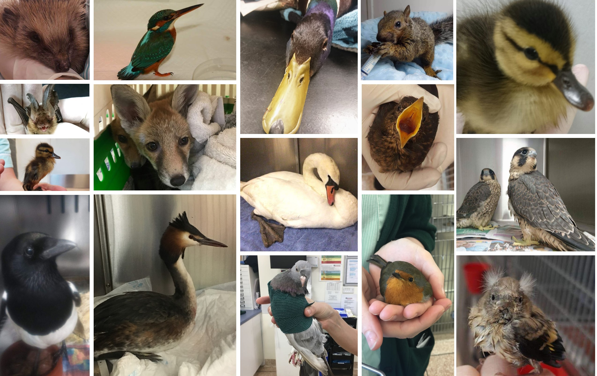
Figure 1: Wildlife casualties presented to a hospital over the years

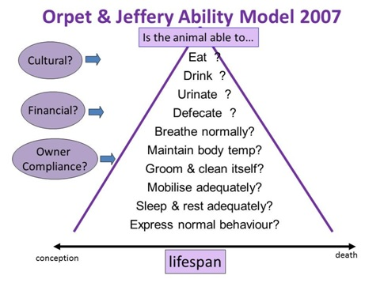
Figure 2: The Ability Model by Orpet and Jeffery (Orpet and Welsh, 2011)

