S1P in the development of atherosclerosis: roles of haemodynamic wall shear stress and endothelial permeability

Christina M. Warboys^{1#} and Peter D. Weinberg²
¹ Department of Comparative Biomedical Sciences, Royal Veterinary College, London, UK
² Department of Bioengineering, Imperial College London, London, UK

# Author for correspondence:
Dr Christina M. Warboys
Department of Comparative Biomedical Sciences,
Royal Veterinary College,
London NW1 0TU,
UK
cwarboys@rvc.ac.uk

Abstract
Atherosclerosis is characterised by focal accumulations of lipid within the arterial wall, thought to arise from effects of haemodynamic wall shear stress (WSS) on endothelial permeability. Identifying pathways that mediate effects of shear on permeability could therefore provide new therapeutic opportunities. Here we consider whether the sphingosine-1-phosphate (S1P) pathway could constitute such a route. We review effects of S1P in endothelial barrier function, the influence of WSS on S1P production and signalling, the results of trials investigating S1P in experimental atherosclerosis in mice, and associations between S1P levels and cardiovascular disease in humans. Although it seems clear that S1P reduces endothelial permeability and responds to WSS, the evidence that it influences atherosclerosis is equivocal. The effects of specifically pro- and anti-atherosclerotic WSS profiles on the S1P pathway require investigation, as do influences of S1P on the vesicular pathways likely to dominate low density lipoprotein transport across endothelium.

Keywords: coronary artery disease; mechanosensor; cytoskeleton; sphingosine-1-phosphate receptor; transverse wall shear stress

“This is an Accepted Manuscript of an article published by Taylor & Francis in Tissue Barriers on [date of publication], available online: http://www.tandfonline.com/[Article DOI].
https://doi.org/10.1080/21688370.2021.1959243
This is an Accepted Manuscript version of the following article, accepted for publication in Tissue Barriers. [INCLUDE CITATION]. It is deposited under the terms of the Creative Commons Attribution-NonCommercial License (http://creativecommons.org/licenses/by-nc/4.0/), which permits non-commercial re-use, distribution, and reproduction in any medium, provided the original work is properly cited

Introduction
In this review, we consider the role of spingosine-1-phosphate (S1P) in atherosclerosis, paying particular attention to the roles of haemodynamic wall shear stress (WSS) and arterial wall – dominantly endothelial – permeability. More specifically, S1P is discussed in relation to the longstanding but controversial hypothesis:

Atherogenic WSS characteristics
↓
elevated permeability to atherogenic molecules
↓
initiation of atheromata

The hypothesis is controversial because there has been long-standing uncertainty about the WSS characteristics that are atherogenic, the transendothelial route for atherogenic molecules and – given that atherosclerosis is an inflammatory disease – whether inflammation is a consequence of the accumulation of atherogenic molecules in the arterial intima or, alternatively, triggered directly by WSS characteristics and itself the cause of elevated permeability.
We first examine these controversies in more detail. We then discuss (i) the effect of S1P on permeability, (ii) evidence for the shear dependence of S1P release and expression of its receptors, and (iii) effects of S1P and its receptors in murine atherosclerosis and human disease. A summary of the arguments is presented in Figure 1.

Atherosclerosis, WSS and arterial permeability
Atherosclerosis is characterised by focal accumulations of cholesterol and other lipids, fibrous proteins and inflammatory cells in the intima and inner media of large and medium-sized systemic arteries. Anichkov (Anichkov, 1933) showed that a similar pathology could be induced in rabbits by feeding them a diet supplemented with cholesterol. The intervention raised plasma cholesterol levels and the subsequent appearance of cholesterol within the inner layers of the arterial wall was convincing evidence that it crossed the arterial endothelium before depositing there. Subsequent studies showed that cholesterol crossed the endothelium as part of an intact lipoprotein (Nielsen, 1996) – predominantly low density lipoprotein (LDL) in people and very low density lipoprotein (VLDL) in rabbits. More modern techniques for causing an atherosclerosis-like condition in mice also depend on generating hyperlipoproteinaemia, although that requires genetic as well as dietary modification (Breslow, 1996). Another modern addition is the understanding that cholesterol can be transported out of the wall, as well as into it, and that this can occur when the lipids are taken up by the high density lipoprotein (HDL) particle (Stein and Stein, 1999).
Why, then, is there disagreement about these findings? The first controversy concerns the location of lesions and hence the direction of transport that is important. Anichkov (Anichkov, 1933) and many subsequent groups (e.g. Cornhill and Roach, 1976) examining disease in hypercholesterolaemic animals found that the lesions occur must frequently in a triangular area on the downstream lip of aortic branch ostia. Elevated uptake of circulating macromolecules was found in the same region, consistent with excessive uptake being the rate-liming factor (Anichkov, 1933; Schwenke and Carew, 1988; Weinberg, 1988). However, when lesions were examined in human post-mortem specimens, the mirror image pattern was observed: lesions occurred least frequently in these regions and instead occurred at the sides and upstream of branch points. Since the disease-free regions rather than the disease-prone ones were thought to have high permeability, it was postulated that it was reduced transport out of the wall, into the lumen, of material made or modified in the wall that caused disease (Caro, Fitz-Gerald and Schroter, 1971). HDL transport would be a good candidate for this material.
This confusion appears to have been resolved by the discovery that lesion patterns change with age in both rabbits and people; lesions occur downstream of branches in immature aortas of both species (Cornhill and Roach, 1976; Sinzinger, Silberbauer and Auerswald, 1980), and at the sides or upstream of branches at later ages (Caro, Fitz-Gerald and Schroter, 1971; Barnes and Weinberg, 1998, 2001; Sloop et al., 1998). Immature rabbit vessels were inappropriately being compared with mature human specimens. Furthermore, patterns of permeability to macromolecules change with age in exactly the same way (Sebkhi and Weinberg, 1994, 1996). Thus, when age is taken into account, there appears to be a good spatial correlation between the location of rabbit lesions, the location of human lesions and areas of high uptake. (Note that mice have a different distribution of disease at aortic branch points (McGillicuddy, Carrier and Weinberg, 2001)).
The second controversy concerns the dependence of high uptake on mechanical factors. When lesions and high permeability were thought to occur downstream of side branches, they were attributed to high WSS, which is expected to occur in such areas as a new boundary layer develops (Fry, 1969). High WSS was thought to cause high permeability by damaging the endothelium. When the “mirror image” pattern of lesions was found in adult human vessels, a protective role was attributed to high shear. Instead, lesions were thought to occur in regions of low WSS (Caro, Fitz-Gerald and Schroter, 1971). Subsequently, the consensus has become low and oscillatory WSS (Ku et al., 1985). However, the evidence for this view is not as robust as commonly assumed. Indeed, the hypothesis is contradicted by all studies where the results of computational fluid dynamics simulations were statistically compared on a location-by-location basis with maps of lesion prevalence (Peiffer, Sherwin and Weinberg, 2013). It has been suggested instead that lesions in both immature and mature vessels occur in regions of multidirectional flow, characterised by the transverse WSS metric, the distribution of which changes with age (Peiffer, Sherwin and Weinberg, 2013; Mohamied et al., 2015). That remains contentious.
The third controversy concerns the routes for transport of macromolecules across the endothelium. Junctions between endothelial cells (EC) are approximately 15nm wide, narrowing to 3nm in regions of tight junctions. Except in endothelium of the blood brain barrier, tight junctions do not form a continuous seal between neighbouring cells; there are breaks in the junctional strands. Hence macromolecules with a diameter up to approximately 15nm might be expected to pass passively through intercellular junctions, albeit less rapidly as size increases, and there is substantial evidence that this does indeed occur. HDL has a diameter of around that size. LDL, however, has a diameter of 23nm and VLDL has a diameter above 30nm. How do they cross?
If we first consider transport of artificial tracers which have sizes equivalent to albumin, HDL and LDL, but which are unlikely to be transported by receptor-mediated routes, direct visualisation shows that they cross endothelium, respectively, via intercellular junctions between neighbouring endothelial cells, through intercellular junctions at points where three or more cells meet, and across endothelial cells, probably via transcytosis (Ghim et al., 2017). In these experiments at least, the role of widened intercellular junctions, occurring when endothelial cells divide or die (Lin et al., 1988; Lin, Jan and Chien, 1990), seems to be negligible, and a recent study argues that the same is true in vivo (Chooi et al., 2016).
In addition to these routes, the possibility of receptor mediated transport needs to be considered. Receptor-mediated transcytosis of albumin is well attested; the major receptor is albondin (Gp60) (Antohe et al., 1993). Although transcellular transport of LDL was originally attributed to passive, fluid-phase transcytosis (Vasile, Simionescu and Simionescu, 1983), strong evidence for receptor involvement has arisen from recent studies. In particular, Alk1 appears to bind LDL and to mediate its transcytosis (Kraehling et al., 2016). Similarly, the ecto-F1-ATPase/P2Ys pathway is thought to play a role in receptor-mediated transcytosis of HDL (Martinez et al., 2015).

S1P in the arterial system
S1P is a highly bioactive lipid signalling mediator that is produced following phosphorylation of sphingosine by sphingosine kinase. Serum S1P levels are regulated by the actions of S1P phosphatase and S1P lyase that dephosphorylate or degrade S1P, respectively. S1P is produced by erythrocytes, leukocytes and activated platelets (Garcia et al., 2001) although EC are the major source of plasma S1P under physiological conditions (Venkataraman et al., 2008). Circulating S1P levels range between 200nM – 1000nM with the majority bound to high-density lipoprotein. S1P can also circulate bound to albumin and other lipoproteins but to a lesser extent (Sattler and Levkau, 2009). At target cells, S1P binds to and activates the S1P family of G-protein coupled receptors (S1PR1 – S1PR5) that couple to different G proteins to elicit a variety of cellular responses (Spiegel 2003). Endothelial cells express only S1PR1 which couples exclusively to Gα_{i} and S1PR3 which couples to Gα_{i}, Gα_{q/11}, Gα_{12/13,} although S1PR1 is expressed at significantly greater levels (Lee et al., 1999). There is conflicting evidence regarding the expression of S1PR2 in EC. S1PR2 is expressed at low levels in bovine microvascular EC (Morales-Ruiz et al., 2001) but is undetectable in human umbilical vein EC (HUVEC) (Lee et al., 1999).

S1P enhances barrier function
The arterial barrier-enhancing properties of S1P were first reported by Garcia et al. in 2001. They demonstrated that S1P (up to 1µM) rapidly increased transendothelial electrical resistance of bovine pulmonary artery and human aortic EC and that this required the activation of S1PR1 (Garcia et al., 2001). Although many subsequent studies have shown that acute application of S1P to EC cultured under static conditions results in increased endothelial transendothelial electrical resistance (Dudek et al., 2004; Mehta et al., 2005; Singleton et al., 2005; Xu et al., 2007; Li et al., 2015), few studies have assessed the effects on transport of plasma macromolecules such as albumin or lipoproteins. Our 2012 study demonstrated that exposure to S1P for 1h dose-dependently reduced the permeability of pig aortic EC to rhodamine-labelled albumin in an S1PR1-dependent manner (Warboys, Overby and Weinberg, 2012). Interestingly, we saw a reduction in permeability even at high doses (up to 250 µM) which conflicts with other studies where doses above 5 µM appear to cause a deterioration in barrier function measured by transendothelial electrical resistance (Garcia et al., 2001; Shikata, Birukov and Garcia, 2003; Li et al., 2015). Our observation of sustained enhancement of barrier function with increasing doses of S1P could result from the extended S1P exposure time or the presence of albumin in the medium, which may bind to and reduce the bioavailability of S1P. Furthermore, the deleterious effects of high doses of S1P have been attributed to the activation of RhoA in an S1PR2-dependent manner (Sanchez et al., 2007; Li et al., 2015) although these studies rely on over-expression of S1PR2 or studies with a putative S1PR2 antagonist with poor selectivity (Blankenbach et al., 2016). Since the expression of S1PR2 in human endothelium is barely detectable (Lee et al., 1999; Garcia et al., 2001), the physiological role of S1PR2 signalling remains unclear. It is possible that in these experiments, higher doses of S1P signal via S1PR3, which can also activate Rho signalling pathways acting to increase endothelial permeability (Shikata, Birukov and Garcia, 2003). The relative expression of S1PR1, S1PR2 and S1PR3 in pig endothelium is unknown and it may be that ligation of S1PR3 and subsequent activation of Rho is negligible.
In vitro data on the protective effects of S1P on endothelial permeability are supported by observations in mouse models. Endothelial deletion of S1PR1 is associated with increased permeability of retinal vessels to FITC-dextran (Jung et al., 2012). S1P has also been shown to reduce permeability to albumin in intact rat mesenteric microvessels (Zhang et al., 2016) and it improves barrier function in animal models of acute lung injury (McVerry et al., 2004; Peng et al., 2004).

Shear stress enhances endothelial responsiveness to S1P
Atheroprotective shear stress (20 dynes/cm²; unidirectional) appears to augment the effects of S1P in HUVEC (Aoki et al., 2007), where it has been shown to promote wound healing (Hughes et al., 2005) and angiogenesis (Kang, Bayless and Kaunas, 2008; Kang et al., 2011). The signalling mechanisms are poorly defined but appear to require Akt activation (Kang, Bayless and Kaunas, 2008). To our knowledge, only a single study has assessed the direct interplay between S1P and shear stress on endothelial permeability. S1P augments the barrier-enhancing effects of atheroprotective shear stress (15 dynes/cm²; unidirectional) in human pulmonary artery EC as assessed by increased transendothelial electrical resistance, suggesting there may be a common signalling mechanism (Shikata et al., 2005). This is explored further below.

Regulation of S1P and S1P receptors by atheroprotective shear stress
Atheroprotective shear stress (8 dynes/cm²; unidirectional) acutely increased the release of S1P from mouse embryonic EC via increased expression of sphingosine kinase (SPHK) and decreased expression of S1P lyase and S1P phosphatase (Venkataraman et al., 2008). This conflicts with an earlier study which found that exposure to low/oscillatory shear stress for 48h increased the expression of SPHK in human aortic EC whereas laminar flow caused a reduction in expression (Chen et al., 2004). However, since neither the release of S1P nor the expression of S1P lyase and S1P phosphatase were studied, the effects on S1P levels are not clear. S1PR1 was also upregulated by atheroprotective shear stresses in HUVEC (Takada et al., 1997; Hughes et al., 2005; Aoki et al., 2007) raising the possibility that shear-induced S1P may act in an autocrine manner on EC to maintain vascular homeostasis. Atheroprotective shear stress also increases the protein expression of gpr3 and gpr12 receptors (Uhlenbrock et al., 2003). These are constitutively active orphan GPCRs that are also activated by S1P (Uhlenbrock, Gassenhuber and Kostenis, 2002). Interestingly, Kruppel-like factor-2 (KLF2), a key atheroprotective gene induced by shear stress, binds to and transactivates the S1PR1 promoter, which could account for the increased expression of S1PR1 in response to atheroprotective shear stresses (Carlson et al., 2006). These in vitro findings are supported by animal studies that appear to show increased expression of S1PR1 in regions of the mouse aorta exposed to atheroprotective shear stress (Jung et al., 2012). The effects of shear stress on S1P biosynthesis and signalling are summarised in Figure 2.

Are S1P receptors mechanosensors?
The mechanisms by which S1P augments the effects of atheroprotective shear stress are poorly defined. It is possible that S1P receptors themselves are mechanosensitive since endothelial deletion of S1PR1 significantly impairs flow-mediated dilatation in resistance arteries (Cantalupo et al., 2017). S1P receptors belong to the G-protein coupled receptor (GPCR) family and there is growing evidence that GPCRs can be activated rapidly by shear stress and function as mechanosensors, possibly due to conformational changes resulting from changes in membrane fluidity (Hu et al., 2021). Indeed, acute exposure to atheroprotective shear stress results in the rapid dissociation of G_{αq/11} from S1PR3 due to a direct activation of G_{αq/11} that is independent of S1P ligation (Dela Paz, Melchior and Frangos, 2017). It is unclear whether S1PR1 and G_{αi}, which promote the barrier stabilising effects of S1P, behave in a similar way. Many signalling pathways activated by S1P that regulate barrier function overlap with those activated by atheroprotective shear stress, which may help us understand how S1P augments the protective effects of shear stress.

Effects of S1P on the actin cytoskeleton and regulation of the paracellular pathway
Exposure of endothelial cells to S1P results in rapid actin polymerisation and dynamic reorganisation of the actin cytoskeleton, forming a prominent cortical actin band (Lee et al., 1999; Garcia et al., 2001; Shikata, Birukov and Garcia, 2003; Dudek et al., 2004; Singleton et al., 2005) that is essential for the barrier enhancing effects of S1P (Garcia et al., 2001). Several studies have also shown that Rac GTPase is rapidly activated in response to S1P (Garcia et al., 2001; Shikata, Birukov and Garcia, 2003; Mehta et al., 2005; Li et al., 2015) and that this depends on the activation of PI3K and recruitment of Tiam1, a Rac1 guanine nucleotide exchange factor (Singleton et al., 2005). Rac plays a critical role in mediating S1P-induced cytoskeletal remodelling via activation of p21-associated Ser/Thr kinase (PAK) (Garcia et al., 2001; Shikata, Birukov and Garcia, 2003). PAK may act at several levels to promote the dynamic reorganisation of the cytoskeleton into dense peripheral bands that strengthen barrier function. Myosin light chain (MLC) can be phosphorylated by PAK (Kiosses et al., 1999) and indeed phosphorylated MLC has been shown to localise to peripheral bands in response to S1P (Garcia et al., 2001; Dudek et al., 2004). PAK also phosphorylates and activates LIM kinase (LIMK), which inhibits cofilin (an actin severing protein) thus preventing actin depolymerisation and promoting the formation of actin filaments (Yang et al., 1998).
The formation of prominent cortical actin bands in response to S1P was also associated with rapid translocation of the actin binding protein, cortactin, which promotes cytoskeletal remodelling by stimulating and stabilising Arp2/3-mediated actin polymerisation at filament branch points; this was found to be important in mediating the barrier enhancing effects of S1P (Dudek et al., 2004). The localisation of cortactin to cortical actin bands following exposure to S1P was dependent on Rac activation but occurred independently of PAK activity, although it is possible that interaction of cortactin with PAK is required (Dudek et al., 2004). The localisation of cortactin to the peripheral actin bands was found to promote MLC phosphorylation via its interaction with non-muscle myosin light chain kinase-2 (nmMLCK2) (Dudek et al., 2004). Atomic force microscopy revealed that S1P rapidly increases the elastic modulus (stiffening) at the cell periphery in a cortactin-dependent manner, suggesting that localised cytoskeletal actomyosin tension within cortical bands may mechanically strengthen cell-cell junctions to increase barrier function (Arce et al., 2008; Viswanathan et al., 2016)
Aside from actions on the cytoskeleton, S1P also rapidly increases the junctional localisation of VE-cadherin and β-catenin, promoting the assembly of adherens junctions and enhancing junction integrity (Lee et al., 1999; Mehta et al., 2005; Xu et al., 2007; Wang et al., 2011). This process is dependent on Rac activation (Lee et al., 1999). Endothelial barrier enhancement in response to S1P is also associated with the rapid redistribution of focal adhesions to the cell periphery, which acts to strengthens cell contacts with the extracellular matrix (Shikata, Birukov and Garcia, 2003). The assembly of focal adhesions is regulated in a Rac-dependent manner via activation of GIT-1 and GIT-2 (ADP ribosylation factor GTPase activation factors; ARF GAPs) which bind to paxillin, a key regulator of focal adhesion assembly - it acts as a scaffold, recruiting signalling molecules to focal adhesions (Shikata, Birukov and Garcia, 2003). Subsequent studies demonstrate that S1P promotes the redistribution of focal adhesions to the cell periphery by increasing binding of focal adhesion kinase (FAK) and paxillin to VE-cadherin protein and that these interactions are abolished in the absence of β-catenin (Sun et al., 2009).

In summary, S1P rapidly improves endothelial barrier function by promoting dynamic remodelling of the cortical actin cytoskeleton and the strengthening of intercellular junctions which is summarised in Figure 3.

Shear stress regulates acute cytoskeletal remodelling in a manner similar to S1P
EC undergo dynamic cytoskeletal remodelling in response to mechanical forces that alter endothelial cell shape and orientation (Galbraith, Skalak and Chien, 1998; McCue, Noria and Langille, 2004). Broadly, there are three phases of cytoskeletal remodelling and adaptation, with consequent alterations in barrier function. There appears to be an immediate compensatory response following application of shear stress (up to 20 min) that is associated with an enhanced cortical actin cytoskeleton and increased barrier function (Seebach et al., 2000; Shikata et al., 2005). This is followed by a phase of enhanced motility, remodelling and realignment associated with stress fibre formation, disruption of cell-cell junctions and thus increased permeability (Jo et al., 1991; Warboys et al., 2010). Recent studies by our group have shown that EC re-orient and align themselves so as to minimise transverse wall shear stress (Arshad et al., 2021). Once endothelial cells have re-modelled, the dense cortical actin cytoskeleton reforms (Birukov et al., 2002) and junctions and cell contacts are re-established, resulting in enhanced barrier function (Warboys et al., 2010; Ghim et al., 2017).
Acute application of shear stress (up to 20 mins) induces rapid cytoskeletal remodelling in a similar manner to that observed following acute exposure to S1P. Alongside a rapid increase in transendothelial electrical resistance, acute application of atheroprotective shear stress to human pulmonary artery EC results in dynamic cytoskeletal remodelling to form prominent cortical actin bands (Birukov et al., 2002; Shikata et al., 2005) and rapid activation and translocation of Rac to the cell periphery (Shikata et al., 2005). This is associated with increased MLC phosphorylation, tyrosine phosphorylation of junctional proteins and increased localisation of cortactin to the periphery (Birukov et al., 2002). Atheroprotective shear stress also results in the localisation of paxillin, FAK, GIT1 and GIT2 to the cell periphery along with increased phosphorylation of FAK on tyrosine⁵⁷⁶, consistent with formation of new focal adhesions at the cell periphery (Shikata et al., 2005). The effects of shear stress on cytoskeletal remodelling and junctional proteins are summarised in Figure 4.

To our knowledge only a single study has assessed S1P signalling under shear stress conditions and provided evidence that S1PR1 signalling mediates (at least in part) acute endothelial responses to flow. Inhibition of S1PR1 significantly reduced the activation of Akt and endothelial nitric oxide synthase (eNOS) in response to atheroprotective shear stress (Jung et al., 2012). This was also associated with increased tyrosine phosphorylation of VE-cadherin (which is linked to junctional destabilisation), reduced integrity of adherens junctions and increased formation of paracellular gaps, although permeability was not assessed (Jung et al., 2012). These experiments suggest that activation of S1PR1 occurs without activation by S1P, supporting the observation that S1PR are mechanosensitive and may respond directly to mechanical force (Dela Paz, Melchior and Frangos, 2017). Furthermore, since S1PR1 associates closely with junctional VE-cadherin in regions of mouse aorta subject to atheroprotective flow, it is possible that S1PR1 functions as part of the mechanosensory complex (Tzima et al., 2005)

Effects on Tricellular junctions
Our recent study confirms that S1P (1 µM) reduces the permeability of human aortic EC cultured under static conditions to an albumin-sized tracer (FITC-avidin) (Ghim, Mohamied and Weinberg, 2020). Using a spatially resolved permeability assay, we determined that tricellular junctions account for > 80% of the overall tracer transport and are thus a major permeability pathway for albumin-sized molecules. The effects of S1P were attributed to a reduction in the number of permeable tricellular junctions. Similar effects were observed when cells were exposed chronically to uniaxial (atheroprotective) shear stress, which may suggest a common signalling mechanism, although in the case of shear stress alone, the permeability of each leaky junction was also reduced.

S1P and the glycocalyx
S1P may also augment the effects of atheroprotective shear stress due to its critical role in regulating the stability of the endothelial glycocalyx, which has been shown to play a role in endothelial mechanotra nsduction (Zeng et al., 2018) and the maintenance of endothelial permeability (Curry and Adamson, 2012). The presence of S1P is necessary to maintain endothelial barrier function under homeostatic conditions (Curry and Adamson, 2013). S1P stabilises the glycocalyx by inhibiting the activity of matrix metalloproteinases in an S1PR1-dependent manner, thereby preventing the shedding of syndecan-1 ectodomain, heparan sulphate and chondroitin sulphate (Zeng et al., 2014). S1P, acting through PI3K, also plays a role in the recovery of the glycocalyx following its collapse (Zeng et al., 2015). Subsequent studies have shown that S1P also stabilises the glycocalyx in intact rat mesenteric microvessels, which is associated with enhanced barrier function (Zhang et al., 2016). Since S1P biosynthesis and signalling appears to be reduced under conditions of atherogenic flow, this may account for the loss of the glycocalyx in these regions and the impairment of barrier function (Van Den Berg, Spaan and Vink, 2009)

S1P and murine atherosclerosis

Studies with FTY720 (fingolimod)
The two earliest papers on the sphingosine analogue FTY720 and atherosclerosis (Keul et al., 2007; Nofer et al., 2007) showed that FTY720 inhibits development of the disease in mice. FTY720 is phosphorylated intracellularly and acts as an agonist of S1PR1, S1PR3, S1PR4 and S1PR5; it has anti-inflammatory and immunosuppressive actions. The first study used Apoe^{-/-} mice and the second used Ldlr^{-/-} knockout mice; in both cases, the mice were fed a lipid-enhanced diet. The effects were large: in the first paper, lesion volume in the brachiocephalic artery and aortic root was approximately halved by a dose of 1.25 mg.kg⁻¹.day⁻¹ and there were similar decreases in macrophage and collagen content; in the second study 0.4 mg.kg⁻¹.day⁻¹ reduced disease by approximately one third and almost completely abrogated necrotic core formation. The results were attributed to interference with monocyte/macrophage (Keul et al., 2007; Nofer et al., 2007) and lymphocyte (Nofer et al., 2007) function.
Not all studies have shown the same effect. Klingenberg et al. (Klingenberg et al., 2007) gave 0.3 mg.kg⁻¹.day⁻¹ FTY720 to Apoe^{-/-} mice on a normal laboratory diet. Blood lymphocytes were reduced but serum cholesterol concentrations were substantially increased. There was no effect on lesion initiation or on the development of established lesions. This may reflect counterbalancing anti-inflammatory and hypercholesterolaemic effects; the latter might have been masked in the trials using a cholesterol-enhanced diet. A later study (Poti, Costa, et al., 2012) found no net effect of FTY720 at 0.4 mg.kg⁻¹.day⁻1 on atherosclerosis in Ldlr^{-/-} mice on a high-fat diet, despite interference with lymphocyte and macrophage function. There was a similar lack of effect of CYM5442, an S1PR1-selective agonist. Neither agonist affected total plasma cholesterol or triglyceride concentrations. The authors speculated that the S1P mimetics failed to influence atherosclerosis in their study and in the study of Klingenberg et al. because the animal and dietary models resulted in less hypercholesterolaemia, and hence less inflammation, than in the earlier studies (Keul et al., 2007; Nofer et al., 2007).

Studies altering the S1P pathway
A number of studies have examined the effects on experimental atherosclerosis of altering the synthesis, degradation or transport of S1P. Sphingosine kinases 1 and 2 catalyse the formation of S1P from sphingosine and both are inhibited by ABC294640. A study (Poti, Bot, et al., 2012) administering ABC294640 to Ldlr^{-/-} mice on a high-fat diet reduced plasma S1P by 40%. Plasma triglyceride concentrations were halved but there was a complex mix of pro- and anti-inflammatory influences and no significant effect on the size of aortic root lesions.

A subsequent study (Potì et al., 2015) from the same group used SKI-II, a sphingosine kinase 1 inhibitor, in Ldlr^{-/-} mice on the same diet or on a diet with a five-fold higher cholesterol content. Plasma S1P concentrations were reduced by approximately the same fraction as in the earlier study. Lesion area in the thoracic aorta was increased by SKI-II in the higher cholesterol group but not on the lower one. This result is consistent with S1P having an atheroprotective effect only in severe hypercholesterolaemia. Blood leukocyte counts were unaffected by SKI-II and triglycerides were again decreased, but inflammatory markers were increased.
Bone marrow from control or sphingosine kinase 2 knockout mice has been transplanted into irradiated Ldlr^{-/-} mice (Feuerborn et al., 2018). Paradoxically, mice receiving sphingosine kinase 2-deficient marrow have 50-100% elevated S1P concentrations in erythrocytes and HDL, an effect that has been attributed to reduced transport of S1P from blood into lymphoid tissue (Sensken et al., 2010). When the mice were placed on a high-fat diet for 14 weeks, plaque area was halved and necrotic core more than halved in the aortic root, and area was reduced by two thirds in the descending thoracic aorta, in the mice that received sphingosine kinase 2 deficient as opposed to wild type bone marrow, and therefore had elevated S1P. Peritoneal monocyte recruitment, capillary leukocyte adhesion and VCAM-1 levels were also reduced, whilst plasma lipids were unaffected. Of particular interest, this study also assessed vascular permeability – the results are discussed below.
Finally, S1P lyase catalyses irreversible degradation of S1P. In a study by Bot et al (Bot et al., 2013), LDLR knockout mice that were transplanted with bone marrow from S1P lyase knockout or control mice were placed on a high-fat diet. Aortic root lesion size was reduced by approximately one third in the chimeras receiving lyase deficient marrow. These mice had profoundly increased S1P in spleen and lymph nodes, reduced lymphocytes but increased monocytes in blood, and increased macrophage activation.

Effects of different S1P receptors
The roles of different S1P receptors in murine atherosclerosis have been investigated either by knocking out the receptor or by administering receptor-specific agonists. The first such study (Skoura et al., 2011) compared Apoe^{-/-} mice with Apoe^{-/-}/S1pr2^{-/-} double knockouts. When the mice were fed a high-fat diet, those with the S1PR2 deletion showed a 70% reduction in the extent of aortic lesions and a >80% reduction in lesion and necrotic core cross-sectional area in the aortic root. There was a large reduction in lesion macrophage content. In irradiated Apoe^{-/-} mice receiving bone marrow from S1PR2 knockout mice, aortic lesion area was reduced 65% compared to those receiving bone marrow from control mice. Thus S1PR2 promotes atherosclerosis; the effect appeared to be mediated via macrophages rather than endothelial or vascular smooth muscle cells.
Consistent with S1PR2 promoting atherosclerosis, administration of ONO-5430514, a specific S1PR2 antagonist, produced a 27% reduction in the area of aortic arch lesions in Apoe^{-/-} mice on a high-fat diet, despite the fact that S1PR2 expression actually increased (Ganbaatar et al., 2020). The antagonist improved endothelium-dependent vasodilatation to acetycholine and reduced the aortic expression of monocyte chemoattractant protein-1, VCAM-1 and a macrophage marker.
The evidence concerning S1PR3 is equivocal. The macrophage content of brachiocephalic artery lesions was reduced by two thirds in Apoe^{-/-}/S1pr3^{-/-} mice compared to Apoe^{-/-} mice, and macrophages had an altered activation profile. However, aortic lesion area was unaffected after 25 or 45 weeks on a standard laboratory diet, and lesion volume in the brachiocephalic artery was also unchanged (Keul et al., 2011). The lack of effect on lesion size may reflect the low dietary cholesterol levels (see above) or may indicate that S1PR3 has no net effect on the disease process.
Finally, S1PR1 appears to protect against atherosclerosis. Administration of KRP-203 a, selective S1P1 agonist, to Ldlr^{-/-} mice approximately halved the aortic area affected by lesions after 6 or 16 weeks on a high-fat diet (Potí et al., 2013). The cross-sectional area of lesions in the aortic root was also significantly reduced at both timepoints. Circulating lymphocytes were reduced. Monocytes were not, but macrophages from the KRP-203-treated mice showed less activation ex vivo.

S1P and human disease
A few studies have examined the association of circulating S1P with coronary artery disease in human subjects. Knapp et al. (Knapp et al., 2009) found that plasma S1P concentrations were approximately 50% lower in patients on the day they suffered a myocardial infarction than in age-matched controls. HDL-cholesterol was also reduced. A subsequent study by the same group (Knapp et al., 2013) found 20% lower S1P concentration in patients with ST-segment elevation myocardial infarction than in controls matched for age, sex and body mass index with no history of cardiovascular or other chronic diseases. In both studies, there was a non-significant trend for S1P concentrations to fall in patients during the course of the trial. Also in both studies, patients were administered anti-platelet therapy before blood was withdrawn, which is a possible confounding factor.
Sattler et al. (Sattler et al., 2010) distinguished between total S1P in plasma and S1P associated with HDL. Patients with myocardial infarction and patients with stable coronary artery disease were compared with controls. Total plasma S1P levels were lower in coronary artery disease patients than in controls but were not lower in infarcted patients. Both patient groups had lower HDL-cholesterol than controls. Plasma levels of HDL-bound S1P were one third lower and those of non-HDL-bound S1P were eight-fold higher in the patient groups. Less clear-cut data were obtained in a later study by the same group (Sattler et al., 2014). S1P levels were assessed in patients with stable coronary artery disease on the day before elective percutaneous coronary intervention. HDL-bound S1P concentrations were not associated with the extent of target lesion stenosis or restenosis. They were significantly lower in patients with 1-vessel rather than multi-vessel disease, but the effect size was small (≈10%).
A more recent study (Soltau et al., 2016) examined serum S1P levels in patients with peripheral artery disease or carotid stenosis, before invasive intervention (although most were on anticoagulants and statins). The patients had significantly lower levels than a control group of healthy blood donors. The effect size averaged approximately 25% when only patients or controls >60 years of age were considered (to exclude the younger cohort of blood donors). There was a recovery of S1P levels in the patient group within 6 months after intervention.
Finally, serum S1P was measured in >300 consecutive patients undergoing coronary angiography for all indications by Deutschman et al (Deutschman et al., 2003), and a positive correlation was obtained with disease severity. Multivariate analysis demonstrated that S1P was more predictive of obstructive disease (odds ratio = 7.61) than fourteen traditional risk factors including age, sex, family history of coronary disease, diabetes mellitus, lipid profile and hypertension. Its concentration was a significant predictor of severity but the effect size was again small: there were ≈10% increases in S1P concentration between mild and moderate stenosis and between moderate and severe stenosis.

Conclusions
Isolated organs perfused with physiological saline become oedematous. This effect is prevented by the addition of platelets or platelet-conditioned medium, and the active ingredient was identified by Garcia and co-workers as S1P (Schaphorst et al., 2003). Many subsequent studies, summarised above, have shown that S1P, acting through the S1PR1 receptor, tightens the endothelial barrier. Given the likely link between endothelial permeability and atherosclerosis, it is therefore natural to ask whether S1P might protect against atherosclerosis. Although this proposition has been extensively tested in mice, the motivation for most studies was that S1P has immunomodulatory and anti-inflammatory effects; such effects might also be expected to be atheroprotective. Despite the existence of this multiplicity of potentially beneficial actions, no clear answer has emerged. The following paragraphs condense key features from above.
The two earliest studies showed that FTY720 – a non-selective S1P receptor agonist – reduces murine atherosclerosis. However, this conclusion was contradicted by two subsequent studies, where no effect was seen. An explanation put forward at the time is that the agonist is effective only in severe hypercholesterolaemia, where greater inflammation is expected. Altering the endogenous S1P pathway gave similarly equivocal results. Inhibiting kinases 1 and 2 reduced plasma S1P but did not affect atherosclerosis. Inhibiting only kinase 1 also reduced plasma S1P; it affected severe but not mild disease. Removing kinase 2 from marrow paradoxically increased plasma S1P and reduced disease, as did removing lyase from marrow. Of the receptors, S1PR2 appears to promote atherosclerosis, S1PR3 has no proven effect and S1PR1, the dominant type in EC, is protective.
Studies of human atherosclerosis have similarly given equivocal results. Although five studies have shown an inverse association between the presence or level of human disease and circulating S1P concentrations, one study has shown the opposite. Furthermore, effect sizes were small in several studies. There has been a failure to distinguish the direction of causality; several of the studies regarded lowered S1P as an effect rather than a cause of cardiovascular events. So far as we are aware, there have been no prospective studies using subjects who were initially asymptomatic, and no intervention studies despite the fact that FTY720 is administered for immunomodulatory purposes, particularly in multiple sclerosis. Thus at present, the hypothesis that S1P is atheroprotective must be regarded as unproven.
Surprisingly, only one study (Feuerborn et al., 2018) of those investigating murine atherosclerosis additionally considered the role of endothelial permeability. That study raised circulating S1P concentrations and reduced lesions by irradiating Ldlr^{-/-} mice and then transplanting bone marrow for Sphk2^{-/-} mice, or from wild type mice as a control. Increased S1P led to decreased extravasation of Evans’ Blue Dye (which binds to plasma proteins, especially albumin), FITC-labelled 500kDa dextran or DyLight-labelled LDL into peritoneal fluid, collected by lavage. It also increased retention of DyLight-LDL in capillaries of the ileal mesentery, as assessed by intravital microscopy. The effects were large: the LDL concentration in peritoneal fluid was halved and its retention by mesenteric capillaries was doubled, for example.
The protocols in both experiments involved inducing hyperpermeability – by intraperitoneal LPS in the lavage experiments and by bradykinin in the intravital microscopy experiments; effects on baseline permeability were not characterised. Under such circumstances, the fraction of LDL transported via the paracellular route, or through large pores induced in the endothelial cells, is likely to be increased.
Very little work has been conducted on vesicular transcytosis and none, so far as we are aware, in normal arterial endothelium. Tjakra et al. (Tjakra et al., 2020) adduced a number of arguments supporting the view that S1P could influence transcytosis in blood brain barrier endothelium, but no experimental evidence that it actually does so. Janiurek et al. (Janiurek et al., 2019) provide circumstantial evidence: ~70% of S1P in the blood circulation is transported by apolipoprotein M (apoM) in HDL, and Apom^{-/-} mice have elevated numbers of bright dots at the “blood brain barrier interface” after injection with fluorescently-labelled albumin. The effect was reversed by adding the selective S1PR1 agonist SEW2871. However, the effect of knocking out Apom was not seen in capillaries or venules.
Concerning the effects of WSS on the S1P pathway, little has been done to understand the differential effects of atheroprotective and atherogenic shear stresses on S1P release or S1P receptor expression. Furthermore, most experiments have been acute rather than chronic, and their relevance in vivo is there for uncertain. Use of the swirling well model (Ghim et al., 2018; Warboys, Ghim and Weinberg, 2019) to rectify these shortcomings would be useful.
In conclusion, a comprehensive analysis that considers both acute and steady-state effects of different types of flow on S1P signalling is needed, as is a specific investigation of the effects of S1P on transcytosis of LDL in arteries under normal physiological conditions. The roles of S1P in atherogenesis would better be investigated in an animal model where the anatomical distribution of disease resembles that in human arteries. Finally, prospective studies are necessary to confirm or refute an influence of S1P on human cardiovascular disease.

Acknowledgements
This work was supported by BHF project grants to PDW and a BHF Intermediate Basic Science Fellowship to CMW.

Disclosures
The authors report no conflict of interest.

References
Anichkov, N. (1933) ‘Experimental arteriosclerosis in animals’, in Cowdrey E.V. (ed.) Arteriosclerosis. New York: McMillan, pp. 271–322.
Antohe, F. et al. (1993) ‘Albumin-binding proteins function in the receptor-mediated binding and transcytosis of albumin across cultured endothelial cells’, European Journal of Cell Biology, 60(2), pp. 268–275. Available at: https://europepmc.org/article/med/8330624.
Aoki, S. et al. (2007) ‘Fluid shear stress enhances the sphingosine 1-phosphate responses in cell-cell interactions between platelets and endothelial cells’, Biochemical and Biophysical Research Communications. Biochem Biophys Res Commun, 358(4), pp. 1054–1057. doi: 10.1016/j.bbrc.2007.05.028.
Arce, F. T. et al. (2008) ‘Regulation of the micromechanical properties of pulmonary endothelium by S1P and thrombin: Role of cortactin’, Biophysical Journal. Biophysical Society, 95(2), pp. 886–894. doi: 10.1529/biophysj.107.127167.
Arshad, M. et al. (2021) ‘Endothelial cells do not align with the mean wall shear stress vector’, Journal of the Royal Society, Interface. NLM (Medline), 18(174), p. 20200772. doi: 10.1098/rsif.2020.0772.
Barnes, S. E. and Weinberg, P. D. (1998) ‘Contrasting Patterns of Spontaneous Aortic Disease in Young and Old Rabbits’, Arteriosclerosis, Thrombosis, and Vascular Biology, 18(2), pp. 300–308. doi: 10.1161/01.atv.18.2.300.
Barnes, S. E. and Weinberg, P. D. (2001) ‘Strain-dependent differences in the pattern of aortic lipid deposition in cholesterol-fed rabbits’, Experimental and Molecular Pathology. Academic Press Inc., 71(2), pp. 161–170. doi: 10.1006/exmp.2001.2395.
Van Den Berg, B. M., Spaan, J. A. E. and Vink, H. (2009) ‘Impaired glycocalyx barrier properties contribute to enhanced intimal low-density lipoprotein accumulation at the carotid artery bifurcation in mice’, Pflugers Archiv European Journal of Physiology. Pflugers Arch, 457(6), pp. 1199–1206. doi: 10.1007/s00424-008-0590-6.
Birukov, K. G. et al. (2002) ‘Shear Stress-Mediated Cytoskeletal Remodeling and Cortactin Translocation in Pulmonary Endothelial Cells’, American Journal of Respiratory Cell and Molecular Biology. American Thoracic SocietyNew York, NY, 26(4), pp. 453–464. doi: 10.1165/ajrcmb.26.4.4725.
Blankenbach, K. V. et al. (2016) ‘Sphingosine-1-phosphate receptor-2 antagonists: Therapeutic potential and potential risks’, Frontiers in Pharmacology. Frontiers Research Foundation. doi: 10.3389/fphar.2016.00167.
Bot, M. et al. (2013) ‘Hematopoietic Sphingosine 1-Phosphate Lyase Deficiency Decreases Atherosclerotic Lesion Development in LDL-Receptor Deficient Mice’, PLoS ONE. Edited by B. Ryffel. Public Library of Science, 8(5), p. e63360. doi: 10.1371/journal.pone.0063360.
Breslow, J. L. (1996) ‘Mouse models of atherosclerosis’, Science. American Association for the Advancement of Science, 272(5262), pp. 685–688. doi: 10.1126/science.272.5262.685.
Cantalupo, A. et al. (2017) ‘S1PR1 (Sphingosine-1-Phosphate Receptor 1) Signaling Regulates Blood Flow and Pressure’, Hypertension. Lippincott Williams and Wilkins, 70(2), pp. 426–434. doi: 10.1161/HYPERTENSIONAHA.117.09088.
Carlson, C. M. et al. (2006) ‘Kruppel-like factor 2 regulates thymocyte and T-cell migration’, Nature. Nature Publishing Group, 442(7100), pp. 299–302. doi: 10.1038/nature04882.
Caro, C. G., Fitz-Gerald, J. M. and Schroter, R. C. (1971) ‘Atheroma and arterial wall shear. Observation, correlation and proposal of a shear dependent mass transfer mechanism for atherogenesis.’, Proceedings of the Royal Society of London. Series B. Biological sciences. Proc R Soc Lond B Biol Sci, 177(46), pp. 109–159. doi: 10.1098/rspb.1971.0019.
Chen, X.-L. et al. (2004) ‘Sphingosine kinase-1 mediates TNF-α-induced MCP-1 gene expression in endothelial cells: upregulation by oscillatory flow’, American Journal of Physiology-Heart and Circulatory Physiology. American Physiological Society, 287(4), pp. H1452–H1458. doi: 10.1152/ajpheart.01101.2003.
Chooi, K. Y. et al. (2016) ‘Role of endothelial permeability hotspots and endothelial mitosis in determining age-related patterns of macromolecule uptake by the rabbit aortic wall near branch points’, Atherosclerosis. Elsevier Ireland Ltd, 250, pp. 77–83. doi: 10.1016/j.atherosclerosis.2016.05.017.
Cornhill, J. F. and Roach, M. R. (1976) ‘A quantitative study of the localization of atherosclerotic lesions in the rabbit aorta’, Atherosclerosis. Atherosclerosis, 23(3), pp. 489–501. doi: 10.1016/0021-9150(76)90009-5.
Curry, F. E. and Adamson, R. H. (2012) ‘Endothelial glycocalyx: Permeability barrier and mechanosensor’, Annals of Biomedical Engineering. Ann Biomed Eng, pp. 828–839. doi: 10.1007/s10439-011-0429-8.
Curry, F. E. and Adamson, R. H. (2013) ‘Sphingosine‐1‐phosphate and the “albumin effect” on rat venular microvessels’, The FASEB Journal. John Wiley & Sons, Ltd, 27, pp. 896.2-896.2. doi: 10.1096/FASEBJ.27.1_SUPPLEMENT.896.2.
Deutschman, D. H. et al. (2003) ‘Predicting obstructive coronary artery disease with serum sphingosine-1-phosphate’, American Heart Journal. Mosby Inc., 146(1), pp. 62–68. doi: 10.1016/S0002-8703(03)00118-2.
Dudek, S. M. et al. (2004) ‘Pulmonary endothelial cell barrier enhancement by sphingosine 1-phosphate. Roles for cortactin and myosin light chain kinase’, Journal of Biological Chemistry. Elsevier, 279(23), pp. 24692–24700. doi: 10.1074/jbc.M313969200.
Feuerborn, R. et al. (2018) ‘Elevating Endogenous Sphingosine-1-Phosphate (S1P) Levels Improves Endothelial Function and Ameliorates Atherosclerosis in Low Density Lipoprotein Receptor-Deficient (LDL-R -/-) Mice’, Thrombosis and Haemostasis. Georg Thieme Verlag, 118(8), pp. 1470–1480. doi: 10.1055/s-0038-1666870.
Fry, D. L. (1969) ‘Certain histological and chemical responses of the vascular interface to acutely induced mechanical stress in the aorta of the dog.’, Circulation research. Lippincott Williams & Wilkins, 24(1), pp. 93–108. doi: 10.1161/01.RES.24.1.93.
Galbraith, C. G., Skalak, R. and Chien, S. (1998) ‘Shear stress induces spatial reorganization of the endothelial cell cytoskeleton’, Cell Motility and the Cytoskeleton. John Wiley & Sons, Ltd, 40(4), pp. 317–330. doi: 10.1002/(SICI)1097-0169(1998)40:4<317::AID-CM1>3.0.CO;2-8.
Ganbaatar, B. et al. (2020) ‘Inhibition of S1P Receptor 2 Attenuates Endothelial Dysfunction and Inhibits Atherogenesis in Apolipoprotein E-Deficient Mice’, Journal of Atherosclerosis and Thrombosis. Japan Atherosclerosis Society. doi: 10.5551/jat.54916.
Garcia, J. G. N. et al. (2001) ‘Sphingosine 1-phosphate promotes endothelial cell barrier integrity by Edg-dependent cytoskeletal rearrangement’, Journal of Clinical Investigation. The American Society for Clinical Investigation, 108(5), pp. 689–701. doi: 10.1172/JCI12450.
Ghim, M. et al. (2017) ‘Visualization of three pathways for macromolecule transport across cultured endothelium and their modification by flow.’, American journal of physiology. Heart and circulatory physiology. American Physiological Society, 313(5), pp. H959–H973. doi: 10.1152/ajpheart.00218.2017.
Ghim, M. et al. (2018) ‘A novel method for segmenting growth of cells in sheared endothelial culture reveals the secretion of an anti-inflammatory mediator’, Journal of Biological Engineering. BioMed Central Ltd., 12(1). doi: 10.1186/s13036-018-0107-6.
Ghim, M., Mohamied, Y. and Weinberg, P. D. (2020) ‘The Role of Tricellular Junctions in the Transport of Macromolecules Across Endothelium’, Cardiovascular Engineering and Technology. Springer, pp. 1–13. doi: 10.1007/s13239-020-00483-x.
Hu, Y. et al. (2021) ‘Flow-mediated vasodilation through mechanosensitive G protein-coupled receptors in endothelial cells’, Trends in Cardiovascular Medicine. Elsevier Inc. doi: 10.1016/j.tcm.2020.12.010.
Hughes, S. K. et al. (2005) ‘Fluid shear stress modulates cell migration induced by sphingosine 1-phosphate and vascular endothelial growth factor’, Annals of Biomedical Engineering. Springer, 33(8), pp. 1003–1014. doi: 10.1007/s10439-005-5756-1.
Janiurek, M. M. et al. (2019) ‘Apolipoprotein M-bound sphingosine-1-phosphate regulates blood–brain barrier paracellular permeability and transcytosis’, eLife. eLife Sciences Publications Ltd, 8. doi: 10.7554/eLife.49405.
Jo, H. et al. (1991) ‘Endothelial albumin permeability is shear dependent, time dependent, and reversible.’, The American journal of physiology, 260(6 Pt 2), pp. H1992-6. doi: 10.1152/ajpheart.1991.260.6.H1992.
Jung, B. et al. (2012) ‘Flow-Regulated Endothelial S1P Receptor-1 Signaling Sustains Vascular Development’, Developmental Cell. Elsevier, 23(3), pp. 600–610. doi: 10.1016/j.devcel.2012.07.015.
Kang, H. et al. (2011) ‘Fluid shear stress and sphingosine 1-phosphate activate calpain to promote Membrane Type 1 Matrix Metalloproteinase (MT1-MMP) membrane translocation and endothelial invasion into three-dimensional collagen matrices’, Journal of Biological Chemistry. J Biol Chem, 286(49), pp. 42017–42026. doi: 10.1074/jbc.M111.290841.
Kang, H., Bayless, K. J. and Kaunas, R. (2008) ‘Fluid shear stress modulates endothelial cell invasion into three-dimensional collagen matrices’, American Journal of Physiology - Heart and Circulatory Physiology. Am J Physiol Heart Circ Physiol, 295(5). doi: 10.1152/ajpheart.00281.2008.
Keul, P. et al. (2007) ‘The sphingosine-1-phosphate analogue FTY720 reduces atherosclerosis in apolipoprotein E-deficient mice’, Arteriosclerosis, Thrombosis, and Vascular Biology. Arterioscler Thromb Vasc Biol, 27(3), pp. 607–613. doi: 10.1161/01.ATV.0000254679.42583.88.
Keul, P. et al. (2011) ‘Sphingosine-1-Phosphate receptor 3 promotes recruitment of monocyte/macrophages in inflammation and atherosclerosis’, Circulation Research. Circ Res, 108(3), pp. 314–323. doi: 10.1161/CIRCRESAHA.110.235028.
Kiosses, W. B. et al. (1999) ‘A role for p21-activated kinase in endothelial cell migration’, Journal of Cell Biology. J Cell Biol, 147(4), pp. 831–843. doi: 10.1083/jcb.147.4.831.
Klingenberg, R. et al. (2007) ‘Sphingosine-1-phosphate analogue FTY720 causes lymphocyte redistribution and hypercholesterolemia in ApoE-deficient mice’, Arteriosclerosis, Thrombosis, and Vascular Biology. Lippincott Williams & Wilkins, 27(11), pp. 2392–2399. doi: 10.1161/ATVBAHA.107.149476.
Knapp, M. et al. (2009) ‘Plasma sphingosine-1-phosphate concentration is reduced in patients with myocardial infarction - Get your full text copy in PDF #878180 | Medical Science Monitor’, Medical Science Monitor, 15(9), pp. CR490–CR493. Available at: https://www.medscimonit.com/download/index/idArt/878180 (Accessed: 14 April 2021).
Knapp, M. et al. (2013) ‘Sustained decrease in plasma sphingosine-1-phosphate concentration and its accumulation in blood cells in acute myocardial infarction’, Prostaglandins and Other Lipid Mediators, 106, pp. 53–61. doi: 10.1016/j.prostaglandins.2013.10.001.
Kraehling, J. R. et al. (2016) ‘Genome-wide RNAi screen reveals ALK1 mediates LDL uptake and transcytosis in endothelial cells’, Nature Communications. Nature Publishing Group, 7. doi: 10.1038/ncomms13516.
Ku, D. N. et al. (1985) ‘Pulsatile flow and atherosclerosis in the human carotid bifurcation. Positive correlation between plaque location and low and oscillating shear stress’, Arteriosclerosis. Arteriosclerosis, 5(3), pp. 293–302. doi: 10.1161/01.atv.5.3.293.
Lee, M. J. et al. (1999) ‘Vascular endothelial cell adherens junction assembly and morphogenesis induced by sphingosine-1-phosphate’, Cell. Cell Press, 99(3), pp. 301–312. doi: 10.1016/S0092-8674(00)81661-X.
Li, Q. et al. (2015) ‘Differential activation of receptors and signal pathways upon stimulation by different doses of sphingosine-1-phosphate in endothelial cells’, Experimental Physiology. John Wiley & Sons, Ltd, 100(1), pp. 95–107. doi: 10.1113/expphysiol.2014.082149.
Lin, S. J. et al. (1988) ‘Enhanced macromolecular permeability of aortic endothelial cells in association with mitosis’, Atherosclerosis. Atherosclerosis, 73(2–3), pp. 223–232. doi: 10.1016/0021-9150(88)90045-7.
Lin, S. J., Jan, K. M. and Chien, S. (1990) ‘Role of dying endothelial cells in transendothelial macromolecular transport’, Arterioscler Thromb Vasc Biol, 10(5), pp. 703–709. doi: 10.1161/01.atv.10.5.703.
Martinez, L. O. et al. (2015) ‘Ecto-F1-ATPase/P2Y pathways in metabolic and vascular functions of high density lipoproteins’, Atherosclerosis. Elsevier Ireland Ltd, pp. 89–100. doi: 10.1016/j.atherosclerosis.2014.11.017.
McCue, S., Noria, S. and Langille, B. L. (2004) ‘Shear-induced reorganization of endothelial cell cytoskeleton and adhesion complexes’, Trends in Cardiovascular Medicine. Elsevier Inc., pp. 143–151. doi: 10.1016/j.tcm.2004.02.003.
McGillicuddy, C. J., Carrier, M. J. and Weinberg, P. D. (2001) ‘Distribution of lipid deposits around aortic branches of mice lacking LDL receptors and apolipoprotein E’, Arteriosclerosis, Thrombosis, and Vascular Biology. Lippincott Williams and Wilkins, 21(7), pp. 1220–1225. doi: 10.1161/hq0701.091996.
McVerry, B. J. et al. (2004) ‘Sphingosine 1-phosphate reduces vascular leak in murine and canine models of acute lung injury’, American Journal of Respiratory and Critical Care Medicine. Am J Respir Crit Care Med, 170(9), pp. 987–993. doi: 10.1164/rccm.200405-684OC.
Mehta, D. et al. (2005) ‘Sphingosine 1-phosphate-induced mobilization of intracellular Ca 2+ mediates Rac activation and adherens junction assembly in endothelial cells’, Journal of Biological Chemistry. J Biol Chem, 280(17), pp. 17320–17328. doi: 10.1074/jbc.M411674200.
Mohamied, Y. et al. (2015) ‘Change of Direction in the Biomechanics of Atherosclerosis’, Annals of Biomedical Engineering. Springer US, 43(1), pp. 16–25. doi: 10.1007/s10439-014-1095-4.
Morales-Ruiz, M. et al. (2001) ‘Sphingosine 1-Phosphate Activates Akt, Nitric Oxide Production, and Chemotaxis through a Gi Protein/Phosphoinositide 3-Kinase Pathway in Endothelial Cells’, Journal of Biological Chemistry, 276(22), pp. 19672–19677. doi: 10.1074/jbc.M009993200.
Nielsen, L. B. (1996) ‘Transfer of low density lipoprotein into the arterial wall and risk of atherosclerosis’, Atherosclerosis. Elsevier Ireland Ltd, pp. 1–15. doi: 10.1016/0021-9150(96)05802-9.
Nofer, J. R. et al. (2007) ‘FTY720, a synthetic sphingosine 1 phosphate analogue, inhibits development of atherosclerosis in low-density lipoprotein receptor-deficient mice’, Circulation, 115(4), pp. 501–508. doi: 10.1161/CIRCULATIONAHA.106.641407.
Dela Paz, N. G., Melchior, B. and Frangos, J. A. (2017) ‘Shear stress induces Gαq/11 activation independently of G protein-coupled receptor activation in endothelial cells’, American Journal of Physiology - Cell Physiology. American Physiological Society, 312(4), pp. C428–C437. doi: 10.1152/ajpcell.00148.2016.
Peiffer, V., Sherwin, S. J. and Weinberg, P. D. (2013) ‘Computation in the rabbit aorta of a new metric – the transverse wall shear stress – to quantify the multidirectional character of disturbed blood flow’, Journal of Biomechanics, 46(15), pp. 2651–2658. doi: http://dx.doi.org/10.1016/j.jbiomech.2013.08.003.
Peiffer, V., Sherwin, S. J. and Weinberg, P. D. (2013) ‘Does low and oscillatory wall shear stress correlate spatially with early atherosclerosis? A systematic review’, Cardiovascular Research, 99(2), pp. 242–250. doi: 10.1093/cvr/cvt044.
Peng, X. et al. (2004) ‘Protective effects of sphingosine 1-phosphate in murine endotoxin-induced inflammatory lung injury’, American Journal of Respiratory and Critical Care Medicine. American Lung Association, 169(11), pp. 1245–1251. doi: 10.1164/rccm.200309-1258oc.
Poti, F., Costa, S., et al. (2012) ‘Effect of sphingosine 1-phosphate (S1P) receptor agonists FTY720 and CYM5442 on atherosclerosis development in LDL receptor deficient (LDL-R-/-) mice’, Vascular Pharmacology. Vascul Pharmacol, 57(1), pp. 56–64. doi: 10.1016/j.vph.2012.03.003.
Poti, F., Bot, M., et al. (2012) ‘Sphingosine kinase inhibition exerts both pro- and anti-atherogenic effects in low-density lipoprotein receptor-deficient (LDL-R -/-) mice’, Thrombosis and Haemostasis. Thromb Haemost, 107(3), pp. 552–561. doi: 10.1160/TH11-08-0583.
Potí, F. et al. (2013) ‘KRP-203, sphingosine 1-phosphate receptor type 1 agonist, ameliorates atherosclerosis in LDL-R-/-mice’, Arteriosclerosis, Thrombosis, and Vascular Biology. Lippincott Williams & WilkinsHagerstown, MD, 33(7), pp. 1505–1512. doi: 10.1161/ATVBAHA.113.301347.
Potì, F. et al. (2015) ‘SKI-II - a sphingosine kinase 1 inhibitor - exacerbates atherosclerosisin low-density lipoprotein receptor-deficient (LDL-R-/-) mice on high cholesterol diet’, Atherosclerosis. Elsevier Ireland Ltd, 240(1), pp. 212–215. doi: 10.1016/j.atherosclerosis.2015.03.020.
Sanchez, T. et al. (2007) ‘Induction of vascular permeability by the sphingosine-1-phosphate receptor-2 (S1P2R) and its downstream effectors ROCK and PTEN’, Arteriosclerosis, Thrombosis, and Vascular Biology. Lippincott Williams & Wilkins, 27(6), pp. 1312–1318. doi: 10.1161/ATVBAHA.107.143735.
Sattler, K. et al. (2014) ‘HDL-Bound Sphingosine 1-Phosphate (S1P) Predicts the Severity of Coronary Artery Atherosclerosis’, Cellular Physiology and Biochemistry. Cell Physiol Biochem Press, 34(1), pp. 172–184. doi: 10.1159/000362993.
Sattler, K. J. E. et al. (2010) ‘Sphingosine 1-phosphate levels in plasma and HDL are altered in coronary artery disease’, Basic Research in Cardiology. Basic Res Cardiol, 105(6), pp. 821–832. doi: 10.1007/s00395-010-0112-5.
Sattler, K. and Levkau, B. (2009) ‘Sphingosine-1-phosphate as a mediator of high-density lipoprotein effects in cardiovascular protection’, Cardiovascular Research. Cardiovasc Res, pp. 201–211. doi: 10.1093/cvr/cvp070.
Schaphorst, K. L. et al. (2003) ‘Role of sphingosine-1 phosphate in the enhancement of endothelial barrier integrity by platelet-released products’, American Journal of Physiology - Lung Cellular and Molecular Physiology. American Physiological Society, 285(1 29-1). doi: 10.1152/ajplung.00311.2002.
Schwenke, D. C. and Carew, E. (1988) ‘Quantification in vivo of increased LDL content and rate of LDL degradation in normal rabbit aorta occurring at sites susceptible to early atherosclerotic lesions’, Circulation Research. Circ Res, 62(4), pp. 699–710. doi: 10.1161/01.RES.62.4.699.
Sebkhi, A. and Weinberg, P. D. (1994) ‘Age-related variations in transport properties of the rabbit arterial wall near branches’, Atherosclerosis. Elsevier, 106(1), pp. 1–8. doi: 10.1016/0021-9150(94)90077-9.
Sebkhi, A. and Weinberg, P. D. (1996) ‘Effect of age on the pattern of short-term albumin uptake by the rabbit aortic wall near intercostal branch ostia’, Arteriosclerosis, Thrombosis, and Vascular Biology. Lippincott Williams and Wilkins, 16(2), pp. 317–327. doi: 10.1161/01.ATV.16.2.317.
Seebach, J. et al. (2000) ‘Endothelial barrier function under laminar fluid shear stress’, Laboratory Investigation. Lippincott Williams and Wilkins, 80(12), pp. 1819–1831. doi: 10.1038/labinvest.3780193.
Sensken, S.-C. et al. (2010) ‘Redistribution of Sphingosine 1-Phosphate by Sphingosine Kinase 2 Contributes to Lymphopenia’, The Journal of Immunology. The American Association of Immunologists, 184(8), pp. 4133–4142. doi: 10.4049/jimmunol.0903358.
Shikata, Y. et al. (2005) ‘Differential effects of shear stress and cyclic stretch on focal adhesion remodeling, site-specific FAK phosphorylation, and small GTPases in human lung endothelial cells’, Experimental Cell Research. Academic Press Inc., 304(1), pp. 40–49. doi: 10.1016/j.yexcr.2004.11.001.
Shikata, Y., Birukov, K. G. and Garcia, J. G. N. (2003) ‘S1P induces FA remodeling in human pulmonary endothelial cells: Role of Rac, GIT1, FAK, and paxillin’, Journal of Applied Physiology. American Physiological Society, 94(3), pp. 1193–1203. doi: 10.1152/japplphysiol.00690.2002.
Singleton, P. A. et al. (2005) ‘Regulation of sphingosine 1‐phosphate‐induced endothelial cytoskeletal rearrangement and barrier enhancement by S1P ₁ receptor, PI3 kinase, Tiam1/Rac1, and α‐actinin’, The FASEB Journal. Wiley, 19(12), pp. 1646–1656. doi: 10.1096/fj.05-3928com.
Sinzinger, H., Silberbauer, K. and Auerswald, W. (1980) ‘Quantitative Investigation of Sudanophilic Lesions around the Aortic Ostia of Human Fetuses, Newborn and Children’, Journal of Vascular Research. Karger Publishers, 17(1), pp. 44–52. doi: 10.1159/000158233.
Skoura, A. et al. (2011) ‘Sphingosine-1-phosphate receptor-2 function in myeloid cells regulates vascular inflammation and atherosclerosis’, Arteriosclerosis, Thrombosis, and Vascular Biology. Lippincott Williams & WilkinsHagerstown, MD, 31(1), pp. 81–85. doi: 10.1161/ATVBAHA.110.213496.
Sloop, G. D. et al. (1998) ‘A description of two morphologic patterns of aortic fatty streaks, and a hypothesis of their pathogenesis’, Atherosclerosis. Atherosclerosis, 141(1), pp. 153–160. doi: 10.1016/S0021-9150(98)00167-1.
Soltau, I. et al. (2016) ‘Serum-sphingosine-1-phosphate concentrations are inversely associated with atherosclerotic diseases in humans’, PLoS ONE. Public Library of Science, 11(12). doi: 10.1371/journal.pone.0168302.
Stein, O. and Stein, Y. (1999) ‘Atheroprotective mechanisms of HDL’, Atherosclerosis. Atherosclerosis, pp. 285–301. doi: 10.1016/S0021-9150(99)00065-9.
Sun, X. et al. (2009) ‘Enhanced interaction between focal adhesion and adherens junction proteins: Involvement in sphingosine 1-phosphate-induced endothelial barrier enhancement’, Microvascular Research. Microvasc Res, 77(3), pp. 304–313. doi: 10.1016/j.mvr.2008.12.004.
Takada, Y. et al. (1997) ‘Cloning of cDNAs encoding G protein-coupled receptor expressed in human endothelial cells exposed to fluid shear stress’, Biochemical and Biophysical Research Communications. Academic Press Inc., 240(3), pp. 737–741. doi: 10.1006/bbrc.1997.7734.
Tjakra, M. et al. (2020) ‘Overview of Crosstalk Between Multiple Factor of Transcytosis in Blood Brain Barrier’, Frontiers in Neuroscience. Frontiers Media S.A. doi: 10.3389/fnins.2019.01436.
Tzima, E. et al. (2005) ‘A mechanosensory complex that mediates the endothelial cell response to fluid shear stress’, Nature, 437(7057), pp. 426–431. doi: 10.1038/nature03952.
Uhlenbrock, K. et al. (2003) ‘Fluid Shear Stress Differentially Regulates gpr3, gpr6, and gpr12 Expression in Human Umbilical Vein Endothelial Cells’, Cellular Physiology and Biochemistry. Cell Physiol Biochem Press, 13(2), pp. 75–84. doi: 10.1159/000070251.
Uhlenbrock, K., Gassenhuber, H. and Kostenis, E. (2002) ‘Sphingosine 1-phosphate is a ligand of the human gpr3, gpr6 and gpr12 family of constitutively active G protein-coupled receptors’, Cellular Signalling. Cell Signal, 14(11), pp. 941–953. doi: 10.1016/S0898-6568(02)00041-4.
Vasile, E., Simionescu, M. and Simionescu, N. (1983) ‘Visualization of the binding, endocytosis, and transcytosis of low-density lipoprotein in the arterial endothelium in situ’, Journal of Cell Biology. J Cell Biol, 96(6), pp. 1677–1689. doi: 10.1083/jcb.96.6.1677.
Venkataraman, K. et al. (2008) ‘Vascular endothelium as a contributor of plasma sphingosine 1-phosphate’, Circulation Research. Circ Res, 102(6), pp. 669–676. doi: 10.1161/CIRCRESAHA.107.165845.
Viswanathan, P. et al. (2016) ‘Differential elastic responses to barrier-altering agonists in two types of human lung endothelium’, Biochemical and Biophysical Research Communications. Elsevier B.V., 478(2), pp. 599–605. doi: 10.1016/j.bbrc.2016.07.112.
Wang, L. et al. (2011) ‘FTY720-induced human pulmonary endothelial barrier enhancement is mediated by c-Abl’, European Respiratory Journal. NIH Public Access, 38(1), pp. 78–88. doi: 10.1183/09031936.00047810.
Warboys, C. M. et al. (2010) ‘Acute and chronic exposure to shear stress have opposite effects on endothelial permeability to macromolecules’, Am J Physiol Heart Circ Physiol, 298(6), pp. H1850-6. doi: 10.1152/ajpheart.00114.2010.
Warboys, C. M., Ghim, M. and Weinberg, P. D. (2019) ‘Understanding mechanobiology in cultured endothelium: A review of the orbital shaker method’, Atherosclerosis. Elsevier, 285, pp. 170–177. doi: 10.1016/J.ATHEROSCLEROSIS.2019.04.210.
Warboys, C. M., Overby, D. R. and Weinberg, P. D. (2012) ‘Dendritic cells lower the permeability of endothelial monolayers’, in Cellular and Molecular Bioengineering. Springer, pp. 184–193. doi: 10.1007/s12195-012-0220-4.
Weinberg, P. D. (1988) ‘Application of fluorescence densitometry to the study of net albumin uptake by the rabbit aortic wall up- and downstream of intercostal ostia’, Atherosclerosis. Elsevier, 74(1–2), pp. 139–148. doi: 10.1016/0021-9150(88)90200-6.
Xu, M. et al. (2007) ‘Sphingosine 1-phosphate rapidly increases endothelial barrier function independently of VE-cadherin but requires cell spreading and Rho kinase’, American Journal of Physiology - Cell Physiology. Am J Physiol Cell Physiol, 293(4). doi: 10.1152/ajpcell.00014.2007.
Yang, N. et al. (1998) ‘Cofflin phosphorylation by LIM-kinase 1 and its role in Rac-mediated actin reorganization’, Nature. Nature, 393(6687), pp. 809–812. doi: 10.1038/31735.
Zeng, Y. et al. (2014) ‘Sphingosine-1-phosphate protects endothelial glycocalyx by inhibiting syndecan-1 shedding’, American Journal of Physiology-Heart and Circulatory Physiology. American Physiological Society Bethesda, MD, 306(3), pp. H363–H372. doi: 10.1152/ajpheart.00687.2013.
Zeng, Y. et al. (2015) ‘Sphingosine 1-phosphate induced synthesis of glycocalyx on endothelial cells’, Experimental Cell Research. Academic Press Inc., 339(1), pp. 90–95. doi: 10.1016/j.yexcr.2015.08.013.
Zeng, Y. et al. (2018) ‘The role of endothelial surface glycocalyx in mechanosensing and transduction’, in Advances in Experimental Medicine and Biology. Springer New York LLC, pp. 1–27. doi: 10.1007/978-3-319-96445-4_1.
Zhang, L. et al. (2016) ‘Sphingosine-1-phosphate Maintains Normal Vascular Permeability by Preserving Endothelial Surface Glycocalyx in Intact Microvessels’, Microcirculation. Wiley Blackwell, 23(4), pp. 301–310. doi: 10.1111/micc.12278.

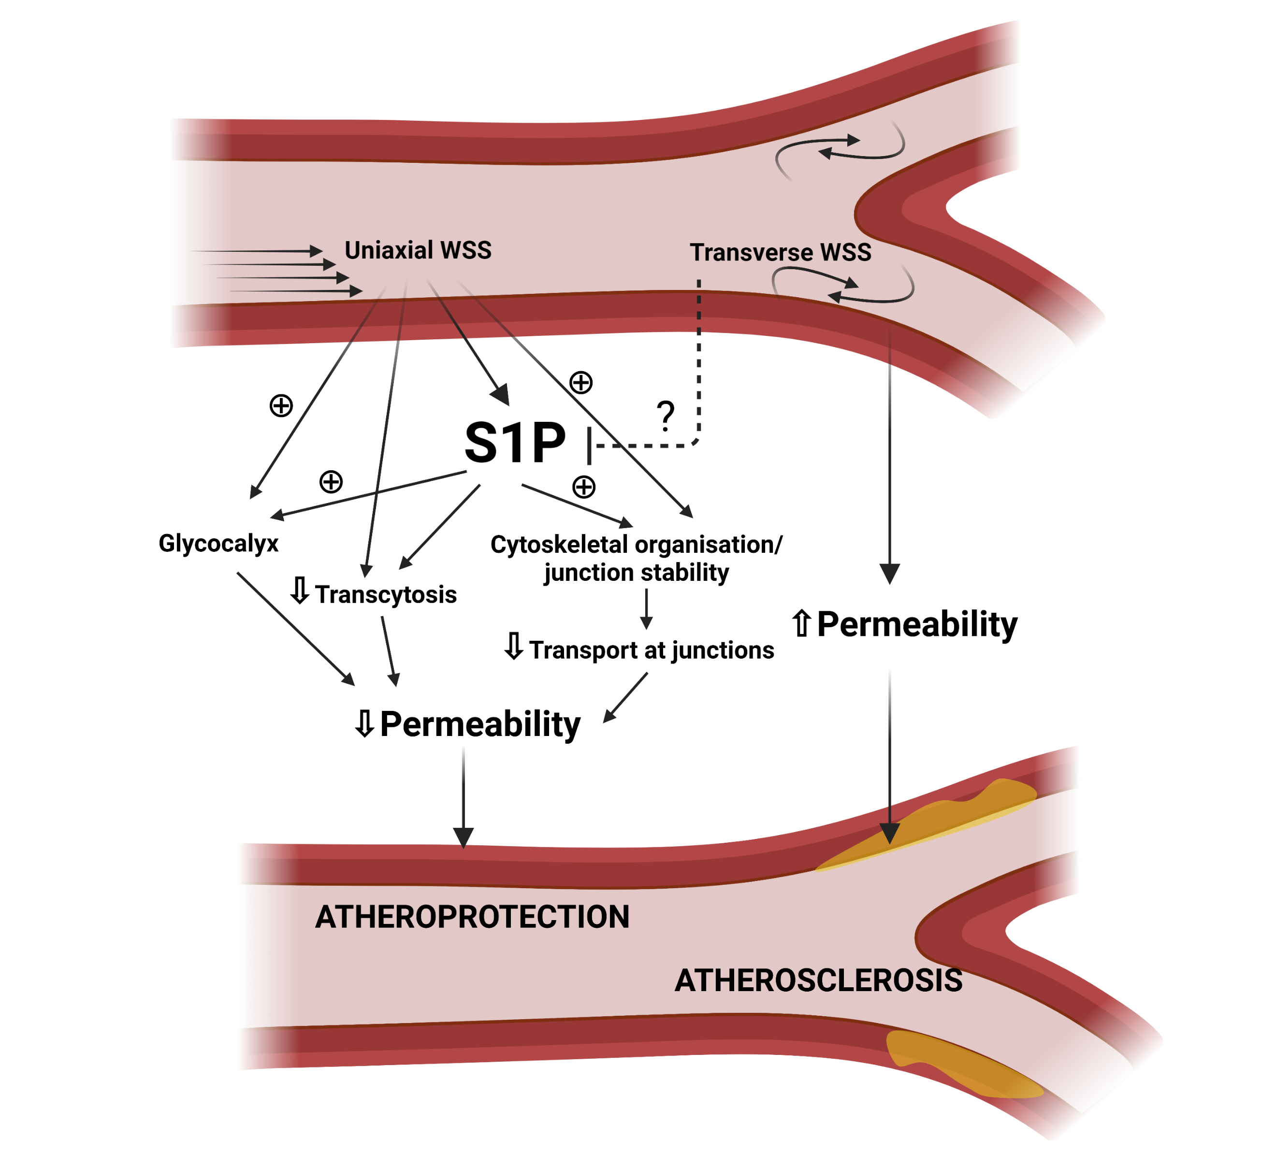

Figure 1. Overview of S1P and shear-mediated regulation of endothelial permeability
Unidirectional wall shear stress (WSS) reduces endothelial permeability and increases barrier function via several mechanisms (1) increased stability of the glycocalyx, (2) cytoskeletal organisation and increased junctional stability and (3) reduced transcytosis. Unidirectional WSS also increases levels of sphingosine-1-phosphate (S1P) that have been shown to reduce permeability by the same mechanisms. Transverse WSS on the other hand increases endothelial permeability and is associated with the development of atherosclerosis although its effects on S1P signalling are not yet known. Figure created with BioRender.com

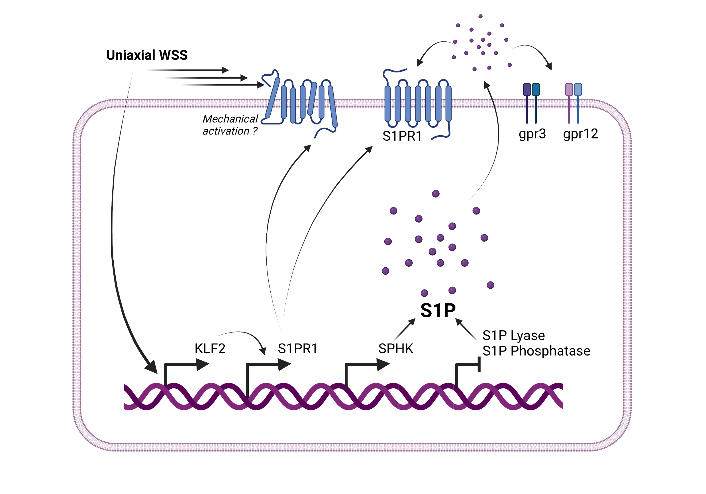

Figure 2. Overview of shear-mediated regulation of S1P biosynthesis and signalling
Unidirectional wall shear stress (WSS) increases the expression of sphingosine kinase (SPHK) and reduces the expression of S1P lyase and phosphatase resulting in increased levels of S1P. Unidirectional WSS also increases the expression of sphingosine-1-phosphate receptor-1 (S1PR1) under the regulation of Kruppel-like factor-2 (KLF2). S1P binds to and activates S1PR1 and gpr3/gpr12 orphan receptors. Evidence also suggests that S1P receptors may undergo direct mechanical activation by shear stress due to conformational changes with the receptor. Figure created with BioRender.com

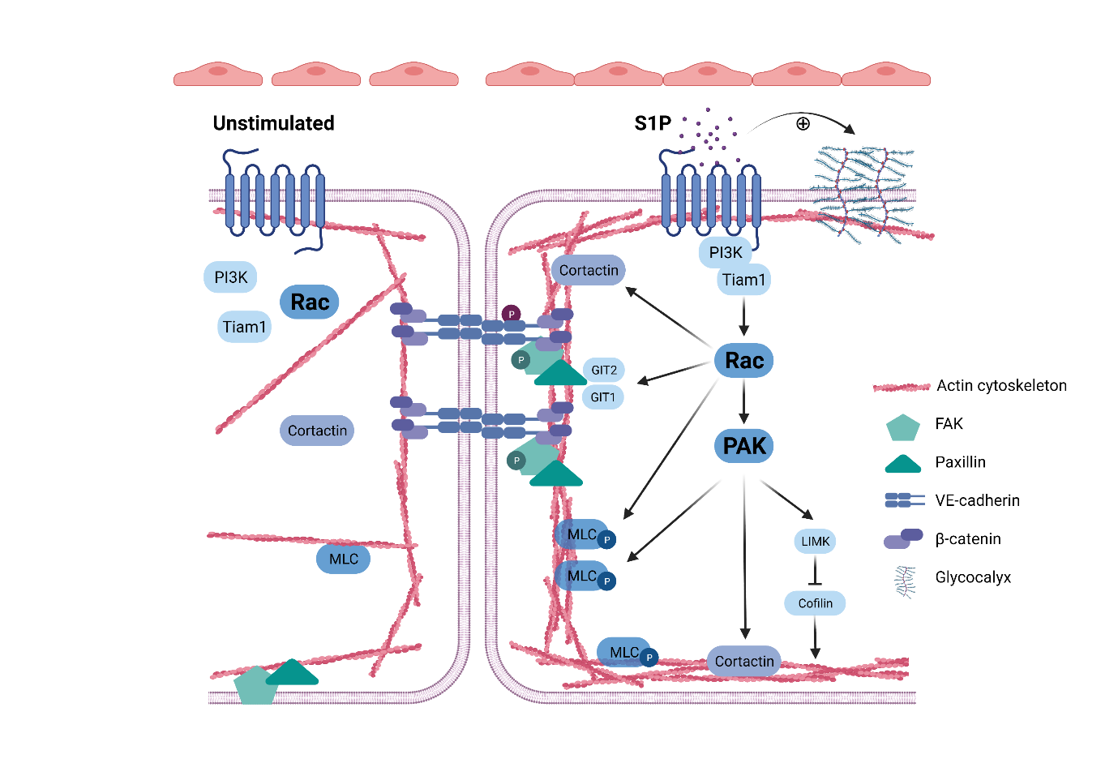
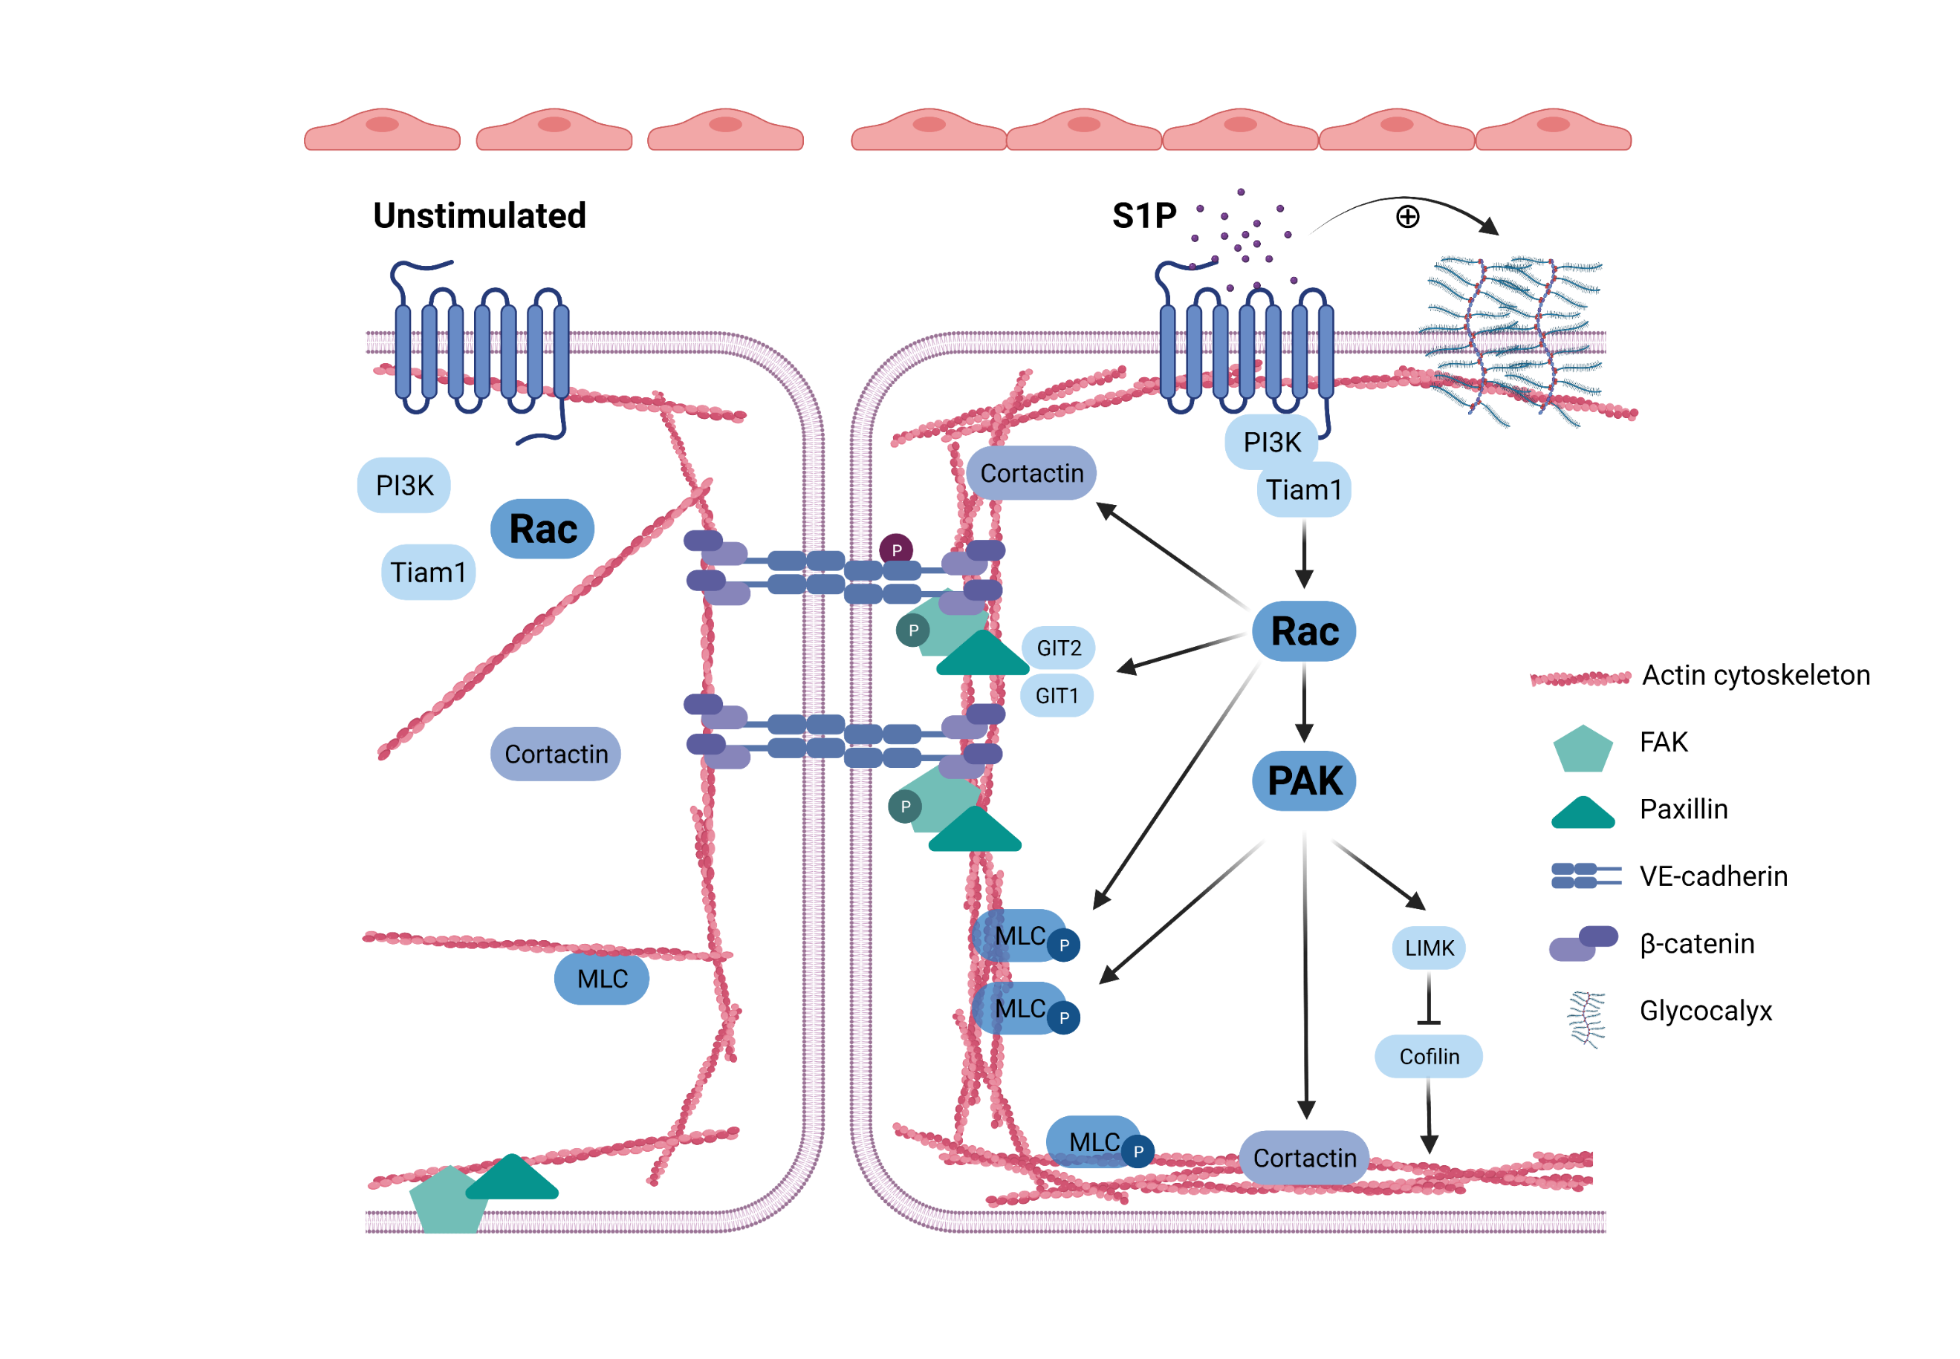

Figure 3. Overview of S1P-mediated regulation of barrier function in static endothelial cells
S1P binds to and activates S1P receptor-1 (S1PR1) leading to the rapid recruitment of PI3K and Tiam1 and the activation of Rac. In response to S1P, Rac and p21-associated Ser/Thr kinase (PAK) induce rapid actin polymerisation and dynamic reorganisation of the cytoskeleton to form a dense cortical actin band via activation of LIMK and cortactin and phosphorylation of myosin light chain (MLC). Rac also increases the localisation of VE-cadherin and β-catenin to adherens junctions resulting in increased endothelial barrier function. Rac also activates GIT1/GIT2 resulting in the redistribution of focal adhesion proteins (focal adhesion kinase (FAK) and paxillin) to VE-cadherin further increasing the stability and integrity of junctional complexes. S1P also stabilises the glycocalyx leading to reduced permeability and increased barrier function. Figure created with BioRender.com

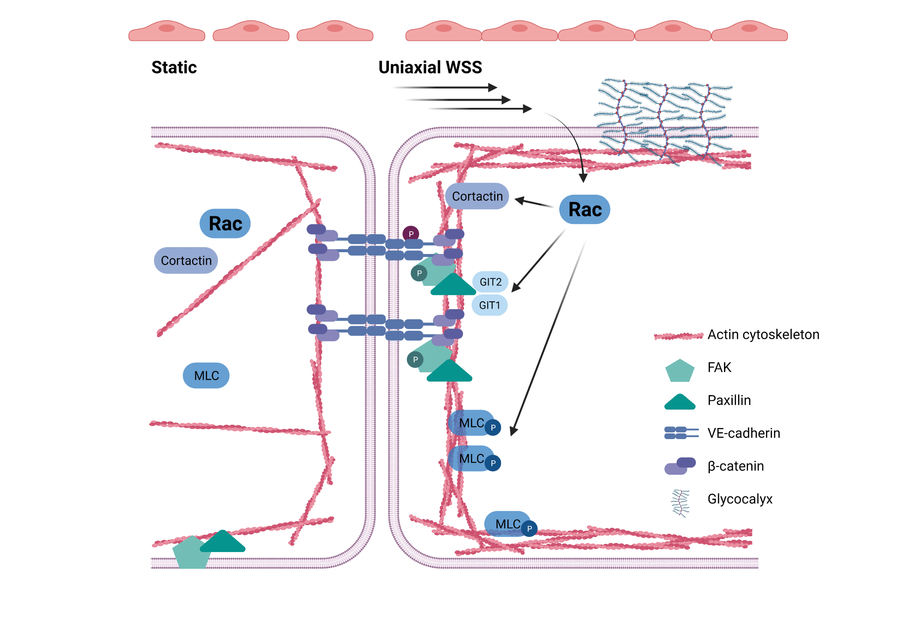

Figure 4. Overview of shear-mediated regulation of endothelial barrier function
Unidirectional wall shear stress (WSS) increases the activation of Rac which induces rapid actin polymerisation and dynamic reorganisation of the cytoskeleton to form a dense cortical actin band via activation of cortactin and phosphorylation of myosin light chain (MLC). Rac also increases the localisation of VE-cadherin and β-catenin to adherens junctions resulting in increased endothelial barrier function. Rac also activates GIT1/GIT2 resulting in the redistribution of focal adhesion proteins (focal adhesion kinase (FAK) and paxillin) to VE-cadherin further increasing the stability and integrity of junctional complexes. Unidirectional WSS also stabilises the glycocalyx leading to reduced permeability and increased barrier function. Figure created with BioRender.com

