Figure 1: Transverse images at the level of the lesion. Sequences include MRI a) T2 weighted, b) FLAIR, c) T1 subtraction, d) CT bone window, e) gross histopathological and f) microscopic low power image showing multiple lobules of bone and cartilage separated by fibrous septa.
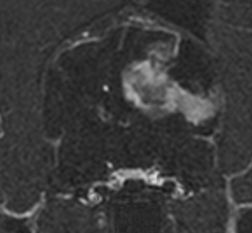
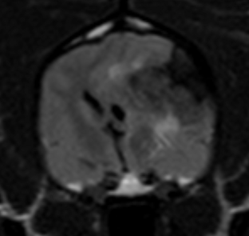
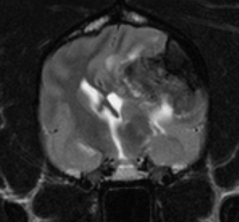
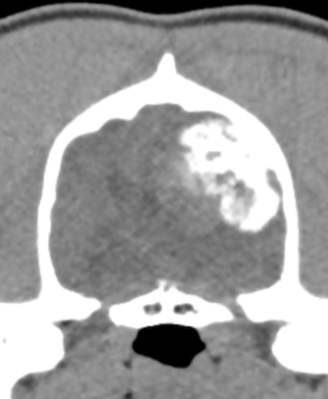
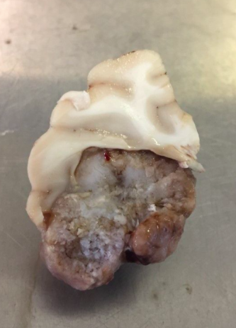
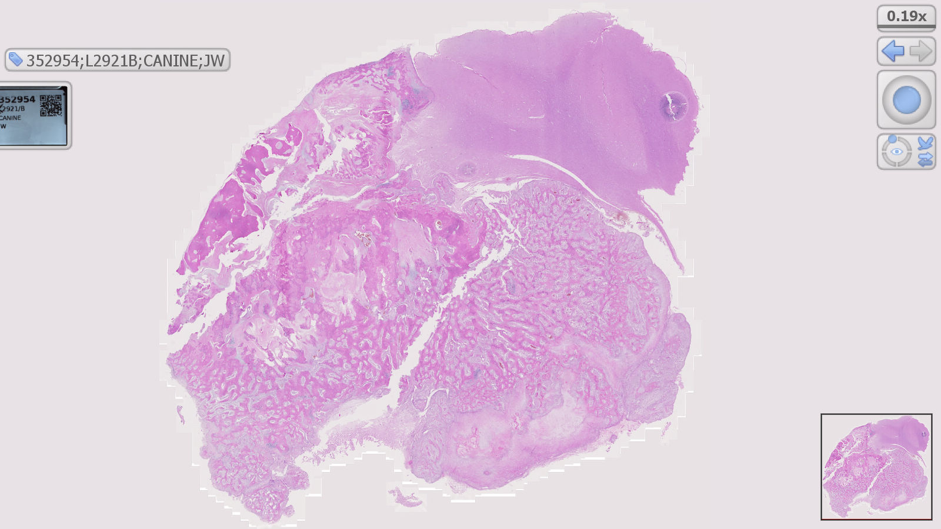
a
c
b
d
e
f
c
b
d
c
b
a

a
b

f

b

